Name _______________________________

Beaver Superhero Activity

Background
The North American Beaver (Castor canadensis) is a truly amazing animal. Beavers have highly adapted body structures and behaviors to support their unique lifestyle. These are just a few of the many specialized adaptations found in beavers:
- webbed feet to help them swim
- thick, waterproof fur to stay warm
- incredibly strong, long teeth to cut and shape wood
- agile front feet for building and manipulating materials
- gut adapted for digesting wood
- ability to see well underwater and hold breath for a long time
- fat for insulation
- wide, flat tail used for swimming, storing fat and scaring away predators

Beaver Superhero
Superheroes have exceptional traits that help them accomplish amazing feats! Use the descriptions above and your imagination to design and draw a Beaver Superhero on the back of this sheet. Highlight and label at least one (or more) adaptations on the beaver’s body that could be considered exceptional traits. You can zoom in on a specific structure if that helps (see example image). This is meant to be a creative activity - do not worry about making it perfect or totally realistic looking! Be prepared to share with a group.
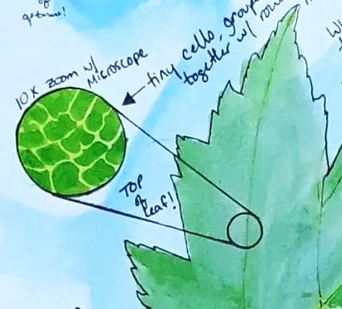

Sharing
In a group of 3-4 students, share your superheroes with each other.

