Beaver Superhero Activity, Teacher Guide
Objective: This is a fun activity, meant to allow creativity and artistic expression. Students will focus on one or more important adaptations of beavers to create a drawing of a Beaver Superhero, highlighting the specific chosen traits.
Materials: For simplicity and conservation of paper, you can have students create their drawing on the back of the assignment handout on simple copy paper. If students want to make a more formal piece of artwork, they could be given better paper such as artistic drawing paper.
Procedure: You can give students more or less time for perfecting their drawings, depending on time available. If you had more time to spend on this, you could have students present their creations to the entire class, rather than in small groups. Make sure that students are reminded that this is not meant to be an accurate scientific illustration, but rather a creative or even exaggerated image used to highlight a specific adaptation. If a student really wants to start by looking at a basic beaver’s body plan, you can show them this image:
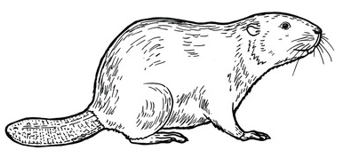
Notes: It would be helpful to first complete the Beaver Adaptations Matching Activity , to introduce students to the large variety of adaptations found in this animal. Also, holding on to student drawing examples would be helpful when explaining the assignment to future students.

