Name ___________________________

Arctic Beavers Flowchart Activity

Objective:
A flowchart is a diagram that uses symbols and arrows to visually represent the steps of a process or system. In this activity, you will synthesize many concepts studied during this unit into one large flowchart. This will allow you to think about order and causation of these events, and the complex relationships between factors. Using tape on your flowchart pieces allows you to move things around and test out different options.

Example: For a basic example of what a flowchart might look like, see the simple one below.
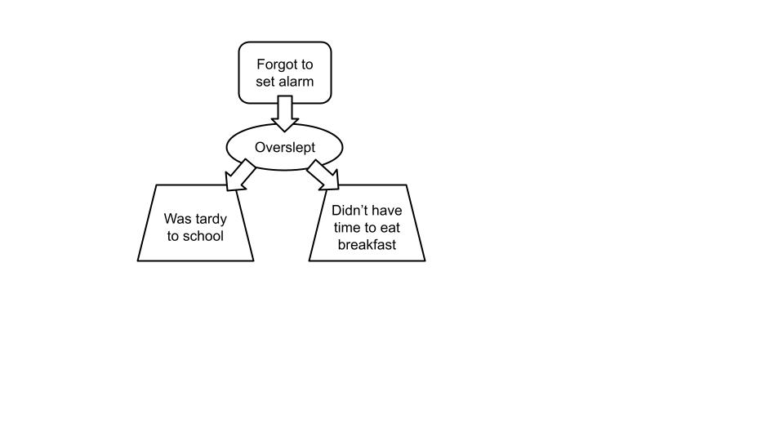
Materials: roll of scotch tape, scissors, pencil and eraser

Procedure:
- Working with a partner, cut out all of the boxes on the second sheet in this packet. Attach a small tape bubble to the back of each box.
- Discuss with your partner how the events and concepts relate to each other. Now start to arrange the boxes ON THE BACK OF THIS SHEET, starting at the top and moving downward. Try out some different placements, discuss, and move things around. Once you think you have a logical flowchart, lightly draw in some arrows using pencil. Then ask the teacher to check it.
- Reorganize your flowchart using feedback from the teacher until you feel that it is as thorough and accurate as possible. Now go over your arrows more darkly using pencil.
- If you want to add any additional new boxes to your flowchart, draw them in.

Questions:
- What are one or two things that this flowchart helped you to understand or to see more clearly?
- What is the main takeaway idea that you will remember from learning about Beavers in the Arctic?

Arctic Beavers Flowchart:
Arrange your boxes and arrows into a flowchart below.

