Arctic Beaver Case Study - Teacher Guide

General Notes:
Vocabulary - some important vocabulary words have been bolded throughout the assignment. Depending on the prior knowledge of the students, you could provide them with a glossary.
Student sharing - students could be asked to contribute ideas with the class on what they learned or thought from any section using an activity such as popcorn sharing, or calling on students using popsicle sticks. If there was more time, you could have students do a pair share and then share out with the class.
Further notes are added to some sections below. Sample answers to questions are shown in blue text.

I. Background
Watch the video clip(s) provided by the teacher. Write down a few ideas below from the video(s) that stood out to you as being important or new. Be prepared to share with the class.
For the video clips, you could use any or all of these. They are all filmed in the U.S.
1. BBC Earth video clip: “Busy Beavers Build Dam Ahead of Winter”,YouTube (4:41 min)
2. BBC Earth video clip “Beaver Lodge Construction Squad”, YouTube (9:46 min)
3. BBC Earth video clip “Master Builders of the Wild: Beavers at Work”, YouTube (3 min)
4. Inside a Beaver Lodge and Cross Section of a Dam, YouTube (6 min) - this video doesn’t show any beavers but gives a great view of their construction projects.
Students may write about the methods shown for felling and moving trees, and dam construction and repair. They may note their impressive breath holding and underwater activities, how large the dams can be, their extensive preparations for winter, and how dry their lodges remain. Students may be surprised by how large some of the fallen trees are, how long their claws are, and how strong and large their teeth look.

History
a. What do you think is the primary reason that the beaver population in North America plummeted so low? What do you think helped it later to recover?
The main reason for plummeting beaver populations was the fur trade during the 17th - 19th centuries.
Outlawing the fur trade, as well as reintroducing beavers and protecting habitat has been responsible for the recovery of the species in North America. (*Note: this recovery due to reintroduction, laws, etc. was NOT the cause of the recent beaver population increase in the Arctic. This has been attributed to climate change. Beavers were not historically found in the Arctic.)
b. Remember that a biological community consists of all of the living things in an area. What do you think would be some benefits to a community of having beaver dams?
Beaver ponds create important habitat for many other species. They provide a protected nursery habitat for juvenile fish. They increase plant growth in the area, which in turn greatly increases complexity of the food web and provides shelter for many organisms. Plant growth also shades the water, thus cooling it, making better habitat for fish such as salmon. Some migratory birds prefer landing on beaver ponds instead of more open bodies of water. Streams and rivers where beaver dams are present are more clear, with lower pollution levels. This is believed to be a result of the beaver dams slowing water and allowing pollutants to settle to the bottom. This provides better habitat for organisms. (*Note: the benefits mentioned above from beaver dams are not necessarily helpful in the Arctic where beaver populations have increased due to climate change and permafrost thaw. Beaver dams in these areas may be detrimental to the stability of the local food webs.)

Changing Conditions in the Arctic
In the permafrost section, it might be useful to show a photo to students of what the collapsing ground can look like due to icy permafrost thawing (from Tom Glass): https://www.thearcticinstitute.org/permafrost-thaw-warming-world-arctic-institute-permafrost-series-fall-winter-2020/
Questions:
- How do you think a biological community in the Tundra would change if permafrost in the area thawed? Land may collapse in some areas, which would destroy habitat. Permafrost thaw leads to more soil availability, which can lead to more plant growth throughout the year. This leads to changes in food webs, due to producer availability. For example, availability of shrubs such as willow was a major factor leading to beavers becoming established in these areas. Thawed soil can lead to increases in invertebrates like worms and insects. Also, thawing leads to changes in liquid water availability, which can lead to changes in organism distribution.

II. Alaska Beaver Research

Increasing Beaver Activity in Arctic Alaska
Questions:
- What do you think are some specific ways that researchers could measure changes in beaver activity? Using satellite images, using wildlife cameras, taking field measurements of location, depth or size of ponds, human observation.

Dr. Ken Tape’s Arctic Beaver Research Team
*Note: There is a documentary about the work of this research team that has been filmed and broadcast by Canadian Broadcasting Corporation (CBC). It is currently only available to view in Canada, or by using a VPN. This document will be updated when the video is available to view in the U.S. The name of the program is “Beavers from Above”, and can be found at https://gem.cbc.ca/the-nature-of-things.

Location for Beaver Research
Note: For the Google Earth activity, students would need to have access to a Chromebook, laptop or iPad. The instructions in the student worksheet were written using the Chrome browser, so they may need to be adjusted for other formats. As an optional math-focused extension, you could ask students to convert the distance from kilometers into miles.
What is the LATITUDE shown near Kotzebue? (round to the nearest degree) __67°__
Where is Kotzebue located, in relation to the Arctic Circle? North of it, by over 15’
Enter the name of your city. What is the latitude shown for your city? (round to the nearest degree) This will vary. For Portland, OR it is 45°
What is the length (distance) reported between the two locations? This will vary. For Portland, OR it is 3318 km

Beaver Activity Data
Question:
- What information can you gather from the above images? Be as specific as you can. There are more ponds present as time goes on. There is a dramatic increase after 2008. The ponds are scattered throughout the area.

Creating a Graph from Beaver Dam Data
Note: For the Graph, you may want to provide students with rulers to connect their data points. As an optional math-focused extension, you could ask students to calculate the average rate of beaver pond construction in the area studied over the years shown.

Sample graph:
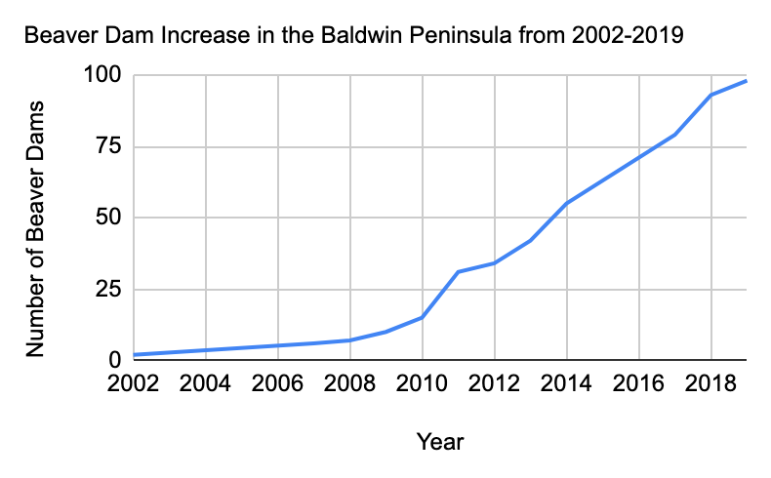
Question:
- In the above graph, was the change very sudden? Or did it change more gradually? The change is gradual, although the slope is steeper after 2010.

Effects of Increasing Beaver Activity on Arctic Communities
- How do you think researchers could measure if there are significant effects of the increasing beaver activity on the local biological communities? There are many possible answers to this, including using simple techniques such as observational study, interviewing local residents, and using wildlife cameras. Some more complex modern methods in use by this research team are measuring the variety of plant species by analyzing light wavelengths, using eDNA barcoding (a molecular biology technique) to look for diversity of macroinvertebrates in bodies of water, and collecting recorded sounds to detect bird species using a computer algorithm.
- What do you think could be some positive impacts of the beaver activity?
Beaver ponds are known to increase biodiversity of birds, plants, and other organisms. Higher biodiversity often leads to more stable communities. They are known to provide calm, sheltered water which may serve as nurseries for many species.
- What do you think could be some negative impacts of the beaver activity?
Beaver ponds were not traditionally found in this region. The ponds create more habitat for shrub growth, which drastically alters the local food webs. The environment would likely become more accessible to a wider range of species, which could end up displacing the species that have traditionally been more specialized and adapted to the Arctic. Water distribution in the area would change as a result of dams.
- How do you think the increased beaver activity might affect indigenous communities of people that live in these areas?
Changes in water distribution may impact travel and access to certain areas, including traditional hunting and foraging areas. Changes to food webs may impact species available for hunting. Changes to stream flow may impact fish migrations. Increased mammal presence around streams may increase parasites such as Giardia. Changes to landscape may make people feel that their longtime home is unrecognizable. One positive aspect may be the hunting of beavers for meat and pelts.
*Note: See the end of this document for an optional Extension idea for including background on the indigenous people of the researchers’ study area.

Closing Thoughts:
Do you think we should be worried about beaver activity in the Arctic? Why or why not?
Students may answer this in different ways, although the drastic change to the area described in this case study should generate some concern, since changes are so recent, the rate of change is fast, and there could be major and lasting impacts on the natural area as well as the lives of indigenous people.
If you answered yes above, what are one or two ideas for how to address the problem?
Continuing to monitor the area and interview local people, doing more research on the impacts on local food webs, potentially trapping or relocating beavers, larger scale responses such as addressing the causes of permafrost warming.

Optional Extensions to the Case Study:

1. Second Data Set
You could include a second set of data to show the impacts in different areas, as well as to challenge students with making a more complex graph. This data set is currently unpublished, but this document will be updated in the future with the citation. The study area in the Seward Peninsula is a smaller area than the Baldwin Peninsula.
Year | Number of Beaver Dams in Baldwin Peninsula area | Number of Beaver Dams in Seward Peninsula area
2002 | 2 | NA/missing
2007 | 6 | NA/missing
2008 | 7 | NA/missing
2009 | 10 | 4
2010 | 15 | NA/missing
2011 | 31 | 3
2012 | 34 | 5
2013 | 42 | 5
2014 | 55 | 8
2015 | NA/missing | 11
2017 | 79 | 14
2018 | 93 | 29
2019 | 98 | 26

Sample Graph:
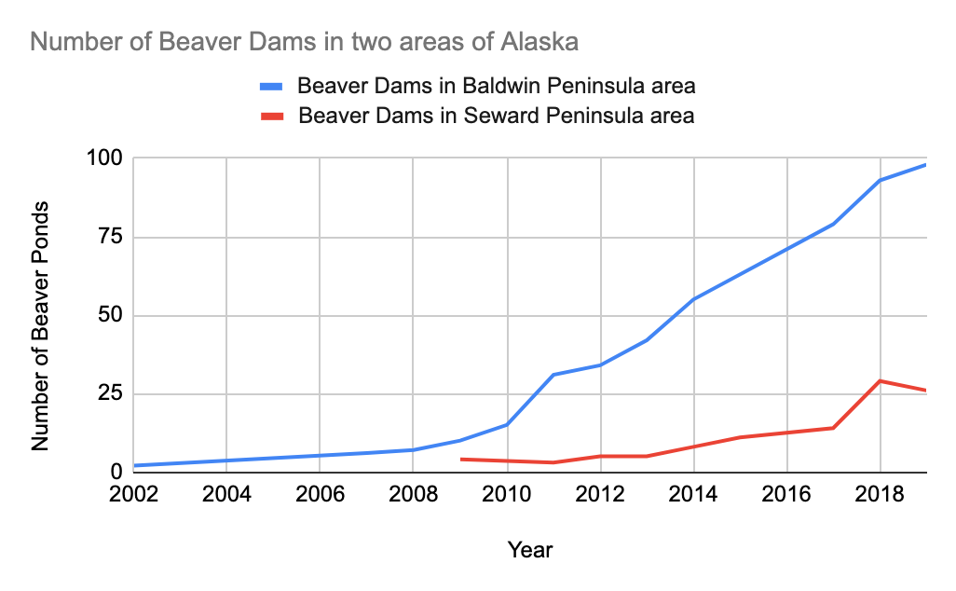

2. Indigenous Communities
Including background information on the indigenous communities in the area and how they may be affected by growing beaver populations would give students a more well-rounded understanding. This would be relevant specifically in Environmental Science courses, which may include topics such as traditional sustainable use of resources, land management, and environmental stewardship.
The Inupiat are the indigenous people of Northern and Northwest Alaska. They traditionally utilized many local terrestrial and marine mammals, birds, fish and plants for food, clothing, art, and more. The recent increase in beaver populations has brought concerns over the loss of traditional fishing areas as well as reduced water quality. Two specific examples of concern are the migration of Arctic Char and the introduction of the parasite Giardia.
This video (3 min 10 sec) shows a short overview of subsistence harvesting by the Inupiat community: PBS, Indie Alaska, Living off the Land in an Alaskan Inupiaq community, Season 8, episode 17
Sources relating to indigenous communities:
- Rosen, Yereth. “Beaver expansion into Alaska’s Arctic tundra presents problems for people – and opportunities”. Alaska Beacon, March 11, 2024,
- Pearce, C., & Wheeler, H. C. (2025). ‘Animals we’ve never seen before’: Historical wildlife management and Indigenous relations with beavers in the mainland Inuvialuit Settlement Region, Canada. History and Anthropology, 1–20.
- Wikipedia contributors. "Iñupiat." Wikipedia, The Free Encyclopedia. Wikipedia, The Free Encyclopedia, 15 Oct. 2025. Web. 3 Dec. 2025.

