Name _______________________________

Arctic Beavers Case Study
Read through some short passages below, and answer any questions that follow. Pay close attention to the vocabulary terms shown in bold.

I. Background

Overview
The North American Beaver (Castor canadensis) is one of the largest rodent species in the world. Beavers are herbivores that eat many parts of a variety of plants, including leaves, twigs, stems, roots and soft inner bark.
Beavers engineer their aquatic surroundings to help them survive. They construct homes called lodges, as well as dams, out of branches, rocks, grass and mud. They use the lodges and dams to create deep water refuges where their families can be protected from predators and prevent the body of water from freezing solid.
Beavers can be considered a Keystone Species due to their extensive ecosystem engineering. A keystone species may have a much larger impact on its environment than a typical species would, due to crucial behaviors that shape the ecosystem. Beavers can change the environment where they live dramatically, altering the local habitat and biodiversity. When beaver dams are added to bodies of water, the water typically becomes deeper, wider, and more calm.
Watch the video clip(s) provided by the teacher. Write down a few ideas below from the video(s) that stood out to you as being important or new. Be prepared to share with the class.

History
Before Europeans colonized North America, the Beaver population is estimated to have been 100 to 200 million individuals. By the early 1900s, beaver populations in North America had plunged to as few as 100,000. Beaver populations have more recently recovered to an estimated 15 million individuals today.
Questions:
- What do you think is the primary reason that the beaver population in North America plummeted so low? What do you think helped it later to recover?
- Remember that a biological community consists of all of the living things in an area. What do you think could be some benefits to a community of having beaver dams?

Changing Conditions in the Arctic
The Arctic region is found at northern latitudes, and includes areas in Alaska, Canada, Greenland, Russia, and Iceland. This region consists of the Tundra biome, which is Earth’s coldest biome, which has very low precipitation. The soil in the tundra is mostly permafrost, which remains frozen all year, with only a thin layer of thawed soil for plant growth available in summer months. These conditions cause the tundra to have few trees.
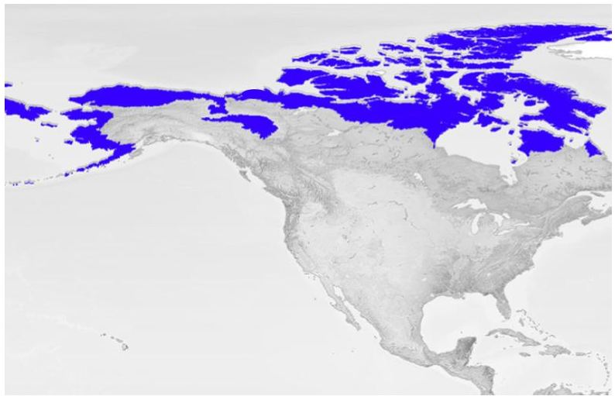
Figure 1: The tundra in North America. Credit: NASA
In recent years, warming temperatures in the Arctic have led to increased permafrost thawing. Warming has also resulted in changes to winter conditions, such as earlier snow melt, shorter time periods when rivers are frozen, and thinning of ice cover on lakes.
When permafrost thaws, this can change plant growth patterns. Also, during thawing the greenhouse gas methane trapped in permafrost is released, which in turn contributes to more warming. Organic material that was trapped in permafrost begins decomposing, releasing carbon dioxide and more methane. Also increased presence of water further speeds up thawing. In some cases, when the permafrost contains a lot of ice mixed with the soil, the landscape can collapse and erode away when it thaws.
In an EPA study, permafrost temperature increased significantly in 14 out of 15 sample sites between the years of 1978-2023.

Questions:
- How do you think a biological community in the Tundra would change if permafrost in the area thawed?

II. Alaska Beaver Research

Increasing Beaver Activity in Arctic Alaska
Beavers did not have a historic presence in the Alaskan tundra. However, using satellite imagery, direct measurements and observations from local communities, we can see that beavers have found a significant stronghold in this area over the past 75 years.

Question:
- What do you think are some specific ways that researchers could measure changes in beaver activity?

Dr. Ken Tape’s Arctic Beaver Research Team
A group of scientists based at the University of Alaska Fairbanks, including ecologists, permafrost scientists, hydrologists, water chemists, wildlife biologists and social scientists, are investigating the extent of beaver activity in the Alaskan Arctic. During field research, they take measurements and analyze data.

Location for Beaver Research
The team works in many areas of Alaska, but one area of special attention has been the Baldwin Peninsula on the coast of Alaska. The town of Kotzebue is located on this peninsula.
- Open up a new tab in Google Chrome, and visit Google Earth. In the search bar at the top of the page, enter Kotzebue, Alaska. You can see that Kotzebue is located on a peninsula that sticks out into the water. (Close any pop-up windows that appear.)

- Use the tool to add a “placemark” to this location: Click on the symbol, then click the plus (+) icon right on the word Kotzebue. It will ask “Save feature to”, then click on “New Map”. In the window, where it says “Untitled Placemark”, type Kotzebue. Now click “done”. Close this window.
- Under the “View” drop-down menu, click on “Show Gridlines”. Notice that lines will appear showing latitude and longitude measurements. Latitude is shown here in Degrees (°) North. This is a measurement of how far north the location is from the Equator. What is the LATITUDE shown near Kotzebue? (round to the nearest degree) ________
- Use the “-” tool to zoom out slowly until you see a yellow line appear labeled “Arctic Circle”. Most scientists use this line to mark the southern boundary of the Arctic region. Any area north of this line is considered to be a part of the Earth’s Polar region. Where is Kotzebue located, in relation to the Arctic Circle? _____________________
- Use the “-” tool to slowly zoom out further, seeing more of the surrounding area. Zoom out until you see the rest of the United States. Use the cursor tool to drag the screen, rotating the Earth. Notice where Kotzebue is located in relation to where you live.
- Using the search bar, find the location of the town where you live. Add another placemark there using the tool. Enter the name of your city. What is the latitude shown for your city? (round to the nearest degree) ___________
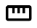
- Using the “-” tool and dragging to rotate the Earth, position the map so that you can just see both of your marked locations. Click on the ruler tool on the toolbar. Then click the cursor on the Kotzebue placemark, then click on your home city. What is the length (distance) reported between the two locations? __________ (Notice that the measurement is given in kilometers. There are about 1.6 km in a mile.)

Beaver Activity Data

Examine the figure below. These maps were made using information from satellite images. Each active beaver dam seen was marked by hand using a white dot.
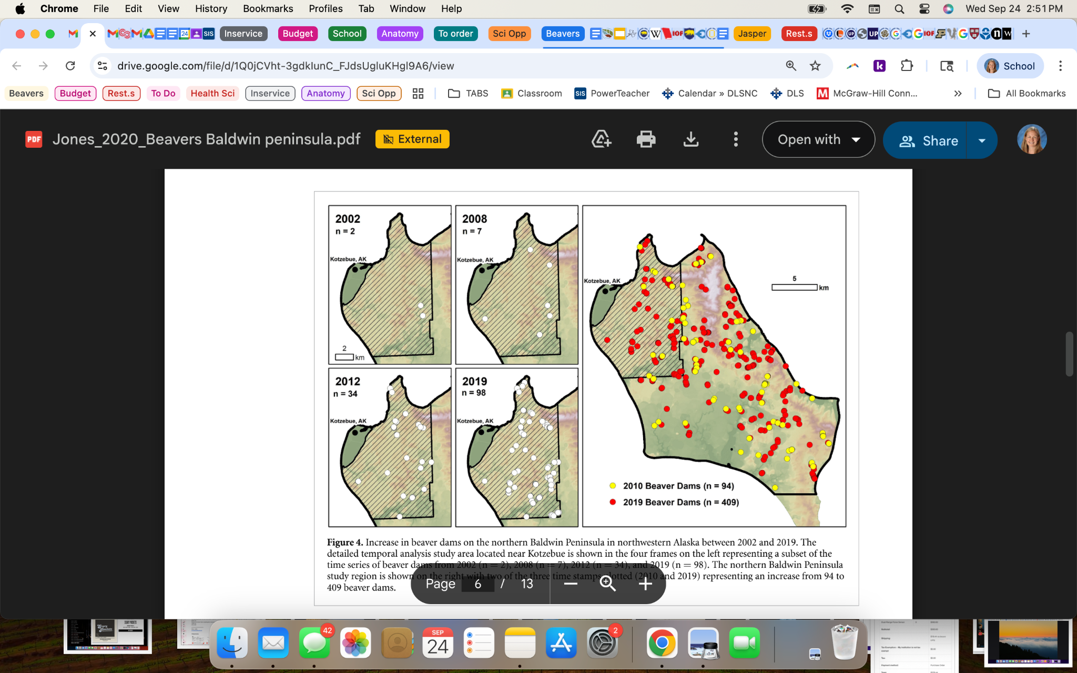
Figure 2: Beaver Activity in the northern Baldwin Peninsula, Alaska. White dots indicate beaver dam locations.
Question:
- What information can you gather from the above images? Be as specific as you can.

Creating a Graph from Beaver Dam Data
Table 1: Data from satellite images in the Kotzebue area of the Baldwin Peninsula, Alaska.
Year | Number of Beaver Dams
2002 | 2
2007 | 6
2008 | 7
2009 | 10
2010 | 15
2011 | 31
2012 | 34
2013 | 42
2014 | 55
2017 | 79
2018 | 93
2019 | 98

Graph the above data in the space provided below. Try to utilize as much of the space given as you can. Make sure to include all of the necessary components of a graph.

Title ______________________________________________________________________



Question:
- In the above graph, was the change very sudden? Or did it change more gradually?

Effects of Increasing Beaver Activity on Arctic Communities
- How do you think researchers could measure if there are significant effects of the increasing beaver activity on the local biological communities?
- What do you think could be some positive impacts of the beaver activity?
- What do you think could be some negative impacts of the beaver activity?
- How do you think the increased beaver activity might affect indigenous communities of people that live in these areas?

Closing Thoughts:
- Do you think we should be worried about beaver activity in the Arctic? Why or why not?
- If you answered yes above, what are one or two ideas for how to address the problem?

References:
- Goldfarb, Ben. “In the Arctic, Beavers Are Climate Winners. Should We Let Them Take Over?” Audubon, Spring 2024, www.audubon.org/magazine/arctic-beavers-are-climate-winners-should-we-let-them-take-over.
- Beaver, California Department of Fish and Wildlife, wildlife.ca.gov/Conservation/Mammals/Beaver. Accessed 21 Sept. 2025.
- “Tundra Biome.” National Geographic Education, education.nationalgeographic.org/resource/tundra-biome/. Accessed 21 Sept. 2025.
- Jones, Benjamin M, et al. “Increase in beaver dams controls surface water and thermokarst dynamics in an arctic tundra region, Baldwin Peninsula, northwestern Alaska.” Environmental Research Letters, vol. 15, no. 7, 30 June 2020, p. 075005, https://doi.org/10.1088/1748-9326/ab80f1.
- Permafrost, Climate Change Indicators, Environmental Protection Agency, www.epa.gov/climate-indicators/climate-change-indicators-permafrost. Accessed 24 Sept. 2025.
- Tape, K.D., Clark, J.A., Jones, B.M. et al. Expanding beaver pond distribution in Arctic Alaska, 1949 to 2019. Sci Rep 12, 7123 (2022). doi.org/10.1038/s41598-022-09330-6.
- Tape, Ken D., et al. “Tundra be dammed: Beaver colonization of the Arctic.” Global Change Biology, vol. 24, 2018, pp. 4478–4488, onlinelibrary.wiley.com/doi/abs/10.1111/gcb.14332.

