Beaver Dam Construction Activity
(Adapted from Opal Creek Ancient Forest Center by Amy Lacks)

Objectives:
- Students will gain an understanding of the importance and complexity of beaver dams.
- Students will use teamwork and communication to produce a group product.
- Students will use the engineering design process to establish a prototype, and alter it based on results. (optional)

Materials:
- plastic dish tubs or other similar containers
- sticks, rocks, pine needles, moss, pinecones gathered from outside
- clay
- watering can

Procedure:
- Have students form teams of 2 (or larger groups if necessary).
- After an introduction to beaver dam building behavior, ask teams to build a dam across the middle of the plastic tub (the shortest way across). They may use any materials they want but should try to make the dam keep water from flowing across it.
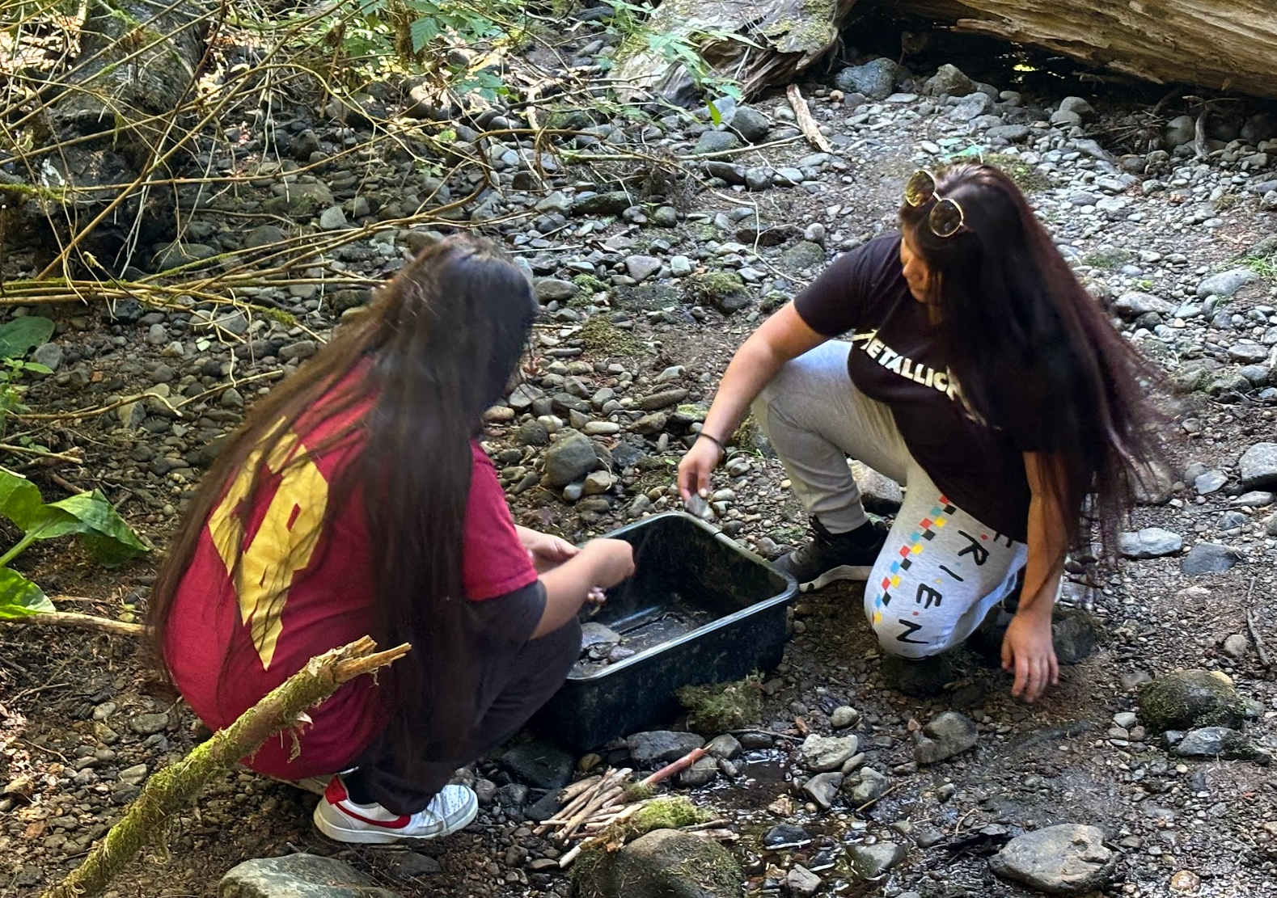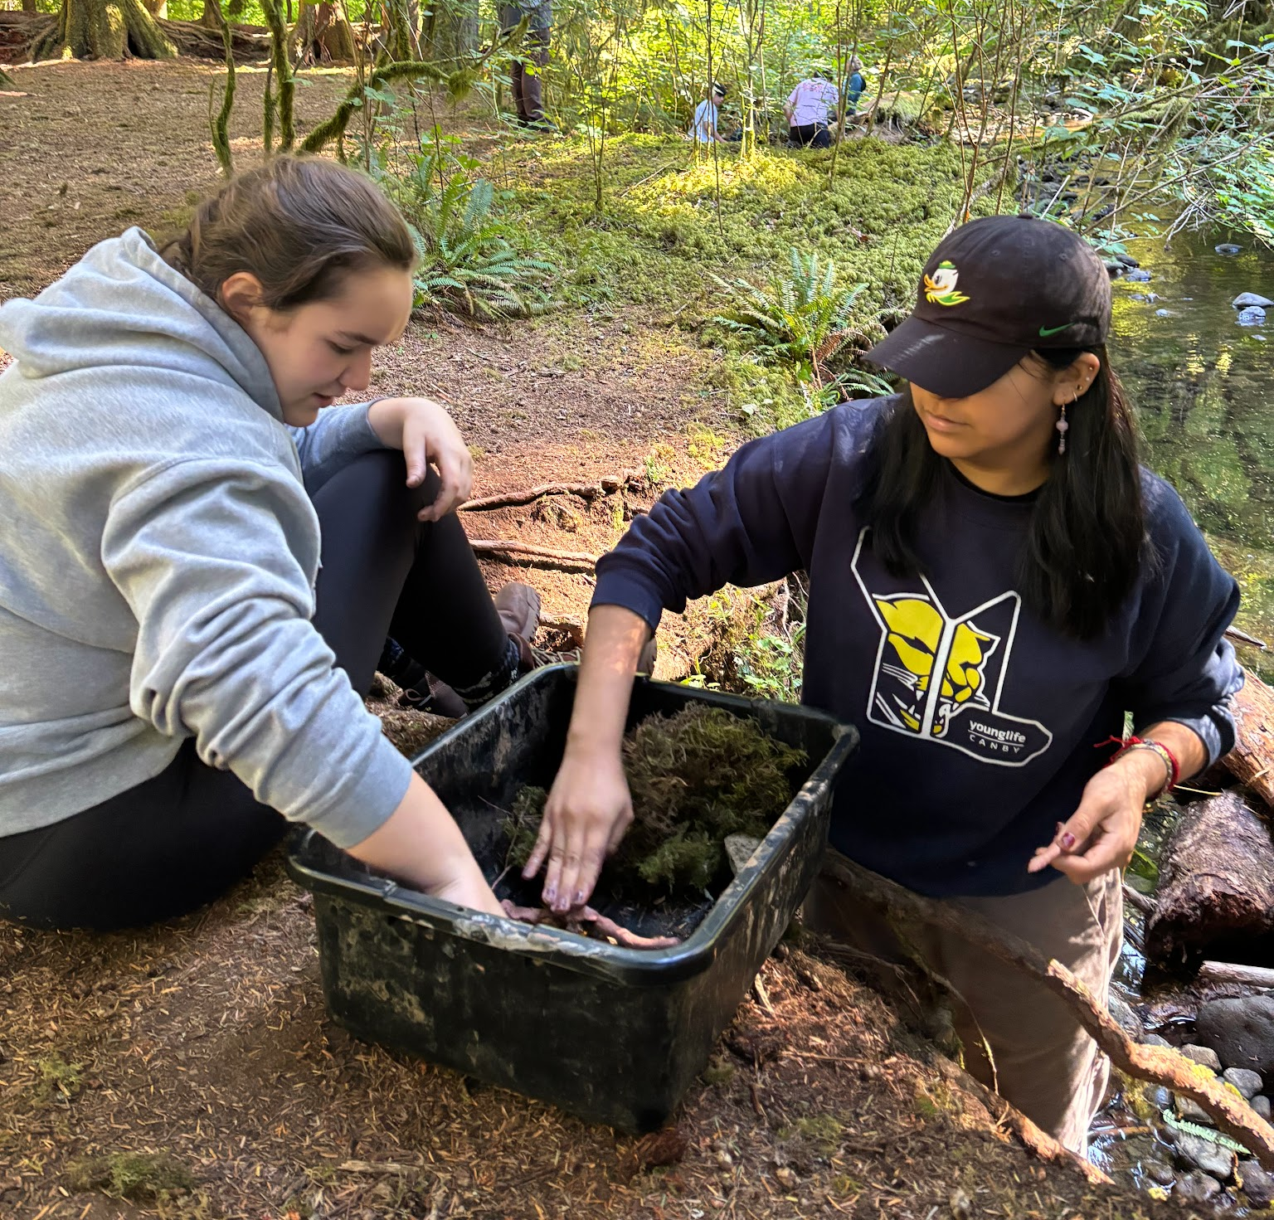
- After the dams are built, place the tubs on a slanted surface (either on a hillside or propped up with an object). Sprinkle water from a watering can on the upstream side of each dam. Notice how well the water is held back, and for how long.
- Optional: Have students use the engineering design process to reevaluate their prototypes for flaws, and improve them. Retest their water-holding ability.
- Have a closing discussion about why some dams worked better than others. You may also want to have a discussion about why the formation of beaver dams is so significant to an ecosystem.
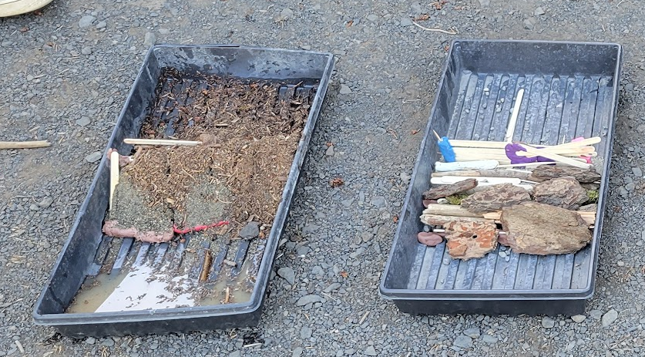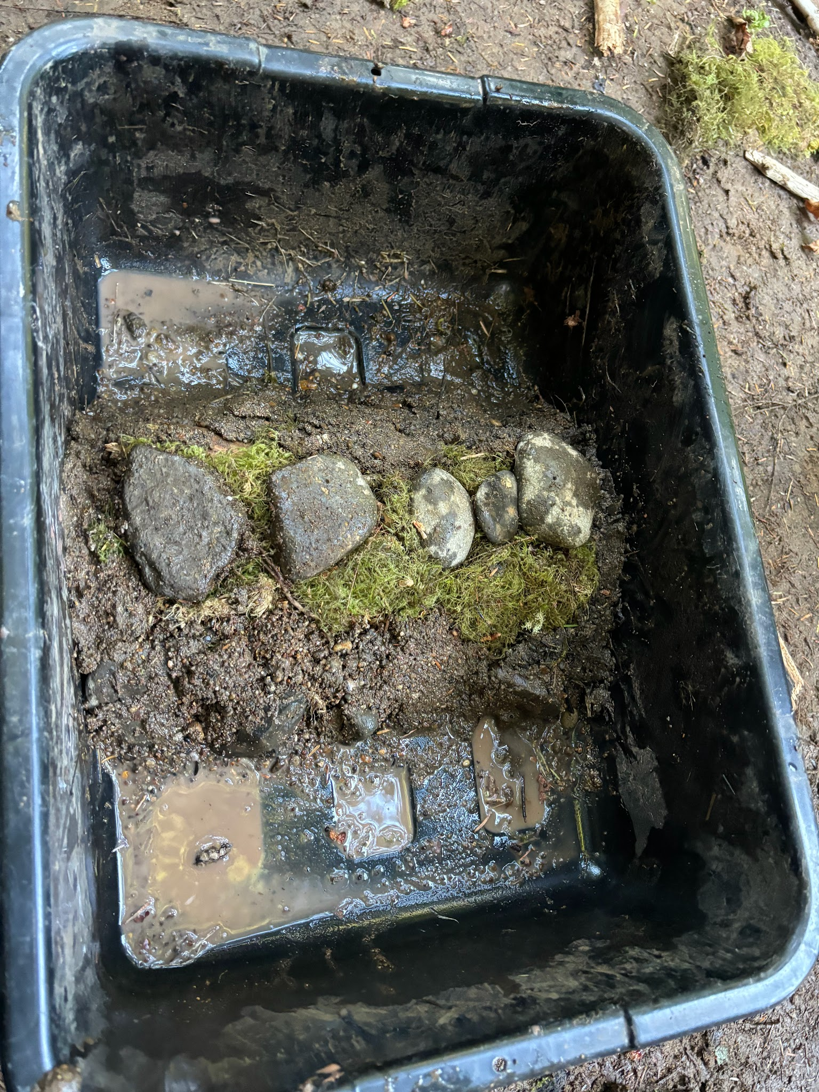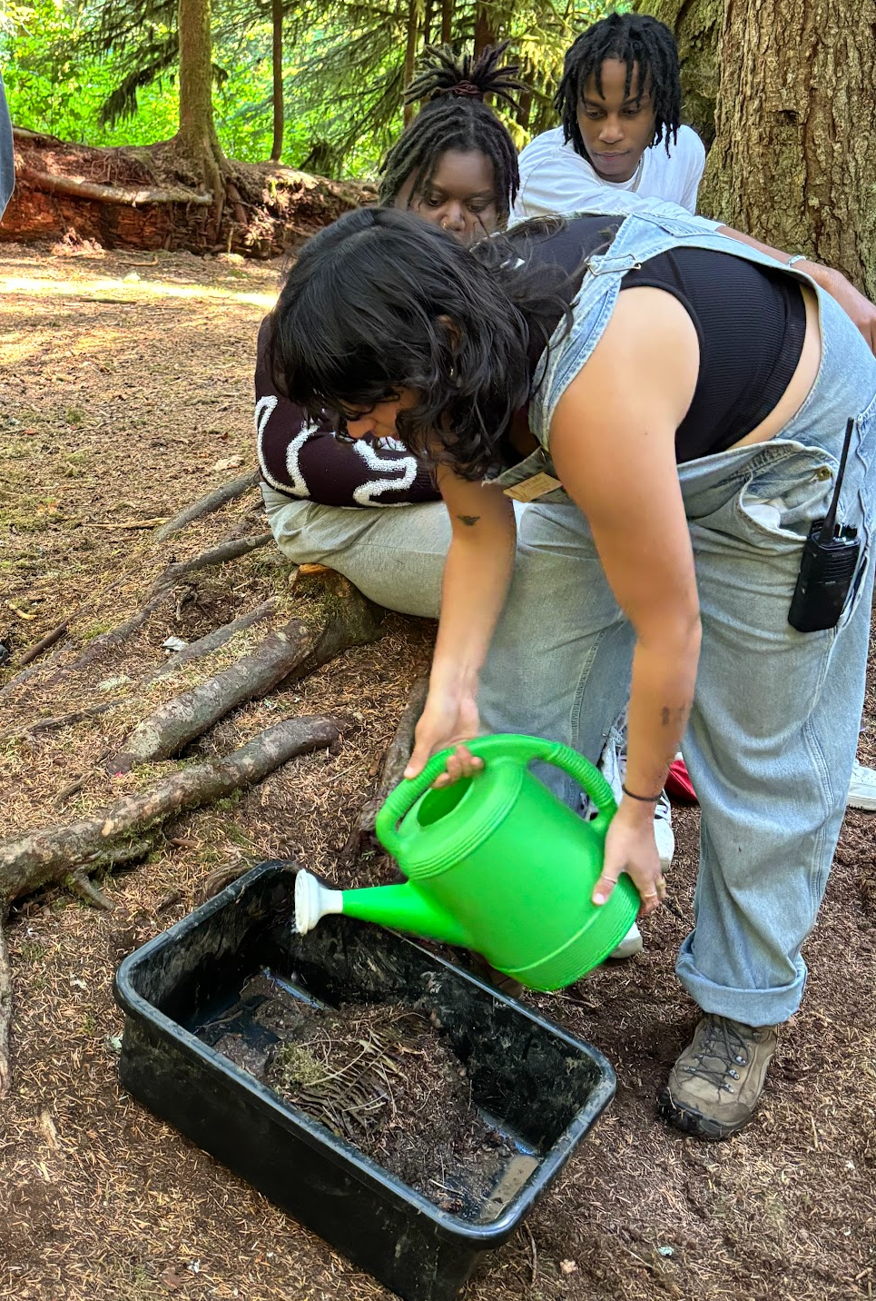
*Note: this activity is very fun if students have access to the outdoors, especially natural areas. However, this could easily be done entirely indoors with materials collected in advance by the teacher.

