Drawing a Soil Profile Teacher Guide & Analyzing a Soil Core Sample
- In Activity 2 we look at a side profile of a pre-created soil sample to make any observations and/or predictions about what we might find inside a core from that sample. These are meant to be fun and adaptable to much younger audiences so we include many items that may not be normally found in a core as the focus is on the process for these lessons and not so much the content of the soil itself.
- In Activity 3 we actually take a core from the pre-made sample and concentrate on the process of observing the sample without contaminating it as well as recording our findings.

Set up Instructions for Activity 2 and Activity 3:
Important Note: The focus of these lessons is on the processes of Soil Profiling and Soil Sampling. The content in these samples should create opportunities for students to actively engage in these processes and does not rely on actual soil samples for our cores.
- Create your soil samples. Be creative with this. We used a variety of ground dirt, garden soil, sand, even kitty litter and mixed in layers of colored chalk, colored glass beads and even toy fossils to enhance the experience for our younger students.
- We sprayed water often to help solidify our cores. Also packing down each layer as tightly as possible.
- Here are a few images of our soil creation process. All of these can be mix-and-matched. Included items like glass stones, polished rocks or mini dino bones is a great addition that really draws in the younger students.
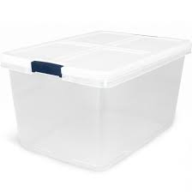 | 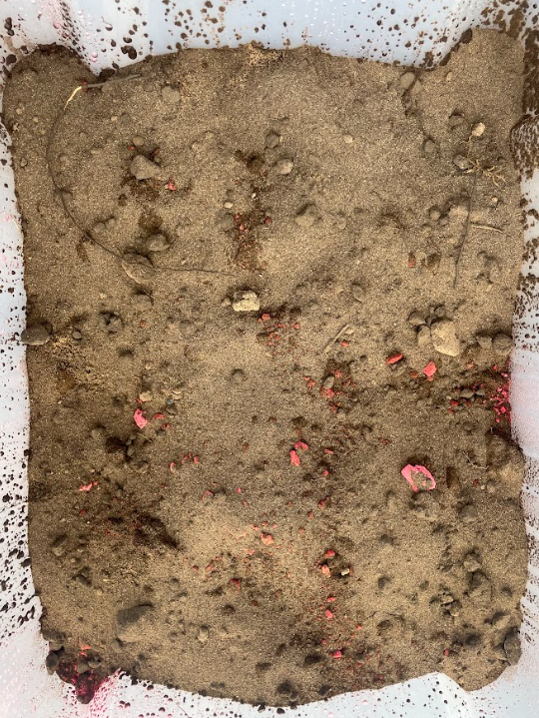 | 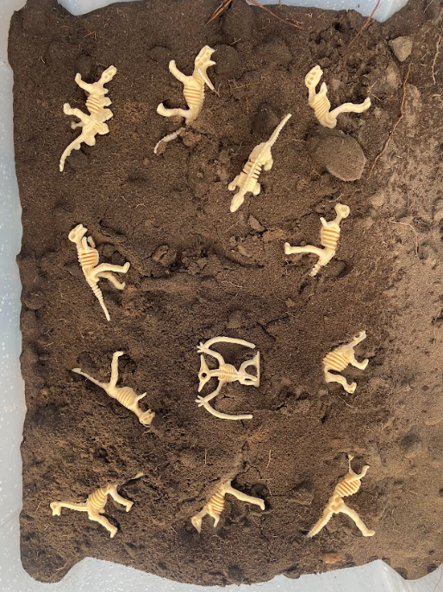 | 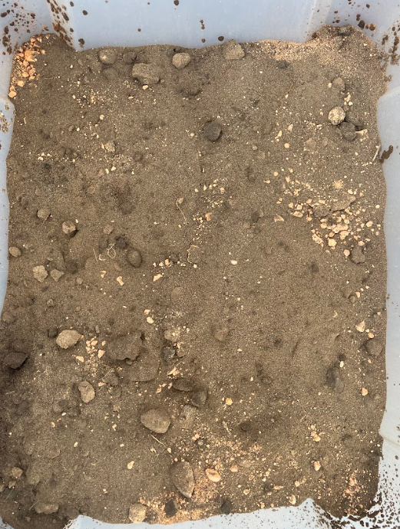 | 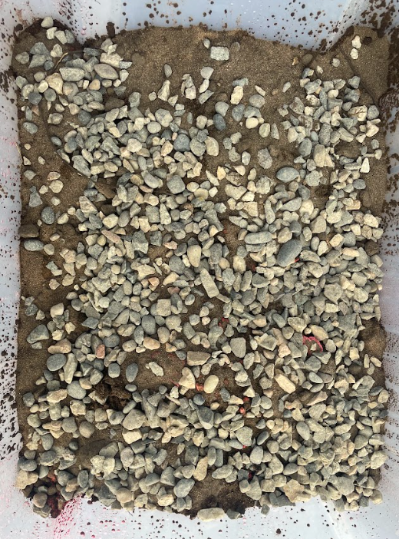
Empty Totes | Sand | Dinosaurs | Dirt with “Gems” | Small Pebbles
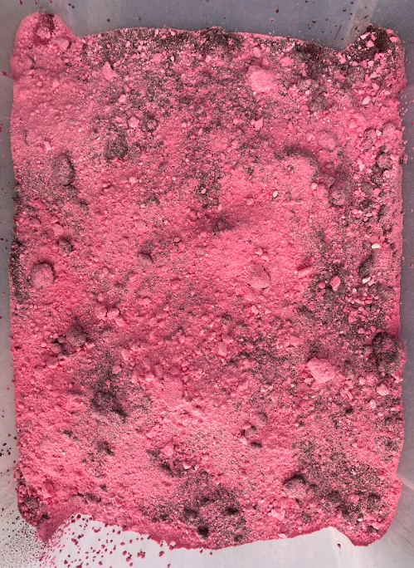 | 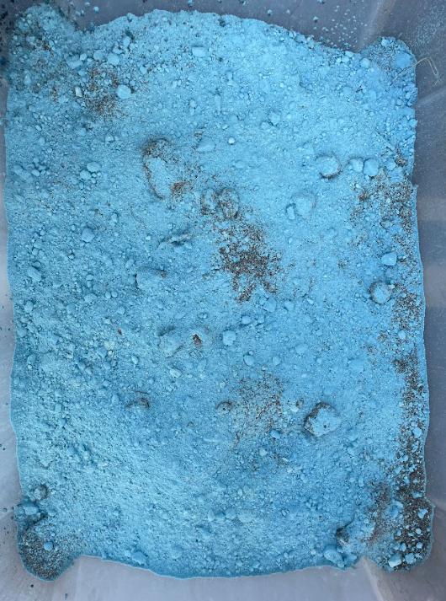 | 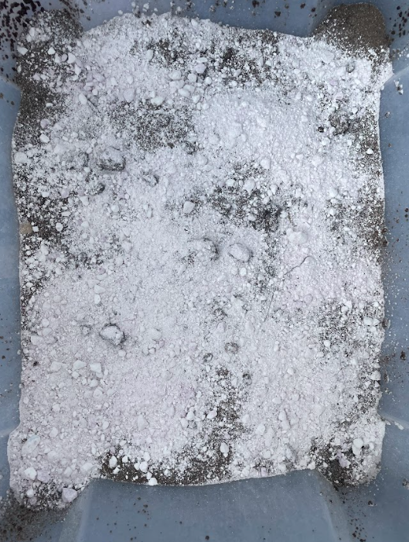 | 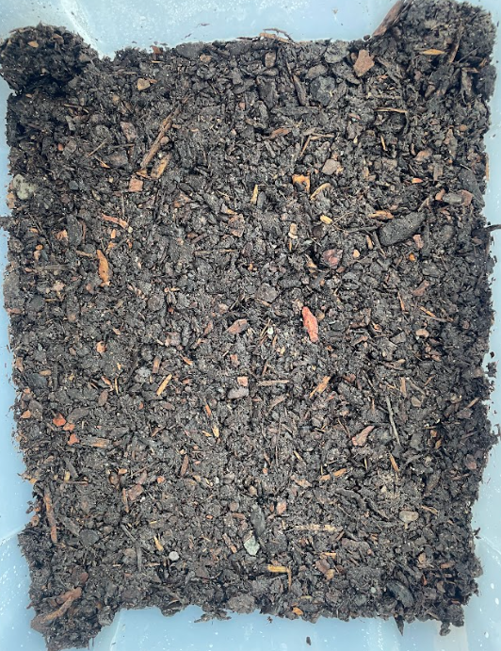 | 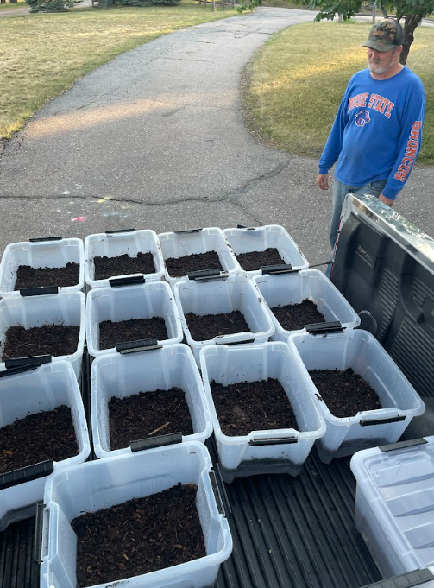
Red Chalk | Blue Chalk | White Chalk | Top Layer: Mulch | Packed & Ready

Activity 2: Drawing a Soil Profile
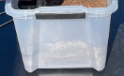
Before students get to “Dig In,” have them draw a profile of their observations on a posterboard. They should be attentive to detail as deemed appropriate for their grade level. For example, elementary students should be able to draw the shapes of the layers and measure the thicknesses and note colors. Middle & high schoolers should be expected to add more predictive details such as consistencies, possible compositions, etc.
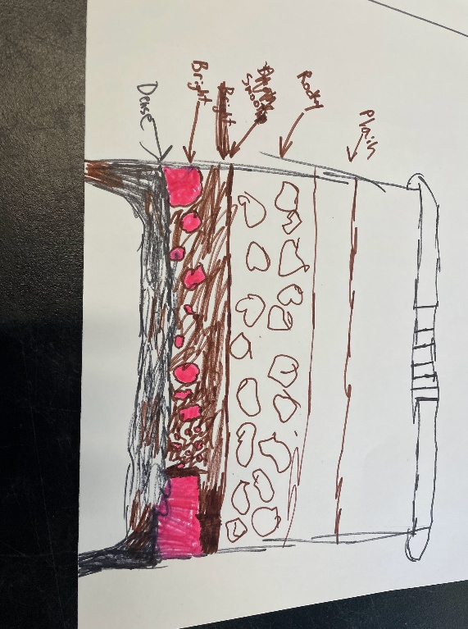
The clearer the bins, the better the quality of the observations will obviously be. Most of the “fun stuff,” such as gems or dino bones won’t be able to be seen from the side profiles. However, they can predict which layers they may be in if you discuss ahead of time what may be inside different layers of soil profiles in general.
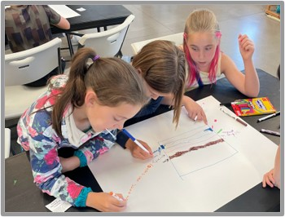
A recommendation would be to include at least one observation per layer that can be seen from the side. Working on this in teams will increase the collaboration and use of key vocabulary terms. Students should be required to complete this portion before being given a core to sample for themselves.
Note: In activity 3, students can document what they find in their core samples. One group chose to add their observations to their posters so they could note which layers contained what.

Activity 3: Analyzing a Soil Core Sample

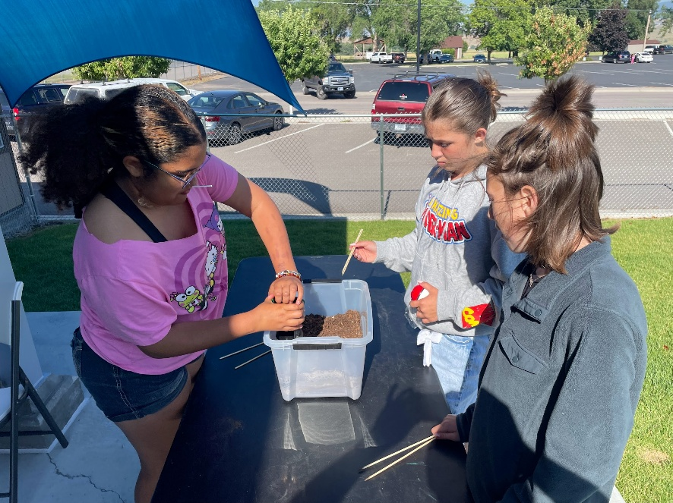

In this activity, students get the chance to pull a core from the soil sample (a bulb planter works really well for this). The caveat is that the students are not allowed to touch the soil sample with their hands. Skewer sticks work really well for being able to separate layers of soil and carefully remove objects of interest that they find.
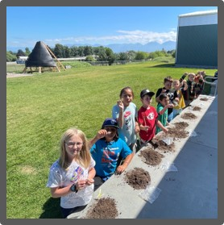
We recommend having students document what they observe as they analyze their soil samples. Providing ziplock bags for students to be able to collect items of interest from their analysis is recommended. We’ve had students keep not only the “fun stuff” such as colored glass, polished stones and dino bones, but also cool rocks, roots, leaves and even bugs! This activity can be done indoors (table clothes highly recommended!) or outdoors.
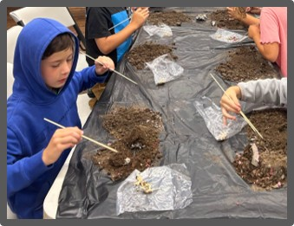
We put different combinations of colored glass in each sample to represent different minerals that may be found. This proved to be a great idea as students were eager to find something new that no one else had. Approximately 8-12 cores could be taken from each bin so a little really did go a long way. Don’t forget to have the student keep a journal of some sorts that documents their findings.

