Activity - Introduction to Core Sampling - Teacher Guide

In Activity 1 we look at different tools that are used for core sampling from the bottom of a body of water such as a lake. We include an introduction to core sampling and a backstory of researcher Mia Tuccillo and her research in Greenland using core sampling.

Instructions:
- Introduce students to Core Sampling using the Lake Coring slides.

- For each group of students print out one copy of page 2 of this document (preferably on card stock as it can be re-used that way). The information has been mixed up on that page. Students are to cut out all of the pieces and the match the NAME, PURPOSE and PICTURE of each of the tools associated with core sampling in aquatic areas.

- Once students have matched what they believe to be the correct pieces, check their results using the key on page 3 of this document.

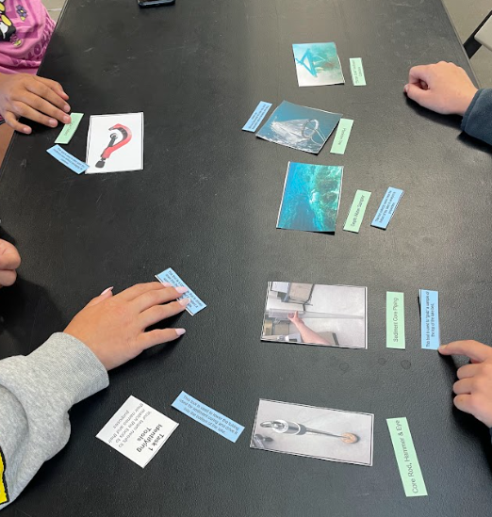

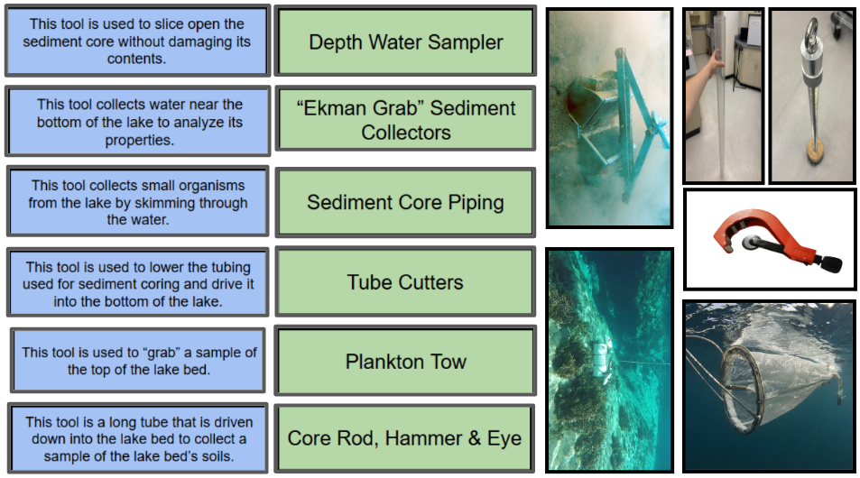

Equipment Name | Equipment Purpose | Photo
Core Rod, Hammer & Eye | This tool is used to lower the tubing used for sediment coring and drive it into the bottom of the lake. | 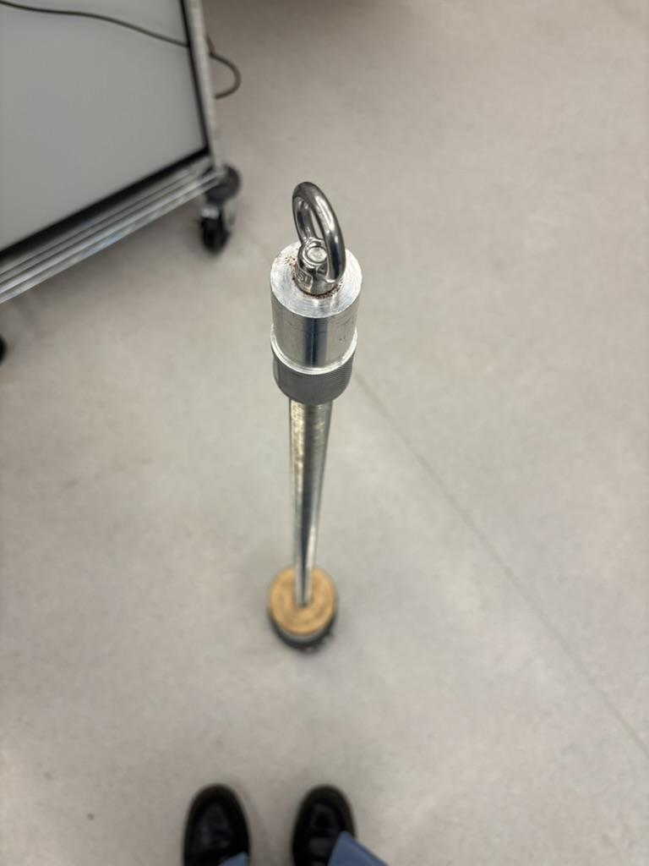
Tube Cutters | This tool is used to slice open the sediment core without damaging its contents. | 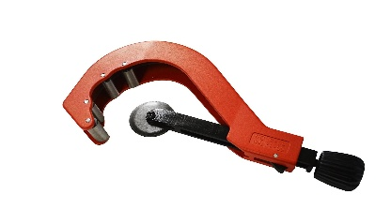
“Ekman Grab” Sediment Collectors | This tool is used to “grab” a sample of the top of the lake bed. | 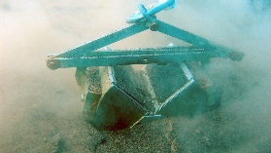
Plankton Tow | This tool collects small organisms from the lake by skimming through the water. | 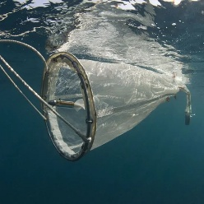
Depth Water Sampler | This tool collects water near the bottom of the lake to analyze its properties. | 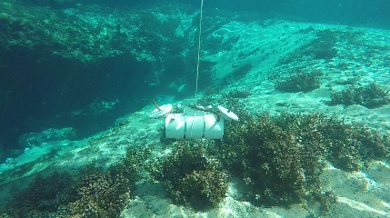
Sediment Core Piping | This tool is a long tube that is driven down into the lake bed to collect a sample of the lake bed’s soiu | 