Teacher Sheet & Answer Key

STUDYING POLAR MAMMALS IN THE WILD

Summary
This activity will have students practice their measuring and data analysis skills, as well as reading and interpreting graphs using real data from wild seals and polar bears. In Case Study 1, students will measure the body length of gray seals and calculate their body mass using the body length data. Then, students will compare differences between body mass and body length between male and female seals and use the graph to make predictions about other seals. In Case Study 2, students will compare changes in the body sizes of three different polar animals (polar bears, gray seals, and harbor seals) over 25 years. Students will use this data set to examine changes and patterns in body mass and body condition of each species and make hypotheses about the environments that these species live in. Both case studies are based on real scientific data for each species and provide examples of how scientists used data from wild animals for conservation and management.

Background Information
Polar mammals live in extremely cold climates, like the Arctic and Antarctic. Because these regions are so remote and inhospitable, they are difficult for scientists to access. In addition, polar mammals, such as seals and polar bears, are large animals, hard to find, and can be dangerous to work with (like all wild animals). So, scientists have to find creative ways to collect data on polar mammals accurately and safely. These data are extremely important because polar regions are rapidly changing, which affects all animals who live there.
One metric that tells scientists a lot about animal health is body size. Body size includes both body length and body mass. Body size can be measured in a variety of ways, including directly measuring it on a wild animal (often one that is safely sedated) or indirectly using drones or photographs. Body size can give information on an animal’s age (younger animals are often smaller) or sex (in some species, males and females are different sizes). Another useful metric is assessing an animal’s body condition. Body condition is a metric that assesses an individual animal’s overall health and appearance; it can range from poor (for an extremely skinny or underweight animal) to excellent (for an extremely fat or large animal). In general, polar mammals need a large body size and a lot of body fat to be in excellent body condition and survive in extremely cold environments.
One way that polar marine mammals stay in excellent body condition is with blubber, thick layers of fat that help them stay warm, pack on fat, and serve as an energy storage. In general, polar animals with more blubber indicate that animals are feeding well and more likely to survive. In contrast, animals who have very little blubber and/or are visibly skinny are not likely to survive during the coldest parts of the year.
Scientists can learn about what's happening in the environment by researching the body size and health of the animals that live there. In polar environments, major changes to the overall health of marine and terrestrial predators can signal changes in food webs. If animals are getting smaller and/or are declining in body condition, scientists can theorize the animal is eating less due to less available or more difficult to access food and resources. The opposite can also be true if animals are getting larger over time.

Materials
- Writing utensil
- Student sheet (Measuring tool included)
- Scissors
- Three colors to write with (markers, colored pencils, or crayons)

Vocabulary terms introduced and used in this worksheet:
- Polar: Relating to regions near the North Pole (Arctic) or South Pole (Antarctic)
- Sexual Dimorphism (or Sexually Dimorphic): Differences in visible physical characteristics (ex. size and shape) between male and females of the same species. Examples of species that are sexually dimorphic include elephant seals, gray seals, lions, peafowl (peacocks and peahens), and orangutans (among many others).
- Body Condition: A metric used to evaluate the overall health of an animal based on its body size, shape, body fat, and muscles. For example, in polar bears, body condition can range from ‘skinny’ (an extremely skinny, underweight animal) to excellent (an extremely fat, large animal).

This worksheet was designed to support the following Next Generation Science Standards
- MS-LS2-1- From Molecules to Organism: Structures and Processes - Analyze and interpret data to provide evidence for the effects of resource availability on organisms and populations of organisms in an ecosystem
- MS-LS2-4- Ecosystems: Interactions, Energy, and Dynamics - Construct an argument supported by empirical evidence to physical or biological components of an ecosystem affect populations

This worksheet was designed to support the following Polar Literacy Standards
(For more information about Polar Literacy go to polar-ice.org)
- 1D: Polar climates create different living conditions
- 4E: Marine and terrestrial predators (indicators) of change in food webs

Students will need foundational knowledge of the following concepts to complete the math sections:
- Creating and understanding line graphs
- Using measuring tools such as a measuring tape
- Plot a data point and extrapolate data
Answer Key:
Case Study #1: Estimating Body Size in Gray Seals
Questions
Question: What is the body length of Gray Seal #1 in meters (m)? ~2.25 m
Question: What is the body length of Gray Seal #2 in meters (m)? ~1.5 m
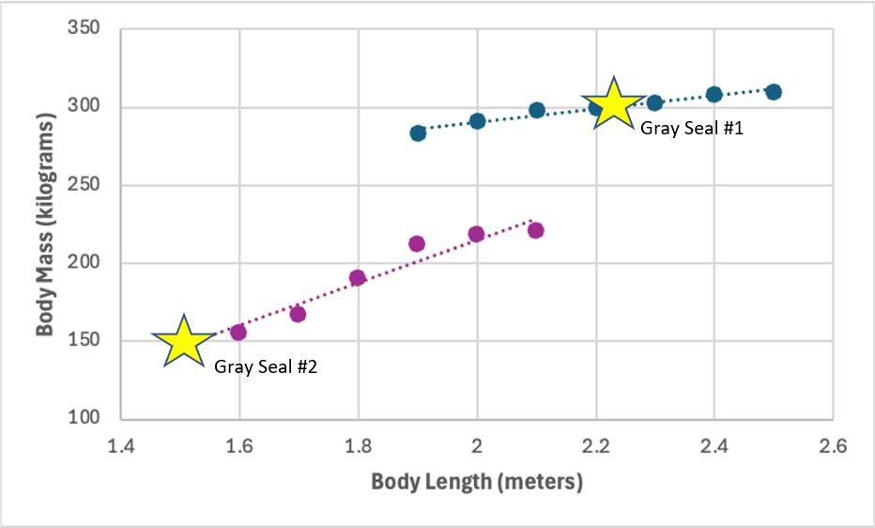
The yellow stars on the graph show where the body length data for Gray Seal #1 and Gray Seal #2 should be.
- Use the graph above to calculate the body mass in kilograms (kg) of each gray seal using the body lengths you measured. What is the body mass for:
  - Gray Seal #1: ~300 kg
  - Gray Seal #2: ~150 kg
NOTE: If students report that Gray Seal #1 is ~2.6 m and 310-325 kg and that Gray Seal #2 is ~1.75 m and is 160-175 kg, they included the hind flippers in the body length (which is not part of the body length)
- Based on their standard length and body mass, determine the sex (male, female, or unknown) of Gray Seal #1 and #2.
Gray Seal #1 is male because its body length is longer than the largest female on this graph.
Gray Seal #2 is female because its body length is shorter than the smallest male on this graph.
- Why is there variation in the data points of gray seal males and females in the graph? (Hint: Why are all males not the same size, and why are all females not the same size?)
Not all seals are the same size, even seals that are the same sex. Just like humans or dogs, gray seals are all different sizes and shapes. This can be due to both genetics (the size of their parents) and the environment (how much food is available).
- Imagine you are in the field and just finished working with an adult gray seal. You look at your datasheet and realize you measured the seal’s mass (it weighed 200 kilograms) but completely forgot to measure its body length. Based on the graph above, what would you expect this seal’s body length to be? Do you think this individual was a male or female? Why?
Based on a body mass of 200 kilograms, we would expect the gray seal to measure ~1.9 meters in body length. This means that the gray seal could either be a small male or a medium-to-large female.
- While you are in the field studying seals, you come across a gray seal that measures 2.25 meters in body length but only has a mass of 200 kilograms. What does this potentially tell you about the health of this animal?
This seal is likely male, but he is underweight. This may mean that this seal is not healthy and may be having a hard time finding food in its environment. Students may also talk about body condition after reading through Case Study 2. This gray seal is likely in poor body condition.

Case Study #2: Polar Mammal Body Mass and Condition Over Time
Questions:
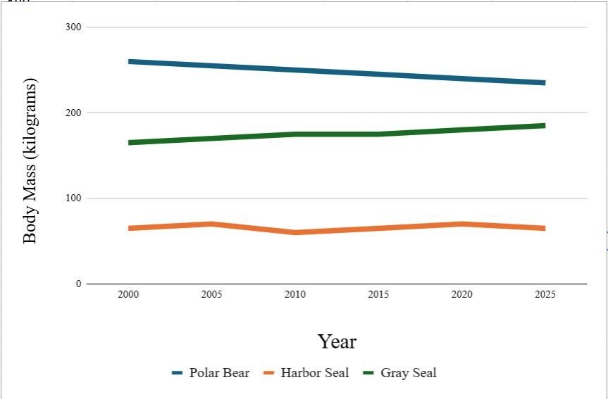
- How does female polar bear body mass change through time? What does this data potentially tell us about the polar bear’s environment?
The body mass of female polar bears decreases through time. They are losing, on average, 5 kg in body mass every five years. This suggests that they are eating less food – either less food is available or they are having a harder time finding food than normal and spending more energy doing so.
- How does female harbor seal body mass change through time? What does this data potentially tell us about the harbor seal’s environment?
On average, the body mass of female harbor seals has roughly stayed the same through the study period. While there is some variation, the overall pattern is stable. This suggests that food availability or access to resources hasn’t changed over time for this group.
- How does female gray seal body mass change through time? What does this data potentially tell us about the gray seal’s environment?
The body mass of female gray seals has increased over the last 25 years. On average, they are gaining ~3-5 kg in body mass every five years. This suggests that they are eating more food or there is more food available in the environment.
- Polar bears rely on sea ice to find food (like seals!). However, the amount of sea ice is declining each year in the Arctic. As a result, polar bears have less sea ice for hunting prey. Based on this information, what would you predict will happen to polar bear body condition in future years of your study?
Answers may vary. Generally though, students should predict that the body condition of polar bears will decline or decrease in the future since there will be less sea ice for finding and hunting prey. They may say that seals will be skinnier or thinner.
- With the data available for these three species, which species would you be most concerned about? Why?
We would be most concerned about polar bears since their population is showing a consistent decrease in body mass through time. This suggests that something in their environment has changed, and we would want to figure out what it is to see how we could potentially stop this decline in body mass and body condition.
- What other data would you like to have from this study to help protect each of these species?
Answers may vary. Examples can include the mass of the males of each species, the diet of each species (and how that has changed), the location of each species, data from farther back than 2000, how much sea ice has changed during this time, etc.

References:
Created by Sarah Kienle and Jacklyn Drewry in collaboration with Polar STEAM

Scientific Data Used in Case Study 1
- Krause, D. J., Hinke, J. T., Perryman, W. L., Goebel, M. E., & LeRoi, D. J. (2017). An accurate and adaptable photogrammetric approach for estimating the mass and body condition of pinnipeds using an unmanned aerial system. PloS one, 12(11), e0187465.
- Lidgard, D. C., Boness, D. J., Bowen, W. D., & McMillan, J. I. (2005). State-dependent male mating tactics in the grey seal: the importance of body size. Behavioral Ecology, 16(3), 541-549.
- Gray seal - https://baleinesendirect.org/en/grey-seal/
- Animal Diversity Web Gray Seal - https://animaldiversity.org/accounts/Halichoerus_grypus/

Scientific Data Used in Case Study 2
- Polar Bears International: https://polarbearsinternational.org/news-media/articles/how-do-scientists-weigh-wild-polar-bears
- Stirling, I., Thiemann, G. W., & Richardson, E. (2008). Quantitative support for a subjective fatness index for immobilized polar bears. The Journal of Wildlife Management, 72(2), 568-574.
- Laidre, K.L., Atkinson, S., Regehr, E.V., Stern, H.L., Born, E.W., Wiig, Ø., Lunn, N.J. and Dyck, M., 2020. Interrelated ecological impacts of climate change on an apex predator. Ecological Applications, 30(4), p.e02071.
- Atwood, T. C., Rode, K. D., Douglas, D. C., Simac, K., Pagano, A. M., & Bromaghin, J. F. (2021). Long-term variation in polar bear body condition and maternal investment relative to a changing environment. Global Ecology and Conservation, 32, e01925.

Online Resources
- Drones Are Helping Scientists Weigh Seals in Antarctica https://dronelife.com/2017/11/30/drones-scientists-weigh-seals-antarctica/
- Polar bears in Baffin Bay skinnier, having fewer cubs due to less sea ice, https://www.washington.edu/news/2020/02/12/polar-bears-in-baffin-bay-skinnier-having-fewer-cubs-due-to-less-sea-ice/
- All polar bears across the Arctic face shorter sea ice seasons, https://www.washington.edu/news/2016/09/14/all-polar-bears-across-the-arctic-face-shorter-sea-ice-season/
- Gray seal, https://www.fisheries.noaa.gov/species/gray-seal
- Harbor seal, https://www.fisheries.noaa.gov/species/harbor-seal
- Seal spy, https://www.whoi.edu/news-insights/content/seal-spy/

