Sea Ice Worksheet Name________________________
In this activity, you will predict if, and when, the Arctic and Southern Oceans will become “ice-free” in summer. Sea ice formation in both regions occurs predominantly in winter, and sea ice melt occurs predominantly in summer (Figure 1). Depending on the season and the year, sea ice covers about 3 to 7 % of the Earth’s surface.
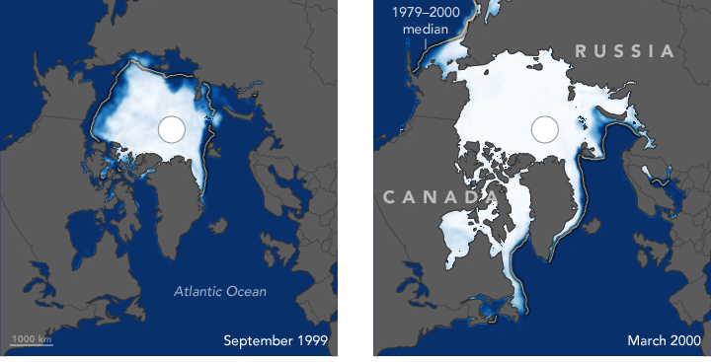

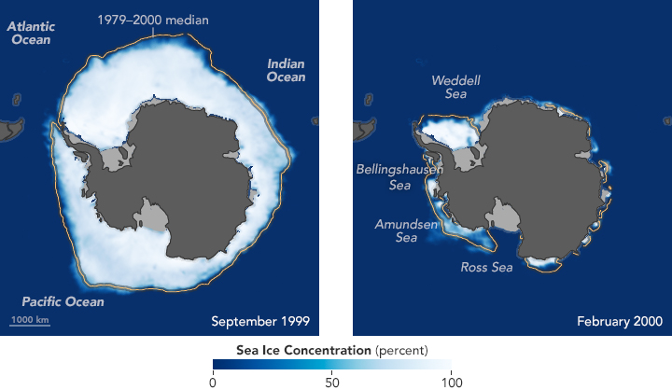
Figure 1. Summer and winter sea ice extent in (top) the Arctic Ocean and (bottom) the Southern Ocean. Images from https://earthobservatory.nasa.gov/.
NASA satellites began mapping sea ice in both polar regions in 1978. The extent and thickness of sea ice cover is important to polar ecosystems. Sea ice is, for example, a nursery for krill, small marine crustaceans and key primary consumers in the Antarctic marine ecosystem. The ice protects juvenile krill, which eat algae growing on the bottom of the ice. Sea ice also hosts the life activities of top predators, such as polar bears in the Arctic, and Weddell seals in the Antarctic.

Sea ice is of great importance to mariners. As polar climates change, opportunities exist in the development of Arctic shipping. The Polar Code of the United Nation’s International Maritime Organization went into effect this year (2017). The code seeks to the balance economic and ecological concerns of high latitude environments.
Minimum extent of Arctic sea ice
The extent of sea ice is expressed in millions of square kilometers. Minimum ice coverage occurs each September. Recent studies show a close correspondence between carbon dioxide emissions and minimum Arctic sea ice extent. Data for both variables are shown below. (To speed our work today, the data are averaged over five-year periods.)

Data source: www.epa.gov/  climate-indicators  Period | Average Minimum  Sea Ice - September  (millions of sq. kilometers) | Average Global  Carbon Dioxide  (ppm)
1979-1983 | 2.9 | 340
1984-1988 | 2.8 | 348
1989-1993 | 2.6 | 355
1994-1998 | 2.7 | 363
1999-2003 | 2.5 | 372
2003-2008 | 2.1 | 382
2009-2013 | 1.9 | 392

- Plot the sea ice and carbon dioxide data.
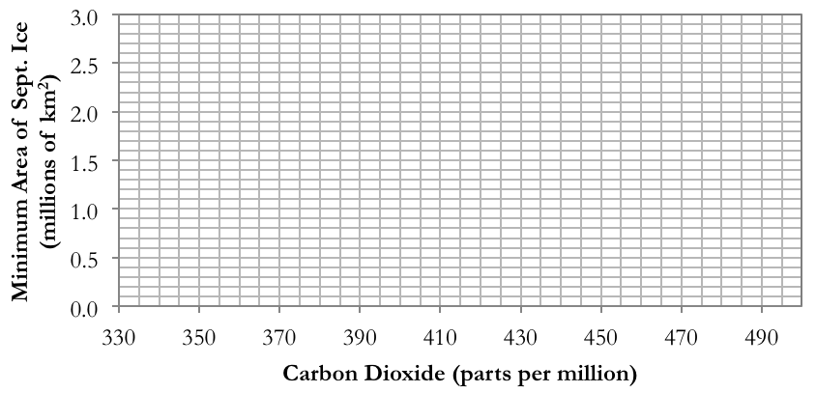
- With a straight edge, draw a “best fit” line through the points. The best fit position minimizes the distance between the line and the plotted points.

- Based only on these data, at what carbon dioxide concentration will the summer Arctic Ocean become completely ice-free?

- Scientists define “ice-free” summer conditions in the Arctic as less than a million square kilometers of ice. At what carbon dioxide concentration does an “ice-free” Arctic Ocean become likely?

- The average global concentration of atmospheric carbon dioxide is currently 406 ppm (spring 2017). How much less is this than the amount you reported for the previous question?

- The average global concentration of atmospheric carbon dioxide is rising 2.25 ppm per year. Using this rate and the value above, estimate the number of years until the Arctic becomes ice-free.

How good is our model?
To estimate when an ice-free Arctic may occur, we relied on a very simple predictive model – our graph. The model assumes that the Arctic sea ice extent derives solely from carbon dioxide concentrations -- surely the real world is more complicated! We can nonetheless estimate how much of the change in sea ice is explained by carbon dioxide concentration. To do that, we’ll need to assume our graphed data are linear and to calculate a linear “correlation coefficient”, called “R”.

- Go to the online correlation coefficient calculator:
http://vassarstats.net/corr_stats.html
(to enter the site, you will need to specify the number of points on your graph)

- Enter your data as “x” and “y” values, and then press “calculate”. Scroll down the reported statistics to find the “r” value; enter it here:

- An r value of 1.0 indicates that the graph is a perfect line with a positive slope. An r value of -1.0 indicates that the graph is a perfect line with a negative slope. An r value of 0 indicates that a linear relationship does not exist.

- R values of less than -0.9 or greater than +0.9 generally indicate strong linear relationships. Are the data you plotted strongly, weakly, or not linearly related?

- The r² statistic (“r squared”), when multiplied by 100%, indicates how much of the variation in the “y” data that changes in the “x” data can account for. Find r² value on the reported statistics. What percent of the variation in ice extent can be accounted for by changes in carbon dioxide concentration?

Correlation does not imply causation…
The statistics tell us that ice extent and carbon dioxide are related, but they do not tell us that carbon dioxide is the cause of changes in Arctic sea ice extent. For example, some other variable may directly affect both ice extent and carbon dioxide. The phrase, “correlation does not imply causation” is a well-known expression of these limitations. Even if our model “holds” and carbon dioxide does cause changes in sea ice extent, we don’t know if the model will continue to hold into the future or if it correctly predicts Arctic ice extent prior to 1979.

- What other variables could be important in regulating the extent of the summer Arctic sea ice each year? List any you think of here.

And what of the Southern Ocean?
Examine the graph below. It shows the extent of sea ice surrounding Antarctica in February, during the Austral summer, plotted against carbon dioxide concentration. The data are five-year averages (starting with 1979-1983), just as for the Arctic.

- Which polar region, the Arctic or the Antarctic, has the most sea ice during the summer?

- Label the time periods represented by the points on the graph.

- Describe any changes you see in the summer Antarctic ice extent over time.

- Predict whether global summertime sea ice is changing over time. What is your reasoning?

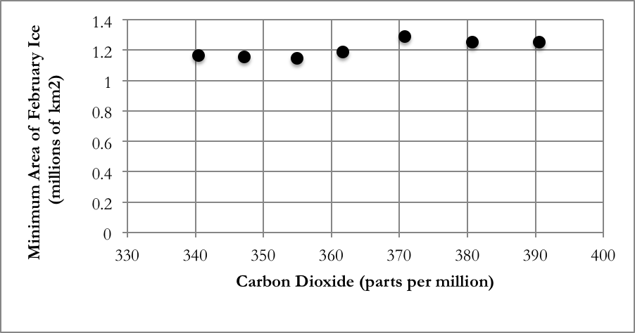

Bonus: Average Antarctic temperatures have increased over the time period of the graph. Any thoughts as to what could be happening in the Antarctic?

Coastal ice tends to persist more longer than the pack ice in the central Arctic Ocean, and scientists suspect Arctic coastal locations will retain some ice cover for decades or more.

