Sea Ice Worksheet Name________________________

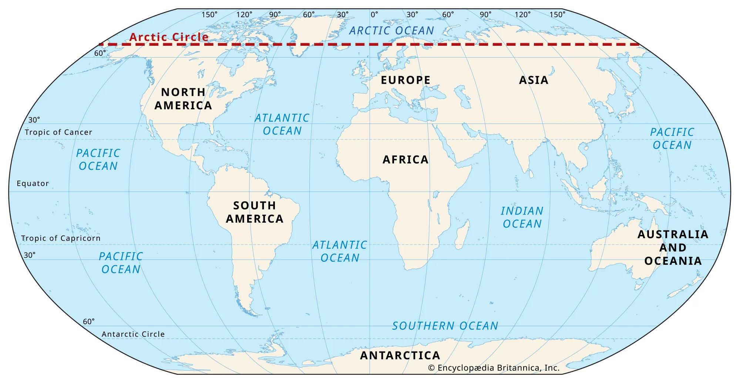
Opening:
- On the map of the world, make a star for the country where you were born.
- Make another star for where you live now.
- Color or circle the Arctic Ocean.

Watch: BBC footage
- What did you notice was happening to the ice in the video?
- What animal was in the video?
- What does this animal eat?
- How is the melting ice currently affecting this animal?
Arctic Sea Ice video
- What is happening to the amount of ice in the Arctic Ocean? (Increasing/decreasing/staying the same)

Part 1:
In this activity, you will predict if, and when, the Arctic Ocean will become “ice-free” in summer. “Ice free” means “no ice”. Sea ice formation occurs in winter, and sea ice melt occurs during the summer (Figure 1).
Summer (ice is melting) Winter (ice is forming)
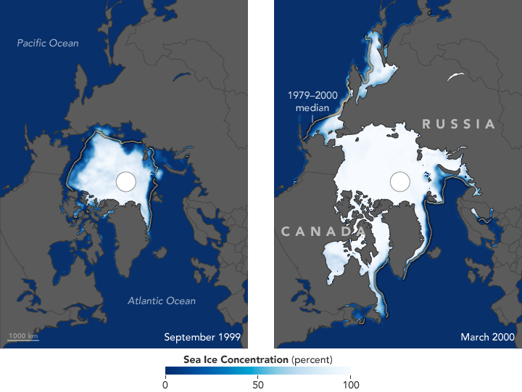
Images from https://earthobservatory.nasa.gov/.
NASA satellites began mapping sea ice in the Arctic Ocean in 1978. You will use their data to make 2 graphs and predict when the Arctic Ocean will be “ice free” (have no more ice) in the summer. In our first graph we will compare the average amount of sea ice in the summer (Y axis) and the average global carbon dioxide levels (X axis). The second graph (next page) will compare the average global carbon dioxide levels (Y axis) vs. time (years on the X axis).
Data source: www.epa.gov/  climate-indicators  Period | Average Minimum  Sea Ice - September  (millions of sq. kilometers) | Average Global  Carbon Dioxide  (ppm)
1979-1983 | 2.9 | 340
1984-1988 | 2.8 | 348
1989-1993 | 2.6 | 355
1994-1998 | 2.7 | 363
1999-2003 | 2.5 | 372
2003-2008 | 2.1 | 382
2009-2013 | 1.9 | 392

- Plot the sea ice and carbon dioxide data. Make a LINE GRAPH.
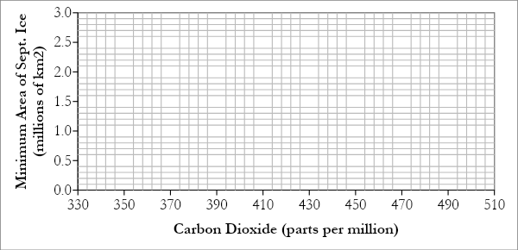
- With a ruler, draw a “best fit” line through the points. Keep drawing your line all the way to the bottom of the graph (check out this resource for more information on best fit lines).
- How much Carbon Dioxide will there be when the Y axis (amount of sea ice) reaches 0.0?
- How much Carbon Dioxide will there be when the Y axis (amount of sea ice) reaches 0.0?

Part 2:
Make a LINE graph of Time vs. CO2 concentration in the atmosphere. Make a TITLE for your graph. (what is your graph about?)
Year | Amount of CO2 in the air (data from NOAA Mauna Loa observatory)
1980 | 338 ppm (parts per million)
1990 | 354 ppm
2000 | 369 ppm
2010 | 390 ppm
2020 | 414 ppm

In the last blank space in the “CO2” column (above), write the amount of CO2 from Question #6.
When you are finished, draw a line between all the points.
Continue your line until it reaches the amount of CO2 from Question #6. Write the year in the last blank space in the “Year” column (above).
- In what year do you predict that the Arctic Ocean will be “Ice free” (“without ice” in the summer?
- How many years from now is that?

Reflection
- Was drawing the graphs difficult or easy for you? Tell me why it was easy or difficult in one sentence.
- Why is Arctic Ocean sea ice important?
- What is causing the Arctic Ocean sea ice to melt?
- What is an effect of the sea ice melting?
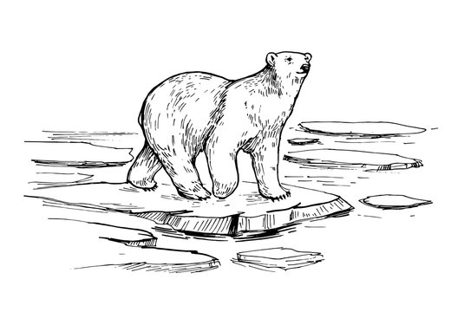
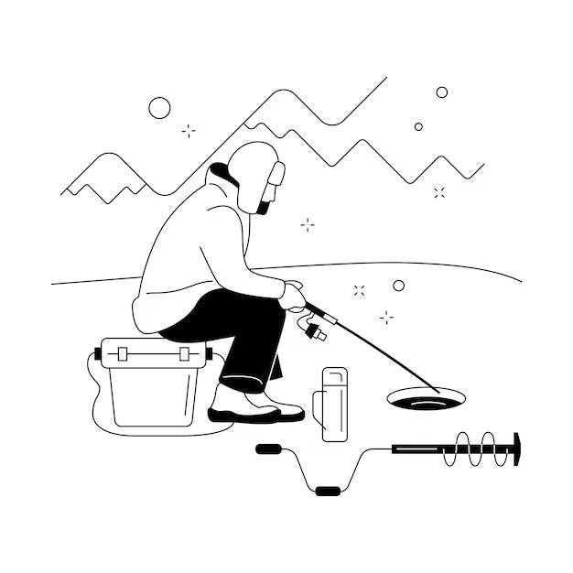

Adapted from Student Worksheet for Sea Ice Activity (Float Your Boat)

