Solution Code For Human
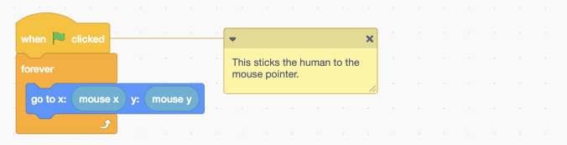
Set of code blocks that says:
- When green flag is clicked
- Forever
- Go to x: mouse x y: mouse y
Note: This sticks the human to the mouse pointer

