Solution Code For Secondary Consumer

Creating and Managing Lifespan of Foxes and Interactions with Humans
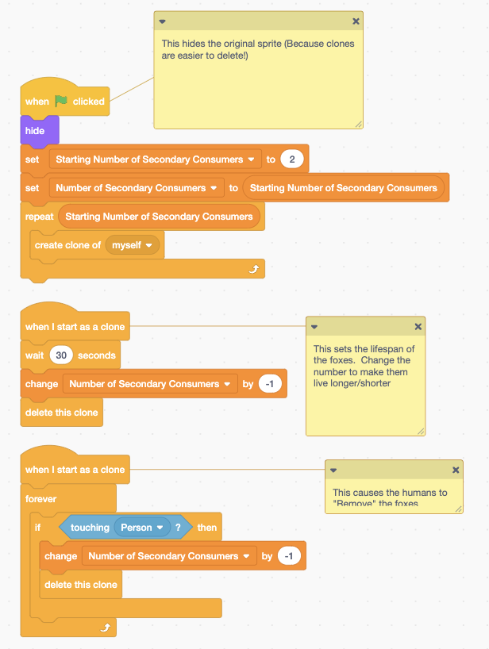

Set of blocks of code that say:
- When green flag clicked
- Hide
Note: This hides the original sprite (because clones are easier to delete).
- Set Starting Number of Consumers to 2
- Set Number of Secondary Consumers to Starting Number of Secondary Consumers
- Repeat Starting Number of Secondary Consumers
- Create clone of myself

Another set of blocks of code that say:
- When I start as a clone
- Wait 30 seconds
- Change Number of Secondary Consumers by -1
- Delete this clone
Note: This sets the lifespan of the foxes. Change the number to make them live longer/shorter

Third set of blocks of code that say:
- When I start as a clone
- Forever
- If touching Person then
- Change Number of Secondary Consumers by -1
- Delete this clone
Note: This causes the humans to “remove” the foxes

Fox Movement and Reproduction
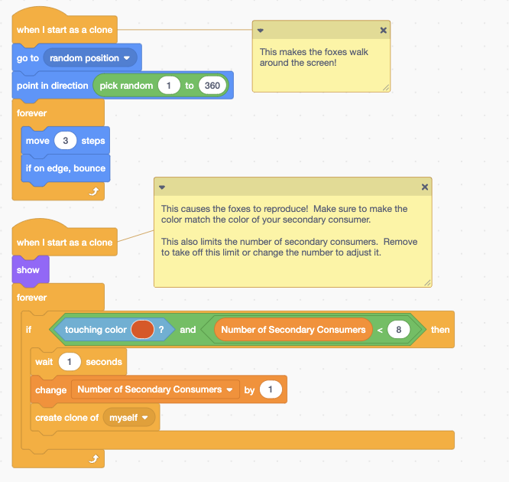

Set of blocks of code that say:
- When I start as a clone
- Go to random position
- Point in direction pick random 1 to 360
- Forever
- Move 3 steps
- If on edge, bounce
Note: This makes the foxes walk around the screen!

Another set of blocks of code that say:
- When I start as a clone
- Show
- Forever
- If touching color (red swatch) and Number of Secondary Consumers is less than 8 then
- Wait 1 seconds
- Change Number of Secondary Consumers by 1
- Create clone of myself

