Solution Code For Producer

Grass Reproduction and Interaction with Voles
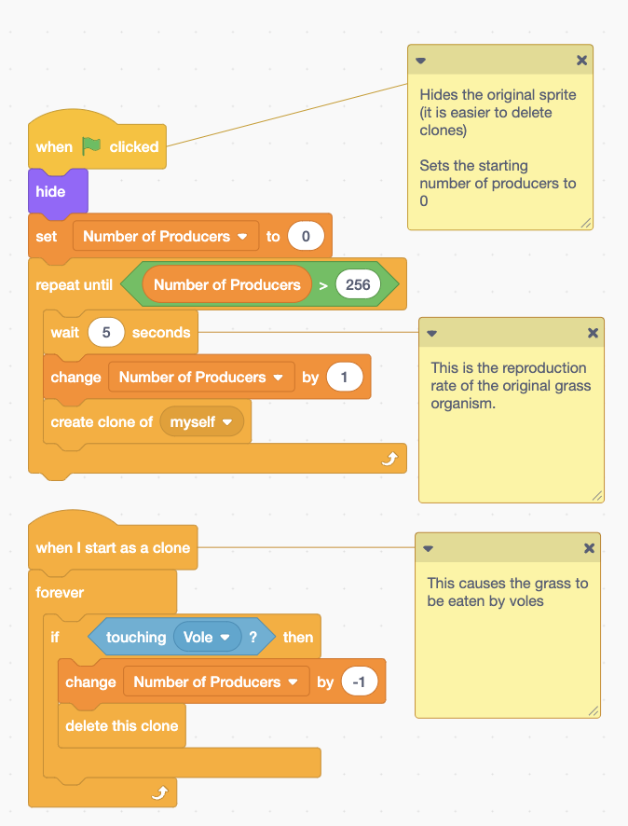

Set of blocks of code that say:
- When green flag clicked
- Hide
- Set Number of Producers to 0
Note: Hides the original sprite (it is easier to delete clones)
- Repeat until Number of Producers is greater than 256
- Wait 5 seconds, change Number of Producers by 1, create clone of myself
Note: This is the reproduction rate of the original grass organisms

Set of blocks of code that say:
- When I start as a clone
- Forever
- If touching Vole then
- Change Number of Producers by -1
- Delete this clone
Note: This causes the grass to be eaten by voles

Growth and Lifespan of Grass
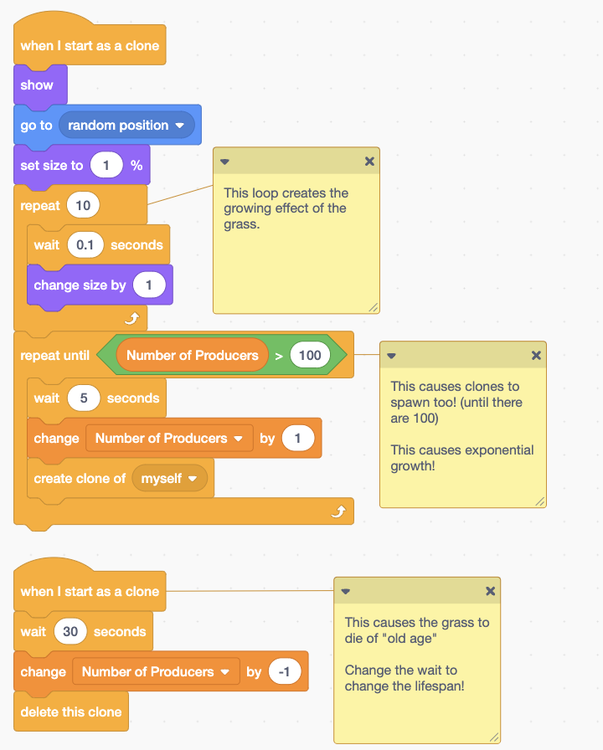

Set of code blocks that say:
- When I start as a clone
- Show
- Go to random position
- Set size to 1%
- Repeat 10
Note: this loop creates the growing effect of the grass
- Wait 0.1 seconds
- Change size by 1
- Repeat until Number of Producers is greater than 100
- Wait 5 seconds
Note: This causes clones to spawn too (until there are 100)! This causes exponential growth!
- Change Number of Producers by 1
- Create clone of myself

Another set of code blocks that say:
- When I start as a clone
Note: This causes the grass to die of “old age”. Change the wait to change the lifespan!
- Wait 30 seconds
- Change Number of Producers by -1
- Delete this clone

Grass Interaction with Humans
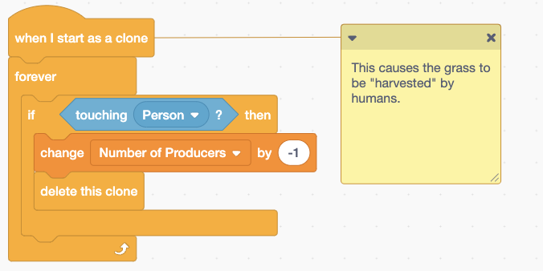

Set of blocks of code that say:
- When I start as a clone
- Forever
- If touching Person then
- Change Number of Producers by -1
- Delete this clone
Note: This causes the gras to be “harvested” by humans.

