Solution Code For Primary Consumer

Setting and Adjusting Number of Consumers and Speed Movement
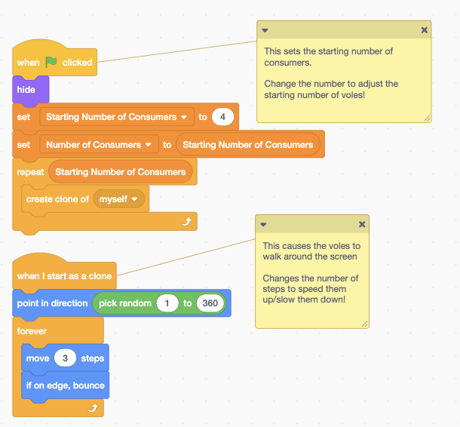

Code blocks that say:
- When green flag clicked
Note: this sets the starting number of consumers. Change the number to adjust the starting number of voles!
- Hide
- Set: Number of Consumers to Starting Number of Consumers
- Repeat: Starting Number of Consumers. Create Clone of: Myself.

Then another set of code blocks that say:
- When I start as a clone.
Note: this causes the voles to walk around the screen. Changes the number of steps to speed them up/slow them down!
- Point in direction: Pick random 1 to 360
- Forever
- Move 3 steps
- If on edge, bounce

Setting Lifespan, Reproduction, Predator/Prey Behavior
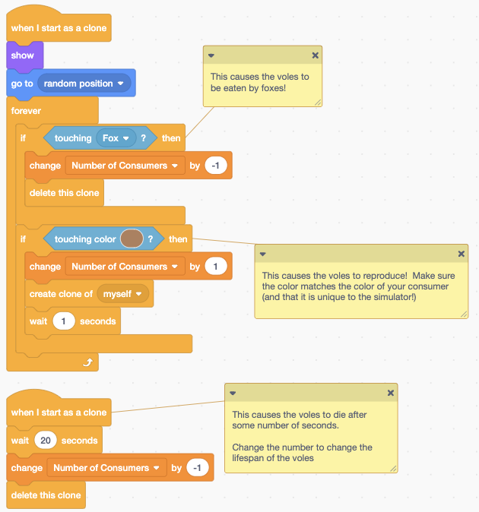

Set of code blocks that say:
- When I start as a clone
- Show
- Go to: random position
- Forever
- If touching fox then change number of consumers by -1 delete this clone
Note: This causes the voles to be eaten by foxes!
- If touching color (shows a brown swatch) then change Number of Consumers by 1 create clone of myself wait 1 seconds.
Note: This causes the voles to reproduce! Make sure the color matches the color of your consumer and that it is unique to the simulator!

Another set of code blocks that say:
- When I start as a clone
- Wait 20 seconds
- Change Number of Consumers by -1
- Delete this clone
Note: This causes the voles to die after some number of seconds. Change the number to change the lifespan of the voles.

Interaction with Humans
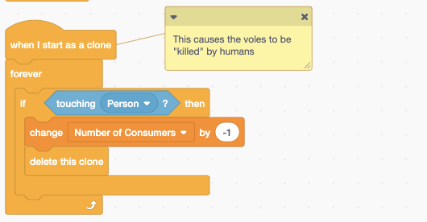
Set of code blocks that say:
- When I start as a clone
- Forever
- If touching Person then change Number of Consumers by -1
- Delete this clone
Note: This causes the voles to be “killed” by humans

