Arctic Ecology Simulation READ ME
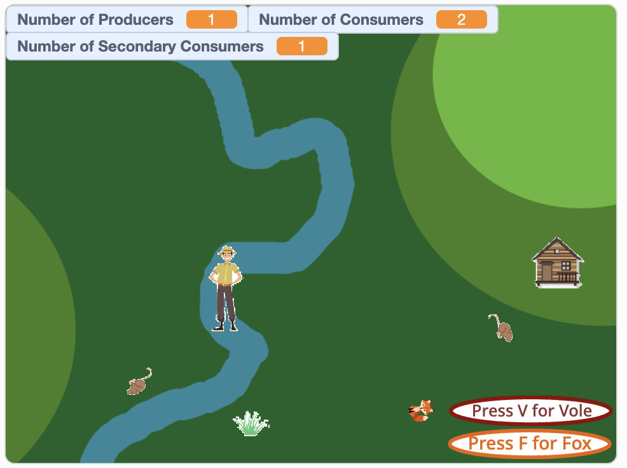
In this project, students will use the Scratch programming language to create a model (aka an “ecosystem simulator” or “ecosim”). This simulator models the population dynamics studied by the Climate-ecological Observatory for Arctic Tundra (COAT). Specifically, it shows the population dynamics of the arctic fox and the tundra vole in the Varanger Peninsula. However, you can change the “costumes” of the sprites and the names of the sprites to match a predator-prey model in any ecosystem you’d like.
In addition to studying population dynamics and human interactions with ecosystems, students will learn the basic components of programming, especially functions, loops, variables, and operators.
Click here to see an example of the finished simulator.

Before you begin
- Create a teacher account in Scratch
- Create student accounts in Scratch and have students log in.
- Have students remix the blank ecosystem simulator project.

Assignments:
1. Create the producer
2. Create the primary consumer
3. Create the secondary consumer
4. Create the human
5. Experiment with different starting values, lifetimes, and reproduction rates.
(note: see solution codes attached to lesson)

