South Pole Telescope Music Resource by Laurie Orth
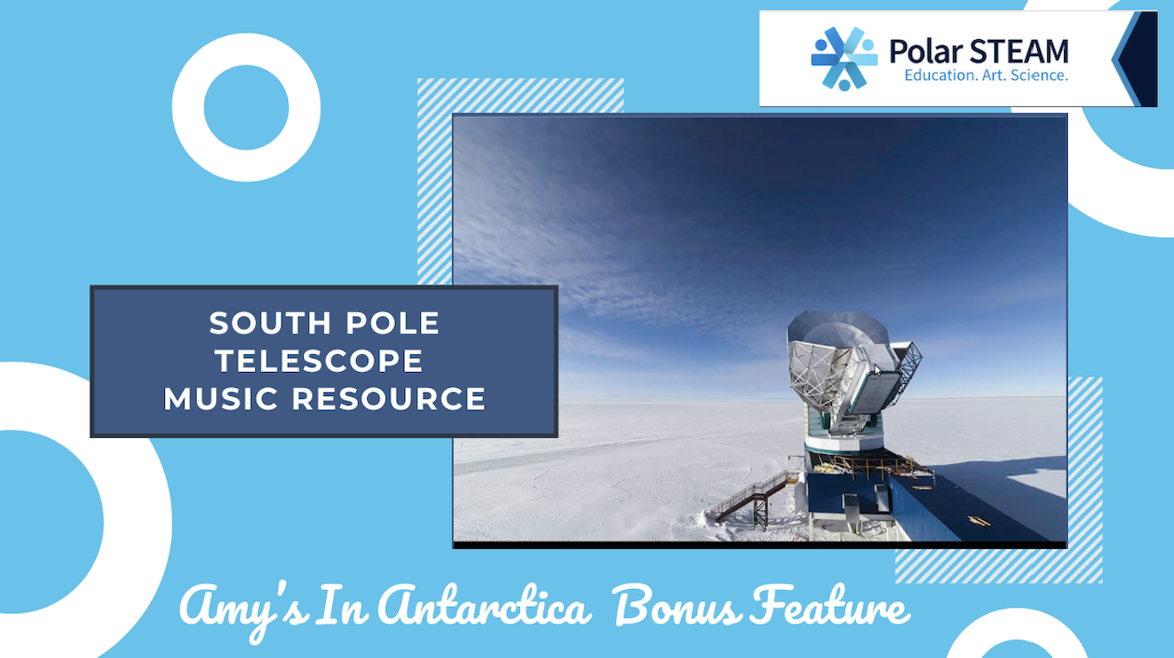

Supporting Information:

Choose a Topic
The topic for this project is the South Pole Telescope and Music Education.

Which aspects would be most intriguing and accessible to students?
Students would be intrigued by learning a complex subject like astronomy and cosmology in their music classroom, by singing a song about such an unusual subject new to them.

Consider why students need to know about it.
Students need to learn more about the universe than is currently taught in their textbooks. Integrating music into education, especially for complex subjects like astronomy, cosmology, and Antarctic research, can significantly enhance the learning experience.

How is this topic meaningful and relevant to their lives?
Music serves as a powerful tool to simplify intricate concepts, making them more accessible and enjoyable for students. Students engaging with these topics through songs or musical activities are more likely to retain the content information and develop a deeper understanding of it.
The creative nature of music and music education encourages self-expression and exploration, allowing learners to connect with the material on a personal level. Moreover, this approach of introducing a complex subject in the music classroom helps to create a supportive atmosphere where students feel safe to ask questions and express their thoughts.
By removing the typical stressors of conventional learning, and teaching across the curriculum through Arts Integration, educators can cultivate a sense of wonder and excitement about the universe for their students, which, in turn, inspires a lifelong passion for science and discovery.

Learning Outcomes
The specific concept taught in these lessons is learning three songs while gaining an introduction to the South Pole Telescope and what it does.

Student outcomes:
- Students will be able to sing each song from memory with 90% accuracy.
- Students will be introduced to the science behind the song lyrics.
- For lesson extension activities:
Students will be able to improve their music reading abilities by playing the Boom Whackers ™ or recorders with 75% accuracy, using the sheet music in this resource.
For teachers who program these songs in a concert, students will be able to participate in a musical performance and share the experience with the audience 100%.
For the creative writing extensions, students will be able to use their imagination and newfound knowledge about astronomy to create poetry about the content in these lessons.

Core Arts Standards covered in this series of lessons:
Anchor Standard 1: Generate and conceptualize artistic ideas and work.
Anchor Standard 2: Organize and develop artistic ideas and work.
Anchor Standard 3: Refine and complete artistic work.
Anchor Standard 5: Develop and refine artistic work for presentation.
Anchor Standard 11: Relate artistic ideas and works with societal, cultural, and historical context to deepen understanding.

Polar Literacy Principles that this resource aligns to:
#1 The Arctic and Antarctic Regions are unique because of their location on Earth.
The South Pole Telescope is located in Antarctica due to its extremely low humidity.
#7 New technologies, sensors, and tools are expanding scientists' abilities.
The South Pole Microwave Telescope is one of the new technologies at the South Pole and is part of the Event Horizon Telescope system.

Instructional Activities

ENGAGE
Ask the students what they know about where Antarctica is, where the South Pole is, what kind of animals live in Antarctica, and what people do who live there. Show learners the pictures included in the PDF Resource Supplement.

EXPLORE
After introducing the South Pole Telescope content for the particular song to be learned, the music teacher may transition to the music activity. Teach the students the song by having them read the sheet music or learn the song by rote. Listen in class to the demonstration on YouTube, and sing along. Students may analyse the sheet music for repeated phrases, ascending or descending patterns, and for vocabulary words they need defined.
After learning the song, the music teacher can divide the music class time up into: the Polar STEAM content part (showing the videos that correspond to the songs,) and then doing the music extension activities. This time-sharing method is excellent if the teacher has the flexibility to devote 5-6 class periods or more to this resource.
For extension activities, students can play individual notes on Boom Whackers™ going over the song several times, and trading marked music and Boom Whackers™ with other students to play different notes. As they get more proficient, they can sing and play at the same time.
For recorder playing, students can go over fingering, and then play it phrase by phrase, slowly. With practice and repetition, they can get their playing up to speed and play along with the accompaniment on YouTube.
For creative writing activity, students can use what they’ve gleaned from the YouTube videos and write their own verse of the song, or a poem.
For writing rap lyrics, this activity will depend on the student’s musical listening preferences. Some students may not enjoy rapping, while others will be thrilled to drop a beat on anything they can make a beat with: desk tops, drum set, drum sticks, rhythm sticks, Boom Whackers™. Some students will be better at making the beats; others will be better at doing the rap. Allow them to practice in small groups and then perform for the class. You can also make quick videos of their rap performances and play the videos back for them to watch if they are excited about performing for the camera.

EXPLAIN
During the extension activity period, the teacher should supplement the music activities by showing the videos included on YouTube. Dr. Amy Lowitz is a wonderful resource and can explain astronomy and cosmology extremely well. Let Amy assist you in this portion of the lesson. Remember, the goal is that the students are “introduced” to the South Pole Telescope material. They do not need to become experts.

ELABORATE
The teacher may allow students to showcase what they have learned with various performance opportunities. Students can sing the songs in class, individually or in a small group, by memory or with choreography. They can perform the songs with Boom Whackers™ or recorders; they can read their poetry out loud for the class, and they can practice reading the narration in the Supplemental Resource PDF in preparation for being a narrator at their music concert. Students can discuss with the class what they have learned about the South Pole Telescope, and they can support each other in diving deeper into the content by watching other Antarctica-related YouTube videos, looking things up on line, and asking questions.

EVALUATE
Music teachers will evaluate and assess students throughout this learning process. Performance in class and for school concerts will allow the teacher to assess students’ level of mastery. Further lesson extensions can be developed as assessment tools for music performance, creative writing, and artwork creation. In order to check understanding and evaluate the effectiveness of the introductory lessons about astronomy, cosmology, and Antarctica shared by Dr. Amy Lowitz in the YouTube videos, students can provide feedback via conversation, Q and A, or creative writing assignments.

YouTube Channel name:
Laurie Orth Music Teacher

YouTube Links for Videos:
Please start this lesson series with the first video, Amy’s in Antarctica.
- Polar STEAM Amy’s in Antarctica
- Polar STEAM Baby Pictures of the Universe
- Polar STEAM Earth Sized Telescope
- Polar STEAM Amy’s in Antarctica Bonus Feature
- Polar STEAM Music Files (Full demonstration and full accompaniment only of each song)
Visit the Polar STEAM website for more information.

