
Created by
2024 Polar STEAM Fellows
Dr. Amy Lowitz
and
Laurie Orth
Narratives, written by Dr. Amy Lowitz, to supplement the music lesson plan included in the South Pole Telescope Music Resource. These narratives can be read to students, as part of the classroom experience, or they can also be used in a music concert setting as narration, read to the audience by students or educators.
The Amundsen Scott South Pole Station is a special research base located at the South Pole, right in the middle of Antarctica. This station is supported by the National Science Foundation, which is part of the U.S. government. Many different types of science are studied at the South Pole Station, including climate research, studying earthquakes (called seismology), ice research (known as glaciology), particle physics, and astronomy.
There are three big microwave telescopes at the South Pole: the South Pole Telescope, the BICEP Array, and BICEP 3. All three microwave telescopes focus on studying something called the cosmic microwave background (CMB). These telescopes are called microwave telescopes because they look for microwaves, which are a type of light that we cannot see. Microwaves have longer wavelengths than the light that our eyes can detect.
The Event Horizon Telescope (EHT) is a group of 12 radio telescopes located all around the world. These telescopes are in places like Hawaii, France, Greenland, and even the South Pole. Radio telescopes detect radio waves, which are a type of light that we cannot see with our eyes. It’s still light, but it is a different kind that is invisible to us.
The EHT telescopes work together as if they are one big telescope the size of the Earth. By joining forces, they can capture images of very small or very distant objects in space that a single telescope cannot see. The EHT mainly takes pictures of two huge black holes that are very far away. Their names are M87* (pronounced "M87 star") and Sagittarius A* (abbreviated as SgrA* and pronounced "Saj-A star").
Black holes are special objects formed when stars collapse, and "supermassive" black holes are even larger than regular black holes. The black hole M87* is about 55 million light years away from Earth. This means if you could travel at the speed of light, it would still take you 55 million years to reach it! M87* is incredibly heavy, weighing as much as about 4 billion suns. On the other hand, SgrA* is about 27,000 light years away and weighs about 4 million suns.
In 2017, the EHT took the first-ever direct picture of a black hole, which shows M87*. This image is very important because it helps us understand more about black holes in space!
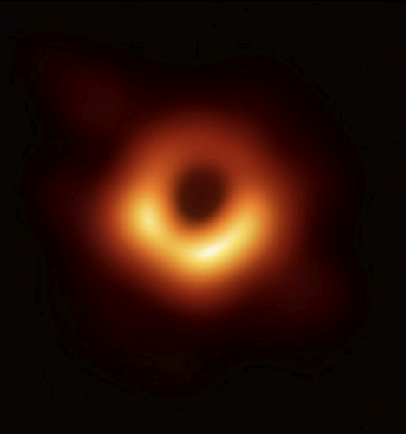Photo Credit: The Event Horizon Telescope Collaboration
The Cosmic Microwave Background, or CMB for short, is like a faint echo of heat from the Big Bang. In the very beginning of the universe, everything was extremely hot and dense. The tiny particles that make up atoms, called electrons and protons, couldn't stick together because the heat and energy were so strong. If any electrons and protons tried to join, the heat would pull them apart again immediately.
Over time, the universe grew larger and cooler. After about 380,000 years, it became cool enough for the electrons and protons to finally stick together. At this point, most of them combined to form hydrogen, which is the simplest atom. When these electrons and protons formed hydrogen atoms, they left behind a special pattern of light in the sky. We call this pattern the CMB.
Although this light is too dim for us to see, and it’s a color our eyes can’t detect, special cameras in telescopes, like the South Pole Telescope (SPT), can capture this light and take pictures of it. The picture below, taken by the SPT in 2009, shows part of the CMB. Scientists study the different shapes and patterns in the CMB to learn about what happened in the very early universe, right after the Big Bang. The CMB also helps scientists understand how the universe has changed from the time of the Big Bang to now.
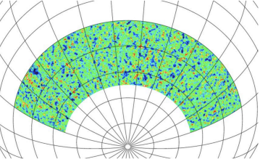Photo Credit: The South Pole Telescope Collaboration
In the photos below, you can see Amy working inside and around the South Pole Telescope.
Amy on her way to the South Pole Telescope, which is in the background.
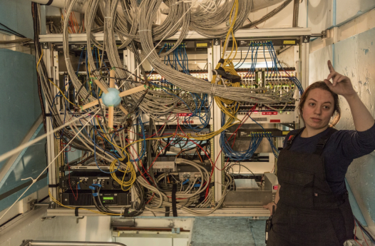Inside the South Pole Telescope
Inside the South Pole Telescope
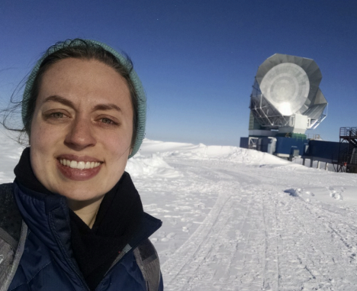Reaching the South Pole Telescope

See appendix for lyrics and notes to Amy’s in Antarctica.
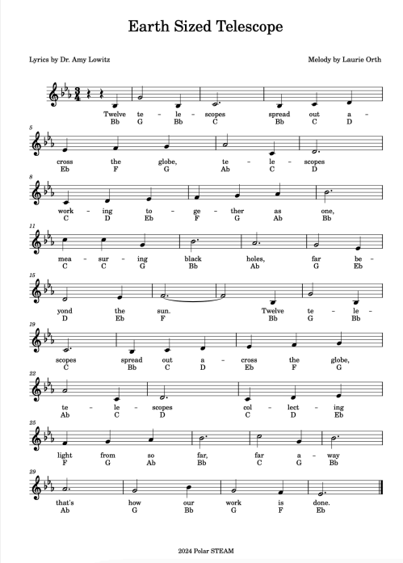
See Appendix for lyrics and notes to Earth Sized Telescope.
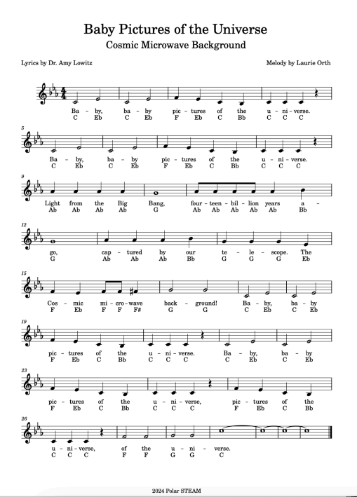
See Appendix for lyrics and notes to Baby Pictures of the Universe

Appendix
Title: Amy's in Antarctica
Lyrics by: Dr. Amy Lowitz
Melody by: Laurie Orth
Footer: 2024 Polar STREAM

Section 1
Lyrics: Flying in a an airplane landing at the South Pole
Melody notes: E E E E F F E E E E D D

Section 2
Lyrics: walking to the station in Antarctica. Very cold outside now,
Melody notes: E E E E F F C D E D C E E E E F F

Section 3
Lyrics: zipping up her parka, walking to the telescope in Antarctica
Melody notes: E E E E D D E E E E F F F C D E D C

Section 4 — Verse D
Lyrical theme: Walking to the telescope.
Melody notes:
- Line: E E E E F F C D E D C

Section 5 — Refrain (Repeated Twice)
Lyrics: South Pole Telescope stares at black holes while Amy’s in Antarctica
Melody notes: C C A A G E G E G C A G C D E D C
This two-line refrain appears twice in the sheet music.

Title: Earth Sized Telescope
Lyrics by: Dr. Amy Lowitz
Melody by: Laurie Orth
Footer: 2024 Polar STREAM

Section 1
Lyrics: Twelve telescopes spread out a
Melody notes: Bb G Bb C Bb C D

Section 2
Lyrics: cross the globe, telescopes
Melody notes: Eb F G Ab C D

Section 3
Lyrics: working together as one,
Melody notes: C D Eb F G Ab Bb

Section 4
Lyrics: measuring black holes, far be
Melody notes: C C G Bb Ab G Eb

Section 5
Lyrics: yond the sun. Twelve tele
Melody notes: D Eb F Bb G Bb

Section 6
Lyrics: scopes spread out across the globe,
Melody notes: C Bb C D Eb F G

Section 7
Lyrics: telescopes collecting
Melody notes: Ab C D C D Eb

Section 8
Lyrics: light from so far, far away
Melody notes: F G Ab Bb C G Bb

Section 9
Lyrics: that’s how our work is done.
Melody notes: Ab G Bb G F Eb

Title: Baby Pictures in the Universe
Lyrics by: Dr. Amy Lowitz
Melody by: Laurie Orth
Footer: 2024 Polar STREAM

Section 1 & 2 (repeated twice)
Lyrics: Baby, baby pictures of the universe
Melody notes: C Eb C Eb F Eb C Bb C C C

This refrain repeats for Section 2

Section 3
Lyrics: Light from the Big Bang, fourteen billion years a
Melody notes: Ab Ab Ab Ab G Ab Ab Ab Ab Ab Bb

Section 4
Lyrics: go, captured by our telescope. The
Melody notes: G Ab Ab Ab Bb G G G Eb

Section 5
Lyrical theme: Cosmic microwave background! Baby, baby
Melody notes: F Eb F F F# G G C Eb C Eb

Section 6
Lyrics: pictures of the universe. Baby, baby
Melody notes: F Eb C Bb C C C C Eb C Eb

Section 7
Lyrics: pictures of the universe, pictures of the
Melody notes: F Eb C Bb C C C F Eb C Bb

Section 8
Lyrics: universe, of the universe
Melody notes: C C C F F G G C

