Part 1. Welcome to Greenland’s Far North
Summertime with twenty-four hours of daylight. The planet’s second largest ice sheet stretching nearly 1,800 miles (2,900 kilometers) long from north to south, 680 miles (1,100 kilometers) at its widest, and with an average thickness of 1 mile (1.67 kilometers) (Figure 1). An unknown number of polar bears (Ursus maritimus). Welcome to Greenland’s Far North!
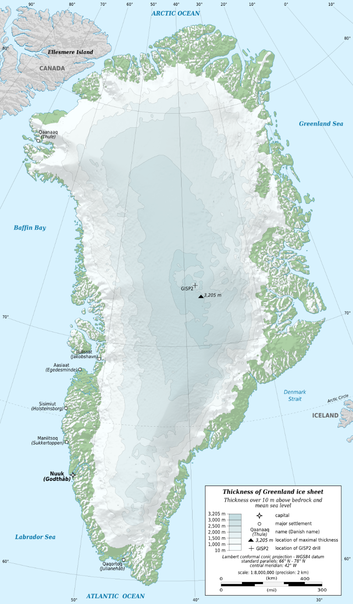
Figure 1. Map of the thickness of the Greenland Ice Sheet. (CC BY-SA 3.0: Eric Gaba/Sting via Wikimedia Commons)
The “Observing Change in Greenland’s Far North” lesson is divided into three parts. In Part 1, you will learn about the importance of the Greenland Ice Sheet to global climatic patterns and the basics of permafrost environments. In Part 2, you will meet a research team investigating the high Arctic water cycle and learn about the tools used in the field. In Part 3, you will develop hypotheses for three watersheds in Greenland’s Far North.

Why Does the Greenland Ice Sheet Matter?
Greenland’s Ice Sheet matters for four main reasons:
- Sea level: As the Greenland Ice Sheet melts, sea level rises. It is a direct, proven effect. This is the biggest reason for concern over Greenland. Scientists estimate that if the entire ice sheet melted, sea level would rise 23 feet. Depending on how rapidly such a change occurred, it could be a global-scale catastrophe because nearly one-third of the world’s population lives in or near a coastal zone. The global impact of several billion refugees and the negative impacts on coastal economic activity would be staggering.
A sea level rise of only two to three feet would create serious global problems: increased coastal erosion, salt water encroachment, loss of barrier formations (islands, sand bars, and reefs), and increased storm surge damage. Through the 1990s, sea level rose at a rate of about 3 millimeters per year. The rate crept up to almost 4 millimeters per year by the end of last decade. For historical perspective, sea level has risen more than 380 feet since the last ice age 18,000 years ago. That’s an average rate of 2.5 inches (10 centimeters) per decade, or 10 millimeters per year. However, most of that rise occurred as the ice age ended. Sea level has been relatively stable for the past several millennia.
- Ocean circulation: Sea level rise is not the only effect of a melting Greenland Ice Sheet. If the Greenland Ice Sheet melts at a faster rate, it will spread a slick of fresh water on top of the heavier salt water of the North Atlantic. This change in salinity could depress the Gulf Stream and alter North Atlantic circulation patterns that control weather in Europe. Combined with a loss of Arctic sea ice, this effect could radically change global ocean circulation patterns.
- Global heat transfer: The loss of Greenland ice mass would affect global atmospheric heat movement. Any heat transfer is driven by a temperature difference. The greater that difference, the faster heat flows. As the polar regions warm, the temperature difference between the equator and the poles is reduced, altering global atmospheric circulation patterns by reducing the force that drives equatorial heat energy toward the poles. Much of the world’s current pattern of rainfall would be altered.
- Regional atmospheric circulation: On average, the top 2,560 meters (8,400 feet) of Greenland is ice. Like a mountain range, this physical mass affects regional atmospheric circulation patterns. If (as) Greenland’s massive range of ice melts, regional circulation patterns will also change.

Where Ground is Frozen
The Far North refers to high latitude locations. In Greenland, these locations have an Arctic Tundra biome (Figure 2). This biome is known for permafrost, extremely low temperatures, little precipitation, slow soil formation, short growing seasons, and low-lying vegetation (Figure 3). Permafrost is any ground that remains completely frozen—32°F (0°C) or colder—for at least two years straight. Permafrost is made of a combination of soil, rocks and sand that are held together by ice. The soil and ice in permafrost stay frozen all year long. Near the surface, permafrost soils also contain large quantities of organic carbon—a material leftover from dead plants that couldn’t decompose, or rot away, due to the cold. Lower permafrost layers contain soils made mostly of minerals.
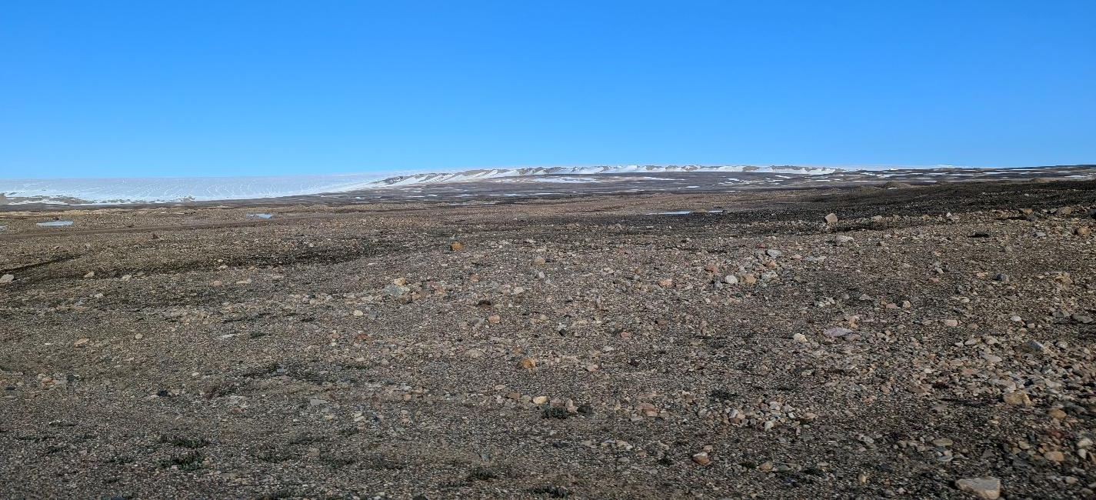
Figure 2. Tundra biome landscape near Pituffik, Greenland. (CC BY-NC-SA 4.0: W. Ray)

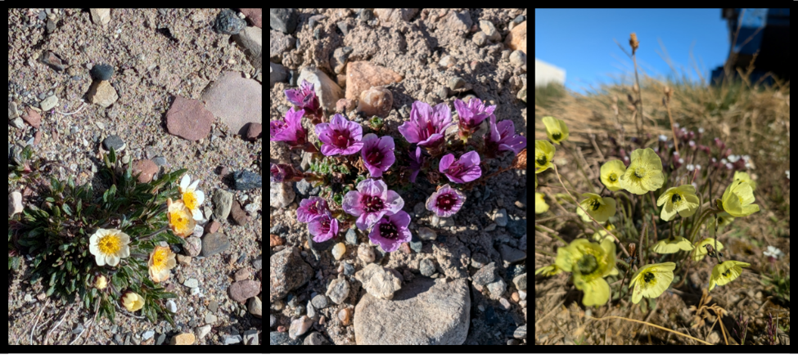
Figure 3. Tundra flowers, from left to right: Entireleaf mountain-avens (Dryas integrifolia), Purple mountain saxifrage (Saxifraga oppositfolia), Arctic poppy (Papaver radicatum). (CC BY-NC-SA 4.0: W. Ray)
A layer of soil on top of permafrost does not stay frozen all year. This layer, called the active layer, thaws during the warm summer months and freezes again in the fall (Figure 4). In colder regions, the ground rarely thaws—even in the summer. There, the active layer is very thin—only 4 to 6 inches (10 to 15 centimeters). In warmer permafrost regions, the active layer can be several meters thick.
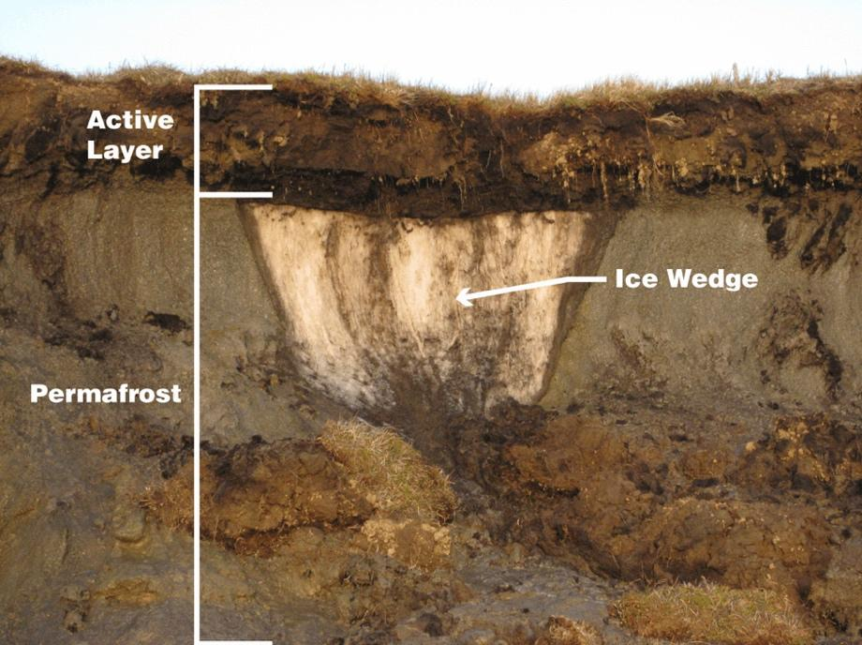
Figure 4. Permafrost layers with an ice wedge. (Public domain: Benjamin Jones, USGS; Modified by NASA)

How Does Climate Change Affect Permafrost?
As Earth’s climate warms, the permafrost is thawing. That means the ice inside the permafrost melts, leaving behind water and soil. Thawing permafrost can have dramatic impacts on our planet and the things living on it. For example:
- Many northern villages are built on permafrost. When permafrost is frozen, it’s harder than concrete. However, thawing permafrost can destroy houses, roads and other infrastructure.
- When permafrost thaws, so do ancient bacteria and viruses in the ice and soil. These newly-unfrozen microbes could make humans and animals very sick. Scientists have discovered microbes more than 400,000 years old in thawed permafrost.
- When permafrost is frozen, plant material in the soil—called organic carbon—can’t decompose, or rot away. As permafrost thaws, microbes begin decomposing this material. This process releases greenhouse gasses like carbon dioxide and methane to the atmosphere. Other sources of methane are deep geologic deposits underlying the permafrost and offshore methane hydrate, an ice-like combination of methane gas and water that is stable at low temperatures and moderate pressures (Figure 5).
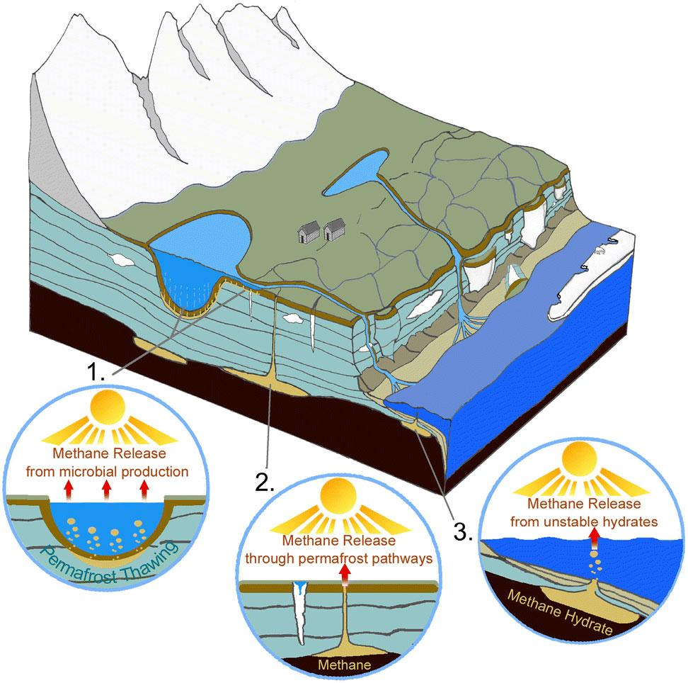
Figure 5. Sources of methane in warming Arctic environments. (Public domain: USGS)

Part 2. Investigating the High Arctic Water Cycle
Research in Greenland provides an increased understanding of how climate change is affecting Arctic environments. The 2023 Arctic Report Card on the Greenland Ice Sheet reported the following headlines (Poinar et al. 2003, p. 1):
- Winter snow accumulation was above average this year, but the Greenland Ice Sheet still lost 156 ± 22 gigatons of mass from 1 September 2022 to 31 August 2023 because discharge and melting exceeded accumulation. [One gigaton is a billion metric tons.]
- Summer high-pressure systems brought warm temperatures, widespread melting, and exceptional rainfall volumes.
- On 26 June 2023, Summit Station reached a temperature of 0.4°C and experienced melt for only the fifth time in its 34-year observational history. [Located in central Greenland at an elevation of 10,551 feet (3,216 meters), Summit Station is a year-round research station operated by the U.S. National Science Foundation (NSF) Arctic Research Program.]
A study of Greenland’s fjords—long, narrow sea inlet with steep sides or cliffs created by a glacier—found that glaciers located in deeper fjords were most affected by warming sea water undercutting the glacier, which causes the ice to break apart and hastens melting (NASA 2021). The “How a glacier melts” video illustrates how a glacier melts.
In Part 1, you learned about four impacts from increasing temperatures in Greenland: sea level rise, changes to oceanic circulation, changes to global heat transfer, and changes to regional atmospheric circulation. Klein et al. (2015, p. 1) explain additional concerns related to a warming Greenland:
Arctic sea ice extent and warming temperatures are of great interest because retreating sea ice decreases the Earth’s albedo, which leads to further reduction in Arctic surface reflectivity and a positive feedback to the global thermal balance. Moreover, declining perennial sea ice extent can influence the intensity of storms, as greater open water in the Arctic Ocean can lead to increased wind speed. Arctic cyclones, especially during summer, are more common than previously believed and could be increasing in frequency in association with sea ice decline and warming in the Arctic. These intense storm events are especially important as their strong winds can fracture sea ice, particularly in the summer when sea ice coverage is already diminishing, which increases
open water and mixing in the Arctic Ocean boundary layer.

What Else is Missing from Our Understanding?
Remember that you learned that permafrost is thawing? How might that affect sea level rise? This is one question asked by Dr. Eric Klein in the Department of Geological Scientists at the University of Alaska Anchorage. With a National Science Foundation-funded career award, Dr. Klein is leading a five-year study of watersheds in Greenland’s Far North to find out how glacier melting, permafrost thawing, and active layer changes affect river discharge in the warming Arctic region. This research will help improve sea level rise models by determining how glacial meltwater interacts with the subsurface. Figure 6 shows a picture of the 2024 field season research team.

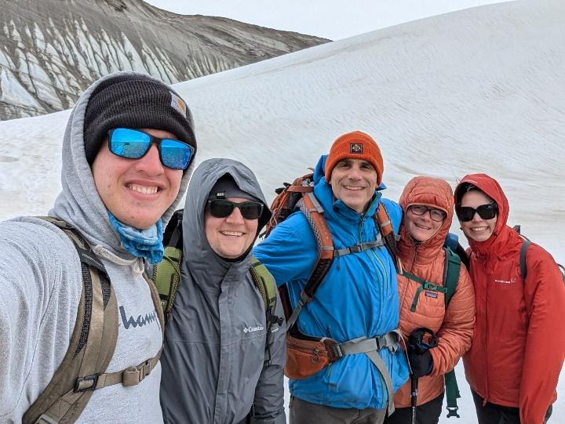
Figure 6. 2024 Field season research team, left to right: Jake Colberg, Logan Wieland, Eric Klein, Waverly Ray, Esther-Marie Hansen (not pictured: Kynan Hughson and Cameron Kuhle). (CC BY-NC-SA 4.0: J. Colberg)

What are the Reservoirs and Transport Pathways in the Arctic Water Cycle?
The water cycle describes how water moves above, on, and through the Earth. In the Arctic regions, we have to take into account how water moves through permafrost and the active layer (Figure 7). One way to understand the water cycle is to distinguish between reservoirs (where water is stored, either for short or long periods of time) and transport pathways, which are also known as fluxes, that move water from one reservoir to another.
- Reservoirs include: surface water (ocean/lakes/rivers/streams/inland seas); atmosphere; cryosphere (snow/glaciers); snow; vegetation/soil moisture; groundwater
- Transport pathways include: evaporation; evapotranspiration; condensation; precipitation; runoff; infiltration; groundwater outflow to rivers/lakes/streams and the ocean
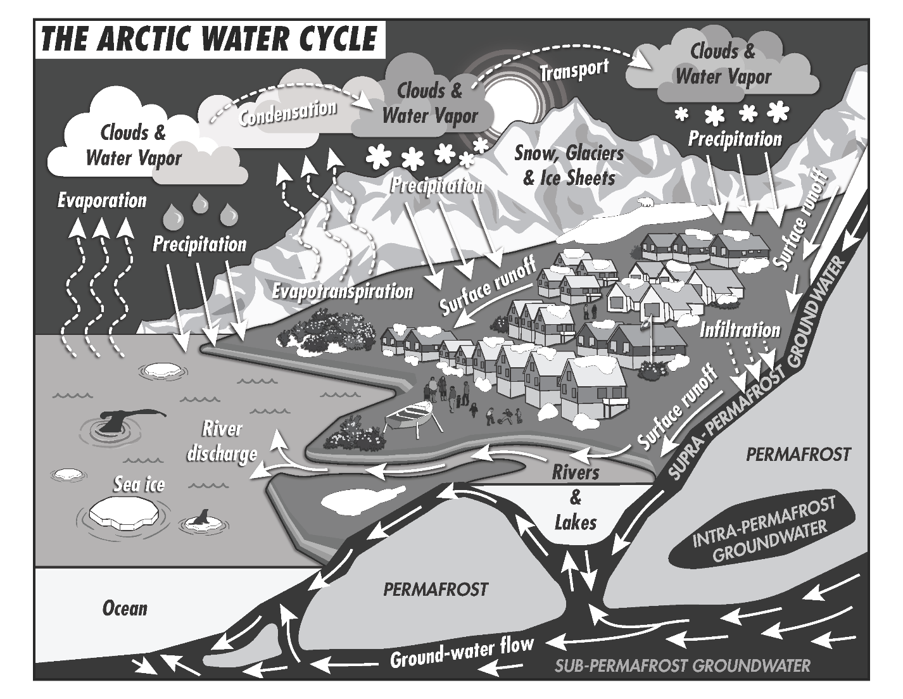
Figure 7. The Arctic Water Cycle. (CC BY-NC-SA 4.0: W. Ray)

Thaw!
What’s the one word that sums up the research team’s field season? It’s thaw! There are several geomorphological features of permafrost thaw:
  - Thaw slump: A type of mass wasting that develops when hillslopes fail due to thawing of ice-rich permafrost.
  - Thaw scarp: The cliff face of a thaw slump.
  - Thermokarst lakes: When permafrost thaws and creates a surface depression that fills with melted water, a thermokarst lake is formed.
  - Ice wedges: A large mass of ice found within permafrost.
  - Polygonal ground: A repeated ground pattern of multi-sided shapes that are roughly equidimensional caused by cycles of freezing and thawing
  - Cracks/fissures: Linear depressions created by ground that contracts when it freezes.

Data Collection Instruments
The research team used multiple data collection methods to observe changes at multiple study sites. Each one provides a valuable insight into how the Far North is changing. Some of the data collection methods are discussed below—in order to simplify the explanation of the research process some data collection methods and subsequent analyses are omitted. For each of the methods described below, a GPS receiver is used to mark the location of data collection.

Data Collection Method 1. Water Quality Meter
A water quality meter houses several probes for real-time collection of data (Figure 8). Numerous variables are documented, including water temperature, pH, dissolved oxygen, and specific conductivity.
- Water temperature is an important measure to understand the thermal exchange between the atmosphere and the Earth’s surface.
- pH is a measure of the relative amount of free hydrogen and hydroxyl ions in water. Water that has more free hydrogen ions is acidic, whereas water that has more free hydroxyl ions is basic. Since pH can be affected by chemicals in the water, pH is an important indicator of water that is changing chemically.
- Dissolved oxygen is a measure of how much oxygen is dissolved in the water—the amount of oxygen available to living aquatic organisms. Zooplankton in thermokarst lakes utilizes dissolved oxygen to survive. Low levels of dissolved oxygen may indicate conditions for the release of methane by microbes.
- Conductivity is a measure of the ability of water to pass an electrical current. Because dissolved salts and other inorganic chemicals conduct electrical current, conductivity increases as salinity increases. Lower salinity levels suggest freshwater input from glacial melting or precipitation.
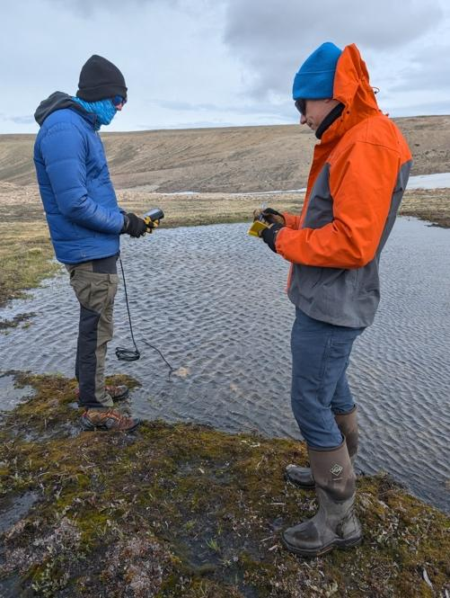
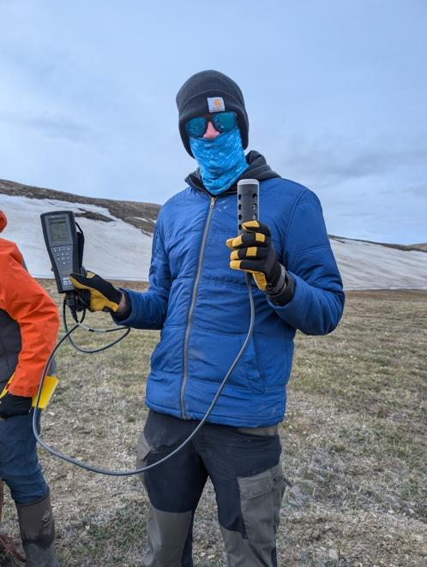

Figure 8. Left photo: Jake holds the water quality meter on the left and the probe with sensors on the right. Right photo: Jake is reporting the data shown on the meter as Eric adds the information to his field notes.
(CC BY-NC-SA 4.0: W. Ray)

Data Collection Method 2. Groundwater Well
In order to understand the depth to permafrost and fluctuating groundwater levels, wells were dug and fitted with PVC pipes drilled with holes so water can move into the pipe as groundwater levels change (Figure 9). Piezometer instruments placed in the wells take pressure measurements to track water changes. Typically, this data is recorded at 15 minute intervals. After the piezometer is deployed, the researchers return later to upload the data to a laptop.
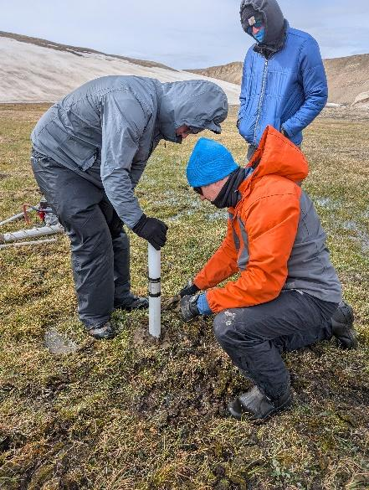
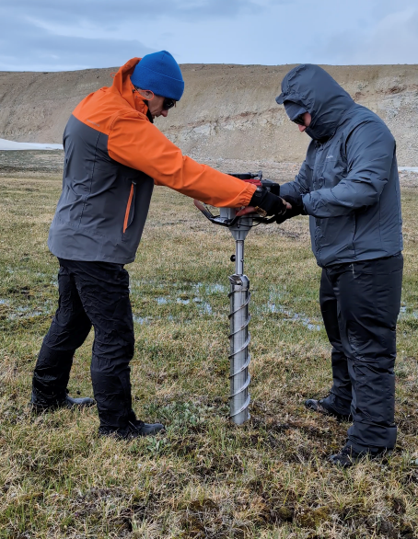

Figure 9. Left photo: Eric and Logan drill into the active layer to install the groundwater well.
Right photo: Installing the groundwater well. (CC BY-NC-SA 4.0: W. Ray)

Data Collection Method 3. Water Sampling
Water samples are collected in the field so that stable water isotope ratios will be analyzed in a lab (Figure 10). Oxygen is one of the most significant keys to deciphering past climates. Oxygen comes in heavy and light varieties, or isotopes, which are useful for paleoclimate research. Like all elements, oxygen is made up of a nucleus of protons and neutrons, surrounded by a cloud of electrons. All oxygen atoms have 8 protons, but the nucleus might contain 8, 9, or 10 neutrons. “Light” oxygen-16, with 8 protons and 8 neutrons, is the most common isotope found in nature, followed by much lesser amounts of “heavy” oxygen-18, with 8 protons and 10 neutrons. Light oxygen is symbolized by ¹⁶O and the heavy isotope of oxygen is symbolized by ¹⁸O. Figure 11 depicts how different stages of the water cycle result in changing ¹⁸O isotopes in the Antarctic region—the same occurs in the Arctic region.
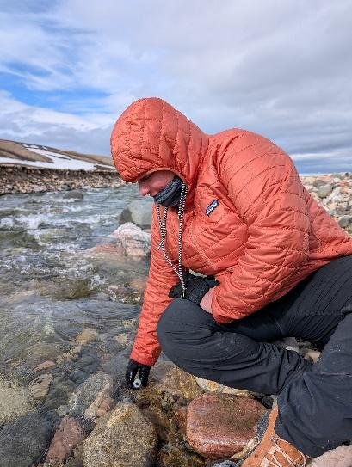
Figure 10. Waverly collects a water sample in a plastic bottle. (CC BY-NC-SA 4.0: W. Ray)

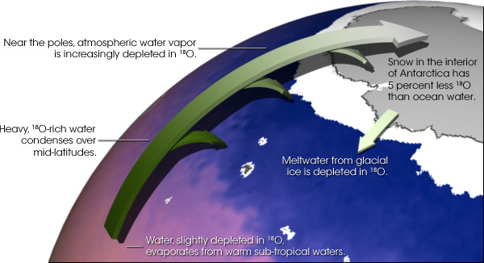
Figure 11. Depiction of water, slightly depleted in ¹⁸O evaporates from warm sub-tropical waters, then heavy, ¹⁸O-rich water condenses over mid-latitude, then near the poles atmospheric water vapor is increasingly depleted in ¹⁸O, then snow in the interior of Antarctica has 5 percent less ¹⁸O than ocean water, then meltwater from glacial ice is depleted in ¹⁸O. (Public domain: Robert Simmon, NASA GSFC)

Data Collection Method 4. Stream Profiles and Discharge
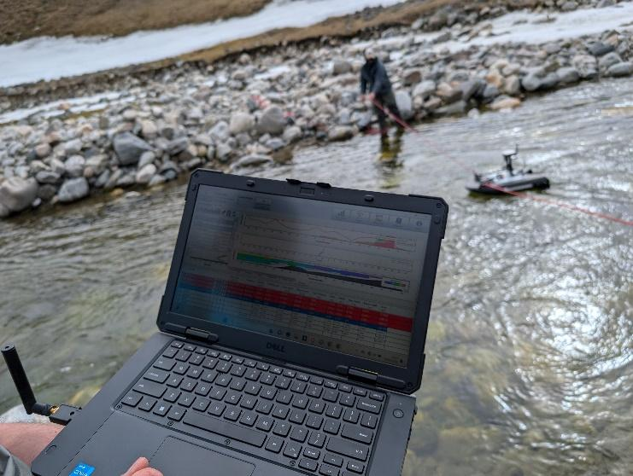
In order to understand how rivers are changing, stream profile and stream discharge data are collected. An acoustic Doppler current profiler (ADCPs) is a commonly used method for measuring streamflow (Figure 12). The ADCP measures water currents with sound, using a principle of sound waves called the Doppler effect. The ADCP works by transmitting "pings" of sound at a constant frequency into the water. As the sound waves travel, they ricochet off particles suspended in the moving water, and reflect back to the instrument providing stream discharge data (Figure 13). The ADCP is utilized multiple times throughout the day to record changing stream velocities.

Figure 12. Logan helps to guide the Acoustic Doppler Current Profiler (ADCP) across the stream while Eric reviews the real-time stream profile data. (CC BY-NC-SA 4.0: W. Ray)

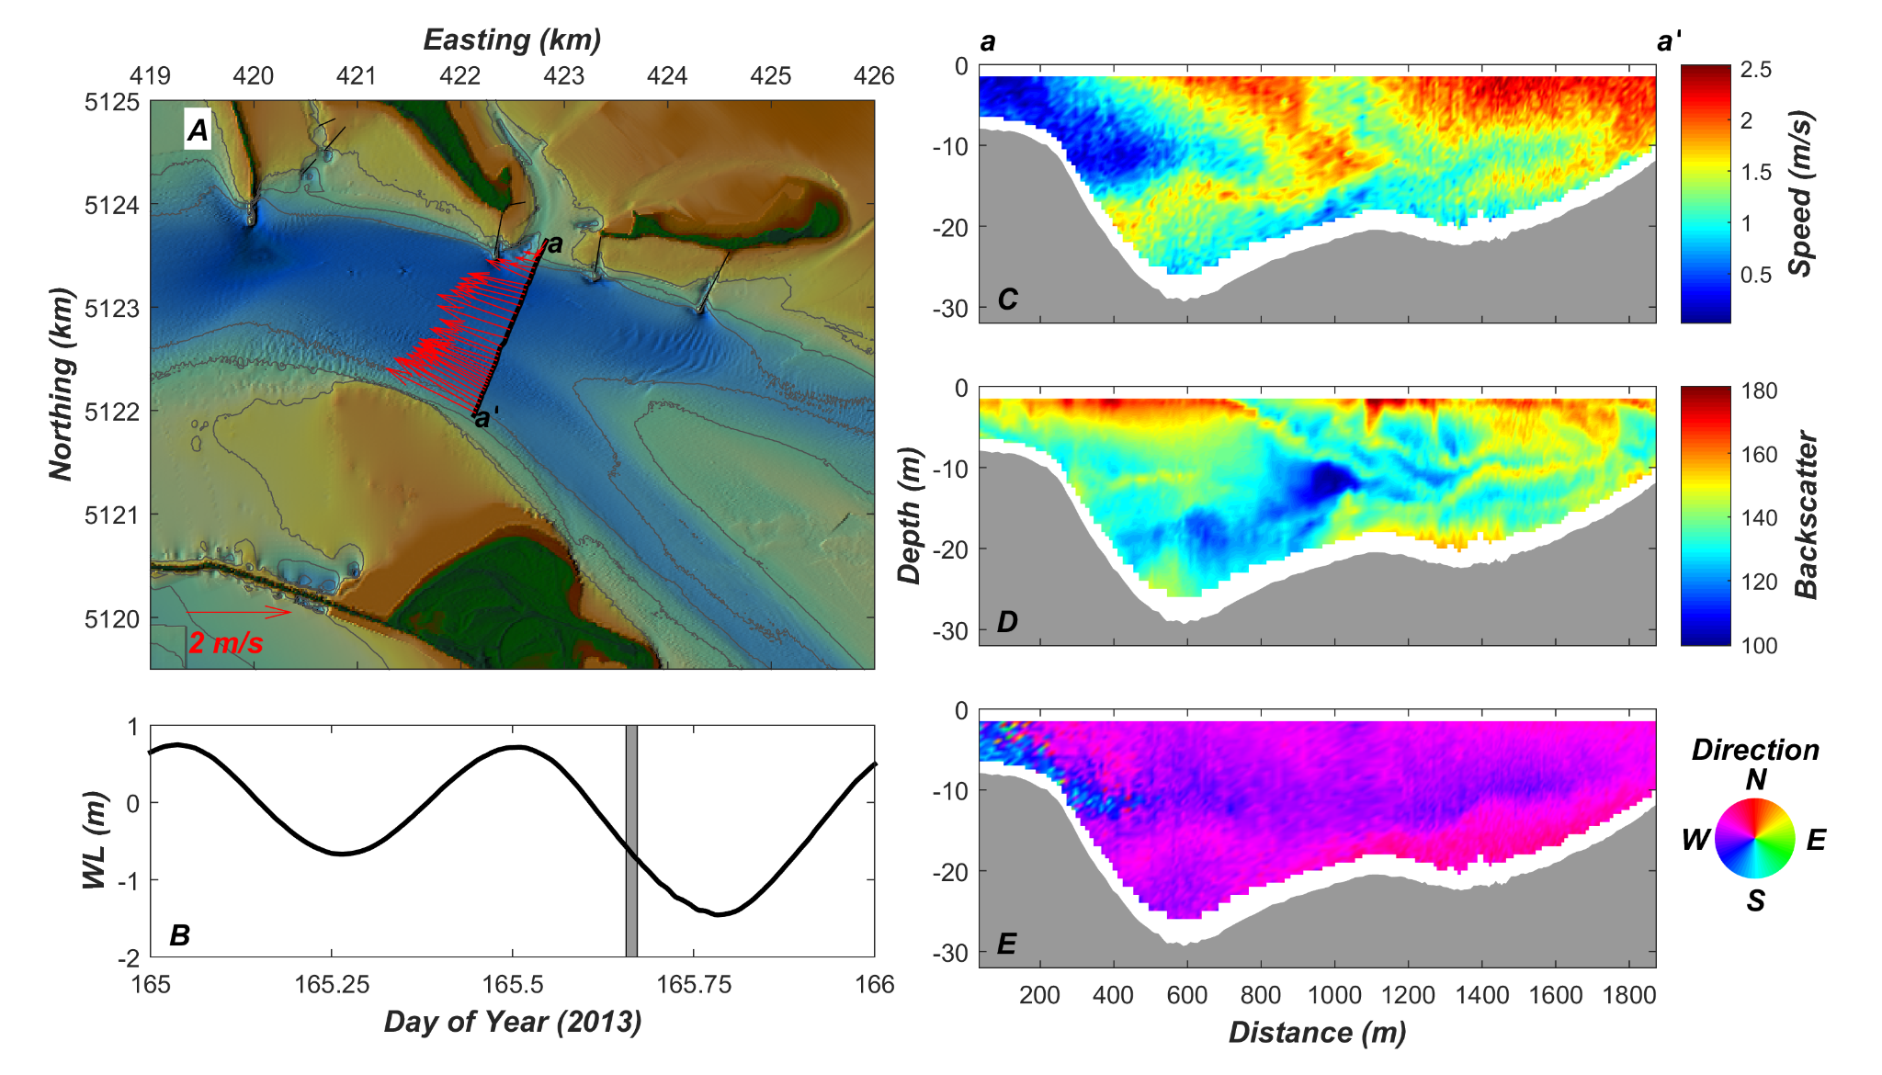
Figure 13. Examples of vessel-mounted acoustic Doppler current profiler (ADCP) data from the mouth of the Columbia River, Oregon and Washington, 2013. In the upper-right, a map shows the velocity of the river currents in red arrows. On the right, the speed (top), backscatter (middle), and waterflow direction (bottom) are depicted on the cross-section of the river. On the bottom-left, water level is plotted over time. (Public domain: Andrew Stevens, USGS)

Part 3. Formulating Hypotheses about the High Arctic Water Cycle

Background: Research on Indigenous Lands
The National Science Foundation (NSF), an independent agency of the U.S. federal government, funds polar research and education. “Given the deep knowledge held by local and Indigenous residents in the Arctic, NSF recognizes the importance of collaboration with Arctic residents” (NSF, n.d.). The Interagency Arctic Research Policy Committee devised five principles for conducting research in the Arctic (IARPC, 2018):
- Be accountable,
- Establish effective communication,
- Respect Indigenous knowledge and cultures,
- Build and sustain relationships, and
- Pursue responsible environmental stewardship.

To better understand the experiences of the Inuit people of Greenland, Esther-Marie Hansen—one of our research team members who is an undergraduate student from Greenland—wrote this brief history.

There have been several different groups of people in Greenland, where the first group came to Greenland 4,500 years ago. The people of Greenland are called Inuit (plural; Inuk is singular). Inuit exist in places like Greenland, Alaska, Canada, and Russia. The Inuit of Greenland today are from Thule Culture, which is the third group that came to Greenland. Several of these groups existed in Greenland at the same time. They had different ways to transport themselves, where the Thule Culture had the qajaq (kayak) umiaq (boat) and dog sleds. This meant they could move around Greenland fast. Hunting was important for survival and the knowledge has been passed down the generations. This means that seals, whales, and fish were some of the main diet, although the animals being hunted were different for each of the Inuit groups. Polar bears, muskox, reindeer, walrus and more were also hunted. Animals move around depending on the season, and that was the reason Inuit had to move around between winter and summer houses. A house could have a few families in one place, and in the summer they would live in tents.

A man’s main role was hunting and making sure to bring food home. A woman’s role was mainly being a housewife, cooking, taking care of the kids, and making clothes. These roles were not definite—a woman could be a hunter with a man or by themselves. Roles are important to survive in these Arctic conditions, but the male and female roles were not gender specific. If more hunters were needed they could raise the girl to hunt with the men, and when the child got older, they decided what role they wanted.

Depending on the area in Greenland, the sea ice can freeze in winter, whereas in other parts it does not. Some of the cities are located where sea ice does not freeze in order to get ships year around. While a lot of places in Greenland get a constant supply of food and different items, a lot of remote places heavily rely on hunting. The cost of food in remote areas can be expensive and can run out as there can be one supply ship arriving each year only when the sea ice breaks up. Families then rely on hunting animals such as beluga and narwhals, seals, walrus, polar bears, caribou, muskox, and more. These animals have quotas in place to preserve species stocks and there are different hunting seasons for each animal.

Greenlandic people were influenced by European whale hunters from around 1500-1700. They traded things which can still be seen in Greenlandic culture. With a colonial past, today’s Greenland is a self-governing autonomous country within the Kingdom of Denmark. The people of Greenland decided not to be a part of Europe, but they are European citizens.

The research team got to meet Esther’s grandfather, Lars Jeremiassen, who is a legendary hunter. We talked to him about what changes he has noticed and she prepared this summary of what we learned:

In the most northern part of Greenland, the hunters have more difficulties with hunting as the ice has started to freeze much later. In the winter in the Thule area they have no sunlight from late October to early February. The moonlight shines through and acts as a lamp, and the hunters need the sea ice to be frozen to hunt in this dark period. This has resulted in hard times at these dark periods for hunters, and they will need their partner to have a regular job to be secure so the family can make ends meet during the winter. The older hunters are the ones that have seen the most change, where the young generation view the changes that are their reality now as their normal. Lars Jeremiassen, who was a fulltime hunter, told us about the ice used to be around 2 meters (6.6 feet) thick in the 1980’s, and today in winter it is 1 meter (3.3 feet). The environmental changes have meant that the animals are no longer as predictable as they search for new environments. Global warming has created an uncertainty for Arctic hunters who hold Indigenous knowledge, and who have hunted for more than 4,000 years in Greenland.

The changes described by Lars Jeremiassen are documented through satellite imagery— since 1979, satellites have provided a reliable tool for continuously monitoring changes in the Arctic ice. Every summer, the Arctic ice cap melts to what scientists call its "minimum" before colder weather begins to make ice cover increase. The Annual Arctic Sea Ice Minimum Area 1979-2022 video provides a visualization of the expanse of the annual minimum Arctic sea ice for each year from 1979 through 2022, with a graph overlay. In 2022, Arctic minimum sea ice coverage tied for 10th-lowest on record, extending a long-term downward trend.

Formulating Hypotheses about the High Arctic Water Cycle
A hypothesis is a testable statement about the natural world. In science, a hypothesis is based on background knowledge and it represents the overall expectation of a research study. As you have read through this lesson on Observing Change in Greenland’s Far North, you probably already have thought of some hypothesis that research sciences could test. For example, do you hypothesize that Arctic sea ice will continue to decrease in the next decade? How do you think data collected in different watersheds in Greenland’s Far North will compare? Let’s look at three study site locations so that you can develop hypotheses about changes to the Arctic water cycle.
A watershed is an area of land that drains all the streams and rainfall to a common outlet such as the outflow of a reservoir, mouth of a bay, or any point along a stream channel. The word "watershed" is sometimes used interchangeably with drainage basin or catchment. Watersheds consist of surface water—lakes, streams, reservoirs, and wetlands—and all the underlying groundwater.
Three of the watersheds studied are introduced below (Figure 14).
- North Mountain River watershed: Not a glaciated basin, 5.8 mi² (15 km²)
The North Mountain River watershed is not connected to the Greenland Ice Sheet. The river originates at a lake and drains into North Star Bay. Wetlands are developing in this watershed.
- Narssarssak River watershed: 5% glaciated, 17.3 mi² (45 km²)
The Narssarssak River begins at a small glacier that is not connected to the Greenland Ice Sheet. This watershed has the least amount of developing wetlands.
- Fox Canyon River watershed: 15% glaciated, 54.1 mi² (140 km²)
The Fox Canyon River begins at the Greenland Ice Sheet and also drains a large glacier. Wetlands are developing in this watershed.

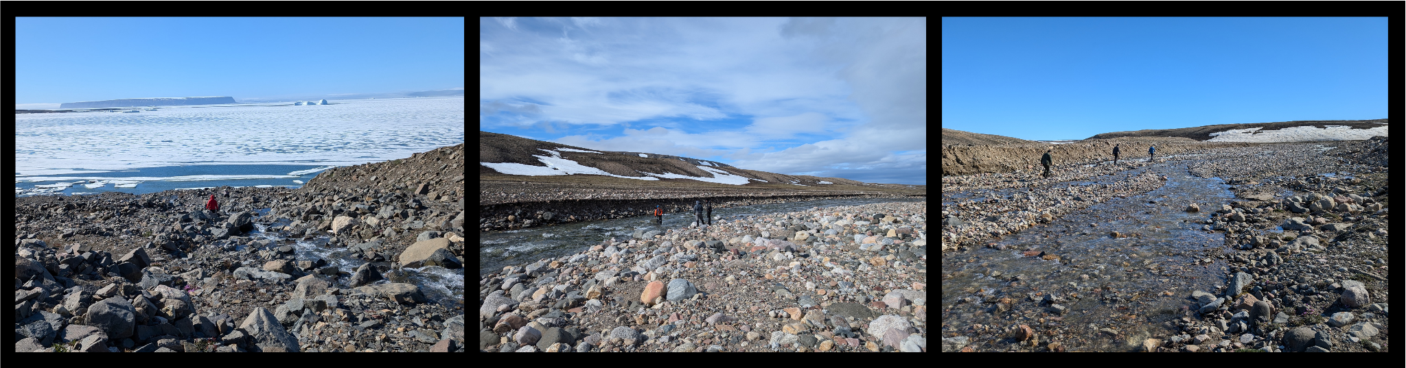
Figure 14. Far left: North Mountain River Watershed (with Esther). Middle: Narssarssak River (with team members). Far right: Fox Canyon River (with team members). (CC BY-NC-SA 4.0: W. Ray)

Attributions
NASA Climate Kids. (2024). What is Permafrost?
NASA Climate Change. (2022). Annual Arctic Sea Ice Minimum Area 1979-2022, With Graph
NASA Earth Observatory. (2007). Why Does the Greenland Ice Sheet Matter?
Riebeek, H. 2005. Paleoclimatology: The oxygen balance. NASA Earth Observatory. https://earthobservatory.nasa.gov/features/Paleoclimatology_OxygenBalance
South Atlantic Water Science Center (SAWSC). 2016. Acoustic Doppler Current Profiler (ADCP) to measure streamflow. https://www.usgs.gov/media/images/acoustic-doppler-current-profiler-adcp-measure-streamflow
United States Environmental Protection Agency. (n.d.). Indicators: conductivity
United States Geologic Survey. (n.d.). Watersheds
USGS Water Science School. (n.d.) pH scale
USGS Coastal and Marine Hazards and Resources Program. (n.d.). Sources of methane escaping from Arctic environments

Works Cited
Interagency Arctic Research Policy Committee (IARPC). (2018). Principles for conducting research in the Arctic. https://www.nsf.gov/geo/opp/arctic/conduct.jsp
Klein, E., Cherry, J.E., Young, J., Noone, D., Leffler, A.J., & Welker, J.M. (2015). Arctic cyclone water vapor isotopes support past sea ice retreat recorded in Greenland ice. Scientific Reports, 5: 10295. doi: 10.1038/srep10295
National Science Foundation (NSF). (n.d.). Examples of community engagement in NSF-funded research. https://www.nsf.gov/geo/opp/arctic/ace/community.jsp
NASA. (2021, January 25). Warming Seas Are Accelerating Greenland's Glacier Retreat. https://climate.nasa.gov/news/3062/warming-seas-are-accelerating-greenlands-glacier-retreat/
Poinar, K., Mankoff, K. D., Fausto, R. S., Fettweis, X., Loomis, B. D., Wehrlé, A., Jensen, C. D., Tedesco, M., Box, J. E., & Mote, T. L. (2023). NOAA Arctic Report Card 2023: Greenland Ice Sheet. NOAA technical report OAR ARC; 23-05. https://doi.org/10.25923/yetx-rs76

