Carbon Fluxes in Arctic Headwater Streams
Introduction: Watch this video to help introduce you to the topic of Carbon Fluxes.

Part I Instructions: As you read this page, annotate essential vocabulary, concepts, and new information.
Introduction: Understanding carbon fluxes in Arctic headwater streams is crucial for environmental science. Investigating these fluxes helps scientists understand how carbon is transported and transformed in the environment. Given the rapid changes in the Arctic due to global warming, knowing how carbon fluxes in these streams respond to and impact climate change is vital. This knowledge can help predict future climate scenarios and inform conservation and mitigation strategies.
Background: Arctic carbon fluxes refer to the movement and exchange of carbon in various forms, such as carbon dioxide (CO₂) and methane (CH₄), within the Arctic environment. These fluxes are critically influenced by the Arctic region's unique and rapidly changing conditions, including permafrost thaw, reductions in ice cover, and shifts in vegetation.
Permafrost, a thick subsurface layer of soil that remains frozen throughout the year and covers most of the Arctic, contains large amounts of stored carbon. As the Arctic warms at approximately twice the global rate, permafrost thaws, releasing this stored carbon into the atmosphere, soil, and aquatic systems. This release can occur as CO₂ or CH₄, both potent greenhouse gases that contribute significantly to global warming.
Headwater streams in the Arctic, often characterized by a Strahler number of 2-4 (see image below), play a crucial role in this process. They act as channels for carbon, transporting it from the land to larger bodies of water and the atmosphere.
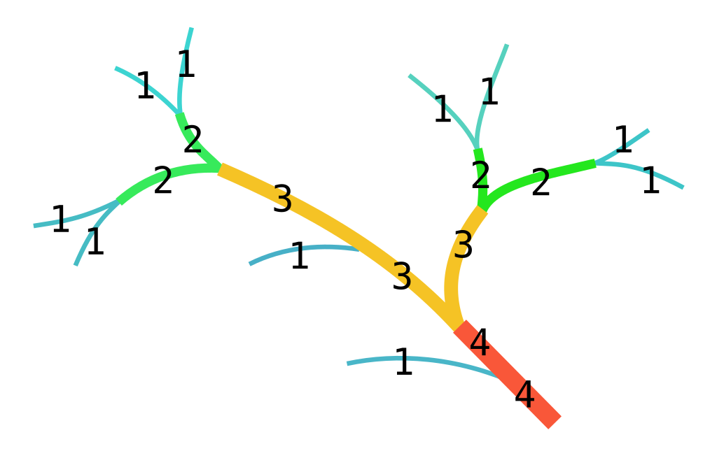
Strahler number. In Wikipedia. https://en.wikipedia.org/wiki/Strahler_number
The Intergovernmental Panel on Climate Change (IPCC) emphasizes the importance of understanding carbon fluxes in its reports. The IPCC highlights that Arctic carbon fluxes are a significant feedback mechanism in the global climate system. As the Arctic continues to warm, increased carbon emissions from thawing permafrost and changing hydrological patterns could accelerate global climate change, creating a positive feedback loop that intensifies warming.
Using complete sentences, summarize what you have learned.

Challenge Questions!
1. How do carbon fluxes in Arctic headwater streams illustrate the concept of feedback loops in the global climate system? | 2. In what ways might changes in the Arctic carbon fluxes affect ecosystems both within and beyond the Arctic region? | 3. How can understanding the movement of carbon contribute to global conservation and mitigation strategies?
Meet the Scientist- Macall Hock
Macall Hock is a dedicated researcher currently engaged as a fellow with the Polar STEAM program. She is pursuing her doctoral studies at San Diego State University, where her research focuses on understanding the impacts of climate change on carbon cycling in the Arctic. Macall's primary project investigates the multi-decadal, year-round fluxes of carbon dioxide (CO₂) and methane (CH₄) to gauge the long-term effects of a warming Arctic ecosystem on stream carbon dynamics in northern Alaska.
Her work aims to quantify the transport of carbon across the tundra via drainage streams and how various landscape types and permafrost conditions influence carbon fluxes. Macall hopes to bridge the gap between Arctic research and conservation, making significant contributions to our understanding of the impacts of climate change on the Arctic carbon balance. The National Science Foundation supports her research and is part of a broader effort to establish long-term field observations critical for grasping the controls on greenhouse gas emissions from the Arctic.
Watch this short video of Macall explaining her research.
Challenge Questions!
4. What educational background and skills might be necessary for a scientist like Macall Hock to research Arctic carbon cycling, and how does this education prepare them to contribute to the broader scientific community? | 5. How can bridging the gap between Arctic research and conservation efforts enhance global environmental policies, and what challenges might scientists face in translating scientific findings into actionable strategies?

Part II:
The Carbon Cascade: Tracking Fluxes in Arctic Streams
Purpose: In this lab, you will observe the dynamics of carbon movement through Arctic ecosystems. Understanding these processes is crucial as they play a significant role in the global carbon cycle, especially in the context of climate change.
Headwater streams in the Arctic are unique environments where the hydrology and carbon fluxes are particularly important to study. These streams, fed by melting snow and ice and late summer season rainfall, act as critical channels for carbon transport from terrestrial to aquatic systems. The extreme seasonal variations in the Arctic, including the intense snowmelt in spring, the relatively mild but active summer, and the cooling and reduced flow in the fall, all contribute to complex hydrological and biogeochemical processes.
Background: In this lab, you will analyze hydrology data collected during three distinct periods, highlighting key variables in each period.
1. Snowmelt (Freshet): This period marks the transition from winter to summer, characterized by a rapid influx of meltwater into the streams. As the snowpack melts, it releases accumulated organic and inorganic carbon into the waterways. Understanding the carbon fluxes during this period is crucial as it sets the stage for downstream processes.
2. Arctic Summer (Baseflow): During the summer, the Arctic experiences 24-hour daylight, which significantly influences the biological activity of its streams. The continuous light, warmer temperatures, and increased microbial activity can lead to heightened carbon processing and transport. This period allows us to observe how carbon dynamics change under sustained energy inputs.
3. Late Season (August-September): As temperatures drop and daylight hours decrease, rainfall increases stream flow. This period is essential for studying the residual effects of summer processes and preparing the ecosystem for the upcoming winter freeze.
Procedure: Throughout the lab, you will analyze the following hydrological parameters: stream flow rates, photosynthetic light levels, temperature fluctuations, and their relationship to carbon fluxes. By comparing data across these different periods, you will infer the primary drivers of carbon fluxes in Arctic headwater streams by analyzing your graph.
Objective: By the end of this lab, you should be able to:
- Analyze and interpret hydrology data from different seasonal periods.
- Identify key factors influencing carbon fluxes in Arctic headwater streams.
- Use data from the field to create graphs that provide visuals of stream dynamics.
- Synthesize findings to draw conclusions about carbon dynamics in these unique environments.
Hypothesis: Based on the information provided in the background, develop a hypothesis (If/Then) on what you think are the key factors influencing the carbon fluxes in the Arctic headwater streams.

Data: This data was collected by our scientist, Macall Hock!
Season | Water Temp (°C) | PAR (µE/m²s) | pCO2 (µatm) | CO2 Flux (mg C/m²/day) | Discharge (m³/s) | DOC (ppm)
Baseflow | 24.554 | 405.6828 | 3350.054 | 158.2026 | 0.399762 | NA
Baseflow | 16.481 | 535.6682 | 3540.037 | 478.2745 | NA | NA
Baseflow | 16.592 | 737.7098 | 3083.708 | 737.7098 | NA | NA
Freshet | 14.9 | 1195.2 | xxxxxxxxxxxx | 4455.877 | NA | 19.72653
Freshet | 12 | 562.29 | 2524.541 | 5787.188 | NA | 20.7934
Freshet | 7.039 | 1305.98 | 5695.255 | 915.834 | 96.76614 | 24.2375
Late Season | 19.564 | 646.7296 | 5855.695 | 2162.661 | 0.081767 | NA
Late Season | 20.021 | 2162.661 | 2429.748 | 1737.274 | 0.547429 | NA
Late Season | 14.53 | 2570.94 | 2512.354 | 1737.274 | 0.127546 | NA

Variable Name | Unit of Measurement | Description
Water Temp (°C) | °C (Degrees Celsius) | Measures the temperature of the water, indicating how warm or cold it is.
PAR (µE/m²s) | µE (Microeinsteins) per m² per second | Measures the intensity of photosynthetically active radiation (sunlight) in the water.
pCO2 (µatm) | µatm (Microatmospheres) | Measures the partial pressure of carbon dioxide in the water. Higher values indicate a higher concentration of CO2 in the water.
CO2 Flux (mg C/m²/day) | mg C/m²/day | Measures the rate of carbon dioxide exchange (flux) across the water surface. Positive values indicate CO2 being released into the atmosphere, while negative values indicate CO2 being absorbed from the atmosphere.
Discharge (m³/s) | m³/s (Cubic meters per second) | Measures the volume of water flowing through a river or stream per second.
DOC (ppm) | ppm (Parts per million) | Measures the concentration of dissolved organic carbon in the water.

Graphing Instructions:
- Choose Variables to Plot: Select two variables to compare (e.g., CO2 Flux vs. Discharge, or pCO2 vs. Water Temp).
- Create Axes:
  - Label the x-axis with one variable (e.g., Discharge).
  - Label the y-axis with the other variable (e.g., CO2 Flux).
- Plot Data Points:
  - Use different colored dots or symbols for each season (e.g., green for Freshet, blue for Baseflow, red for Late Season).
- Draw Trend Lines: Add a line through the points for each season to show trends.

Alternative: Create your graph and insert it into this digital document using either Google Sheets or Excel. Use a different color for each season. Ensure that you properly scale your X and Y axes.



Analysis:
- How do stream flow rates vary across the different seasonal periods (Freshet, Baseflow, Late Season), and what impact might these variations have on carbon transport in Arctic headwater streams?

- What trends in photosynthetic light levels PAR) across the seasons can you observe, and how might these trends affect the biological activity contributing to stream carbon processing?

- How do temperature fluctuations across the seasonal periods correlate with changes in carbon fluxes, and what might this suggest about the influence of temperature on carbon dynamics?

- By comparing the data collected during the snowmelt, Arctic summer, and fall Late Season periods, what can you infer about the primary drivers of carbon fluxes in these streams, and how do these drivers change with the seasons?

- Based on your analysis of stream flow rates, photosynthetic light levels, and temperature, what conclusions can you draw about the overall carbon dynamics in Arctic headwater streams, and how might these findings inform our understanding of the global carbon cycle?

Conclusion:
After your analysis, you will write a concluding statement using the CER (Claim Evidence Reasoning) method.
Question: What are the key factors influencing the carbon fluxes in the Arctic headwater streams?
Claim: I claim that the primary factor influencing carbon fluxes during the year is ________________.

Evidence 1: | Reason 1:
Evidence 2: | Reason 2:
Evidence 3: | Reason 3:

Now, you will write a cohesive statement using your CER table.
__________________________________________________________________________________________________________________________________________________________________________________________________________________________________________________________________________________________________________________________________________________________________________________________________________________________________________________________________________________________________________________________________________________________________________________________________________________________________________________________________________________________________________________________________________________________________________________________________________________________________________________________________________________________________________________________________________________________________________________________________

Part III

Sketch Prompt: Arctic Carbon Flux Visualization
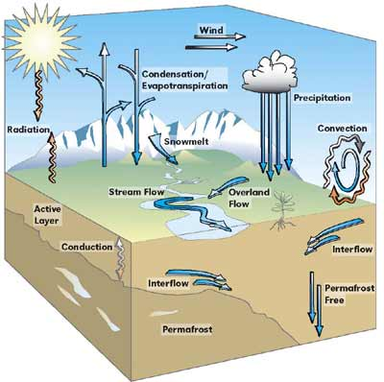
Based on the lesson about carbon fluxes in Arctic headwater streams, create a visual representation that captures the key concepts we've explored. This sketch should help reinforce your understanding of the complex processes occurring in these unique environments.
Sketch Instructions:
1. Draw a cross-section of an Arctic landscape that includes:
- A headwater stream
- The surrounding tundra
- Permafrost layers beneath the surface
- The atmosphere above
2. Use arrows to show the movement of carbon between different components:
- From permafrost to the stream
- From the tundra to the stream
- From the stream to the atmosphere
- From the atmosphere back to the tundra (through photosynthesis)
3. Include visual representations of the three seasonal periods we studied:
- Snowmelt
- Arctic summer
- Late season
4. For each season, add small symbols or icons to represent:
- Relative stream flow rates
- Sunlight intensity
- Temperature
5. Add labels to identify key components and processes in your sketch.
Remember, this is a conceptual drawing, not a scientific illustration. Focus on conveying the main ideas we've discussed about carbon fluxes in Arctic headwater streams. Use your creativity to make the sketch informative and visually appealing.
Reflection Questions:
After completing your sketch, consider the following questions:
1. How does your visualization help explain the concept of carbon fluxes in Arctic ecosystems?
2. What challenges did you face in representing the complex interactions between different components of the system?
3. How might you modify your sketch to show the potential impacts of climate change on these carbon fluxes?

Arctic Carbon Flux Visualization Sketch Rubric
Criteria | 1 | 2 | 3 | 4 | 5
Landscape Elements | Only 1-2 required elements included (stream, tundra, permafrost, atmosphere) | 3 required elements included | All 4 required elements are included, but lacking detail | All 4 required elements included with adequate detail | All 4 required elements included with exceptional detail and accuracy
Carbon Movement | No arrows showing carbon movement | 1-2 carbon movement paths shown | 3 carbon movement paths shown | All 4 required carbon movement paths shown | All carbon movement paths shown with additional relevant paths included
Seasonal Representation | Only 1 season represented | 2 seasons represented | All 3 seasons represented but lacking clear differentiation | All 3 seasons clearly represented | All 3 seasons represented with distinct and accurate characteristics
Seasonal Factors | No seasonal factors (stream flow, sunlight, temperature) shown | 1 seasonal factor shown for each season | 2 seasonal factors shown for each season | All 3 seasonal factors shown for each season | All seasonal factors shown with clear variations across seasons
Labeling | No labels included | Few labels included, many inaccuracies | Most major elements labeled, some minor inaccuracies | All major elements accurately labeled | Comprehensive labeling including processes and interactions
Visual Appeal | Sketch is messy and hard to interpret | Sketch is somewhat organized but still unclear | Sketch is organized and mostly clear | Sketch is well-organized and easy to understand | Sketch is exceptionally well-organized, clear, and visually appealing
Scientific Accuracy | Many scientific inaccuracies | Some scientific inaccuracies | Mostly scientifically accurate with minor errors | Scientifically accurate | Exceptionally accurate with additional relevant scientific details

Use the space below to complete your sketch.

