Boom Whackers™ Info from Laurie Orth - Music and STEAM Educator

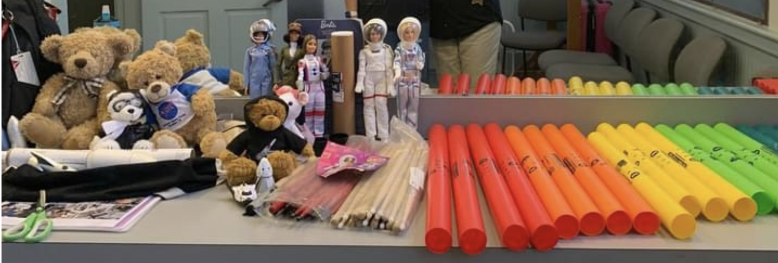
Boom Whackers are a wonderful resource for a music educator, or for any educator who wants to bring accessible musical instruments and activities into their classroom. There are many reasons to use Boom Whackers including the fact that they are very inexpensive, portable and sturdy. Here are a few of my tips and tricks with using this fun set of musical instruments:
Always introduce them to the class with your RULES first. Please do not assume students will exhibit restraint when given a Boom Whacker! Before handing them out to the class, go over how to hold them (hand located at the end of the tube, not in the middle of the tube, and the student can tap their hand, or thigh to make the Boom Whacker sound. They can also tap the back of a chair, the floor, if they are seated on the floor, or a table top.) Demonstrate the proper way to “tap” the boom whacker, and not “hit” it hard on any body part or surface.
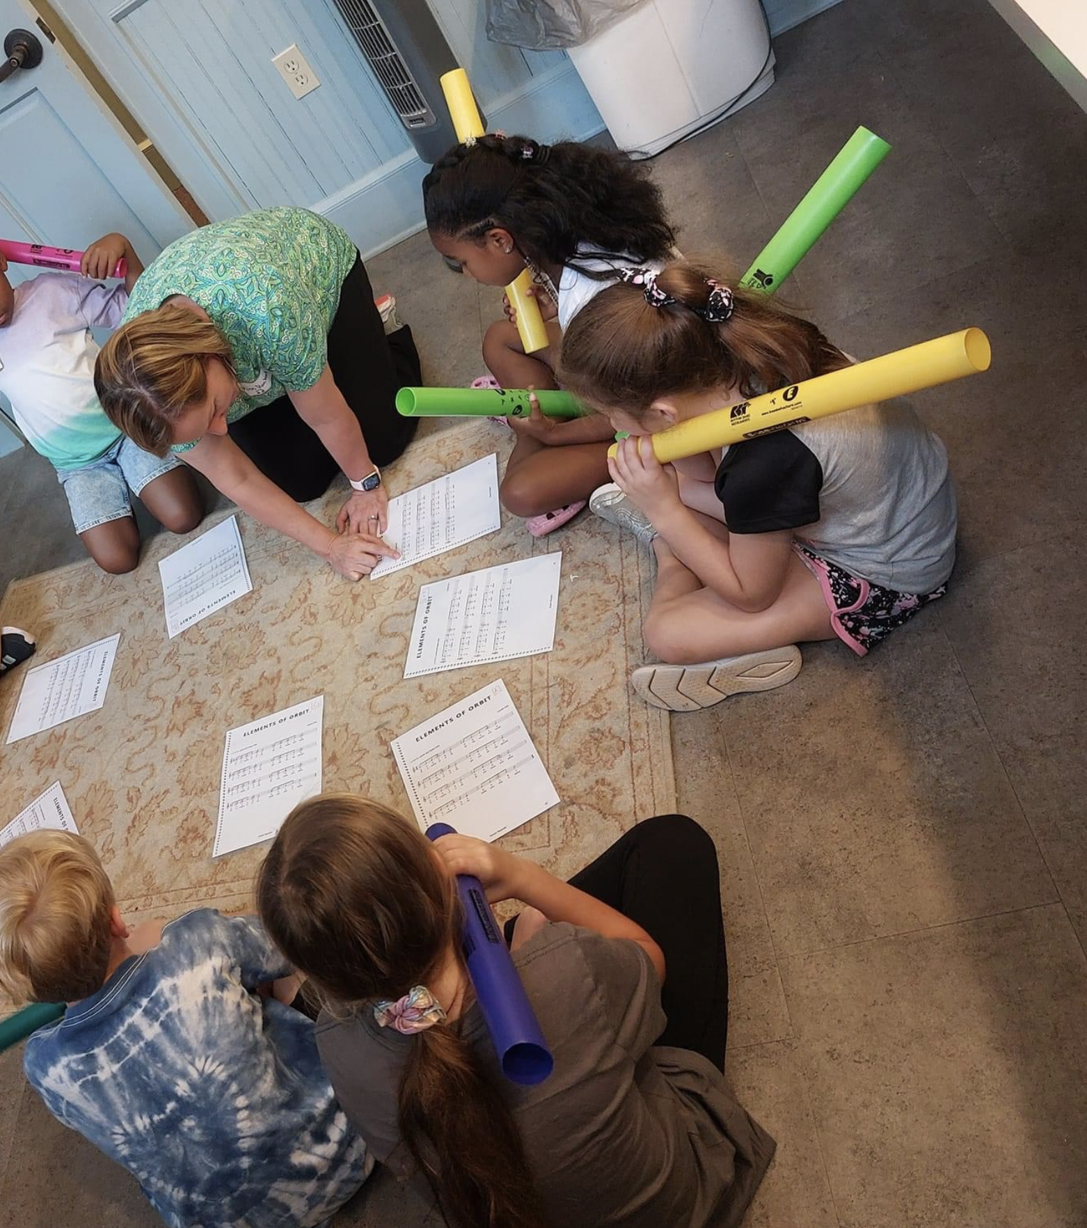

Even with these rules and instructions, I’ve seen young boys completely forget what they’ve just heard and have HIT the boom whackers extremely hard on a desktop. I’ve seen middle school boys HIT the boom whackers together very hard, and not only does that cause a startle reflex in me, and others, it can damage the plastic tubing, or cause injury, usually to a bystander. Repeat the RULES often and as necessary. Safety Huddles can go a long way to enjoying these great instruments. Have students lead the Safety Huddles as well, so they gain ownership of the proper way to use these instruments.
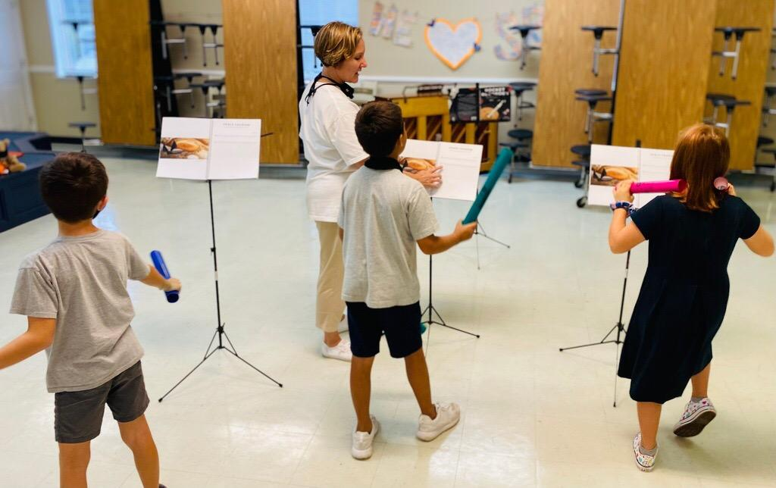

Here are my typical RULES: “Today we are going to use Boom Whackers in class. These are NOT baseball bats, they are not weapons. Using them incorrectly will cause you to lose the privilege of playing them. They are musical instruments that are sturdy but can be damaged if you abuse them. Hold one at the bottom of the tube with one hand and TAP the Boom Whacker on your opposite, open, facing up, palm to make them sound. If you tap your hand too hard, it will hurt. Don’t do that. If you need to hear the notes louder, you can tap on a hard surface, like the floor, if you are sitting on the floor, desk or table top.
Do not tap the music stands with the Boom Whackers.
Do not TOUCH your neighbors with the boom Whackers.
Do not take huge back swings to play your note. This will cause you to play your note late and could injure your neighbor. Small motions are best. You may be able to play your note by tapping two of the SAME colored Boom Whackers together. Again, do NOT tap them together too vigorously as this can damage the tubes.
Do not put these tubes up to your ears, your eyes, your nose, mouth or chin. They are not trumpets for you to yell through and damage other students’ ear drums.”
“Shoulder Holders” is what I say to get the students to stop playing and silence their instruments, by placing them on their shoulders.” I learned this term from an expert music educator and clinician, Artie Almeida.
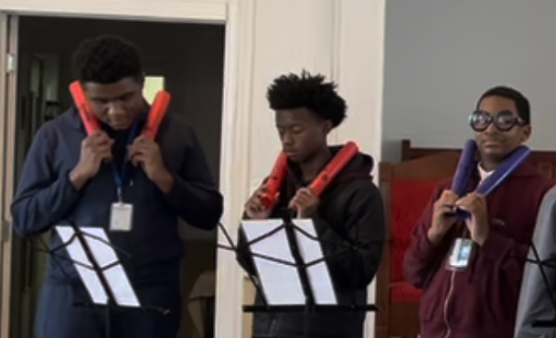
Boom Whackers can be bent or squashed if a student sits on them, or hits them really hard on a hard surface.
There are lots of YouTube videos to watch for Boom Whackers information and performances. Some of them will show you a less guarded, potentially injurious to others way to play and many will show you the correct way to play them. Now you have some background information and you can decide how to proceed with your students. YouTube videos featuring high school and college students are also fun to watch with your students, as they are very intricate, interesting and show just how musical a Boom Whackers ensemble can be. I always strive for a controlled environment for students and you do have to be careful with these instruments. Boom Whackers are fun, they make learning fun, but you don’t want a student to get hurt on your watch because you assumed they’d know what to do with them.
Other features: There are Octave End Caps that can be purchased to make the Boom Whackers sound an octave lower than they do without the End Caps. Watch YouTue for more info about this. There are Diatonic Boom Whackers sets for a C Major Scale. Think of the white notes on a piano keyboard. There are also Chromatic Boom Whacker sets for the accidentals that you may encounter when playing repertoire in other keys besides the key of C major. Think of the black notes on a piano keyboard.
Music: I have used easy/beginner recorder music for Boom Whackers and it works well. For my Polar STEAM music resource, I have included the note names on all of the songs, along with the words. These note names may be enough for students to go by. I have also included a picture of how I prep a set of sheet music copies to use in my classroom.
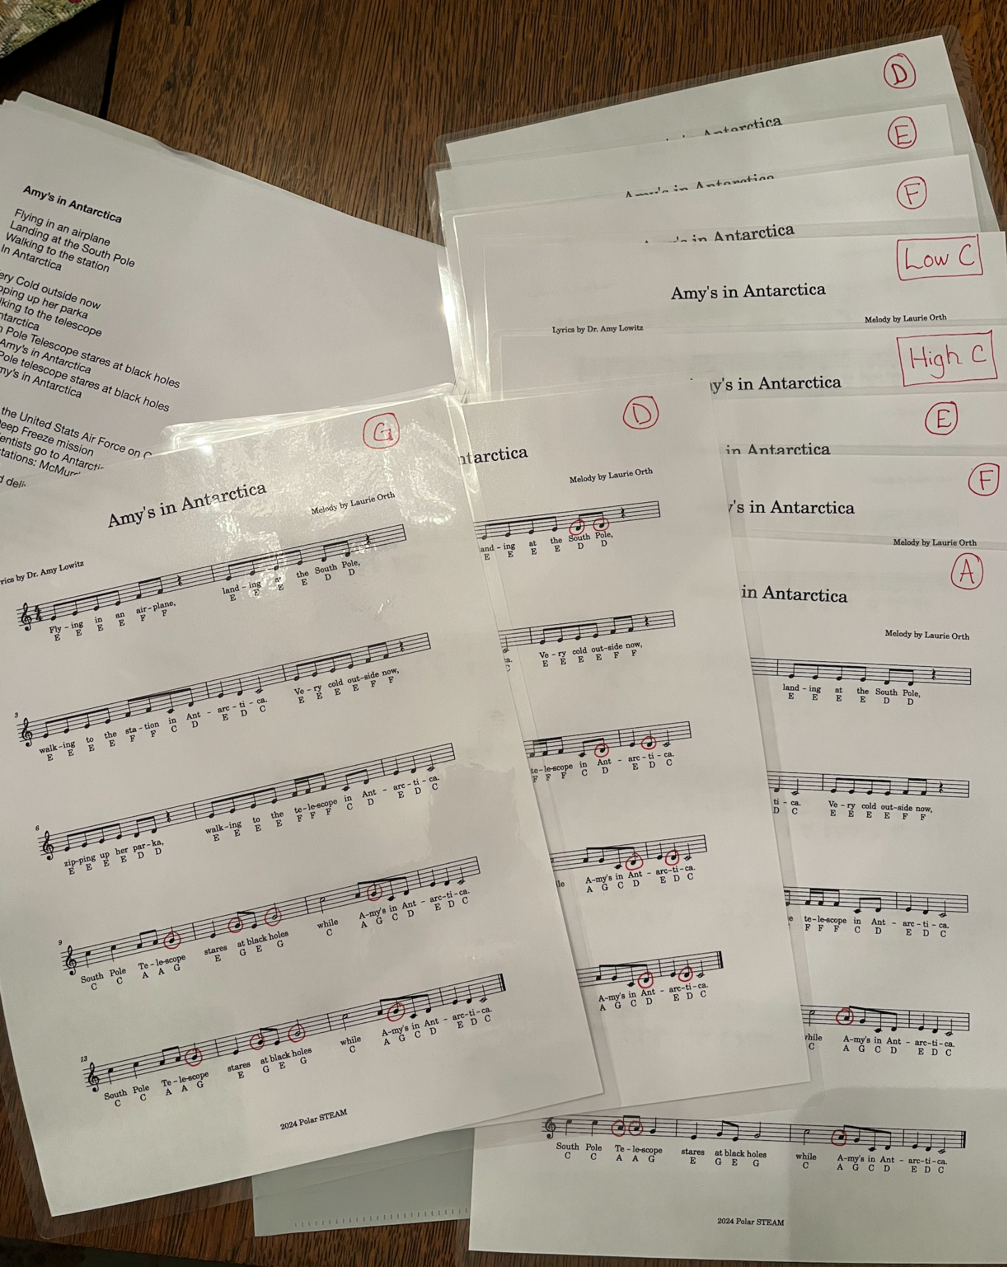
I make copies of the music based on the number of students in a class, and this number may be cut in half if you have 2 students to a music stand. I go the extra step and circle the notes for each Boom Whacker. There is a Low C, or “Middle C” used in the piece. I circle all the Low C’s on the page for “Amy’s in Antarctica.” I label that sheet “Low C.” Then I take a second copy and circle all the “D’s”, and ditto for “E,” ‘F,” “G,” “A,” and “High C.” This way, a student can see where exactly they are to play the note.
I teach the song first, so that students have the tune and the words in their heads. After that, I incorporate the Boom Whackers, and they have the tune, the words, the note name and the red circled note as clues/cues where they are to play their note. The Polar STEAM music resource on YouTube has these songs available as a demonstration with vocals and as accompaniment only, with no vocals, for you to use as you wish. Polar STEAM Music Files
Buying Boom Whacker™ sets: you can purchase these from music retail or online outlets or on Amazon. I use West Music https://www.westmusic.com/ as they have all the sets, end caps, and music books that will accommodate your Boom Whacker needs. How many sets should you get? The Diatonic sets have 8 tubes in them, and would work for 8 students. If you get 2 full sets, you can still use them for 8 students, giving each student 2 of the same Boom Whackers to play together, in an “X” formation, instead of tapping their hand, or the desktop. Scale up pending the number of students you have. As you get more comfortable with these instruments, you can ask students to help you pass them out or collect them after class time. I’ve seen music class rooms with huge Boom Whackers sets, with 8-10 of EACH note, and I have my own small set that travels with me in a giant tote bag.
Please set your students and yourself up for success by starting with the RULES for how to play the Boom Whackers before you hand them out in class.

