Modeling the Melt in the Arctic Tundra- Student Worksheet

Part 1: Understanding the Problem
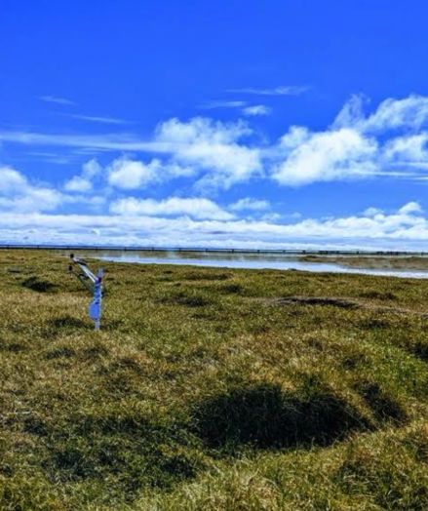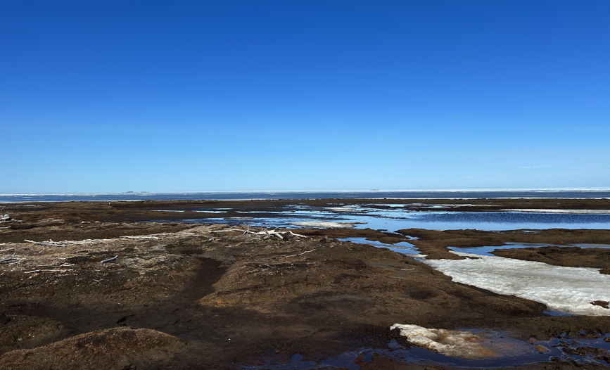
Photo Credit: Dr. Julia Guimond and Taylor Ohlstrom

Where do you think these pictures are taken? Why do you think that? Did anyone in your group think something different?

Watch the video with your teacher and answer the following questions:

  - How is groundwater created and where is it stored?

  - What happens when too much fresh water is pumped out by wells?

  - What happens to the drinking water when there is too much saltwater?

Write 3 or more sentences about how you think saltwater intrusion effects the following places:
- Southeast United States (Georgia, Florida, South Carolina, Louisiana, etc.)
- Central America (Panama, Costa Rica, Honduras, Guatemala, etc.)
- The Arctic (Alaska, Greenland, Canada)

Explain in your own words what saltwater intrusion is.

Explain in your own words why saltwater intrusion is a problem.

Explain in your own words why saltwater intrusion matters to us in our community.
Part 2: The Math

Go to the data here

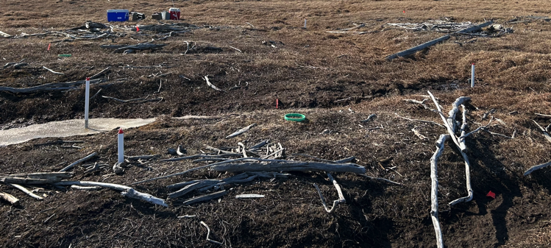
The data comes from different “wells” (the white things in the pictures) that also calculate data from the field. Each site is a different well and shows different parts of the tundra.

Your job is to find any trends in the data just like scientists do! You will create scatterplots and linear regressions for the variables below:
- Salinity vs. Elevation
- Salinity vs. Thaw Depth
- Thaw Depth vs. Elevation

In the field, the correlation coefficient is considered pretty good if it is above 0.5. Keep that in mind when answering the following question!

Find the following information for each relation

Write your line of best fit: y = _________ x + __________

Interpret the slope and y intercept by filling in the blanks

Slope Interpretation (Replace anything that is in red!): For every 1 (x-variable unit), the (y-variable name) INCREASES/DECREASES by (slope) (y-variable units)

Y Intercept Interpretation (Replace anything that is in red!): At 0 (x-variable units), the (y-variable name) will be (y-intercept) (y-variable units)

Is the y intercept realistic? Remember, you can’t have negative salt values!

If the elevation was 1.5 meters, what would the predicted salinity and thaw depth be?

If the elevation was 0.5 meters, what would the predicted salinity and thaw depth be?

What can you say about how elevation, thaw depth, and salinity are related?

Draw a picture of what the tundra could look like based on your data. Make sure to include the following:
- A representation of the thaw depth
- A representation of the salinity
- The differences in elevation
- A creative way to show the trends and relationships in your data
- A way to identify this is in the Arctic
These will be hung in the hallway to show others this relationship. Other students will have the chance to vote on which picture shows the relationships the best! Be creative!

Part 3: The Outreach
You are now a climate scientist analyzing risk factors for saltwater intrusion in different parts of the world. Your goal is to evaluate the 4 scenarios below and determine their risk for saltwater intrusion.

Scenario 1 — Crescent Bay, Maine (Populated Coastal Town)
Elevation: 1–2 meters above sea level
Thaw Depth: 0.8 meters
Notes: Town near shoreline, freshwater marsh, rising storm surges, shallow aquifer.
Task: Determine risk level and ecological implications.

Scenario 2 — Arctic Peninsula (Unpopulated)
Elevation: 0–3 meters
Thaw Depth: ~0.6 meters
Notes: Permafrost-based wetlands, migratory bird habitat, coastal erosion.
Task: Determine risk and impacts on permafrost and wildlife.

Scenario 3 — Salinas Flats, California (Agricultural)
Elevation: 3–5 meters
Thaw/Soil Depth: No permafrost; wells at 1–2 meters
Notes: Heavy irrigation, sandy soils, reliance on shallow groundwater.
Task: Evaluate risk and effects on agriculture and soil chemistry.

Scenario 4 — Cape Windfall, Oregon (Unpopulated Cliffs)
Elevation: 10–15 meters
Thaw Depth: 0.3 meters
Notes: High cliffs, deep groundwater, stable shrub communities.
Task: Determine risk and ecosystem stability.

As a climate scientist, which regions are most at-risk and why? Make sure to use your mathematical models from before!

Choose one region to study, research that area and give 3 research based recommendations for what could be done to curb saltwater intrusion.

Now that you have studied saltwater intrusion, create a one page public service announcement explaining the following:
- What saltwater intrusion is
- How elevation and thaw depth affect saltwater intrusion
- What regions are at risk and why
- How it affects all parts of the world, not just coastal areas
- What could be done to curb saltwater intrusion

