PART 1. WHAT IS HAPPENING TO THE ICE IN THE ARCTIC?

- A caption is a short explanation that helps the reader understand a figure, graph, or image without needing to ask you questions about it. It should tell: a) What the graph shows and b) What the main trend or takeaway is. Think of it as the “story of the graph in one or two sentences.”

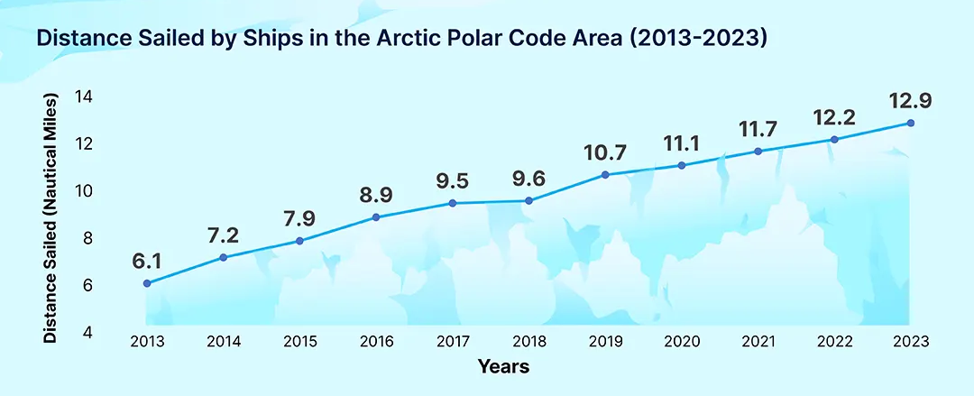
Source:https://straitsresearch.com/statistic/melting-arctic-ice-drives-cruise-and-shipping-growth

Have a look at the graph. What would you write in its caption?
Do you need some help to get started? Have a look at these sentence starters: Between __ and __, ships traveling in the _ region __ their total distance sailed from about _ million to _ million nautical miles. This trend suggests that as __, __. This data relates to other trends where scientists have observed (you can mention graph 1 here) that __.
- Look at this graph. Create a See-Think-Wonder table to explain your thoughts.
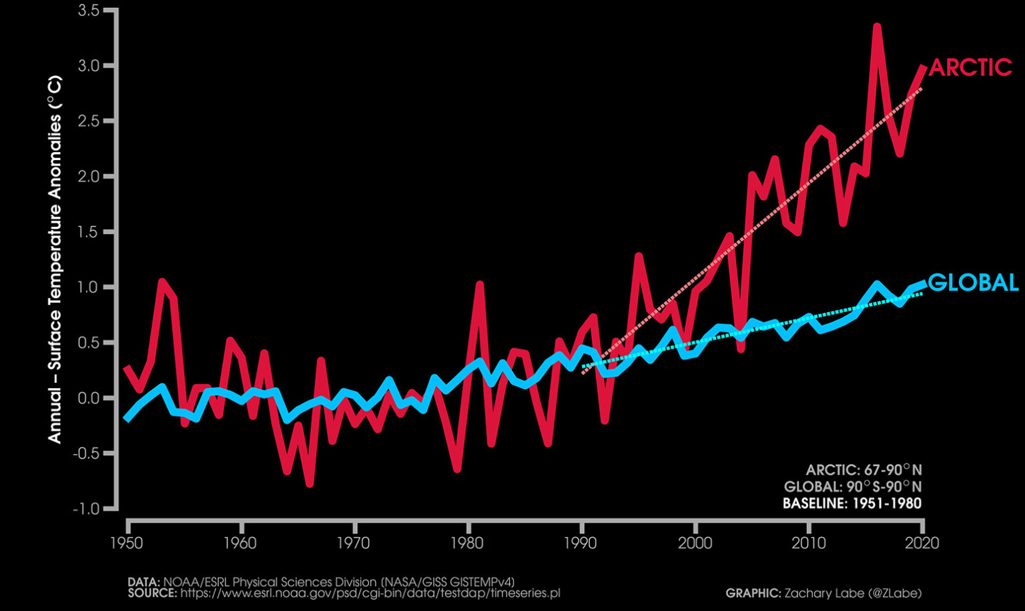
Do you need some help to get started? Here are some ideas:
- Compare the temperature anomalies in the world to the Arctic.
- Compare the range of temperature anomalies globally vs the Arctic.
- Describe using specific numbers from the graph whether that temperature difference is positive or negative (in other words, is the temperature getting warmer or colder on average)?
- What does it make you think about? Remind you of? Do you have an idea of why it happens?
I SEE… | I THINK… | I WONDER…
- The title of the graph in question 2 is “Arctic Amplification”. Why do you think scientists gave it this name?

LAB: What Happens When the Arctic Changes Color?
In the Arctic, the ground is covered by white snow and ice for much of the year. But as the climate warms, more dark soil and open water become exposed when the snow and ice melt. These changes affect how much sunlight is absorbed or reflected, which can influence how warm the region becomes.

In this lab, you will model what happens when the Arctic is white (snow-covered), dark (land/vegetation), or blue (open water). You’ll test how quickly each type of surface warms under the same light.

Question: How does the surface type (snow, soil, or water) affect how much it warms up under sunlight?

Independent variable: type of surface
- Sugar → models snow/ice (white Arctic surface)
- Soil → models land or vegetation (dark Arctic tundra)
- Colored water → models open ocean or meltwater

Dependent variable: temperature (°C)

Complete the hypothesis: If ice, ocean and soil are heated at the same temperature, then the __________ will warm up the fastest because ___________________________.

Procedure
- Label the dishes Snow (Sugar), Land (Soil), and Water (Colored Water).
- Add 4 cm of each material to each dish.
- Record the starting temperature of each surface.
- Place all three dishes under the lamp at the same distance.
- Turn on the lamp and start timing.
- Record the temperature of each surface every 5 minutes for 30 minutes.
- Turn off the lamp and record the final temperature.
5. Collect the data and graph your results:

 | Temperature on each surface after turning light on (°C)
 | 0 min | 5 min | 10 min | 15 min | 20 min | 25 min | 30 min
Soil
Ice and snow
Ocean



6. Which surface warmed up the fastest? Which stayed coolest? Why do you think that is? Use data points from the graph to support your answers.
7. Given the results you saw in your experiment, if the real Arctic changes from mostly white (snow and ice) to darker land and water, how might that affect the region’s T⍛?
8. Describe, using your observations from the lab, how replacing white snow with darker land or water could create an amplification cycle that would lead to even more warming in the Arctic.

9. A positive feedback loop amplifies changes over time (as opposed to a negative feedback loop, where it counteracts change, leading to equilibrium). How is the melting of the Arctic an example of a positive feedback loop?

PART 2. HOW ARE ECOSYSTEMS CHANGING IN THE ARCTIC?

10. Watch this video about phenology. Use what you learn from the video to explain:
- What is phenology?
- What is bud burst?
- What have scientists observed in recent years?
- What happens with bud burst when temperatures increase by 1 °C?
- Choose a specific example from the video. Describe your example, mentioning how different parts of a food web are affected by changes in when plants bloom.
a.

b.

c.

d.

e.

11. NEON (U.S National Science Foundation's National Ecological Observatory Network) is a continental-scale observation facility designed to collect long-term ecological data. In this phenocam video, NEON scientists monitored the change in seasons from their observatory in Harvard, Massachusetts.

- If you were a scientist using this camera, what kind of data might you collect from these images? Why?
- What patterns or clues could scientists look for in phenology videos from around the country to understand how the environment is changing over time?

12. Let’s go back to the Arctic and Alaska. There, scientists have observed a phenomenon known as “the greening of the Arctic”. This is an example from Qikiqtaruk along the Canadian Yukon Arctic coast. Source: teamshrub.com
1989 | 2019
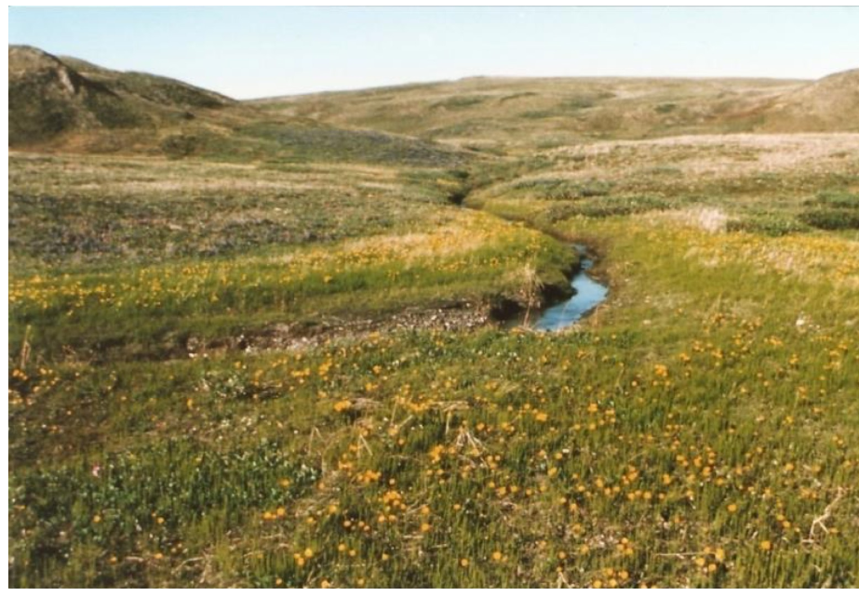 | 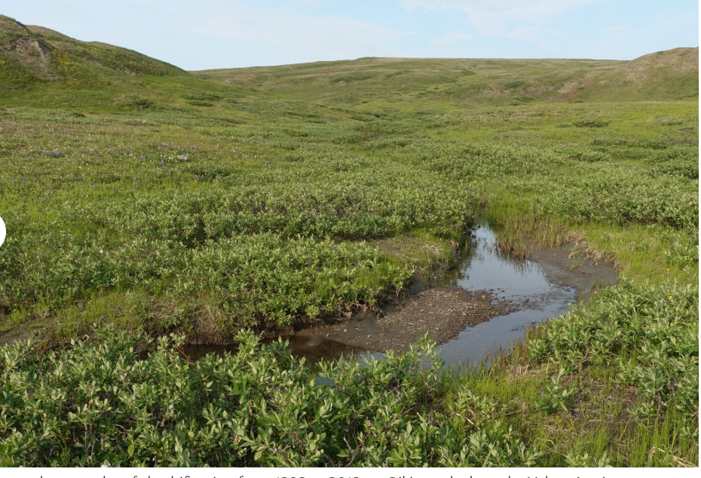

- What type of organisms and what chemical processes make an ecosystem green?

- Based on your answer to part a, what would it mean that a specific place is greener than it used to be? What is there more or less of?
- Why could it be a good thing that the Arctic is greener than before? (Hint: Think about what gas plants remove from the atmosphere).

- Why do you think scientists are worried about the Arctic turning greener then? (Hint: why are plants able to survive longer?).
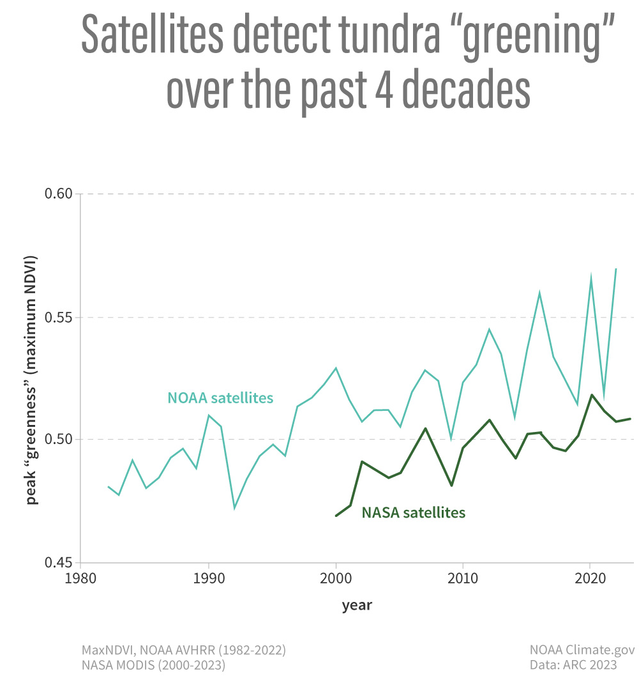
13. This graph shows how scientists have been measuring the amount of “green” in the Arctic tundra using two different methods, NOAA and NASA satellite data.
- Summarize the trends observed.

- Do both methods show the same trend? (Use specific data point examples to answer the question.)
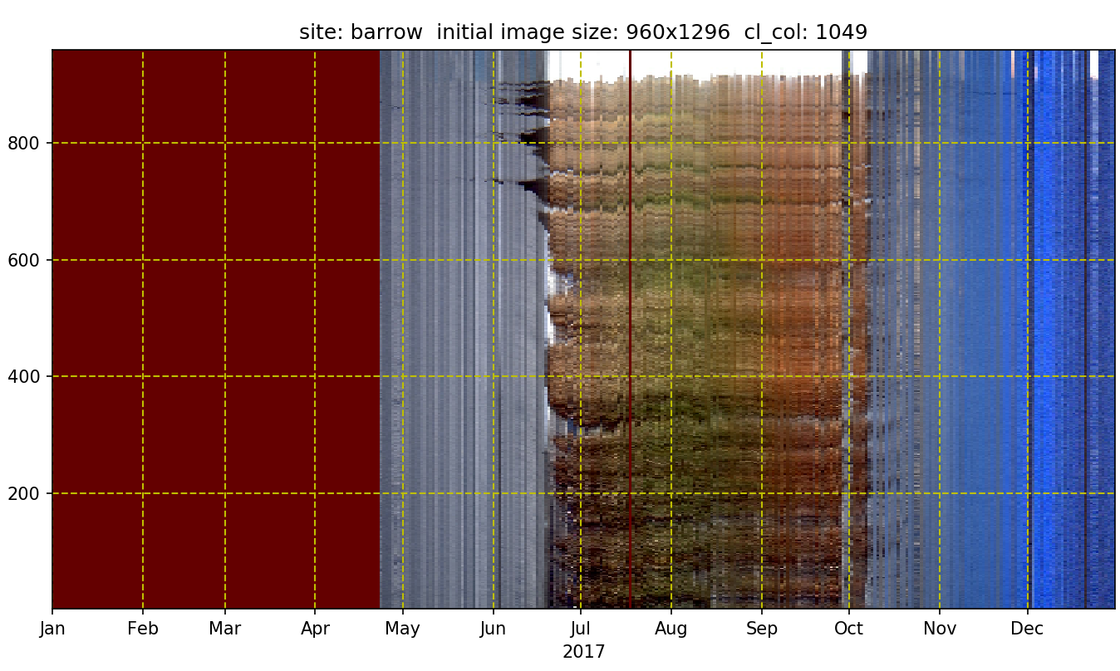
14. In this graph, NEON scientists took phenology images from the same location every day for a full year (Utqiaġvik, Alaska, 2017). Each thin vertical sliver represents one day, showing the color of the landscape. When all the slivers are combined, they form the timeline shown of how the ecosystem changed through the seasons.

- Look at the phenology image from Utqiaġvik. How can you tell when winter starts or ends?

- What does each of the colors seen in the model correspond to (maroon, gray, brown, green, and blue)?

- Looking at the phenology model, what is the plant growing season in Utqiaġvik?

- How might this compare to what you’d expect in Massachusetts?
- Given what you know about the greening of the Arctic, describe in detail how this graph will change in the next 100 years.
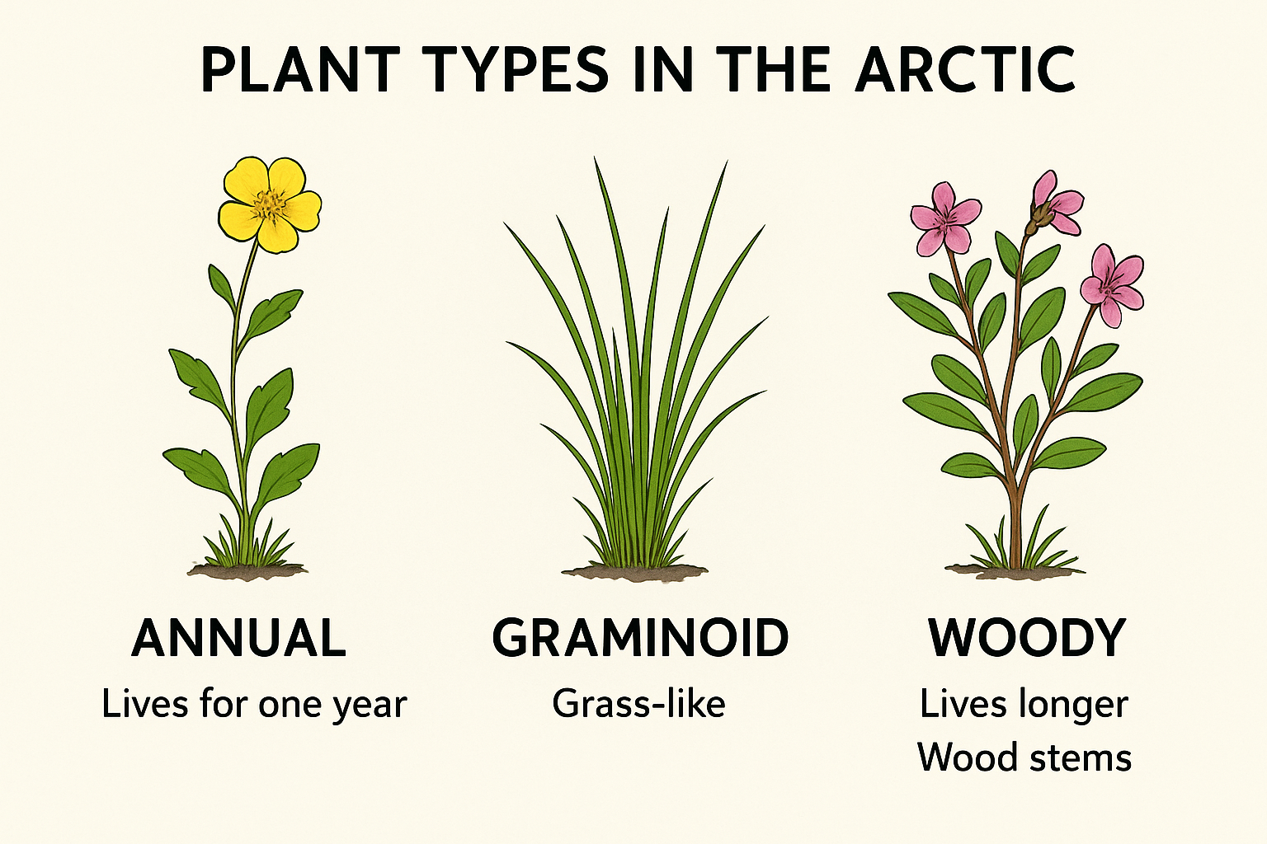
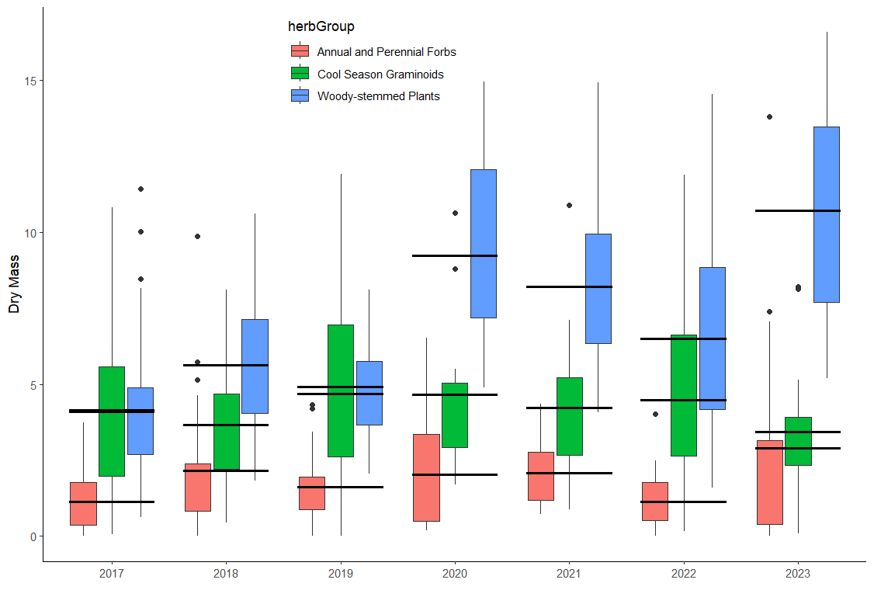
15. Scientists at NEON are studying how these changes affect the amount of different types of plants. Looking at the graph below:
Is the greening of the Arctic affecting all plants equally? Explain your answer.
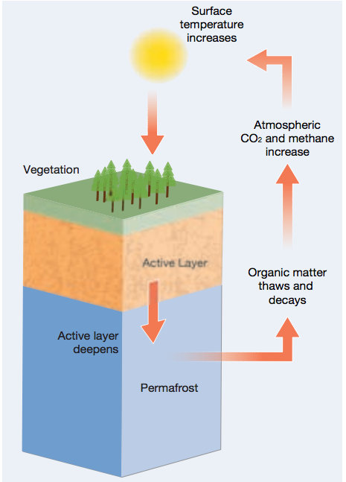
PART 3. PLANTS AND PERMAFROST

16. Permafrost is ground (soil, rock, or sediment) that stays at or below 0 °C (freezing) for at least two consecutive years. It contains vast stores of frozen organic material (plants, microbes, etc.).When permafrost thaws, organic material decomposes and releases greenhouse gases like CO₂ and methane, which in turn can warm the soil and atmosphere further. As more woody plants (like shrubs) are growing in tundra areas, more snow is trapped by their branches, keeping the soil warmer and allowing for more permafrost thawing.
Diagram source: https://www.carbonbrief.org/what-is-permafrost-q-a/

- How will an increase in the amount of shrubs or woody plants in the Arctic tundra affect the amount of permafrost?

- Given that warmer soil temperatures can promote more shrub or woody plant growth, which in turn reduces permafrost, explain how this is an example of a positive feedback loop.

17. Based on what you observed in the lab about how dark surfaces warm faster than white surfaces, how do you think the presence of woody shrubs (which trap snow and darken the soil) will affect soil temperature and permafrost in the Arctic?
PART 4. REFLECTION.
18. Which part of the Arctic system (ice, plants, permafrost) surprised you the most? Explain why, and describe one question you still have about how the Arctic is changing.

19. How do the changes in ice, vegetation, and permafrost connect to each other?

20. How did the lab help you understand feedback loops in the Arctic?

21. If you were a scientist, what question would you investigate next?

PART 5. SUMMATIVE ASSESSMENT. CREATE A VISUAL MODEL
Using what you learned in Parts 1–3, create a visual model that shows how the Arctic is changing:

Guiding Questions to help you design your model
- How does the loss of snow and ice affect the temperature of the ground and water?
- How does warmer soil allow shrubs to grow, and how does this in turn affect permafrost?
- How does the change in surface color relate to warming and feedback loops?
- How does the greening of the Arctic connect to the timing of plant growth (phenology) and food webs?
- Can you show a cycle that repeats or amplifies itself (positive feedback)?
- Optional: How might these changes affect humans or animals in the Arctic?
- Optional Challenge: Include predictions for the Arctic in 50–100 years based on the feedback loops and changes you’ve illustrated.
- Add any human or ecological impacts you think are important.

1. Include these key elements:
- Snow and ice
- Dark land/vegetation
- Ocean liquid water
- Temperature changes
- Shrubs/woody plants
- Permafrost thaw
- Greening of the Arctic
- Feedback loops

2. Use arrows to show cause-and-effect relationships.
3. Label any positive feedback loops you identify.
4. Add short captions or notes to explain what is happening.
5. Be creative: use boxes, colors, or symbols to illustrate your ideas.

Word Bank
Arctic amplification- Snow and ice- Dark land/vegetation- Ocean liquid water
Temperatures- Shrubs/woody plants- Permafrost thaw- greenhouse gases
Positive feedback loop- Greening of the Arctic- Bud burst / phenology- Growing season

OTHER POSSIBLE FORMATIVE ASSESSMENTS
- A woman in the market talked to us about how she likes to collect cloudberries (a woody shrub) in the north of Alaska. She has tried to grow them in Barrow, but it never works because by the time the plants start making fruit, they freeze. Given what you have learned, do you think she will be able to grow them in the distant future? Explain your reasoning.

- In North Powder, Oregon, the Huckleberry festival has been happening during the second half of September since 1962. Lately, though, organizers are considering moving the dates, as during the festival, there are no more fresh berries. Use your knowledge on Arctic amplification and the greening of the Arctic to answer these questions:

- Why is that happening?
- Should they move the festival to an earlier or later day? Explain your prediction.

Acknowledgment
This resource was created thanks to the incredible opportunity provided by Polar STEAM, which supported Elsa Herraez Hernandez’s travel to the research station in Utqiaġvik, Alaska. During the summer of 2025, Elsa worked alongside the NEON Science research group led by field ecologist Will Hendricks and his team. Their expertise, collaboration, and generosity made this educational work possible.

