STUDYING POLAR MAMMALS IN THE WILD

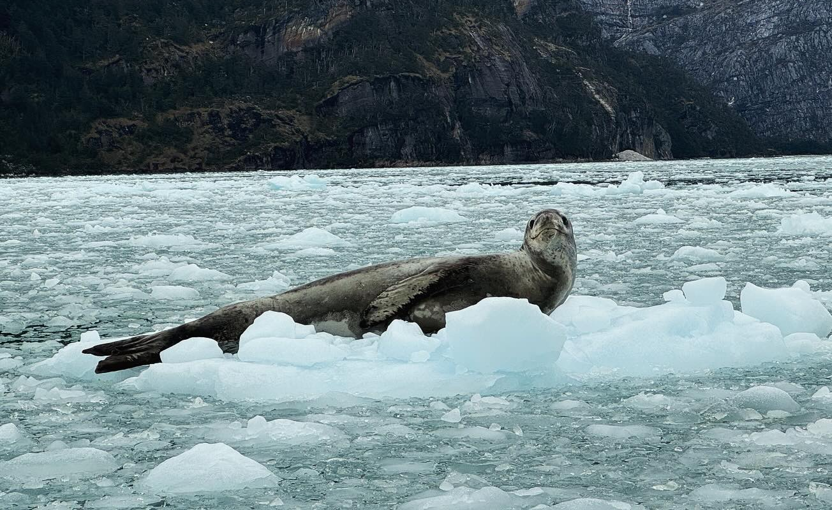
Polar mammals, like beluga whales, polar bears, and leopard seals, live in extremely cold environments (Fig. 1). Polar refers to the regions near the North Pole (Arctic) or South Pole (Antarctic; Fig. 2). An interesting fact about the names of these regions is that Arctic comes from ancient Greek for “bear” and is the only polar region with polar bears. Antarctic means “opposite the bear” and has NO polar bears (but A LOT of penguins).

Figure 1. A leopard seal lying on its side on ice.
Photo credit: Sarah Kienle
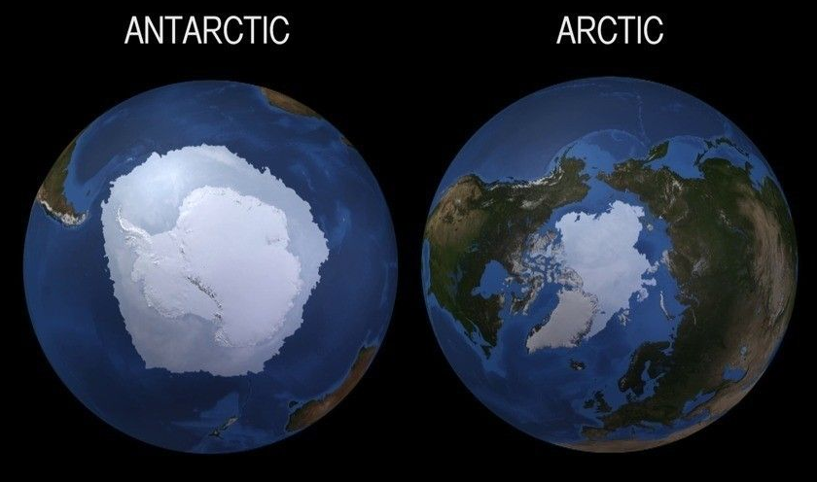
Polar regions are extremely cold. In fact, the coldest temperatures on Earth have been recorded in Antarctica. Polar regions are also difficult to travel to because they involve long plane and boat rides, and cannot be accessed during some parts of the year. Therefore, polar mammals living in these regions are extremely difficult to study in the wild.

Figure 2. Illustration of ice sheets in the Antarctic and Arctic
Image source: NASA

Even when scientists are able to travel to the Arctic or Antarctic, the animals living in these areas are often very large, hard to find, and can be dangerous to work with. Due to all of these factors, scientists have to find creative ways to collect data on polar mammals accurately and safely.

Below, we will explore the different ways that scientists study the body size of polar mammals. In Case Study #1, you will learn how scientists measure the length and mass of seals. You will then practice measuring seal body lengths, calculate seal body mass, and graph your results. In Case Study #2, you will examine, graph, and compare real data collected from wild polar mammals and make inferences about their body size changes through time. This is exactly what marine mammal researchers do when studying these polar species.Data from long-term studies of body size like this are what scientists use to make conservation decisions for wild polar animals.

Case Study #1: Estimating Body Size in Gray Seals

Let’s start with learning a little bit about gray seals. Gray seals live in the polar region of the North Atlantic Ocean. Like other seals, gray seals spend part of their year at sea feeding. For the other part of their year, they are on land breeding, resting, or molting. Adult gray seals have coats that can be a range of shades of gray and brown and are covered in black spots. Their pups look very different because they are born with white coats (Fig. 3). Adult gray seals have long noses that make them easy to tell apart from other seals that live in the same areas.

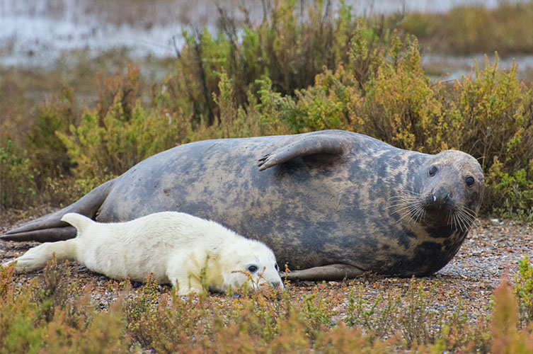
It is very difficult to weigh wild seals, especially big ones like gray seals. For example, an adult male gray seal can weigh more than 900 pounds (or >400 kilograms). That’s the same mass (or weight) as a grand piano or refrigerator!

It is actually much easier to measure a wild seal’s body length (or, the distance from the tip of the nose to the tip of their tail) than their body mass. Question: Why do you think it is easier to measure a seal’s body length than their body mass?

Figure 3. Gray seal mom and pup resting on a beach
Image credit: Shuttershock.com

How do you think biologists measure a seal’s length?

Below we describe three common methods for measuring body length: direct measurements, scaled photographs, and drone measurements.

- Direct Measurements: One of the most accurate ways to measure a seal’s body length is to take a direct measurement using a handheld measuring tape. This method works best if an animal is asleep, sedated, and lying on its belly. Scientists measure the length of a seal with a measuring tape to find the distance from the tip of the nose to the tip of the tail (Fig. 4).
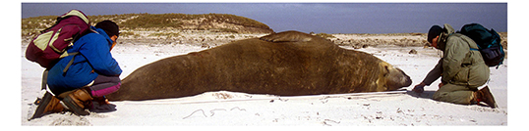
Figure 4. Two researchers are measuring the standard length of a male southern elephant seal lying on its side. Photo source: http://www.eleseal.org/res/res_size.html

- Scaled Photographs: Another way to measure an animal’s length is by taking a scaled photograph and then estimating the length from the photograph (Fig. 5). To do this, you need to have a measuring tape or something of a known size next to a resting, relaxed, or sedated animal and take a high quality photo with the scale bar visible. Then, on your computer, you can calculate the length of the animal using the scale bar.

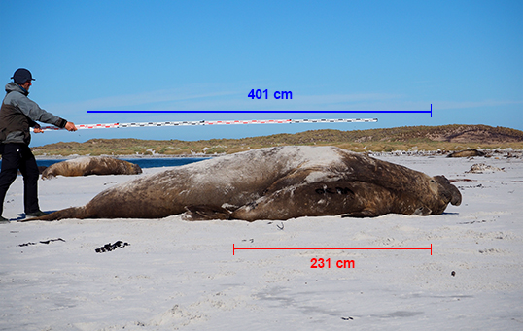
Figure 5. A researcher is holding a measuring tape above a resting male southern elephant seal. The photographer takes a photo of both the entire length of the animal and the scale bar to estimate the seal’s body length from the photograph. Photo source: http://www.eleseal.org/res/res_size.html

- Drone Measurements: Drones are a new technology that scientists are using to measure an animal’s body length. If you fly a drone directly over a seal and the seal is lying flat, the drones can calculate their distance from the seal and then estimate their length (Fig. 6). This method works best if the animal is still and lying in a straight line on its belly.
Question: Which of the drone images below is going to provide the most accurate measurement of the seal’s standard length - A, B, C, or D?

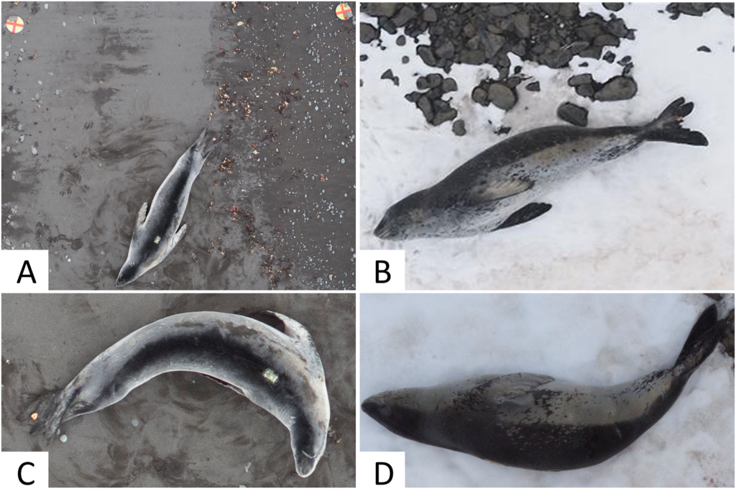
Figure 6. Four images of leopard seals taken from a drone: (A) A leopard seal in a straight position lying with its belly on the sand; (B) A leopard seal in a straight position lying on its side on the snow; (C) A leopard seal lying in a curved body position with its belly on the sand; (D) A leopard sea lying in a curved body position with its side in the snow. This figure was published in a scientific paper titled “An accurate and adaptable photogrammetric approach for estimating the mass and body condition of pinnipeds using an unmanned aerial system” by Krause et al. (2017) published in the scientific journal PLoS ONE.

How do you think scientists use an animal’s body length to estimate body mass?

To estimate a seal’s body mass from their body length, a couple of things need to happen. First, you need an equation or graph that has data on the species’ average body mass and body length. Scientists create these graphs and equations from data that has already been collected from specific species. Then, they look for patterns in the data and then develop an equation that can be used to predict an animal’s body mass using only their body length.

Let’s try this with some real scientific data from gray seals (Fig. 6)!
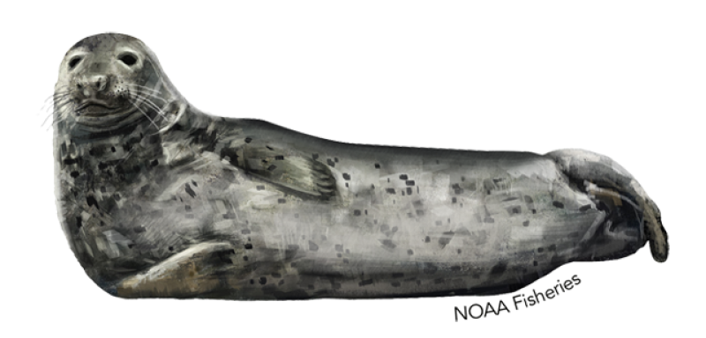
Figure 6. An image of a gray seal lying on its side.

First, it is important to know that gray seals are sexually dimorphic. This means that males and females are different sizes and shapes. Adult male gray seals typically range from 270-400 kilograms (600-880 pounds), while adult female gray seals typically range from 150-250 kilograms (330-550 pounds).

There have been several studies of wild gray seals where scientists have measured the mass and length of gray seals. Using this data, we can create a graph to estimate body mass for adult male and adult female gray seals.

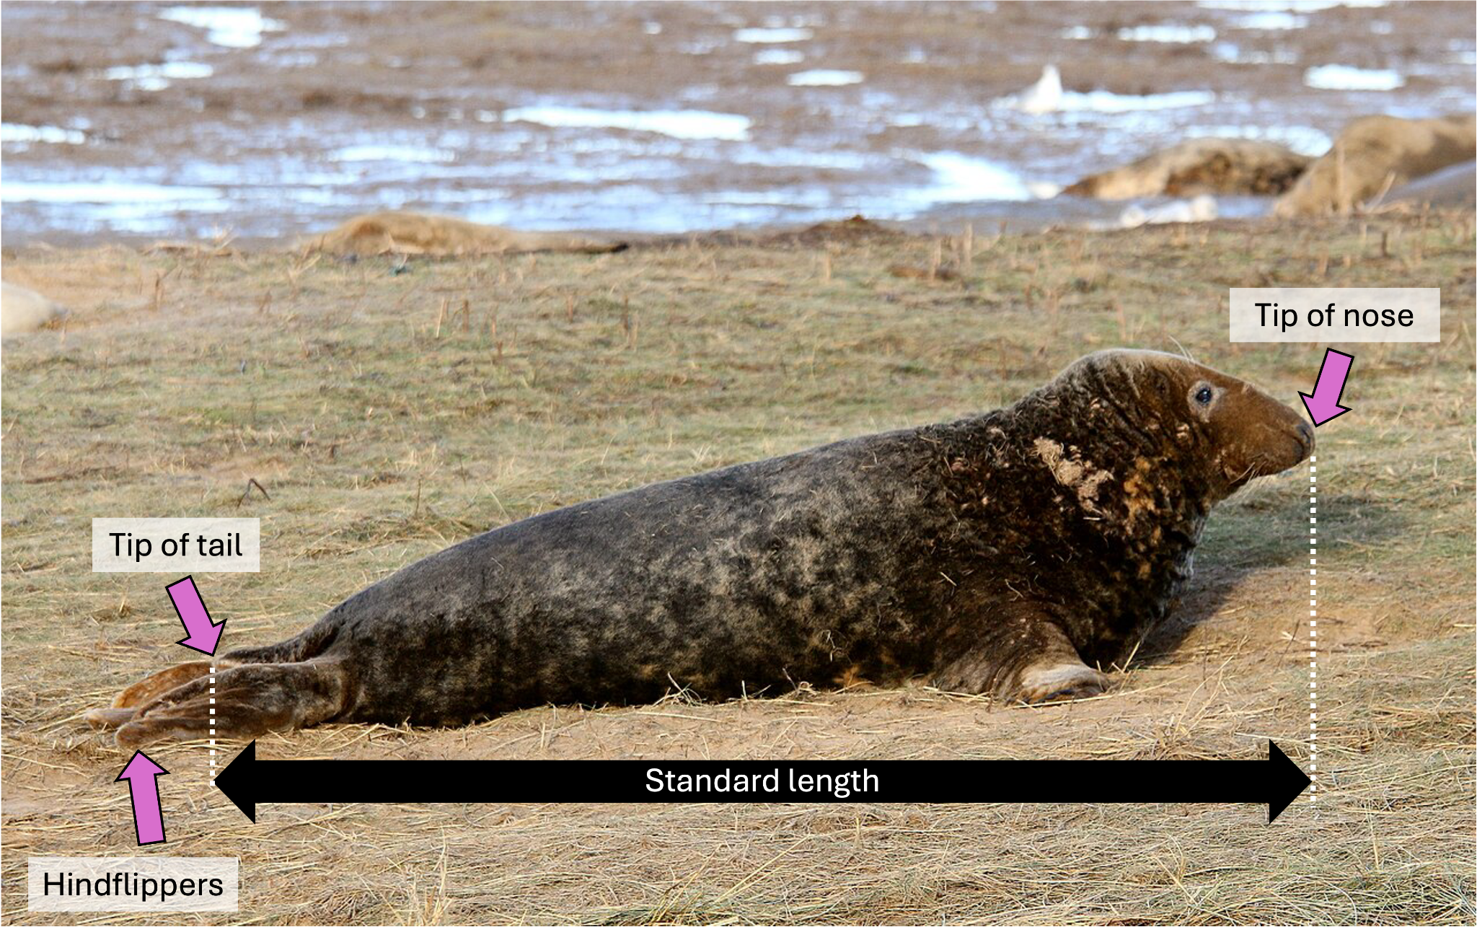
Figure 7. Adult gray seal lying on its belly on grass shown from the side. Labels show the location of the hindflippers (far left), tail, and tip of nose (far right). The measurement from the the tip of nose to tip of tail (shown in dashed white lines) is the standard length. The tail is the little triangle bit sticking up above the flippers. Photo source: https://www.flickr.com/photos/58415659@N00/38804871202/

Instructions
- Cut out the ruler provided on the last page
- Measure each seal’s body length in meters from the tip of their nose to the tip of their tail. (Hint: Their hindflippers are not the same as the tail. See Fig. 7 above.).
- Once you have measured the body lengths of Gray Seal #1 and #2, plot their body lengths onto the graph below.
- Use the line graph data for males (blue line) and females (pink line) to estimate the body mass of Gray Seal #1 and #2.
- Use your data to answer the Case Study 1 questions below.

Gray Seal #1

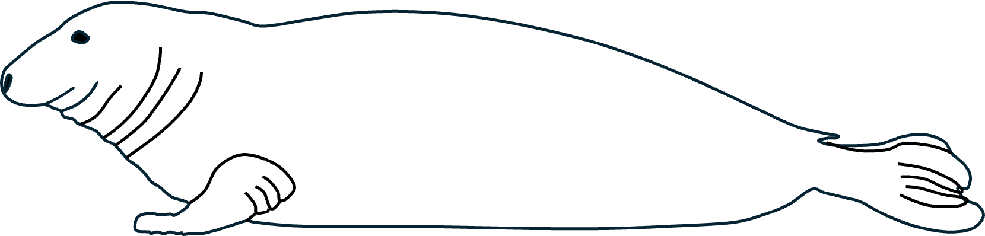

Question: What is the body length of Gray Seal #1 in meters (m)? _____________

Gray Seal #2

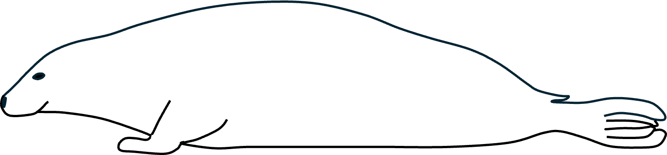

Question: What is the body length of Gray Seal #2 in meters (m)? _____________

Gray Seal Body Length vs. Body Mass
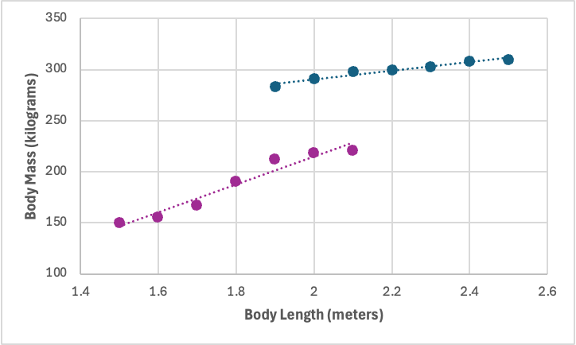

Case Study 1 Questions

- Use the graph above to calculate the body mass in kilograms (kg) of each gray seal using the body lengths you measured. What is the body mass for:

  - Gray Seal #1:

  - Gray Seal #2:

- Based on their standard length and body mass, determine the sex (male, female, or unknown) of Gray Seal #1 and #2.

  - Gray Seal #1:

  - Gray Seal #2:

- Why is there variation in the data points of gray seal males and females in the graph? (Hint: Why are all males not the same size, and why are all females not the same size?)

- Imagine you are in the field and just finished working with an adult gray seal. You look at your datasheet and realize you measured the seal’s mass (it weighed 200 kilograms) but completely forgot to measure its body length. Based on the graph above, what would you expect this seal’s body length to be? Do you think this individual was a male or female? Why?

- While you are in the field studying seals, you come across a gray seal that measures 2.25 meters in body length but only has a mass of 200 kilograms. What does this potentially tell you about the health of this animal?

Case Study #2: Polar Mammal Body Mass and Condition Over Time
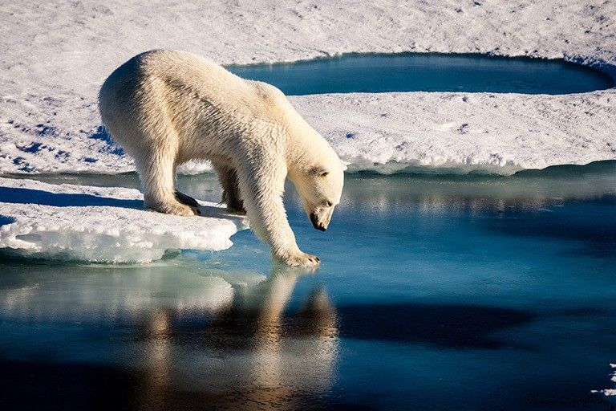
Imagine you are studying three species of marine mammals that live in the Canadian Arctic: polar bears, gray seals, and harbor seals (Fig. 8). You are part of a long term research study that has been collecting body mass data from these three species since 2000. The goal of this research project is to see if there are any changes in the body mass and body condition of these three species over time.

Figure 8. Polar bear on sea ice about to enter the water
Source: Mario Hoppmann

Body condition is a metric used to assess the overall health of an animal based on its body size, shape, body fat, and muscle. Animals may be the same body length but may differ in their body mass and body condition. For example, an extremely skinny polar bear will weigh less than an extremely fat polar bear, even if they are the same body length (Fig. 9).

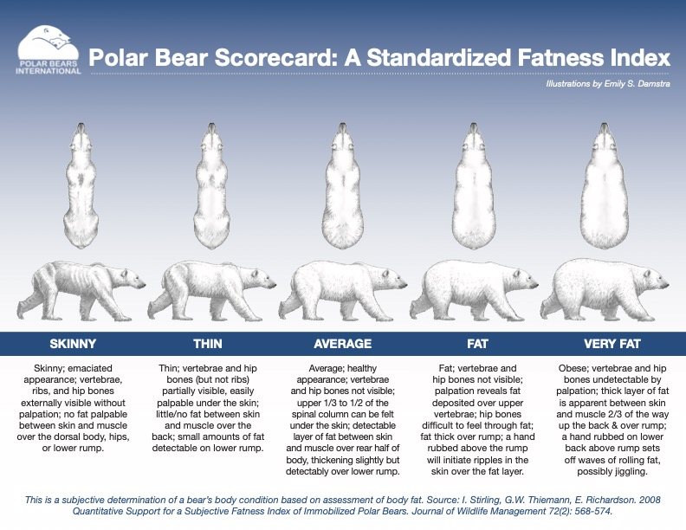
Figure 9. Graphic showing how polar bears of the same length can be in different body conditions. Body conditions for polar bears range from ‘skinny’ (far left) to ‘very fat’ (far right). Source: Polar Bears International & Stirling et al. (2008).

When species get larger or are in better body condition over time, you can predict that there is more food available in the environment and that animals are healthier. When species get smaller or are in poorer body condition, you can predict there is less food in the environment and that animals are not as healthy. Together, this type of long term dataset helps shed light on the overall health of Arctic mammals and the ecosystem they live in.

Based on your data from the last 25 years for female polar bears, female harbor seals, and female gray seals, you make the following table. You are interested in looking at how body mass has changed over time for each of these three species.

 | Polar Bears | Harbor Seal | Gray Seals
Year | Body Mass (kg) | Body Mass (kg) | Body Mass (kg)
2000 | 260 | 65 | 165
2005 | 255 | 70 | 170
2010 | 250 | 60 | 175
2015 | 245 | 65 | 175
2020 | 240 | 70 | 180
2025 | 235 | 65 | 185

Note: You also measured body length every five years, but there were no changes in body length for the three species throughout the study.

Instructions
- Make a line graph using the data for each species in the blank graph provided below. Year is on the x-axis, and body mass is on the y-axis. (Hint: Choose a different color to represent each species).
- Use your completed graph to answer the Case Study 2 questions below.
. 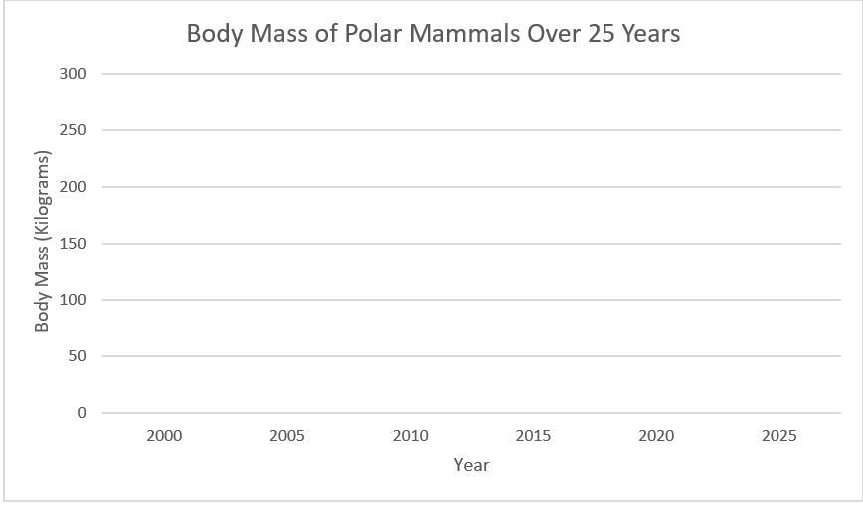

Case Study 2 Questions
- How does female polar bear body mass change through time? What does this data potentially tell us about the polar bear’s environment?

- How does female harbor seal body mass change through time? What does this data potentially tell us about the harbor seal’s environment?

- How does female gray seal body mass change through time? What does this data potentially tell us about the gray seal’s environment?

- Polar bears rely on sea ice to find food (like seals!). However, the amount of sea ice is declining each year in the Arctic. As a result, polar bears have less sea ice for hunting prey. Based on this information, what would you predict will happen to polar bear body condition in future years of your study?

- With the data available for these three species, which species would you be most concerned about? Why?

- What other data would you like to have from this study to help protect each of these species?

REFERENCES

Scientific Data Used in Case Study 1
- Krause, D. J., Hinke, J. T., Perryman, W. L., Goebel, M. E., & LeRoi, D. J. (2017). An accurate and adaptable photogrammetric approach for estimating the mass and body condition of pinnipeds using an unmanned aerial system. PloS one, 12(11), e0187465.
- Lidgard, D. C., Boness, D. J., Bowen, W. D., & McMillan, J. I. (2005). State-dependent male mating tactics in the grey seal: the importance of body size. Behavioral Ecology, 16(3), 541-549.
- Gray seal - https://baleinesendirect.org/en/grey-seal/
- Animal Diversity Web Gray Seal - https://animaldiversity.org/accounts/Halichoerus_grypus/

Scientific Data Used in Case Study 2
- Polar Bears International: https://polarbearsinternational.org/news-media/articles/how-do-scientists-weigh-wild-polar-bears
- Stirling, I., Thiemann, G. W., & Richardson, E. (2008). Quantitative support for a subjective fatness index for immobilized polar bears. The Journal of Wildlife Management, 72(2), 568-574.
- Laidre, K.L., Atkinson, S., Regehr, E.V., Stern, H.L., Born, E.W., Wiig, Ø., Lunn, N.J. and Dyck, M., 2020. Interrelated ecological impacts of climate change on an apex predator. Ecological Applications, 30(4), p.e02071.
- Atwood, T. C., Rode, K. D., Douglas, D. C., Simac, K., Pagano, A. M., & Bromaghin, J. F. (2021). Long-term variation in polar bear body condition and maternal investment relative to a changing environment. Global Ecology and Conservation, 32, e01925.

Online Resources
- Drones Are Helping Scientists Weigh Seals in Antarctica https://dronelife.com/2017/11/30/drones-scientists-weigh-seals-antarctica/
- Polar bears in Baffin Bay skinnier, having fewer cubs due to less sea ice, https://www.washington.edu/news/2020/02/12/polar-bears-in-baffin-bay-skinnier-having-fewer-cubs-due-to-less-sea-ice/
- All polar bears across the Arctic face shorter sea ice seasons, https://www.washington.edu/news/2016/09/14/all-polar-bears-across-the-arctic-face-shorter-sea-ice-season/
- Gray seal, https://www.fisheries.noaa.gov/species/gray-seal
- Harbor seal, https://www.fisheries.noaa.gov/species/harbor-seal
- Seal spy, https://www.whoi.edu/news-insights/content/seal-spy/

