🌎Thinking Like a Geoscientist

💡 Learning Objectives
After completing this module, you should be able to:
- Describe the scientific method and make geoscientific observations, documenting them accurately.
- Recognize and interpret common imagery used in the geosciences.
- Classify the five major spheres (reservoirs) of the Earth System.
- Analyze key cycles that link the Earth System’s spheres.
- Describe what clouds are and explain the mechanism of cloud formation.
- Describe and explain latent heat in the Earth System.
- Use Google Earth to explore and investigate the Earth System and the Cryosphere.

⛏️Lab Activities
- Activity A: Sketching Nature
- Activity B: Geoscience Spotlight
- Activity C: An Introduction to the Earth System
- Activity D: Imagery in the Geosciences
- Activity E: An Introduction to the Water Cycle
- Activity F: Cloud Formation
- Activity G: Using Google Earth to Explore Glaciers and Glacial Landforms

⛏️Activity A: Sketching Nature
- Take a moment to recall a time when you were outside in nature. Close your eyes and visualize that experience vividly.
- Below are four squares labeled: Sounds, Sights, Smells, and Emotions. Spend 2 minutes per square (8 minutes total) drawing or writing what you remember hearing, seeing, smelling, and feeling in that moment. Use any materials you have, pens, pencils, markers, etc., to express your reflections creatively.
Sounds  Drawings will depend on the student. As long as they draw something there isn’t a correct or incorrect response here. | Sights
Smells | Emotions

⛏️Activity B: Geoscientist Spotlight
- Turn to your neighbors and discuss the following questions:
  - What is science or what makes something science? Science is a systematic enterprise that builds and organizes knowledge about the natural and physical world through observation, experimentation, and logical reasoning. It involves forming hypotheses, testing them through controlled methods, analyzing data, and developing theories or laws that explain and predict phenomena.
  - What do scientists do? This answer will be more varied but can include any or all (and more) from below:
    - Observe and Collect Data - They study phenomena in nature or controlled environments, using tools and instruments to gather accurate measurements.
    - Formulate Questions and Hypotheses - Ask testable questions and propose hypotheses.
    - Conduct Experiments and Investigations - Design experiments or field studies to test hypotheses under controlled conditions, ensuring results are reliable.
    - Analyze and Interpret Results - Using statistical and computational methods, scientists interpret data to identify patterns, relationships, and anomalies.
    - Develop Theories and Models - Create frameworks that explain observations and predict future outcomes, refining these models as new evidence emerges.
    - Communicate Findings - Publish research in journals, present at conferences, and share knowledge with the public and policymakers.
    - Collaborate and Peer Review - Work with other experts and subject their work to peer review to ensure accuracy and credibility.
    - Apply Knowledge -Scientific discoveries often lead to technological innovations, medical advances, and solutions to environmental and societal challenges.

- During the classroom discussion, each group will share their ideas.
After the group discussion, read the following Scientist Spotlight highlighting, Dr. Naruki Hiranuma, and answer the questions on the next page.
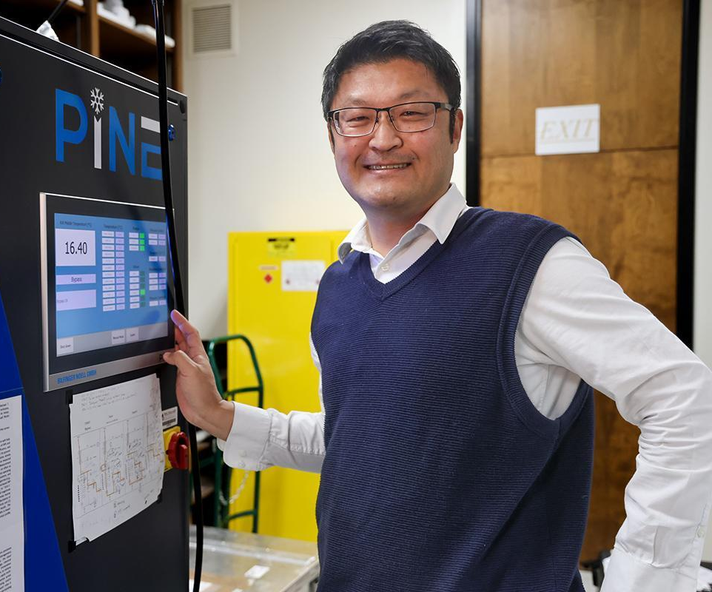
Dr. Naruki Hiranuma grew up in Japan in a Korean-Japanese family, an experience that shaped his passion for supporting underrepresented students in science. After earning his Bachelor’s degree, he came to the U.S. for graduate school, where he met his Ph.D. mentor, Dr. Sarah Brooks. Inspired by her work, he pursued a career in academia, earning a Ph.D. in Atmospheric Science from Texas A&M University and completing postdoctoral research in the U.S. and Germany, gaining a global perspective on scientific discovery.
Now an Associate Professor of Physics at the University of Texas El Paso, Dr. Hiranuma studies arctic cloud microphysics, ice nucleation, and geo-engineering, exploring how these processes shape Earth systems. A recipient of the DOE Early Career Research Program Award, the NSF CAREER Award, and the Presidential Early Career Award for Scientists and Engineers, he combines research with outreach and mentoring, guiding students on their own exciting journeys through the world of science.
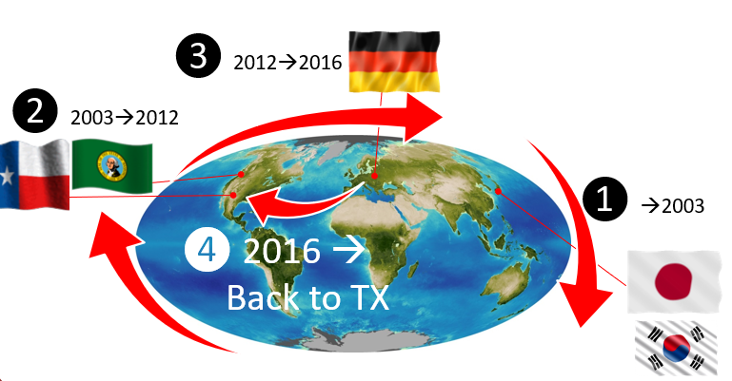
- What degrees does this scientists possess and from which academic institutions?
Bachelors from Japan
Ph.D. in Atmospheric Science from Texas A&M University

- What research interests does this scientist have? How does this research contribute to a better understanding of long term environmental change?
Dr. Hiranuma studies arctic cloud microphysics, ice nucleation, and geo-engineering, exploring how these processes shape Earth systems.
Have students consider how his research might be important to understanding long term environmental change.

- How does their research relate to the topics we have learned or will learn in this course?
Have students consider how his research might relate to this course. What have they been learning (or will learn)?
You could also rewrite this question to ask, why is Dr. Hiranuma’s work significant or important to their own life or community?

- What did you find most interesting about this scientist and/or their research?
Answers will vary. Note their interests as this may be helpful to drive future discussions.

- What new questions do you have after reviewing this scientist and their work?

Answers will vary. Note their questions as these may be helpful for future topics and discussions. Also note any misconceptions or difficulties.

⛏️Activity C: An Introduction to the Earth System
- Match each item at a-e to its “home” sphere/reservoir. Spheres: Geosphere, Hydrosphere, Atmosphere, Biosphere, and Cryosphere.
  - The Greenland Ice Sheet: Cryosphere
  - Mt. St. Helens: Geosphere
  - The Great Lakes: Hydrosphere
  - A Polar Bear: Biosphere
  - Ozone: Atmosphere
- What is the common or typical state of matter (solid, liquid or gas) for most materials in:
  - the atmosphere: Gas
  - the hydrosphere: liquid
  - the cryosphere: solid
  - the biosphere: solid (mostly true some invertebrates and microorganisms are exceptions)
  - the geosphere: solid (melt - lava and magma, are an exception; there are a few others)
- Bring each sphere to life with your sketches!
Cryosphere  Drawings will depend on the student. As long as they draw something, and it fits with the sphere then there isn’t a correct or incorrect response. | Geosphere | Hydrosphere | Biosphere | Atmosphere

Earth is never still, it’s always shifting, reshaping, and transforming.

Imagine you could watch Earth in fast-forward, like a time-lapse movie. What kinds of changes would you notice in the Earth System over time?
Answers will vary. Examples could be fluctuating sea levels; advance and retreat of ice sheets; plate tectonics; volcanic eruptions; there are many options here, let students really think about this one!

Would these changes feel like sudden, dramatic events or slow, gradual shifts? Share your ideas in your own words, don’t worry about using technical terms.

Answers will vary. Examples may be considered sudden, or slow. Have students start to shift their thinking on what constitutes “fast” vs “slow”.
⛏️Activity D: Imagery in the Geosciences
- Consider the image below. Which type of image could this be? Select your choice from the list below. Note, this image was taken by NASA.
  - Digital Elevation Model
  - Aerial Image
  - Topographic map
  - Satellite image

- Explain your selection: discuss that it was taken by NASA. Note the overall scale of the image, and its lack of labels, direction, etc. Some students may recognize the image, others may not.

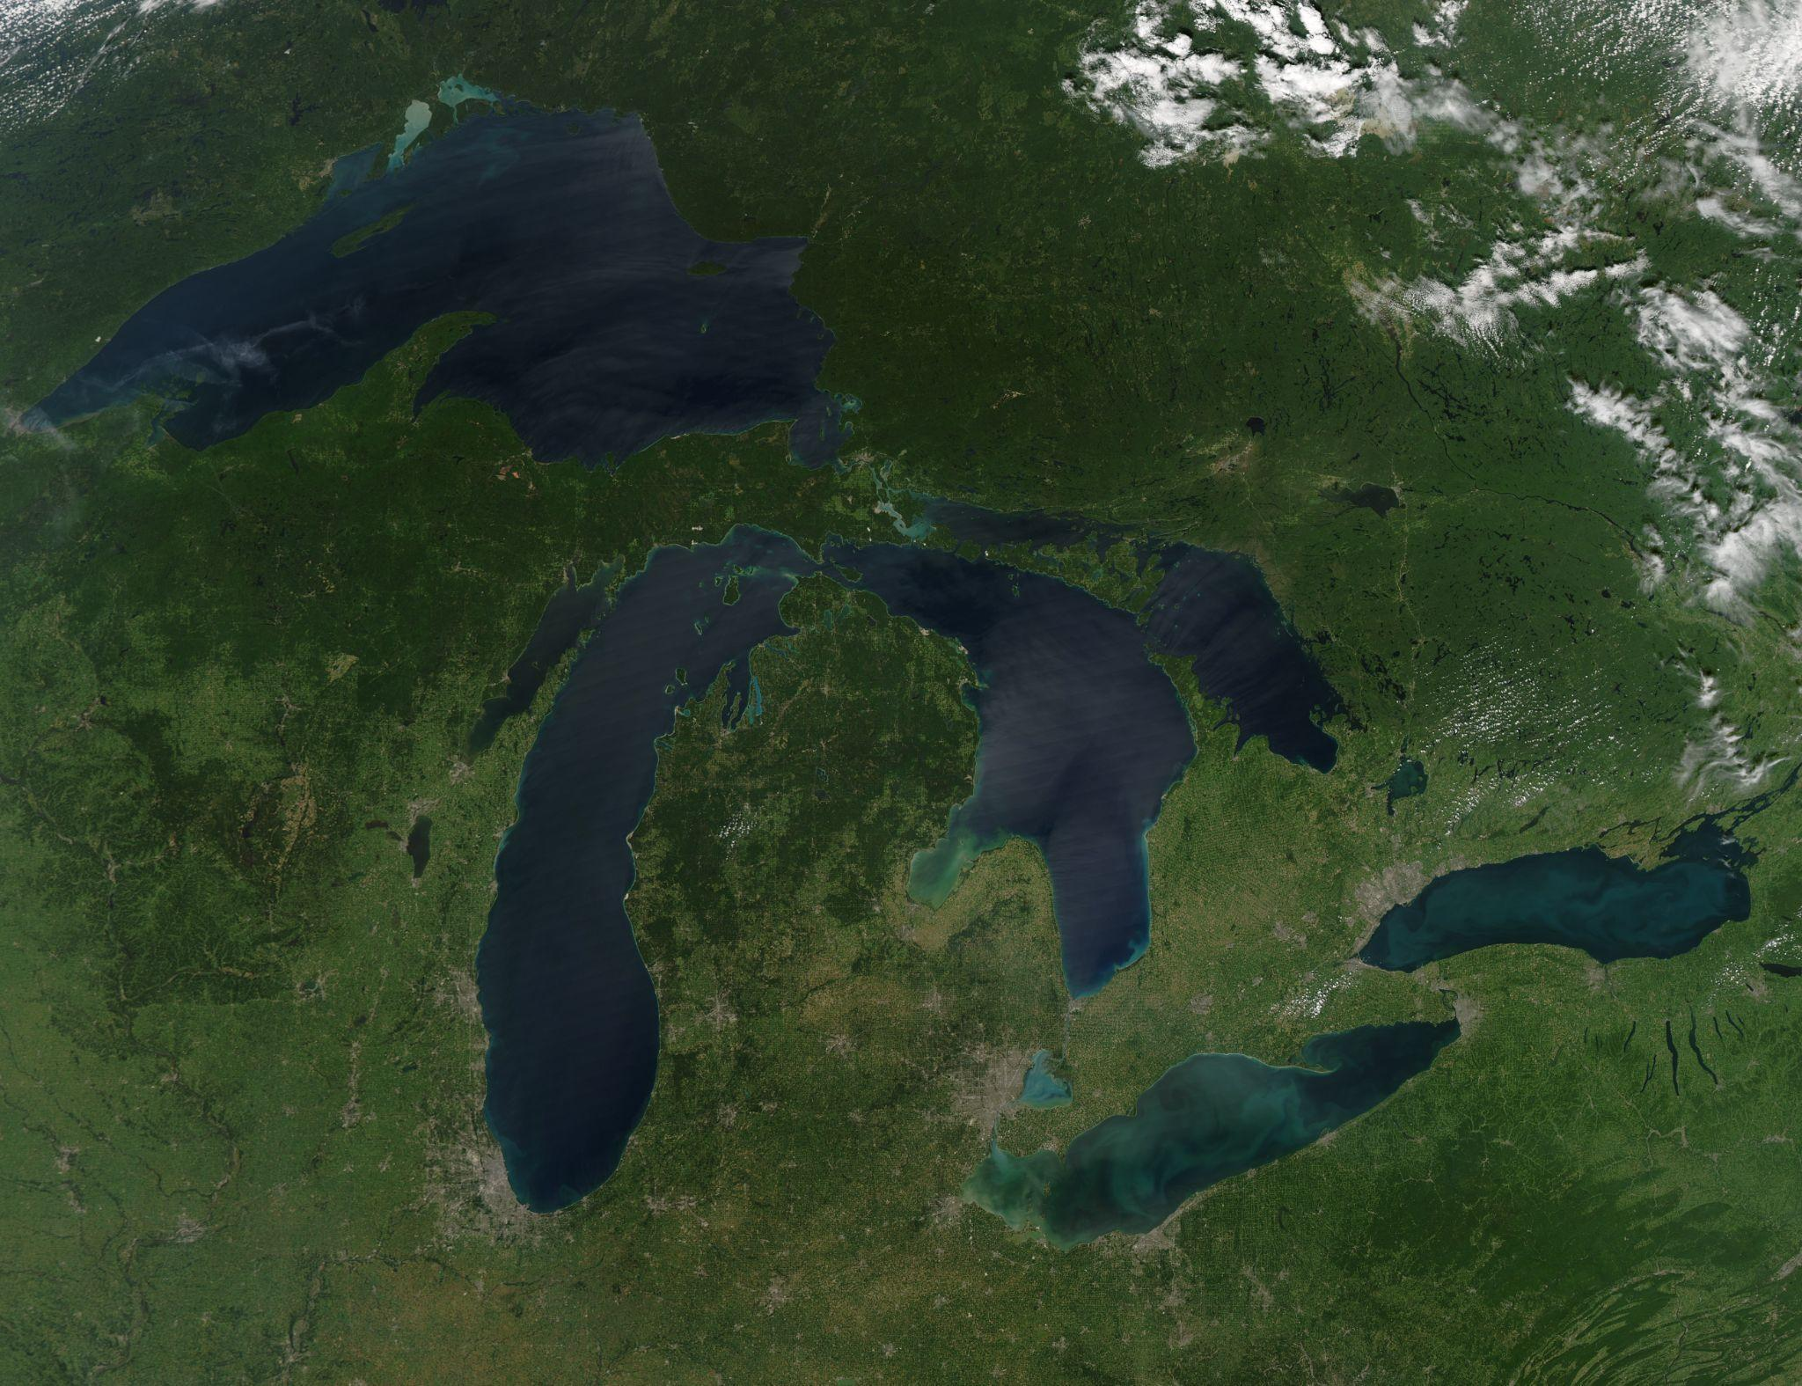
Source: NASA
- Consider the image below. Which type of image is this? Select your choice from the list below. Note, this image was taken by Prof. B as she flew over eastern California!
  - Digital Elevation Model
  - Aerial Image
  - Topographic map
  - Satellite image

- Explain your selection: discuss that it was taken by a person in an airplane (ask if anyone has taken a similar photo!). Note its lack of labels, scale, direction, etc.
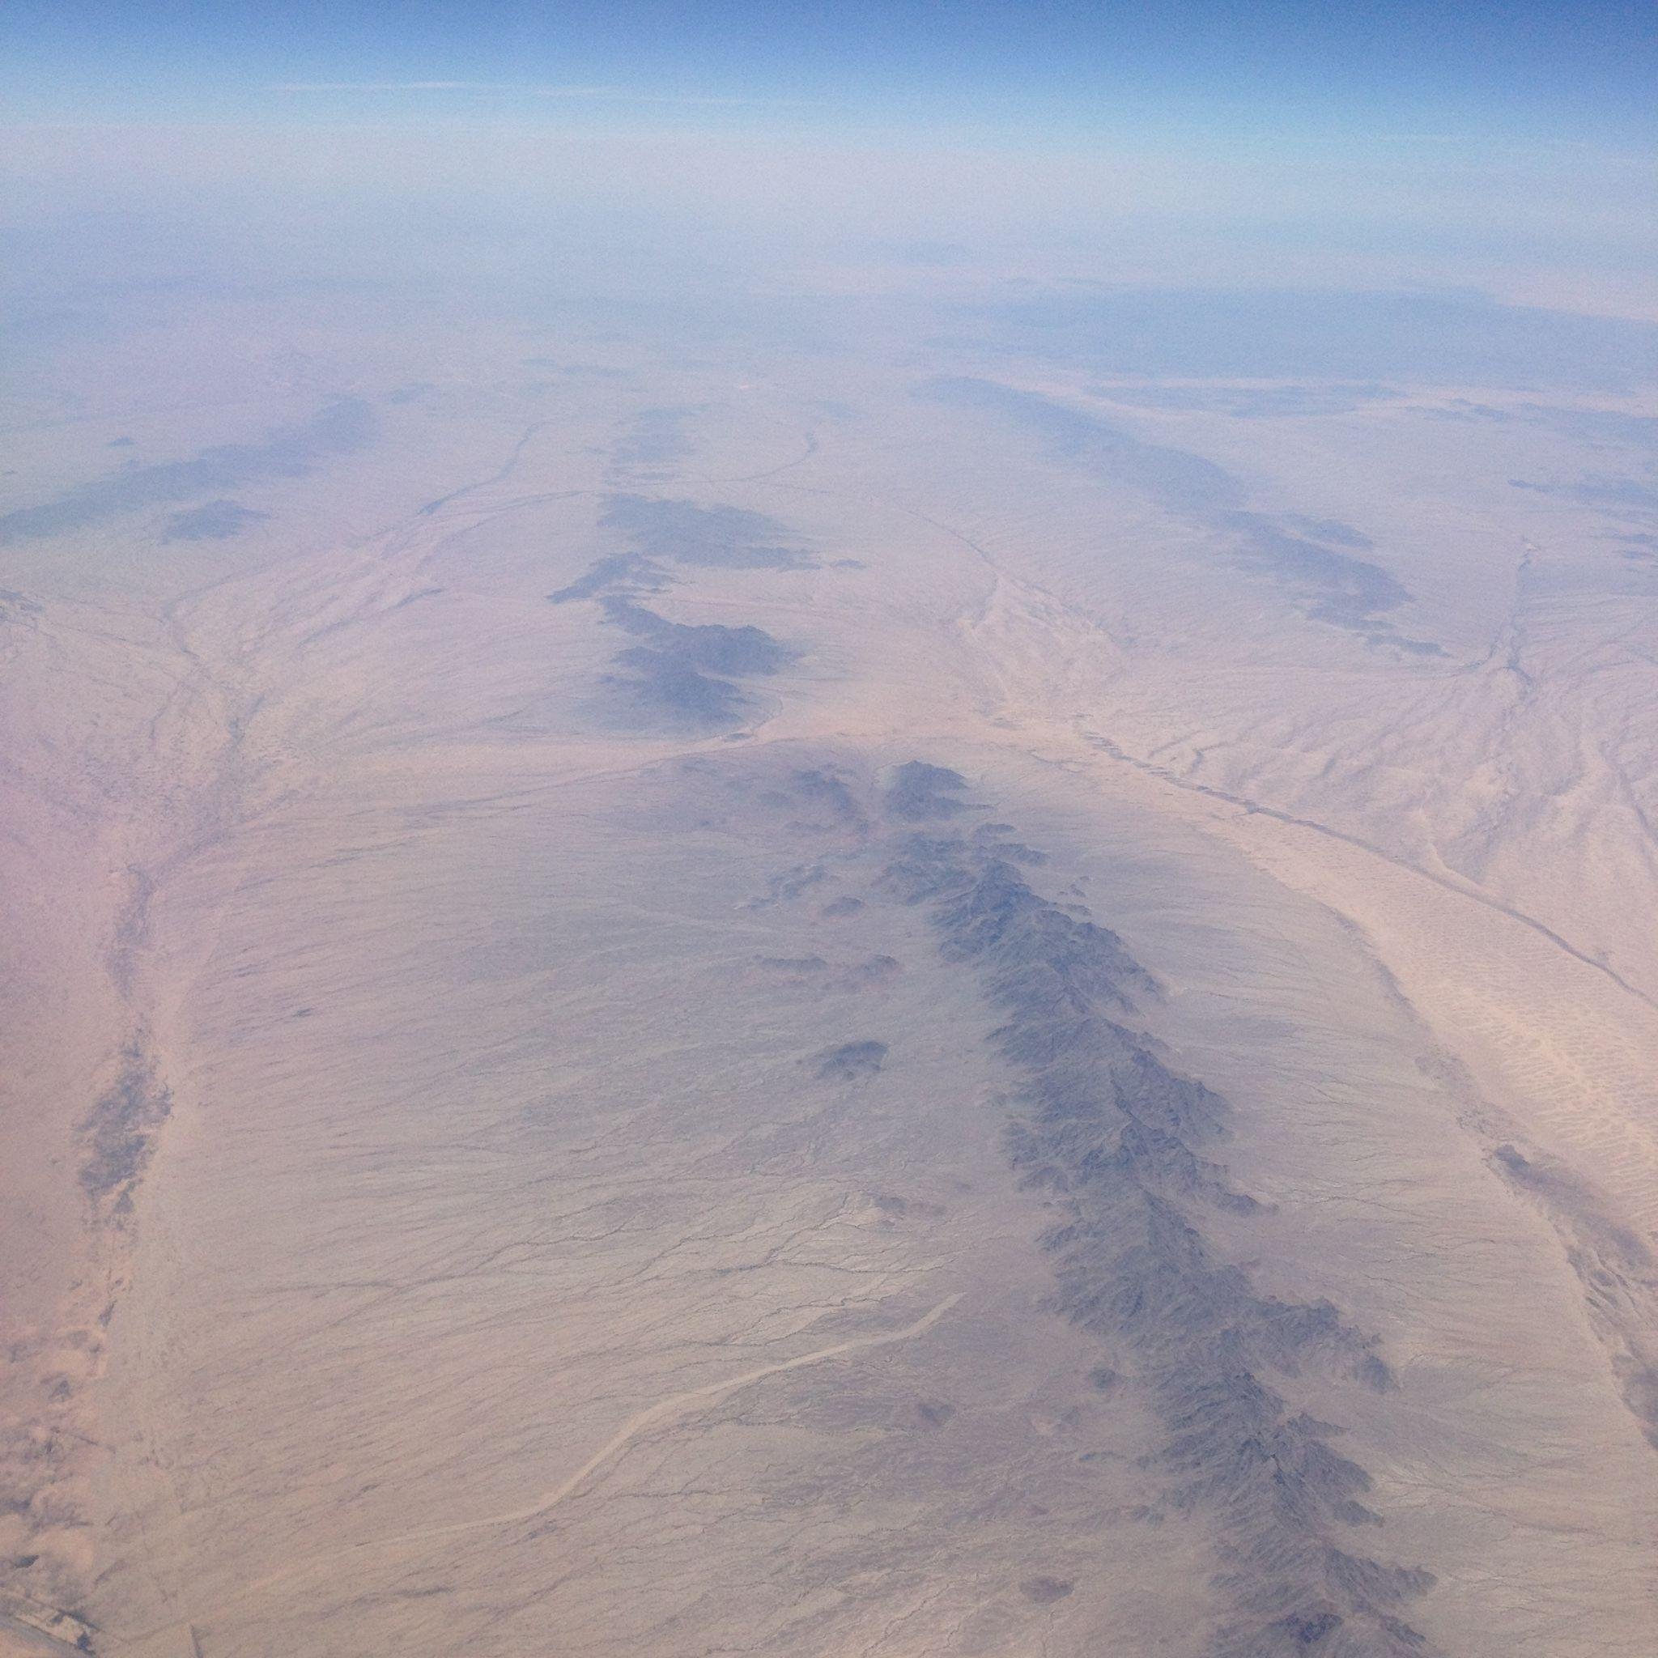
Source: Chloe Branciforte
- Consider the image below. Which type of image is this? Select your choice from the list below. Note, this is a computer model of Mount Hood, a volcano, in Oregon!
  - Digital Elevation Model
  - Aerial Image
  - Topographic map
  - Satellite image

- Explain your selection: discuss the appearance of this image - it looks like a video game (students might mention Minecraft). Note its lack of labels, scale, direction, etc. Some student may recognize the image, others may not.
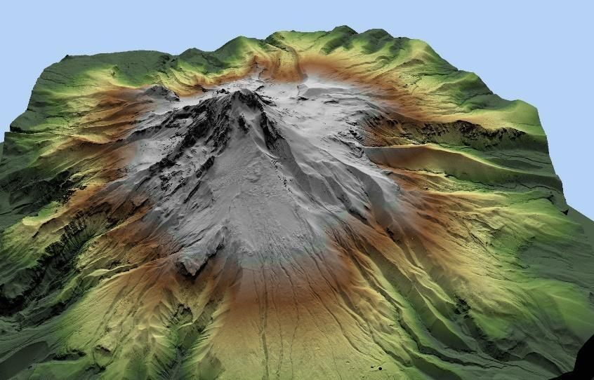
Source: USGS

- Consider the image below. Which type of image is this? Select your choice from the list below. Note, this map is of Mount Hood, a volcano, in Oregon and was published by the United States Geological Survey (USGS)
  - Digital Elevation Model
  - Aerial Image
  - Topographic map
  - Satellite image
- Explain your selection: A topographic map represents the three-dimensional features of the Earth's surface on a two-dimensional plane. It shows: Elevation and landforms using contour lines, which connect points of equal elevation. Natural features such as mountains, valleys, rivers, and lakes. Human-made features like roads, trails, and buildings. These maps often include scale, legend, and north orientation for accurate navigation.

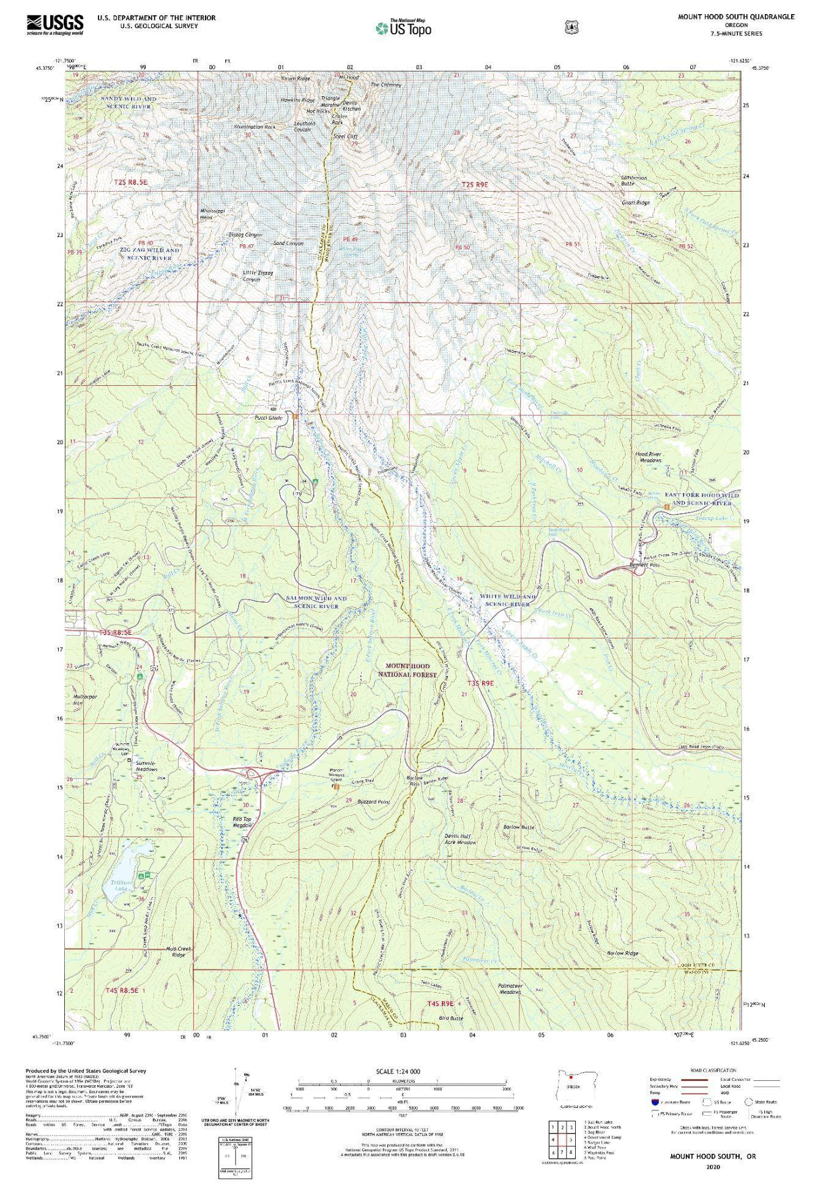
Source: USGS

⛏️Activity E: The Hydrologic (Water) Cycle
Energy and matter are exchanged between the spheres through various earth cycles. These cycles connect the spheres and help keep the earth dynamic and ever changing. During this course we will see many Earth System Cycles including the Water (Hydrologic) and Rock cycles. Other important cycles include the biogeochemical cycles like Carbon, Nitrogen, Sulfur and Phosphorus cycles. For this activity we will focus on the Water cycle.
Critical Thinking Question: Water Cycle
Most of us have at least a basic sense of the Water Cycle, but it’s far more dynamic than it first appears. Even if some of the terms on the diagram look unfamiliar, you already have an intuitive understanding of how water moves through the Earth System. What’s fascinating is that not every cycle touches all the Earth’s spheres at once. Sometimes the connections are clear and dramatic, while other times they’re subtle and harder to trace. As you work through the next questions, draw on your own experiences, think about the rainstorms you’ve seen, the rivers you’ve crossed, or even the morning dew on grass. All of these moments are part of the story of water in motion.
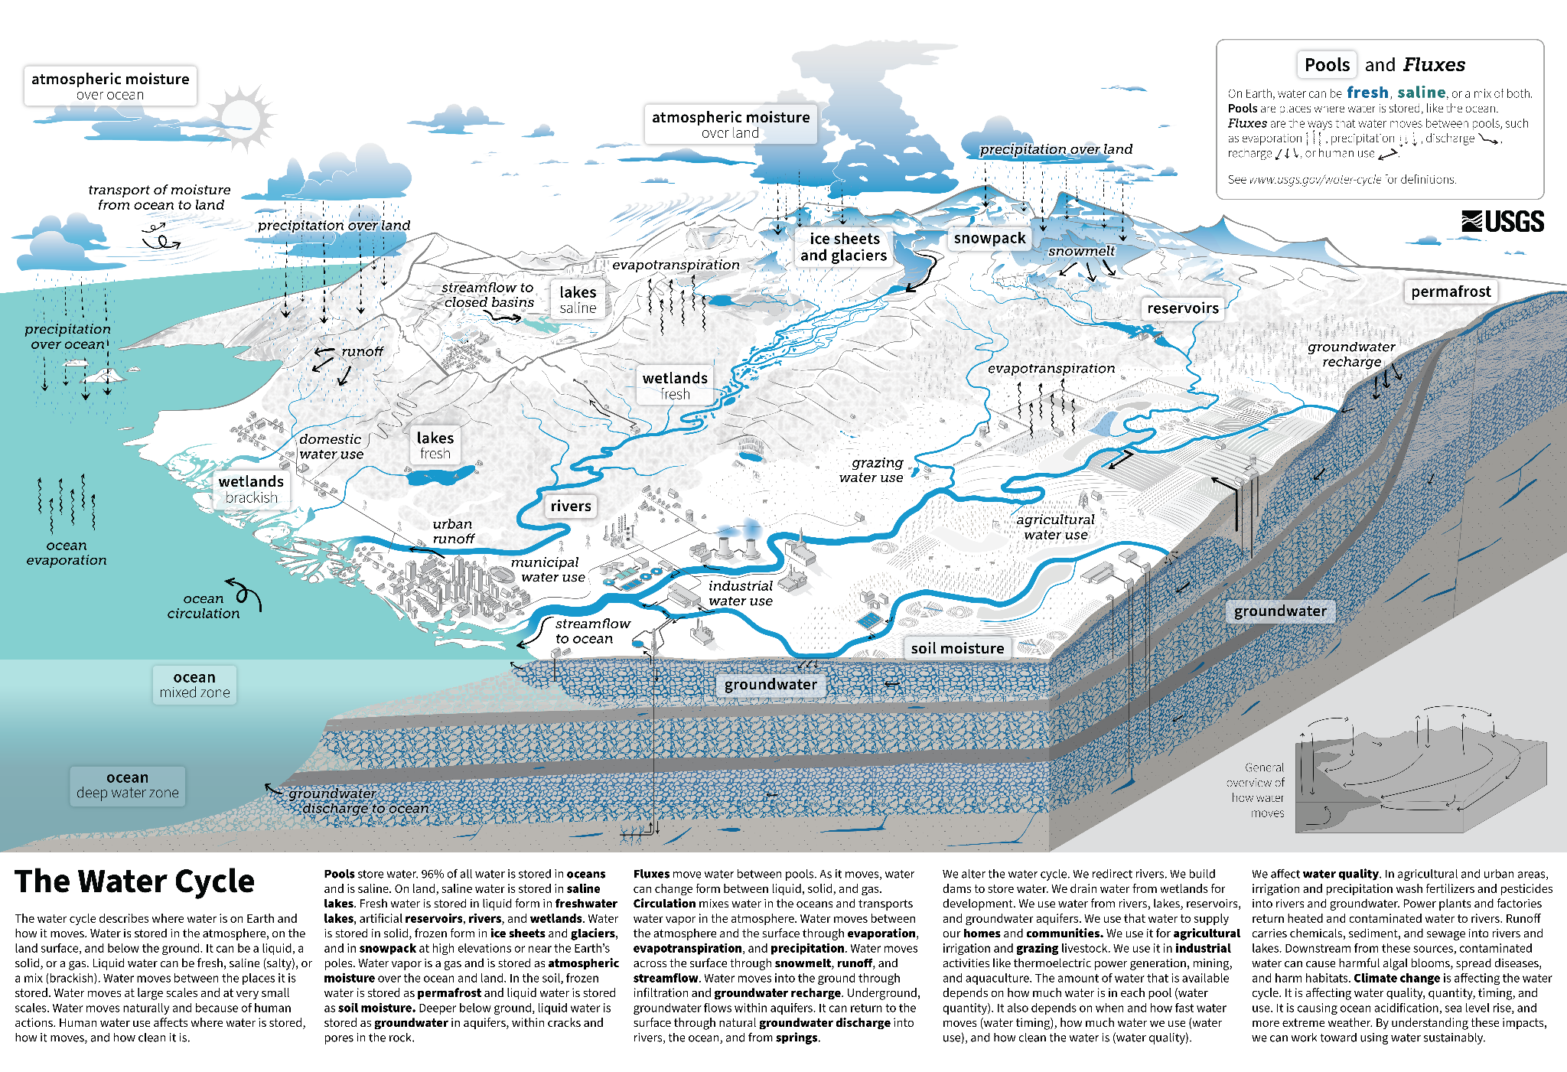
The global water cycle, including how human water use affects where water is stored, how it moves, and how clean it is. (Public Domain, USGS)

Consider the Water Cycle.
- How does the water cycle weave its way through Earth’s different spheres? As you think about it, consider where water shows up, how it moves, and which parts of the Earth System it touches. Write down the spheres you discover. Then, explain how water connects to each one, what role does it play, and what changes or interactions does it cause? Answers will vary.
Example: The water cycle is the ultimate connector, it links all spheres through continuous movement and transformation. From clouds drifting in the atmosphere, to rivers flowing across the hydrosphere, ice storage in the cryosphere, soaking into the geosphere, and nourishing life in the biosphere, water drives interactions that shape Earth’s climate, landscapes, and ecosystems.

Atmosphere: Water enters the atmosphere mainly through evaporation from oceans, lakes, and rivers, and transpiration from plants. It forms clouds through condensation and drives weather patterns. Changes in atmospheric temperature affect evaporation rates and precipitation, influencing climate and storms.

Hydrosphere: This is where most of Earth’s water resides, in oceans, rivers, lakes, and groundwater. It acts as the main reservoir for evaporation and precipitation. Ocean currents redistribute heat and moisture globally, impacting climate systems.

Cryosphere: Water is stored as ice and snow in glaciers, ice caps, and permafrost. Regulates Earth’s climate by reflecting sunlight (albedo effect) and storing freshwater. Melting ice adds water to oceans, affecting sea level and ocean circulation; seasonal snowmelt feeds rivers and groundwater.

Geosphere: Water infiltrates soil and rock layers, becoming groundwater or contributing to erosion. It shapes landscapes through weathering and sediment transport. Water dissolves minerals, forms caves, and can trigger landslides when saturation occurs.

Biosphere: Living organisms depend on water for survival. Plants absorb water from soil and release it back to the atmosphere via transpiration. Water supports metabolic processes and ecosystems. Vegetation influences local humidity and precipitation patterns; human activities alter water distribution through agriculture and urbanization.
- Imagine the water cycle at Earth’s poles over many years, how might melting ice, shifting snowfall, and warming temperatures change the way water moves through this frozen world? Answers will vary.
Example: Imagine the water cycle at Earth’s poles unfolding over decades. As temperatures rise, the balance between frozen and liquid water shifts dramatically. Melting ice sheets release vast amounts of freshwater into the ocean, reducing the extent of permanent ice cover and altering sea levels globally. Seasonal snowfall patterns also change, warmer air can hold more moisture, so some regions may experience heavier snowfalls, while others see rain replacing snow entirely. This disrupts the traditional cycle where snow accumulates, compacts into ice, and slowly returns to the ocean. With less reflective ice and more exposed land or open water, the poles absorb more solar energy, accelerating warming, a feedback loop known as the albedo effect. Meltwater streams carve through glaciers, speeding their retreat, and permafrost thaw introduces liquid water into previously frozen soils, creating wetlands and releasing stored carbon. Over time, the polar water cycle becomes more dynamic and less predictable, shifting from a stable frozen reservoir to a system dominated by rapid melting, variable precipitation, and increased evaporation.
- Imagine you are a scientist studying the Polar Regions. How would you measure changes in ice, snow, and water over time? What tools, observations, or experiments would you use to track the water cycle in this frozen world? Answers will vary.
Example: As a scientist studying the Polar Regions, you would likely rely on a combination of remote sensing, field measurements, and modeling to track changes in ice, snow, and water over time. Satellite observations would be essential for monitoring large-scale trends, tools like NASA’s ICESat-2 and ESA’s CryoSat measure ice thickness and elevation changes with laser and radar altimetry. For snow cover and melt patterns, you could use passive microwave sensors and optical imagery from satellites such as MODIS to detect seasonal variations. On the ground, you could deploy GPS stations and collect ice cores to measure ice movement and analyze historical layers of snowfall. Automated weather stations and snow gauges could help track precipitation and temperature changes. To study meltwater flow, you could use ground-penetrating radar and install sensors in glacial streams to measure discharge and water chemistry. Finally, you could integrate these observations into climate and hydrological models to simulate how warming temperatures alter the polar water cycle. This combination of satellite data, field experiments, and modeling would give a comprehensive picture of how ice, snow, and water interact in a rapidly changing frozen world.

⛏️Activity F: Cloud Formation
- What would you expect clouds to be composed of?
  - Water drop
  - Water vapor
  - Ice crystal
  - All of above
- What term is applied when a gas changes into a liquid?
  - Condensation
  - Vaporization
  - Sublimation
- What happens when the air is cooled and/or saturated with water vapor and it cannot hold any more water.
  - Condensation
  - Vaporization
  - Sublimation
- What term is applied when a liquid changes into a gas?
  - Condensation
  - Vaporization
  - Sublimation
- Evaporation is a surface phenomenon, whereas boiling is a bulk phenomenon. What term is applied to these phenomenon?
  - Condensation
  - Vaporization

Deposition

Do you think geoscientists can measure the weight of gas (water vapor)? Yes

How do you think that could be accomplished? What tools might help us? Answers vary

What is dry ice? Hint - it’s temperature is below -100 ˚F (-78.5 ˚C)!

Frozen water

Frozen carbon dioxide

Frozen helium

Frozen hydrogen

☁️Making a Cloud!
For the next section, we will mix dry ice and water in a beaker to recreate clouds through vaporization and sublimation! The beaker will be placed on a digital scale, so that you will be able to see a decrease in the weight of what is put in a beaker as a function of time. The observed weight loss is the mass of gas (cloud) you generated. Through this exercise, you will understand the cloud formation process and phase transformation, as well as latent heat energy, which is a source of storm energy in the air.

Instructions:
Step 1: Put on gloves for your safety and keep your experimental system sterile.
Step 2: Gather the materials listed in the table below before we begin:
Quantity | Item
1 | Pair of Gloves
1 | Permanent marker
1 | 50 mL Plastic Falcon Tube
1 | 250 mL Beaker
1 | ~400 g Dry Ice (solid form of carbon dioxide)
1 | 400 mL Water (Activation Solution)
1 | Digital Scale

Step 3: Add 50 mL of tap water to the plastic falcon tube and label the tube as H₂O with a permanent marker.

Step 4: Place the Beaker (your cloud generation system!) on top of your digital scale, like in the picture below.
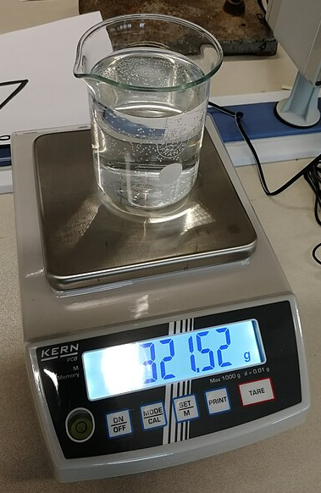
(CC-BY; 4.0, AGeremia)
Step 5: In the beaker, combine the 50 g of dry ice and the 50 mL of water, and mix well to produce carbon dioxide gas!
Step 6: Measure and record the starting weight (grams) of your cloud system in the table below. You will do this every 10 seconds once you complete Step 5.
Step 7: Measure and record the ongoing weight (grams) of your cloud generation system every 10 seconds.
Time (seconds) | Weight of cloud system (grams)
0 (right after adding water to the system)
10
20
30
40
50
60 (1 minute)
70
80
90
100
110
120 (2 minutes)

Yikes - why is there white smoke? The solid (dry ice) reacts with the liquid (water), and the dry ice sublimates and transforms into carbon dioxide gas. This results in losing dry ice to make the gas (pollutant simulant).
But wait, why does the dry ice stop sublimating while there is still liquid water available? Some of the liquid (water) freezes and transforms to ice crystals which isolates the dry ice from the available liquid water. This stops the reaction between liquid water and solid dry ice and prevents the absorption of latent heat which in turn stops the gas carbon dioxide generation.
Step 8: Ask your instructor on how to properly dispose of the materials used during this lab and how to properly clean up your station.

Step 9: After completing the experiment, answer the questions below:
We have evidence that the weight of dry ice sublimation is equivalent to the weight of water freezing; thereby, the weight loss seen on the scale is directly related to the amount of dry ice sublimation.
- Calculate the energy absorbed by your cloud.
Use the following formula:
Y = 142cal/g * X
Where 142cal/g l (read as 142 calories per gram) is the amount of energy used in the sublimation of dry ice.
Where X, is the weight change of the cloud system in grams. See Table in Step 7.
X (g) = Weight of cloud system at time 120s (g) - Weight of cloud system at time 0s (g)
Where Y, is the latent heat absorbed by the system in calories
For example, sublimating 1 gram of dry ice requires 142 calories of energy (≈ latent heat absorbed). Therefore, the sublimation of 8 grams of dry ice requires about 1100 calories of latent heat energy (8 g x 142 cal/g = 1136 cal). In other words, the 8 gram weight reduction in the system weight implies 8 gram reduction in the dry ice weight, and it is equivalent to about 1100 calories of latent heat absorption.

- Which phase change(s) did you observe during this experiment?

- Did you observe the release of latent heat or absorption of latent heat?

- Hypothesize, what would happen to the weight of the cloud system after 10 minutes?

- Would the size of the dry ice impact the rate of weight loss? Support your reasoning.

⛏️Activity G: Exploring Glaical Landforms with Google Earth
For this class, we’ll be using the free web version of Google Earth. You can use the lab computers or your own laptop or tablet, but try to avoid using your phone, since it limits what you can do. Spend some time exploring the program and getting to know the tools, like 2D and 3D views, the ruler, pins, and layers such as timelapse, latitude/longitude, and gridlines. Have fun discovering what the program can do!
- Open Google Earth
- Locate the gear symbol in the top right corner (next to your avatar) and click it. This is the Settings feature. Scroll down to the section titled: Formats and units. Ensure your units of measurement read: Feet and miles. For the future we can always change this setting. Scroll all the way to the bottom of Settings and click the DONE button to make your changes.

- Cut and paste the following coordinates into the search bar: 61°19'31"N 147°59'46"W. Welcome to Mt. Goode in Alaska. Zoom out enough to see the glacial landform. Change your view from 2D and 3D to navigate the area and view it from all angles.
  - Does this glacial landform appear to be composed of sediment or bedrock?
  - Which process is represented here, erosional or depositional?
  - Which glacial landforms can be identified here? Glacial horn, Arete, Cirque, glacial valley (filled with the glacier)
  - Which type of glacier made these landforms? Mountain glacier
- Cut and paste the following coordinates into the search bar: 40°16'41"N 105°40'08"W. Welcome to Rocky Mountain National Park in Colorado. Zoom out enough to see the glacial landform. Change your view from 2D and 3D to navigate the area and view it from all angles.
  - Does this glacial landform appear to be composed of sediment or bedrock?
  - Which process is represented here, erosional or depositional?
  - Which glacial landforms can be identified here? Glacial horn, Arete, Cirque, glacial valley, spur, col
    - What is this term used for this type of glacial lake? Tarn lake
  - Which type of glacier made these landforms? Mountain glacier
- Cut and paste the following coordinates into the search bar: 37°44'35.8"N, 119°35'33.7"W. Welcome to Yosemite National Park in California! Zoom out enough to see the cross-section of Yosemite Valley. Change your view from 2D and 3D to navigate the valley and view it from all angles.
  - Which type of glacier formed Yosemite Valley? Mountain glacier
  - How can you tell? U-shaped valley
- Cut and paste the following coordinates into the search bar: 37°42'58.2"N, 119°38'45.7"W. We will visit another section of Yosemite National Park. Zoom out enough to see the glacial landform. Change your view from 2D and 3D to navigate the area and view it from all angles.
  - Does this glacial landform appear to be composed of sediment or bedrock?
  - Which process is represented here, erosional or depositional?
  - What is this glacial landform? Hanging valley (U-shaped)
  - Which type of glacier made these landforms? Mountain glacier
- Cut and paste the following coordinates into the search bar: 37°52'54.3"N, 119°20'47.7"W. Welcome to another section of Yosemite National Park. Zoom out enough to see the glacial landform. Change your view from 2D and 3D to navigate the area and view it from all angles.
  - Does this glacial landform appear to be composed of sediment or bedrock?
  - Which process is represented here, erosional or depositional?
  - Which glacial landform can be identified here? roche moutonnée
  - What information about the glacier can we interpret from this landform? Glacial ice flow direction
- Cut and paste the following coordinates into the search bar: 58°54'34"N 136°54'04"W. Welcome to Glacier Bay National Park and Preserve in Alaska. Zoom out enough to see the glacial landform. Change your view from 2D and 3D to navigate the area and view it from all angles.
  - What glacial landform is represented by Tarr Inlet or Johns Hopkins Inlet? Fjord (U-shaped valley filled with sea water)
  - Next, follow Tarr Inlet back to its glacier. Make visual observations about the terminus of the glacier. Answers will vary
  - Next, turn on the Historical Imagery and Timelapse. This can be found to the right of the ruler function. Watch what happens to the terminus during the timelapse from 1984-2022. Note – you can slow down or speed up the timelapse. Make visual observations about the terminus through time and in current view. Answers will vary. Note - the changing size and shape of the terminus as well as the conveyer belt motion of the glacier.
- Cut and paste the following coordinates into the search bar: 60°36'27"N 144°55'24"W. We are visiting another spot in Alaska! Zoom out enough to see the glacial landforms. Change your view from 2D and 3D to navigate the area and view it from all angles.
  - What type of glacier is this? Mountain glacier
  - Examine the landforms at the terminus of the glacier.
    - Are they depositional or erosional?
    - How can you tell? Made of sediment - glacial till
    - What landforms are these? End moraines, specifically, terminal and recessional moraines
  - Next, zoom out enough to view the neighboring glacier to the northeast. Locate the large river system to the east of these glaciers.
    - What type of river is this? Braided river
    - How can you tell? Multiple channels separated by sand and gravel bars (looks like braided hair)
    - What does this indicate about sedimentation? High sedimentation rate - more sediment is entering the system than the water can carry at any single time.
- Cut and paste the following coordinates into the search bar: 43°09'12"N 76°52'42"W. Welcome to Rose, New York. Zoom out enough to see the town of North Rose too. Notice the distinct patterning of the ground surface; light and dark green. Some of this is due to agriculture, however many of those fields are exploiting low areas between hills. View this SketchFab model to better see the topography of the area.
  - Are these glacial landforms composed of sediment or bedrock? Hint - this model is from a different location, but provides an internal view. Sediment
  - Which process is represented here, erosional or depositional?
  - What are these glacial landforms? Drumlins
  - Which type of glacier made these landforms? Continental ice sheet
  - On a topographic map, these glacial landforms can be seen as concentric, elongate circles (see map below). At this location near Rose, NY what is the likely direction of ice movement? From north to south
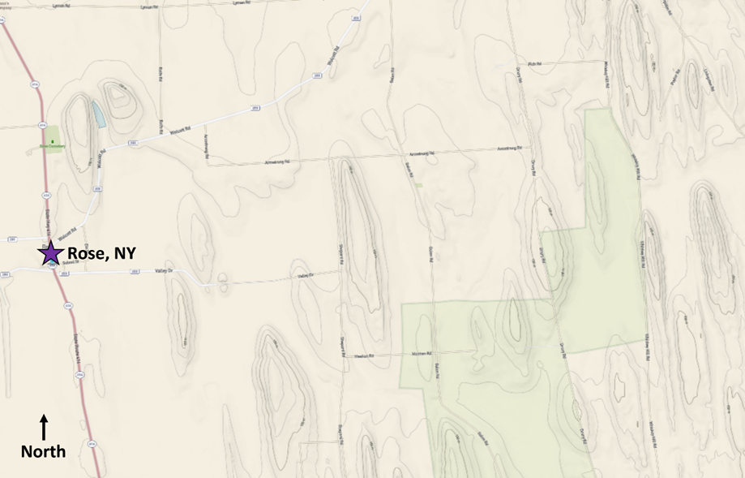
Topographic map near Rose, New York (CC-BY, Chloe Branciforte via TopoView)

- Examine this 3D model.
  - What type of glacial sediment is this? Glacial erratic

- Examine this Gigamacro image.
  - What type of glacial sediment is this? Glacial till
  - In which glacial landforms would you expect to find this sediment? Drumlins, Kettles and Kames, moraines (all types)

- Cut and paste the following coordinates into the search bar: 48°40'18"N 113°43'24"W. Welcome to Glacier National Park in Montana. Zoom out enough to see the glacial landforms. Change your view from 2D and 3D to navigate the area and view it from all angles.
  - What erosional landforms are visible in this area ? Identify at least five. Glacial horn, Arete, Cirque, glacial valley, spur, col
  - What type of glacier likely formed this landscape? Mountain Glacier

- Examine the graph below. In your own words, what does this graph convey? Students should notice that over time, ice volume decreases at Waterton-Glacier International Peace Park.
Follow-up conversation: Discuss long term system change and impacts to the cryosphere more broadly.
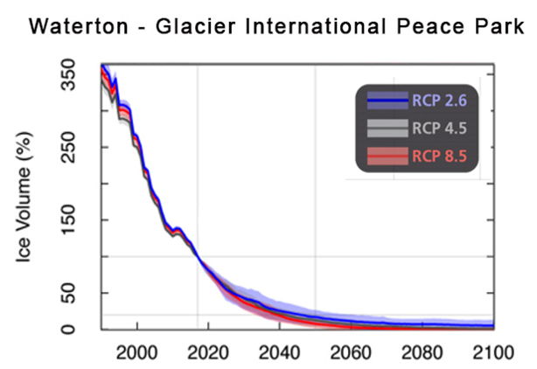
Glacial data from Waterton-Glacier National Park in Montana. (CC-BY, USGS; Modified from Bosson et al. (2019))
Copyright Statement: This module was developed by Chloe Branciforte and Naruki Hiranuma, and is marked with CC-BY 4.0 (Attribution 4.0 International license). To view a copy of this license, visit https://creativecommons.org/licenses/by/4.0/

