Introduction to the Earth System

An Open Educational Resource (OER) for Polar STEAM (2025)

Chloe Branciforte and Naruki Hiranuma

Contents
💡 Chapter Learning Outcomes 3
What is Science? 3
The Scientific Method 4
How scientific is it? 5
What are the Geosciences? 7
🌎Who works as a geoscientist? 7
What are the two major branches of geology? 9
How do geoscientists view the Earth? 9
Measurements in the Geosciences 14
Imperial System Abbreviation 14
Imperial System Measurement 14
Metric System Abbreviation 14
Metric System Measurement 14
Metric System 14
Imperial (English) System 14
Measurement Conversions 15
Introduction to the Earth System 17
Earth Systems Overview 18
The Symphony of the Spheres 19
The Exosphere: Space Environment 19
The Atmosphere: Gaseous Earth (Troposphere, greenhouse gases, etc.) 22
The Hydrosphere: Liquid Water (fresh, marine, groundwater, etc.) 26
The Cryosphere: Water-ice 27
Geosphere: Solid Earth (rock, including molten rock) 29
Biosphere: Life 34
Anthroposphere: Human portion of the biosphere 35
A review of important Earth cycles 35
The Rock Cycle 37
The Water Cycle 38
The Wilson Cycle 39
Milankovitch Cycles 40
Biogeochemical Cycles 41
Earth Systems collide: Events and Interactions 43
Key words from this chapter 49
Acknowledgements: 53

💡 Chapter Learning Outcomes
- Describe the scientific method and construct and document geoscientific observations.
- Identify common imagery used in the geosciences.
- Categorize the five spheres (reservoirs) of the Earth System.
- Analyze several cycles that connect the spheres of the Earth System.
- Identify names and symbols of common chemical elements present in the geosphere.
- Utilize Google Earth to explore the Earth System.

What is Science?
Science is not just a subject; it’s a way of thinking. Science is the process used to objectively investigate the universe and everything in it. Geoscience (or Earth Science), including geology, offers an important perspective for understanding our world. As geoscientists, we study the Earth of the past, present, and, sometimes, the future.
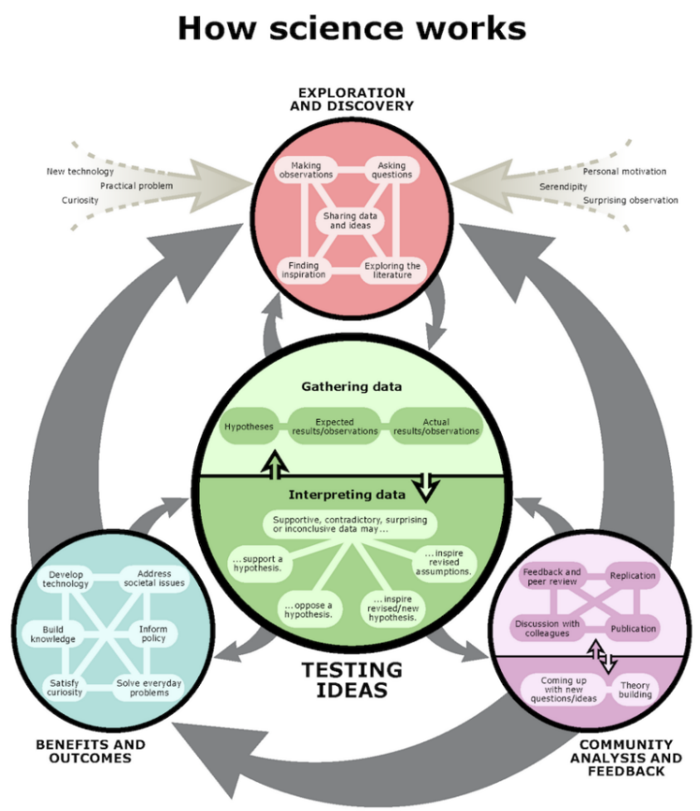
Figure 1: Understanding Science: How Science Works. ©University of California Museum of Paleontology. Used with permission (13 November 2020). [All rights reserved].

The Scientific Method

Previously, you may have encountered the scientific method; however, it is worthwhile to review as it is foundational to any science course. While the scientific method is not linear, oftentimes an early stage of the scientific method is observation. An observation requires using the five senses to engage with the world around you. Observations may be simple, like identifying the outward color of a mineral. Sometimes, however, observations will require you to learn basic background information through an experiment or test. For example, testing the streak of a mineral will require you to rub the mineral across a porcelain plate. This can produce a colored powder that can then be recorded. It is important to document observations. Many geoscientists record their observations in a field notebook or on a computer or tablet. Documentation ensures records can be accessed in the future, and methods can be duplicated by others. Oftentimes, observations will lead to questions. In fact, you may find yourself with many questions; this is okay! You may even find yourself repeating the observation portion of the scientific method many times to feel confident to move forward in the process. This is also okay, because your continued investigation keeps the process of science alive.
The questions generated during the observation stage can be constructed into a hypothesis. A hypothesis is a testable prediction of how something works. A hypothesis should be framed in such a way that it is easy to test. Science works to rigorously disprove a hypothesis. Only hypotheses that withstand the rigor of testing become accepted. Regardless of whether a hypothesis is verified or rejected, new information will be gained. When a hypothesis is rejected, this does not equate to failure of the experiment. Instead, it indicates we need to revisit the original observations, make new ones, ask new questions, and form a new hypothesis to test. This seems repetitive, and it is, but that is how science operates.
Another important component of the scientific method is communication. This stage is often skipped in traditional discussions, but it is very important, and, with the advent of the internet and social media, it has become considerably easier to accomplish. Communication within the scientific community allows for experiments to be replicated in novel ways, expanding the original hypothesis and addressing questions from many perspectives. This is also why a diverse scientific community is so important! In addition to communication within the scientific community, communication with the public is also important. This can be done through a press conference, news report, written article, or via social media. Social media has encouraged a rapid, global exchange of information and many scientists can be found across the platforms. Check out: #Science, #SciComm, and #ScienceComm for access to ongoing science. However, with everything on the internet, it is important to be cautious and critically evaluate a source. That said, be open to new information and willing to adapt and change your mind when confronted with data, evidence, and facts. If you have an interest in science and journalism, many institutions now offer science communication or science journalism degrees. Check out examples of science communication courses from the University of Chicago!
During an individual scientist’s career, they will often only participate in a small portion of the scientific method. Hundreds of related observations and tested hypotheses accumulate for scientists to formulate a theory. A scientific theory is an explanation for a natural phenomenon that is supported by a wealth of scientific data. A theory is not yet a scientific law if there is still some debate on the exact workings of the theory or the reasons why a phenomenon occurs. Lastly, the application of science, much like communication, is also left out of broader discussions. This portion is important, as it illustrates our collective use of science, whether it be individual, local, national or global. This includes everything from running water, electricity, and technology to planning evacuations during an emergency. Interested in knowing more? Watch this video for more on the scientific method!

How scientific is it?

Trans-fat free! AI takes over! Clinically proven to reduce the appearance of wrinkles! These aren't exactly the headlines you'd find in a scientific journal, but they are examples of internet click-bait, which most of us encounter every day. In fact, we are regularly targeted by media messages about science in the form of advertising or reporting. Similarly, our lives are affected by all sorts of science-related policies, from what additives are allowed (or required) to be mixed in with gasoline, to where homes can be built, to how food is processed. Understanding the nature of science can help uncover the real meaning of media messages and evaluate the science behind policies. The Science Checklist from UCMP, examines what makes science, well science, the key features that set science apart from other human endeavors. This checklist was developed to help people distinguish scientific investigations from non-scientific ones.
Science is science if it…
- Focuses on the natural world.
- Aims to explain the natural world.
- Uses testable ideas.
- Relies on evidence.
- Involves the scientific community
- Leads to ongoing research.
- Benefits from scientific behavior
Sometimes without a lot of background knowledge, it can be challenging for someone to determine what is science, and what is not. Generally, it is healthy to be skeptical, especially when scrolling social media and the internet. As a student, the general education courses you complete are designed to help develop your critical thinking skills and become a better consumer of information. The next time you find yourself asking, “ugh…why do I have to take this class?”, recall, that class has been designed to help you grow, think and learn!
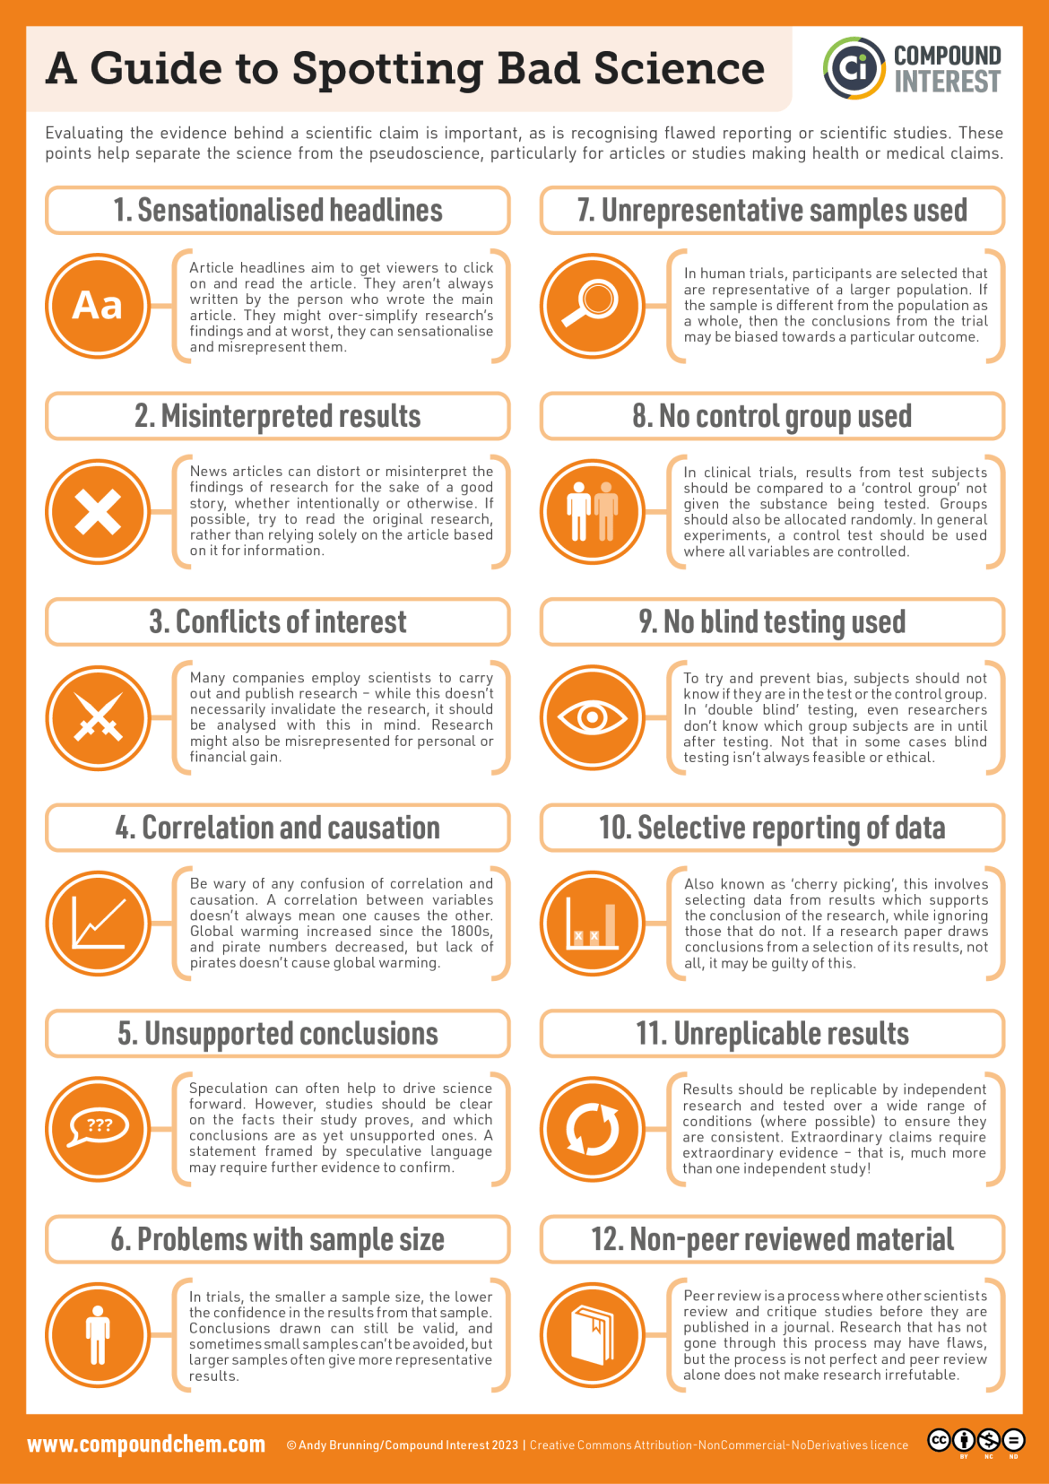
Figure 2: A guide to spotting ”bad” science. (CC-BY-NC-ND; Andy Brunning/Compound Interest 2023)

What are the Geosciences?

Earth is a complex and dynamic place, with many moving components and processes. Geoscience or Earth Science examines the Earth: a considerably massive subject. Take a minute to think about everything you encounter every day that relates to Earth. Is your mind blown yet? Welcome to the career of a geoscientist! A geoscientist is someone who studies the Earth System.
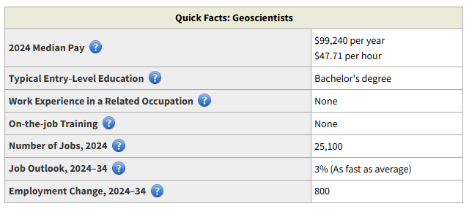
Figure 3: Quick facts regarding a geoscience career (Public Domain; US Bureau of Labor Statistics).

🌎Who works as a geoscientist?
Many geoscientists are employed by universities where they teach and/or do research, and state and federal agencies, including geological surveys, like the Illinois State Geological Survey (ISGS) or United States Geological Survey (USGS). Additional career pathways are available in the private sector including mining and natural resource extraction, environmental policy, legislation, and consulting. Many of these careers require a college degree and postgraduate work (Master’s or PhD). Most geoscientists divide their time among field research, where they collect data, samples, or measurements, laboratory work, where they analyze data, samples, conduct experiments or computer modeling, and the “office” where they write papers, reports or draft maps and diagrams showing the results of their studies. All geoscientists use some form of imagery, from paper maps to Google Earth, computer rendered animations to aerial photographs.
The broad range of subjects within the geosciences are frequently multidisciplinary, involving cross-over with many other fields including STEM (Science, Technology, Engineering and Mathematics), Social Sciences, and the Arts (STEAM). A geoscientist typically solves problems using an interdisciplinary approach. This requires them to work with and learn from many fields to address diverse questions. For example, a paleoclimatologist, a scientist who studies climates of the past, searches for information about past climates through ice or sediment cores, fossils, and rocks. The information they collect can be used to understand climate through geologic time, but also long term environmental change. Their research can be utilized for hazard mitigation, planning and policy, and preparation at the city, county, state, and federal levels.
The geosciences are rapidly changing and look very different than they did even a decade ago. Modern geoscientists are comfortable working with technology, including social media, and commonly work in interdisciplinary and/or multidisciplinary teams. For many geoscientists, field work can be a large component of their job, and field work has also evolved significantly. Initially geologists were only able to rely on themselves to get to an area, usually by hiking, horseback, pack mule or canoe. With the introduction of motorized transport, including ships, trains, cars, and eventually planes, areas farther away became much easier to study. Technology has continued to be an important driving factor in field work evolution. The phrase “I’m going to do field work” has expanded to include both works outdoors AND in the laboratory, whether with test tubes and beakers, or coding and KMZ files. For many geology undergraduates, field work, in its many forms, is a fundamental component of their curriculum. For us, Google Earth ensures we can all participate and have world at our fingertips!
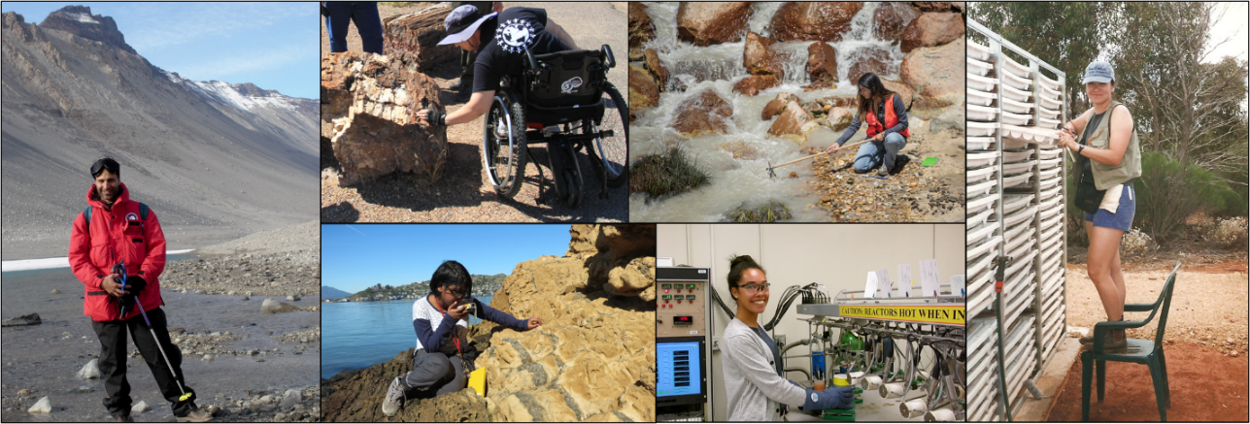
Figure 4: Field work. Clockwise, from left: Michael in Antarctica; Jen examining petrified wood in Petrified Forest National Park; Angelica sampling water; Tari examining core trays; Carina examining in the lab; Meghomita making measurements at outcrop (CC-BY; Chloe Branciforte).
Interested in the geosciences? Talk to your instructor for advice! It is recommended that you complete as many math and science courses as possible. Also visit National Parks, State Parks, museums, gem & mineral shows, or join a local rock and mineral club. Typically, natural history museums will have wonderful displays of rocks, including those from your local region. Additionally, many colleges and universities also have their own collections/museums. If you are unsure of what your region offers, oftentimes a simple Google search (example, rock and mineral organizations nearby) will help determine what is available.

How do geoscientists view the Earth?

There are many ways to view Earth. The most obvious way is to go outside and walk around, but keep in mind that this may not always be an option. Field work remains one of the best ways in which a geologist can investigate a particular location. Field work focuses on specific questions, requires extensive planning and preparation, and is often expensive. Therefore, any research that can be done in advance, such as collecting imagery, is helpful in shortening the time in the field and reducing the cost.
To represent the surface and sub-surface of Earth, geoscientists use aerial photographs, Landsat, DEM imagery, or maps. Maps were some of the first items used to represent the Earth, or a part of it. A topographic map represents topography, the shape and character of the Earth's surface, and depicts both natural and human-made features. Bathymetric maps represent bathymetry and typically contour depth of water. Both maps use contour lines to denote elevation (or depth soundings), where each contour line connects points of equal elevation (or depth). Contours make it possible to measure the height of mountains, depths of oceans, and steepness of slopes.
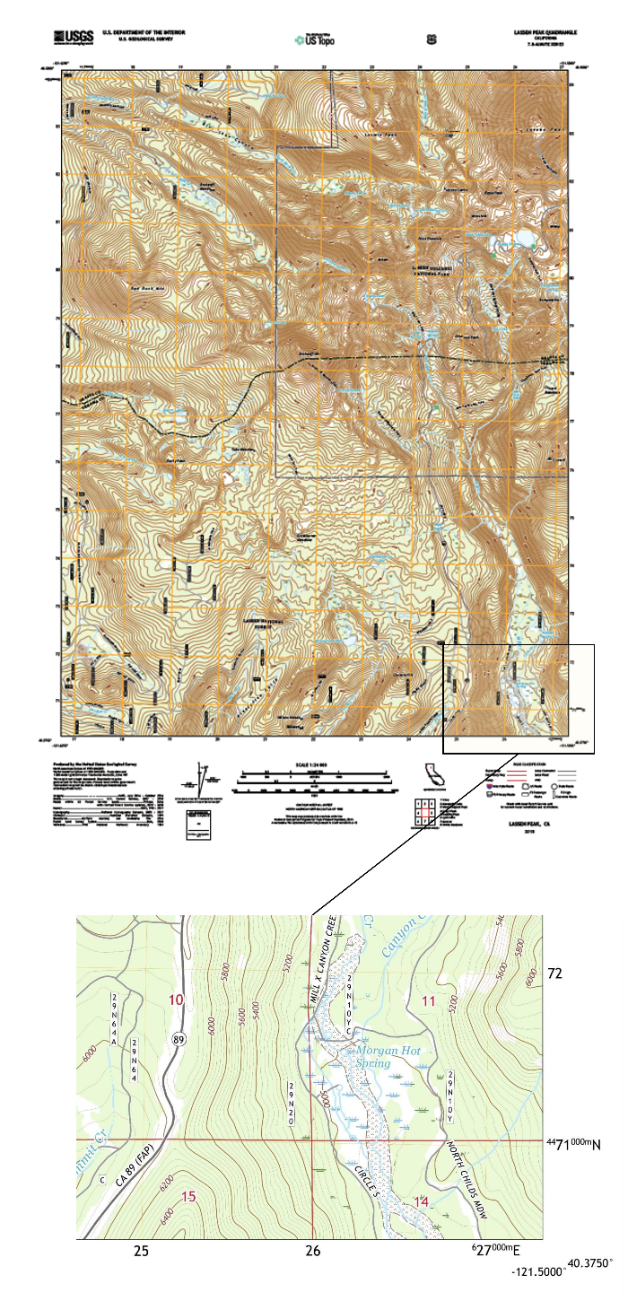
Figure 6: Top, a topographic map of the Lassen Peak Quadrangle (2018). Bottom, a close-up of the southeastern corner. (Public Domain; USGS).
Aerial images are photographs taken from an aircraft, helicopter, airplane, blimp, or other flying object, like a drone. These photographs are typically taken by mounted cameras or by hand by the photographer. There are several different types of aerial imagery including: an oblique aerial photograph, which are photographs taken at an angle; and vertical photographs, which are taken straight down. The earliest surviving aerial image is from the late 1800’s. Drones and other popular camera equipment continue to make access to these types of photos easy, quick, and relatively inexpensive. Next time you fly, sit by the window and snap a photograph of the ground below!

Figure 7: Taken from a passenger plane over the Rincon near Carpinteria in Southern California. (CC-BY; Matthew Sauter)
Satellite images are pictures of Earth or other solar system bodies collected by imaging satellites operated by governments and businesses around the world. Here in the US, all satellite images are produced and published by NASA Earth Observatory and are freely available to the public. The first images taken from space were done in the 1940’s and the first satellite photograph was taken in 1959. In 1972, one of the most famous space photos, “The Blue Marble” was taken. This coincided with the beginning of the Landsat program here in the US, which is the largest program for acquisition of imagery of Earth from space. Check out this video for more about satellite imagery!

Figure 8: A Landsat image of Chicago from 2003. (Public Domain; NASA).
A digital elevation model (DEM) is a 3D computer generated representation of the surface of Earth, planetary body, moon, asteroid, etc. DEMs are commonly built using data collected by remote sensing techniques, but they may also be built from land surveying. Want to create your own DEM files? Watch this video from Open Topography to learn how!
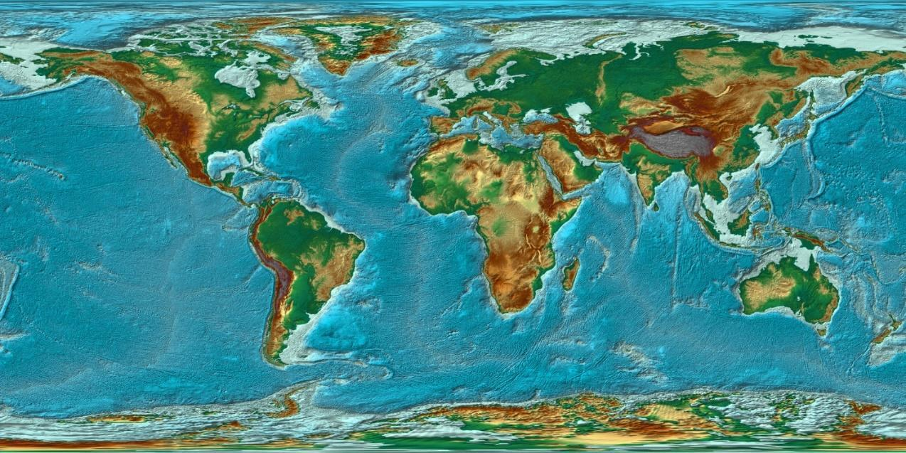
Figure 9: World bedrock digital elevation model. Color coding is directly related to topographic height, with blue and green at the lower elevations, rising through yellow and brown to gray at the highest elevations (CC-BY 2.0 DEED, Kevin Gill via Flickr).

Measurements in the Geosciences
Observations and measurements are used across the sciences. An observation is information obtained directly from one of the five human senses. A measurement is a means of expressing an observation with great accuracy. Measurements are expressed by both a numerical value and a unit. It is critically important to always ensure your number has a unit!
In the US, we use two systems to measure: the English or Imperial System and the Metric or International System (SI). Typically, scientists will utilize the metric (SI) system for consistency.
The following are common measurements for the geosciences:
- Length: the distance between two points
- Mass: the amount of matter in an object
- Time: the duration of the event being observed
- Temperature: a measure of kinetic energy, commonly known as heat.
- Rate: a measure of distance per time, for example miles per hour (mph).
If you are unfamiliar with measurement abbreviations, the following tables will be helpful references.
Table 1: Abbreviations for common Imperial and Metric measurements.
Imperial System Abbreviation | Imperial System Measurement | Metric System Abbreviation | Metric System Measurement
-- | -- | mm | millimeter
in | inch | cm | centimeter
ft | feet | m | meter
mi | mile | km | kilometer
°F | Fahrenheit | °C | Celsius

Table 2: Common conversions between the metric and imperial systems.
Metric System | Imperial (English) System
1 km | 0.621371 mi
1 m | 3.28084 ft
1 cm | 0.393701 in

Measurement Conversions

Measurement conversions are an important part of the sciences. If you struggle with math or suffer from math anxiety, remember, you are not alone, and we can do this! Math is a skill to learn, in the same way you learned to read and write. Like learning a language, it takes consistent practice to become fluent. Learn a few simple techniques to help reduce your math anxiety in this TedEd video.
The internet contains a wealth of information, good, bad, and ugly. You will likely find many conversion tools with a simple Google search; however, the process behind conversions is helpful to learn, particularly if you plan to enter a STEM-based field. Help on conversions is available here.
Scientific Notation
Occasionally you may encounter measurements reported in scientific notation. Scientific notation will contain exponents and is useful for measurements that are very small or extremely large. If you are on your phone calculator, rotate your phone to landscape and transform from most scientific notation formats. Additional information on Scientific Notation can be found in this video.
Table 3: Scientific notation equivalents for numbers written in decimal notation.
Decimal notation | Scientific notation
2.0 | 2 x 10⁰
300 | 3 x 10²
4321.768 | 4.321768 x 10³
-53,000 | -5.3 x 10⁴
6,720,000,000 | 6.72 x 10⁹
0.2 | 2 x 10⁻¹
987 | 9.87 x 10²
0.00000000751 | 7.51 x 10⁻⁹

Scientific Error
When recording measurements, scientists will sometimes indicate scientific error. Errors are differences between observed values and what is true in nature. For measurements, scientists commonly consider both accuracy (how close a measurement is to the true or accepted value) and precision (how close measurements of the same item are to each other). Precision is always independent of accuracy. The best quality scientific observations are both accurate and precise.
Learn more about accuracy versus precision in this TedEd video.
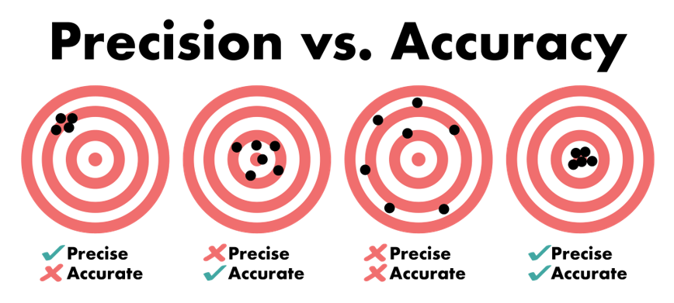
Figure 10: It is possible to be very precise but not very accurate, and it is also possible to be accurate without being precise. In this example, the closer the darts land to the bullseye, the more accurate they are. (CC-BY 4.0; Emily Haddad).
What is Rounding?
Rounding makes a number simpler but ensures it remains close to the original value. The rounded result is less accurate, but easier to use. This is why you should never round until you are ready to calculate the final answer. Your instructor will likely let you know what place they would like you to round. Want to know more about rounding decimals? Watch this Khan Academy video.
So, how do you round numbers? First, identify which place value your instructor prefers you round to (whole number, tenth, hundredth, thousandth, etc.); ask for clarification if you are unsure. Second, look at the next smallest place value, the digit to the right of the place value you're rounding to. If the digit in the next smallest place value is less than five, you leave the digit as-is. Any digits after that number (including the next smallest place value you just looked at) become zeros, or drop-off if they're located after the decimal point. This is rounding down. If the next smallest place value is greater than or equal to five (5, 6, 7, 8, or 9), you increase the value of the digit you're rounding to by one. Just like before, any remaining digits before the decimal point become zeros, and any that are after the decimal point are dropped. This is called rounding up. For example, if we were to round 1.75 cm to the nearest tenth, the new value would become 1.8 cm. If we were asked to round 1.75 cm to the nearest whole number, the new value would become 2 cm. Watch this video to learn how to round to the nearest tenth.

Introduction to the Earth System
Throughout Earth’s entire 4.54-billion-year history, every event in the history of our planet happened because something forced it to happen. An asteroid caused an extinction. Extinctions led to novel new evolutionary pathways for origination. Plate tectonics caused continents to move around. In each of these realities, we might be tempted to simply describe them as they have been here, in a linear fashion. A caused B. We could leave it at that. However, is it really that simple?
Contained within our galactic system is a solar system powered by an average G type star. “On a mote of dust suspended in a sunbeam” (Carl Sagan in the book Pale Blue Dot) resides our Earth System. Like any system, it is composed of many moving parts, powered by flows of energy and sustained in a state of dynamic equilibrium. Simply put, a system is a naturally occurring group of interacting, interrelated, or interdependent elements that form a complex whole. Within the Earth System, there are subsystems, reservoirs, or spheres. These subsystems encompass the space environment (exosphere), gaseous environment (atmosphere), liquid environment (hydrosphere), solid environment (geosphere), and living environment (biosphere). The icy environment (cryosphere) is typically broken away from the hydrosphere, and for emphasis the anthroposphere (human environment) from the biosphere. Energy, coming from the Sun and the Earth’s interior power the system. As energy flows through these systems, so do nutrients and elements, through what are called biogeochemical cycles. Examples of these include the carbon and nitrogen cycles. Check out this video for more!
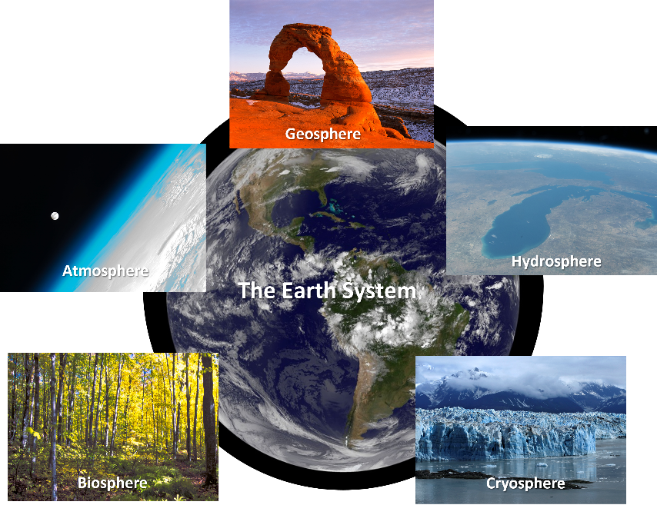
Figure 11: Earth systems science seeks to understand the interconnectedness of our planet. (center - Public Domain, NASA; clockwise - Public Domain, NASA; CC-BY, Alan Vernon; Public Domain, USDA; Public Domain, NASA; Public Domain, NPS/Neal Herbert Drum)
Energy does not flow through these systems in a linear fashion. Its pathways are complex, taking advantage of the points where systems interact to transfer from one system to another and back again. In order to really gain a grasp of how our planet works today and how it has worked in the past (uniformitarianism), we need to use some of the principles of systems thinking. If we think in terms of systems, we begin to think in terms of cycles, feedback, forcing mechanisms, storage sinks, and flows of energy and material.
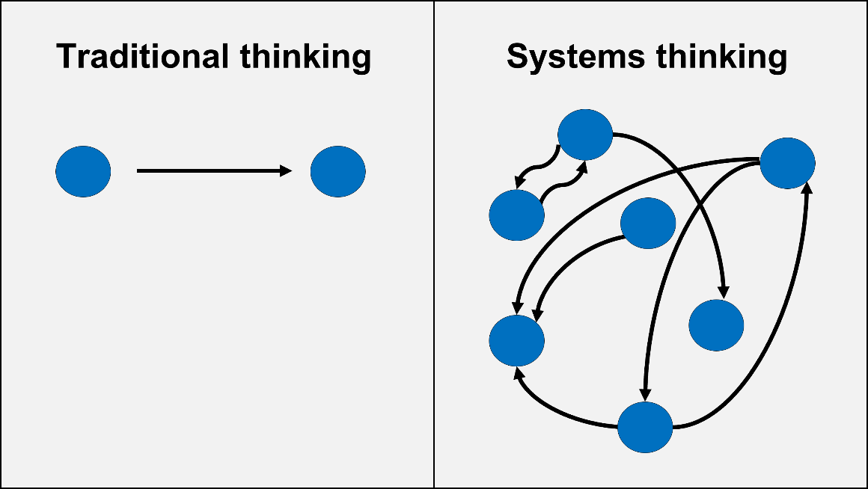
Figure 12: Systems thinking transcends linear approaches to problems and ways of understanding how things work (CC-BY, Chloe Branciforte)
Remember the extinction caused by an asteroid mentioned above? While the asteroid (from the exosphere) did indeed cause an extinction, it was the effect that asteroid had on the hydrosphere, atmosphere, and geosphere that led to the destruction that occurred in the biosphere. In systems thinking, the asteroid was a forcing mechanism that put the entire Earth system into a state of disequilibrium, past a tipping point of no return. While certainly some organisms were directly crushed by the impending rock from space, most were killed by the downstream effects as its energy rippled across the interconnected web of systems.

Earth Systems Overview
Events influence the Earth system, though they usually begin within a particular sphere. Let’s use a volcanic eruption as an example. When a volcanic eruption occurs, what happens?
- Ash and rock are blasted into the atmosphere.
- Gases are emitted into the atmosphere.
- Lava may run downslope.
- Pyroclastic flows, superheated ash, may rush downslope at great velocity.
- Lahars, or volcanic mud- and debris- flows, may result from the rapid melting of snow and ice, bringing large amounts of debris down slope.
- Flora and fauna in the immediate vicinity of the volcano may be impacted.
There are other effects associated with volcanic eruptions beyond these, however, these are direct effects on each sphere from the event. These direct effects are not the end of the story. There are also indirect interactions that aren't always as obvious. What are some of the indirect interactions (or forcings) that result from an eruption? For example, how is the biosphere affected by impacts to the geosphere? Ultimately, understanding the interconnectedness of the Earth system is critical for gaining a holistic view of how our planet is affected by individual events. In the history of our planet, there is no shortage of such events!

The Symphony of the Spheres

With this background, let’s explore the spheres in more detail. In particular, the sections below will describe the major spheres including the:
- Exosphere
- Atmosphere
- Hydrosphere
- Cryosphere
- Geosphere
- Biosphere
- Anthroposphere

The Exosphere: Space Environment

The exosphere is the space environment. Thought of from the perspective of the Earth, it is the location in the solar system, around our star, within the Milky Way galaxy, and so forth. All the energy that powers the other systems on our planet, with the exception of the geosphere, comes from the Sun, outside our planet. This solar radiation, ranging from gamma radiation through long-wave radio waves, is critical for the normal operation of the biosphere, atmosphere, and hydrosphere. The exosphere is also the source of dangerous radiation in the form of galactic cosmic rays and solar particle events. Ultimately, the exosphere is a place hostile to life, but paradoxically critical to it also.
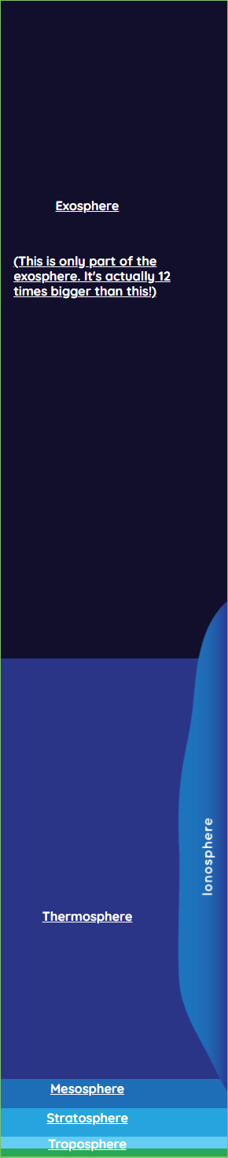
Figure 13: The Exosphere is the uppermost region of the Earth's atmosphere and has no clear upper boundary since it gradually fades into outer space. (Public Domain, NASA)
Energy from the Exosphere
The Sun powers our solar system. In addition to the Sun, some planets have a significant source of internal heat. Venus is one such planet, releasing its heat through volcanism. Saturn produces more internal heat than it receives from the Sun, given its great distance from the star it orbits. Earth is also one of these planets. In Earth’s case, the radiation received from the Sun is the primary driver for the entire Earth System, including its climate.
When considering the energy that arrives from the Sun, it is worth studying the image below from NASA. Radiation from the Sun reaches the Earth System in a wide range of wavelengths spanning the entire electromagnetic spectrum. Much of this energy is blocked by the Earth’s atmosphere, allowing only radio waves, visible light, short-wave infrared radiation, and some amount of UV radiation to penetrate to the surface of the planet. This selective admission is important for the functioning of life on Earth as we see it today. But it has not always been this way. The Earth’s atmosphere has evolved along with life, affecting life’s evolution and also being changed by life itself. The types of radiation that are admitted to the surface have also changed over time.
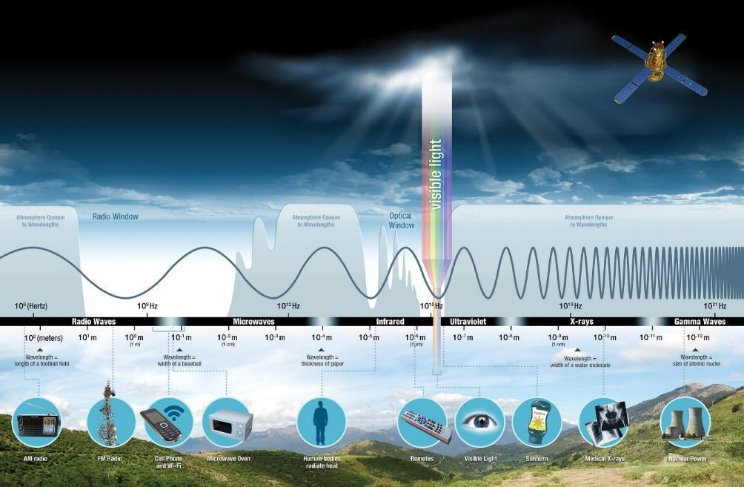
Figure 14: Full spectrum of electromagnetic energy. (Public Domain, NASA)
Energy from the Sun flows through the Earth system in its many forms and powers the hydrologic and the biogeochemical cycles that all make life possible on our planet. Of the radiation that enters the atmosphere, the shortwave (UV/Visible/infrared) radiation is most important. UV radiation gives you “sunburn” and is carcinogenic over time. Your eyes evolved to detect the violet to red wavelengths of visible light. Infrared radiation is what you experience as heat. Some of this is reflected by clouds, a notoriously difficult factor to model, given their variability. The rest of it hits the Earth’s surface, being absorbed in places like land and ocean (low albedo/dark in color) and reflected in other places like ice and snowpack (high albedo/light in color). Watch this video from NOAA illustrating the high variability of global albedo.
Want to learn more about light? Watch this episode of Crash Course Astronomy #24.
After the energy is absorbed, it can be re-radiated in the form of longwave infrared radiation. This is still in the form of heat but has lower energy (longer wavelength). As this radiation attempts to leave the atmosphere, much of it is absorbed by greenhouse gases, such as water vapor, carbon dioxide, methane, and nitrogen dioxide. This trapping of heat by gases is what is referred to as the greenhouse effect and this effect is critical for life on Earth. Want to learn more about the Greenhouse Effect? Watch this video.
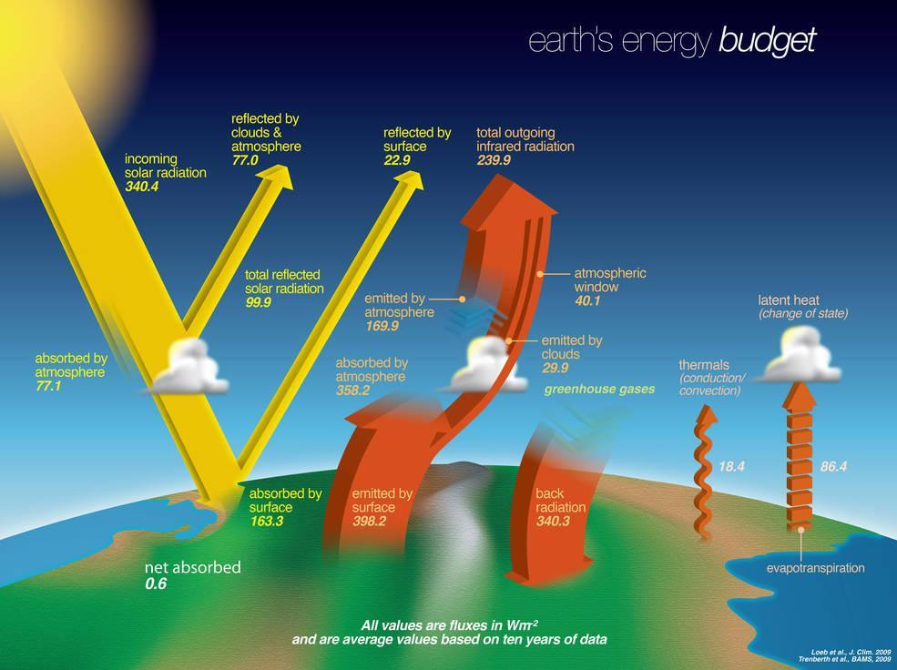
Figure 15: Earth’s energy budget (Public Domain, NASA)

The Atmosphere: Gaseous Earth (Troposphere, greenhouse gases, etc.)

The atmosphere is the gaseous envelope that surrounds our planet. Our current atmosphere can be thought of as the third atmosphere our planet has had. The primordial atmosphere of the Hadean and outgassing processes eventually gave way to one dominated by volcanic gases and rich in CO₂. Once photosynthesis evolved around 3.8 billion years ago, the atmosphere would increasingly contain oxygen and nitrogen. Since about 600 million years ago, the concentration of oxygen in the lower atmosphere (troposphere) has been pretty consistent with what we have today.
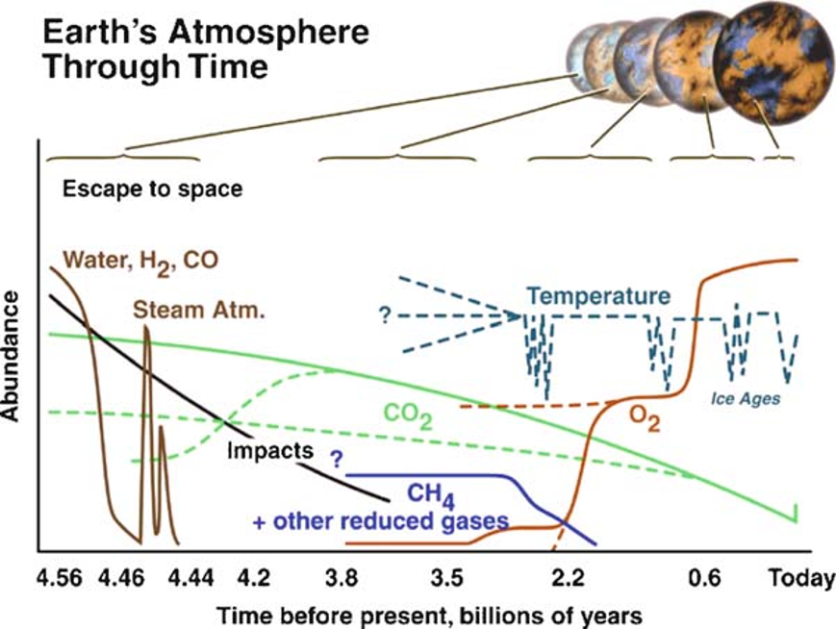
Figure 16: Evolutionary history of the atmosphere over Earth history. (Public Domain, NASA)
Our atmosphere is layered, with the densest portion at the bottom. This layer, the troposphere, is where most of the action occurs. It is where all human activity and weather occurs. It is really the upper boundary of mountain growth along mountain belts (or orogenic belts). It is affected on a daily basis by the uneven heating of the land and sea and the rotation of the Earth, creating what is called the planetary boundary layer. Above the troposphere is the stratosphere. In the stratosphere, exospheric UV radiation is absorbed by photochemically produced ozone. Ozone at this level of the atmosphere is very important for protecting life. Human activity, through the release of chlorofluorocarbon compounds via hairspray, refrigerants, and more had carved a hole in this critical layer. During the late 1980s, the world came together to ratify the Montreal Protocol. This banned these classes of chemicals and prevented the concentration of this important gas from deteriorating to an even more dangerous state.
Above the stratosphere lies the mesosphere (middle atmosphere) and thermosphere. As you ascend upward into the mesosphere, temperatures and pressure decrease. At the thermopause, the lower boundary of the thermosphere, pressure continues to drop but temperatures suddenly begin to rise sharply.
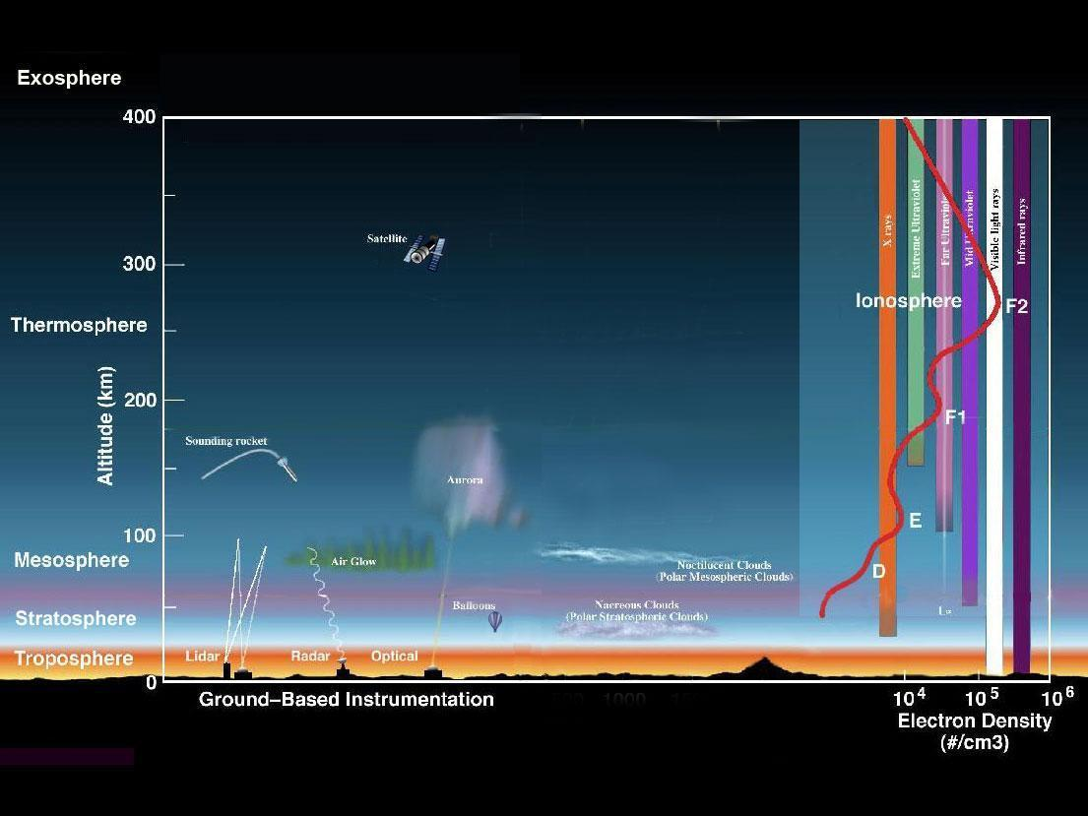
Figure 17: Layers of the atmosphere: troposphere, stratosphere, mesosphere and thermosphere. (Public Domain, NASA).
The atmosphere plays a very important role in the Earth’s climate. The most important of these is the concentration of gases in the troposphere that trap heat and prevent it from escaping to the exosphere. Solar radiation, incoming as shortwave infrared energy, will warm the surface (land and water) and then be re-radiated as longwave radiation. This gets trapped by greenhouse gases like water vapor, CO₂, CH₄, and NO_{X}. All of these are gases that are increasing in concentration due to human activity. This heat gets trapped in the atmosphere, which has a much lower specific heat capacity than water. Generally, this means that the hydrosphere ends up absorbing this heat in all of its uneven nature around the planet, leading to increases in evaporation in some places and precipitation in others. It also generally warms the oceans and land surfaces, leading to higher ocean and land temperatures.
The uneven heating of the atmosphere is very important for normal weather patterns. Rising warm air at the equator and descending cool air at the poles create the foundation for convection cells that circulate air between the equator and poles. The rotation of the Earth produces the Coriolis Effect, which deflects the movement of air in these cells in an easterly direction at the poles (Polar Cell), westerly direction in the mid-latitudes (Ferrell Cell), and again in an easterly direction in the tropics (Hadley Cell).
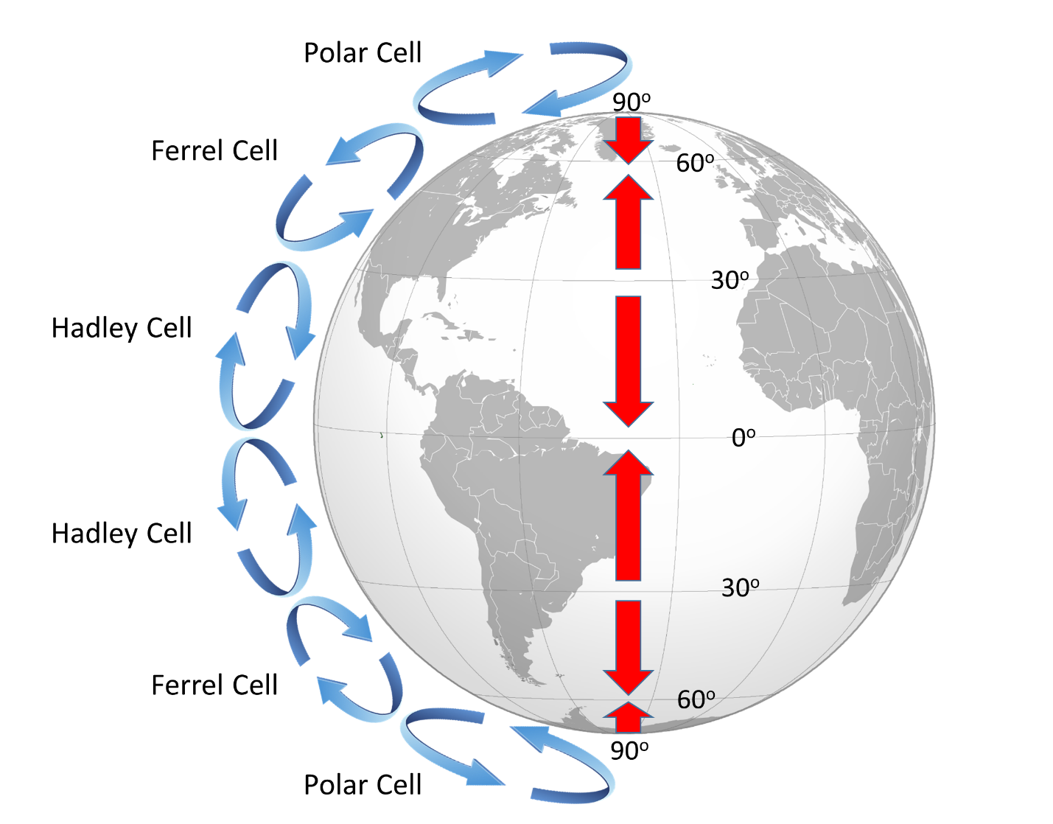
Figure 18: On a rotating Earth, there are three atmospheric convection cells in each hemisphere, leading to alternating bands of surface winds (red arrows) (CC-BY-SA, Paul Webb).
These latitudinal variations not only drive our weather, but they also lead to important gradients in the biosphere, called the latitudinal biodiversity gradients (LDB). Generally, biodiversity decreases from the tropics to the poles. Today, this change in biodiversity is directly related to temperature changes with latitude. It is important to note here that today’s LDB is not the norm for Earth’s past. In fact, during the Eocene epoch, it is very likely that the temperate regions of the planet were the most diverse. This is because it was so much hotter in the tropics.

The Hydrosphere: Liquid Water (fresh, marine, groundwater, etc.)

The hydrosphere makes up the liquid envelope of our planet. It consists not only of the oceans, but also all freshwater contained in lakes, rivers, streams, and groundwater. While it is considered separately here, the cryosphere is a critical element of this sphere also, as it provides a significant storage sink for water. Freshwater and marine systems have many similarities and differences. However, the key feature of all liquid water in the hydrosphere is its ability to regulate heat in various ways.

Figure 19: Doldrums in the Pacific Ocean (CC-BY 4.0, Chloe Branciforte)
Water has a high heat capacity (specific heat). That is, it will absorb a great deal of heat energy before it gets hot itself. Because of this, water is a critical regulator of energy on the planet. 1 kg of water must absorb 4,184 Joules (J) of energy for its temperature to rise 1°C. By comparison the mineral copper only requires 385 J to accomplish the same task. This means that excess heat from the atmosphere, the Sun, or the land during the day can be absorbed by water with very little effect. Ultimately, while the hydrosphere is driven by the exchange of heat itself (the hydrologic cycle), it also regulates the planet in the same way sweat helps regulate your body temperature during a workout.
Another critical heat regulating feature of the hydrosphere are ocean currents. Whether the continents are combined into a single supercontinent or split into what we have today, warm surface waters will move and exchange with cool nutrient-rich bottom waters. This exchange, or convection, produces currents and gyres. These rivers in the ocean move heat around the planet. Temperature is not the only physical property in play when it comes to marine currents, as the salinity of marine water can vary enough to produce density-driven currents. The combined thermohaline circulation patterns in the ocean regulates our climate. Watch this video from NASA’s Perpetual Ocean for more on ocean currents.

The Cryosphere: Water-ice

The cryosphere is the solid portion of the hydrosphere. It is worth discussing separately from the hydrosphere because of the particular importance of ice in exchanges of heat and light between Earth’s systems. Like water, ice has a heat regulation effect. The presence of polar ice caps provides a very important counterweight to the extreme heat experienced in the mid-latitudes. The temperature differences between these regions drive the movement of air in the atmosphere, forming Hadley Cells (warm air rising and cool air descending) that, while deflected by the Earth’s rotation and Coriolis Effect, drive our weather. Polar ice is also a critical water storage sink. As it melts, sea level rises, and isostatic adjustment of continents occurs.
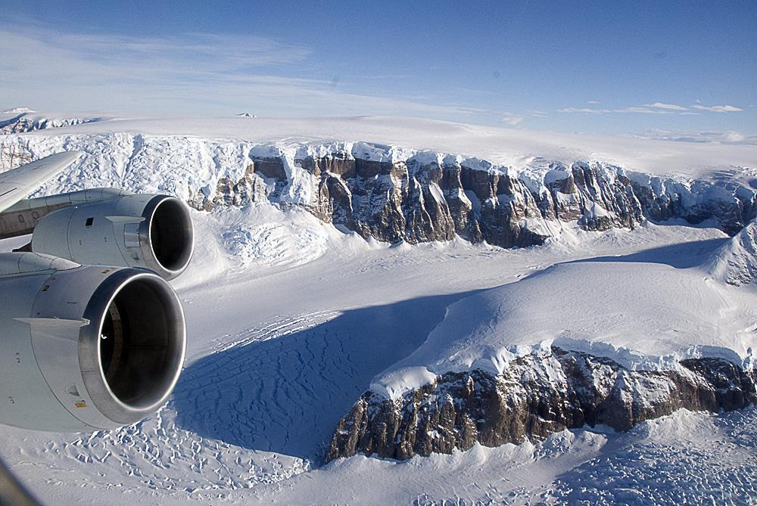
Figure 20: A view of the Antarctic cryosphere. (Public Domain, NASA)
The Earth has not always had polar ice. Just 40 million years ago, there was no ice at the poles because the planet’s climate was so warm. With the rise of the Himalayas and Andes came increased silicate weathering. As mountains rise, this form of weathering pulls carbon dioxide out of the atmosphere and deposits the byproduct of that carbon into the oceans as bicarbonate ions. Eventually water began to be stored on land over Antarctica first, as a continental glacier. Later, ice would form over the northern polar regions in the sea.
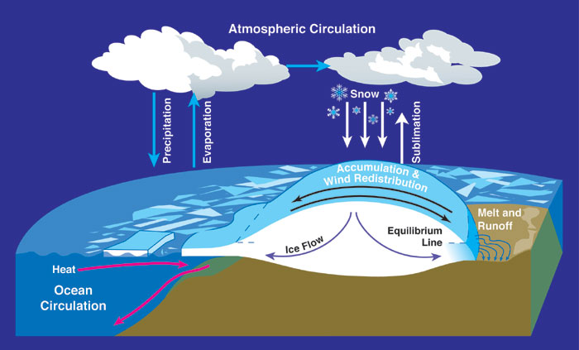
Figure 21: Earth's cryosphere (Public Domain, NASA)
The polar ice caps are only part of the story of the cryosphere. The ebb and flow of continental glaciers in places like Greenland and valley glaciers all over the world provide us with important visual thermometers for global temperature changes. As glaciers and sea ice retreat, there are changes in the color distribution on the Earth’s surface. Albedo, a measure of this, is highest on ice and lowest on ocean water. When sunlight hits ice, it reflects nearly 100% of the energy. When sunlight hits water, which is much darker, the water absorbs nearly all of the incoming energy. As the climate warms, ice recedes, and the climate warms more.
Additionally, glacial ice exerts a powerful influence on the geosphere by eroding, sculpting, and smoothing rock surfaces through processes like abrasion and plucking. These actions result in distinct landforms, such as U-shaped valleys and striated bedrock, and are different from those produced by fluvial systems. Such landforms offer tangible evidence of ancient glaciation events, including those from the most recent Ice Age.

Geosphere: Solid Earth (rock, including molten rock)

The geosphere is the solid part of our planet, think rocks, mountains, soil, and the Earth's inner layers. You might hear the term lithosphere used in some contexts, but here's where things get a bit tricky: in plate tectonics, "lithosphere" refers specifically to the rigid outer layer of the Earth, which includes the crust and the uppermost mantle. That’s a narrower definition than what we need when talking about Earth’s systems as a whole. To keep things clear and consistent, we’ll stick with the geosphere when referring to the solid Earth in the context of the Earth System. It’s a broader term that includes everything from the crust all the way down to the core.
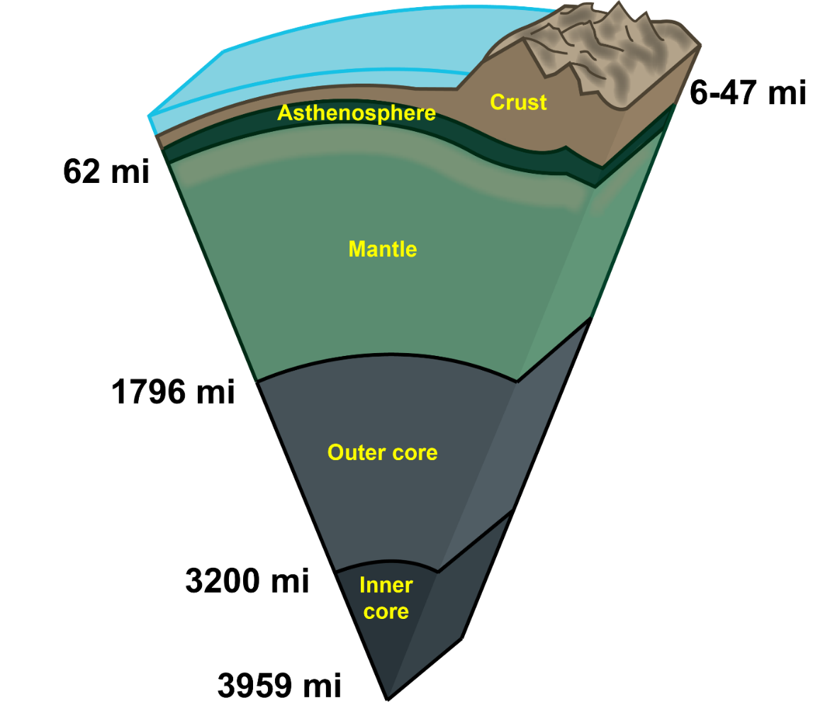
Figure 22: Cross-section of the Earth showing its main divisions (CC-BY-SA, Volcan26; modified by Chloe Branciforte)
A wide range of items are included within the geosphere, for example, rocks and minerals, the continents, lava and magma, mountains, the abiotic (non-living) parts of soils, and fossils, to name a few. For our course it will be important for future units that you are comfortable with basic chemistry, specifically element (chemical) symbols. Common elements of the crust and mantle include: iron (Fe), oxygen (O), silicon (Si), aluminum (Al), manganese (Mn), Potassium (K), magnesium (Mg), calcium (Ca), sodium (Na), hydrogen (H), helium (He), phosphorus (P), titanium (Ti), barium (Ba) and carbon (C). It would be helpful to bookmark the periodic table for future reference.
Energy from Earth’s Interior
Unique among the spheres, the geosphere produces its own energy. Unlike Mercury and Mars, who have a negative energy balance as they lose more heat over time than they create, Earth’s interior experiences a balance. Since the formation of all of the planets, they have been cooling over time. Whether a planet can balance this heat loss with its own heat production is a function of the composition of its interior. In Earth’s case, and for all terrestrial planets to varying degrees, it is producing much of its own interior heat through radioactive decay. The heat from this decay is caused by particles, emitted during decay of unstable isotopes, bouncing off of other particles. These collisions transform this kinetic energy into heat. The Earth’s interior is like a giant heat engine, it’s hottest at the core and gets cooler as you move toward the surface. This temperature difference creates what’s called the geothermal gradient, meaning the deeper you go, the hotter it gets. This internal heat isn’t just sitting there, it powers major Earth processes like plate tectonics, which in turn cause volcanoes, earthquakes, and other natural hazards.
So where does all this heat come from? There are three main sources:
- Radioactive decay: Unstable elements deep inside Earth break down and release energy.
- Primordial heat: Leftover heat from when Earth first formed is still slowly escaping.
- Frictional heating: As materials move and grind against each other inside the Earth, they generate heat.
Once this heat is produced, it moves outward through conduction (heat transfer through solids), convection (heat carried by moving fluids), and advection (heat carried by moving material). Together with gravity, this heat drives the movement of tectonic plates and shapes the dynamic planet we live on.
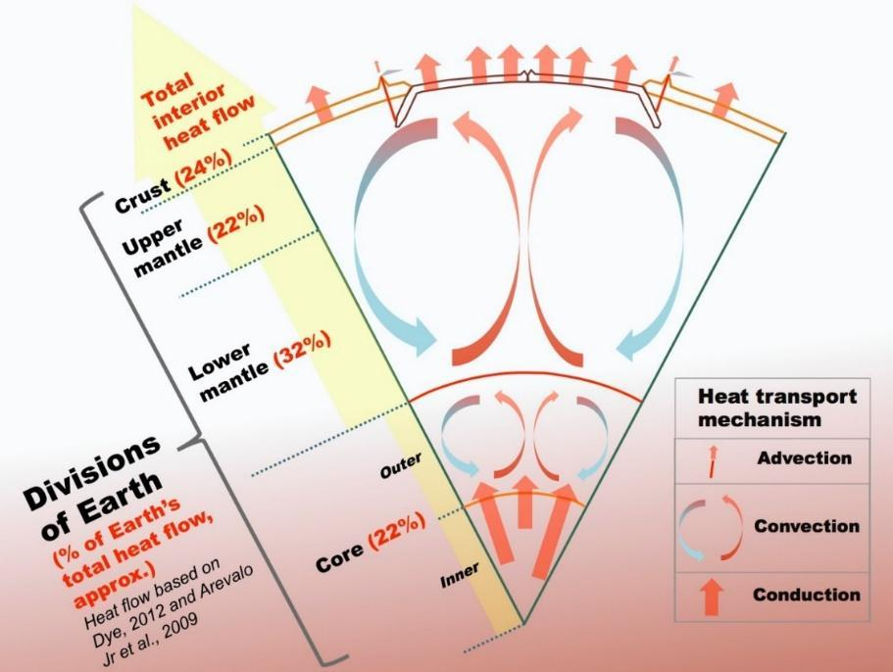
Figure 23: Cross-section of the Earth showing its main divisions and their approximate contributions to Earth’s total internal heat flow to the surface, and the dominant heat transport mechanisms within the Earth (CC-BY-SA, Bkilli1)
Through plate tectonics, this internal energy teams up with solar energy to help drive the biogeochemical cycling that provides important nutrients that sustain life, including carbon, hydrogen, nitrogen, oxygen, phosphorus, and sulfur. Because of this, energy from the Sun is only part of the story of our planet’s geologic past. The combination of these sources of energy is critical for the function of Earth’s systems. You can see examples of some of these important interactions in the figure below.
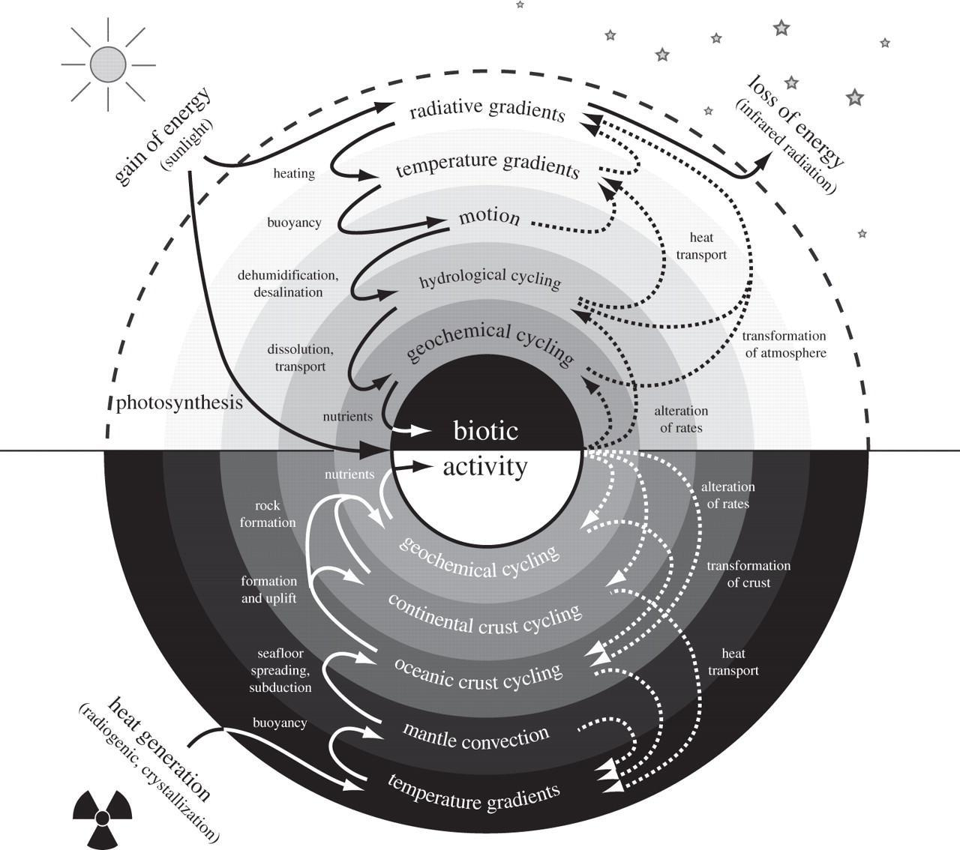
Figure 24: The Earth system’s two main sources of energy and some of the transfers and flows of that energy, all of which contribute to biotic activity. Solid lines are modes of energy transfer and dissipation. Dotted lines are processes, or effects, created by these flows of energy. (Kleidon, 2012)

Table 4: Geological Sources of Important Elements for Life. All of these elements are ultimately sourced from within the Earth's interior. Plate tectonic processes, driven by Earth's interior heat, drive one end of the biogeochemical cycling of these nutrients while the Sun's incoming energy drives them from above.
Elemental Nutrient | Primordial Source on Earth | Important Life Processes
Carbon | Cosmogenic, Mantle, Volcanism | Basic element of organic chemistry, important nutrient for photosynthesis of glucose.
Hydrogen | Cosmogenic, Mantle, Volcanism | Basic element of organic chemistry, important nutrient photosynthesis of glucose.
Nitrogen | Cosmogenic ammonia, Earth's atmosphere | Important for the creation of amino acids and enzymes.
Oxygen | Cosmogenic, Volcanism, Carbon Dioxide dissociation, Photodissociation in Atmosphere of Water | By-product of photosynthesis, necessary for respiration and associated oxidation.
Phosphorus | Phosphides in Earth's core, Inorganic minerals such as apatite and fluorite, ocean-floor sediments | "Spine" of DNA molecule, an important micronutrient that helps energy in cells via ATP.
Sulfur | Cosmogenic, stored in Earth’s interior, volcanism | Allows for the synthesis of a greater variety of amino acids, an important nutrient for chemosynthesis.

Because of this independent heat energy, the solid Earth is much more dynamic than any other terrestrial planet we know of. Mercury, Venus, and Mars are very different places with differing amounts of interior activity. Some natural satellites in our solar system likely also produce their own interior heat. Examples may include Saturn’s natural satellite Titan. Earth, because of plate tectonics, is a much more active planet and one where the rocks are constantly interacting with and having an effect on the liquid and gaseous portions of the planet.
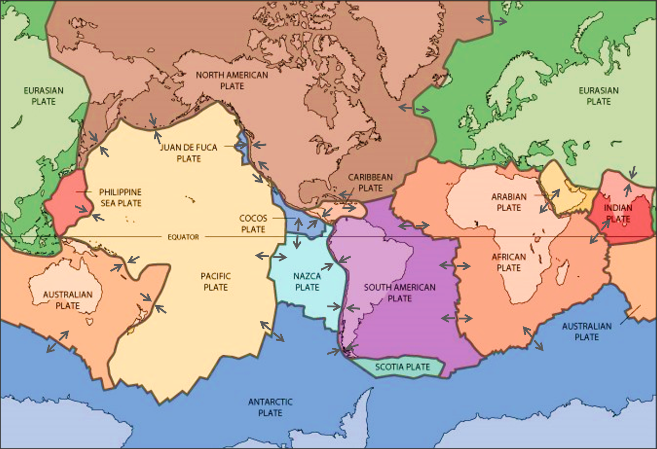
Figure 25: Major tectonic plates and relative sense of motion. in the Earth’s geosphere. (Public Domain, USGS; modified by Chloe Branciforte)
It is hard to pin down the most important geosphere elements for driving long term environmental change on the Earth. Volcanism is very likely most important, due to the input of gases like SO₂ into the atmosphere, which can have a cooling effect due to its ability to reflect solar radiation back into space. There is also airborne dust, sometimes referred to as loess and measured as a component of particular matter. This airborne dust can absorb heat, and then heat the atmosphere, causing warming in places where dust is moved from elsewhere.
Earth is a complex and dynamic planet which has changed continuously since its origin. It is important to note here that Earth is really, really old, 4.54 billion years old to be precise). Earth's appearance as we see it today, is very different from how it would have appeared during the time of dinosaurs. Earth continues to change, and the future Earth will look vastly different from today.
Check out a 3D model of Earth: Earth Terrain and Sea Map by John Davies on SketchFab.

Biosphere: Life

Without a tectonically active geosphere, an atmosphere with the right concentration of gases, and a hydrosphere made up so heavily of liquid water, there would likely be little to no biosphere on Earth. Unique among planets in our solar system and perhaps anywhere, Earth contains an amazing array of life. The origins of life on Earth are still somewhat elusive, but we do know that over time it has evolved to live in balance with the other spheres to the point where because the biosphere is such a critical influence on the other spheres, it can be considered on its own terms. Being located in the habitable zone (Goldilocks Zone) of a G-type star has its perks. Is Earth unique in this? Several exoplanets have been identified that are located in the habitable zones around their stars, but as yet, no extraterrestrial life has been confirmed. This video provides a sense of life on Earth. You are viewing the ebb and flow of life forms in the oceans through the lens of chlorophyll from space, with data collected by the MODIS sensor. This data was collected by NASA between 2002 and 2010 and displays visually the intricate link between photosynthetic life and seasonality.
The biosphere plays a very important role in the climate, particularly when it comes to the regulation of greenhouse gases. Of course, the decomposition of organic matter is a major source of CH₄ and NO_{X} gases, aside from what humans contribute. But the real effect is the planet-wide exchange of CO₂ and O₂ that is so critical to regulating temperature and providing breathable oxygen. Check out this supercomputer simulation of CO₂, offered by NASA Goddard. The red concentrations mostly represent CO₂, but you will see as the animation and narration progress that, during the southern hemisphere summer, carbon monoxide (CO) concentrations from fires in Africa and South American increase significantly. As the animation progresses, note the role that the biosphere plays in the annual fluctuations of CO₂ in various places around the planet, but particularly in the Amazon and Congo basins.
About 3.8 billion years ago, the biosphere began to alter the Earth’s atmosphere for its own purposes. The evolution of photosynthesis and the subsequent Great Oxygenation Event have left a long legacy that lives on today, in the form of algae and other plants that provide the base of the trophic levels so critical to our existence. Today, the biosphere is once again altering the Earth’s atmosphere, but through the actions of a single species.

Anthroposphere: Human portion of the biosphere

Humans are a force of nature. No other species in the history of life has held such a role. Yet, humans remain an integral part of the biosphere. Watch this video from NASA of the Earth at Night to get a sense of our impact. Because of our outsized impact, it is useful and perhaps even appropriate to consider the human element of the planet independently from the other spheres. Thus, the anthroposphere. The human impact on the planet goes well beyond altering the atmosphere and climate, leading some scientists to consider whether the Earth itself has indeed entered a new geological epoch. As of this writing, the Anthropocene Working Group, a subcommittee of the Quaternary Working Group of the International Commission on Stratigraphy has officially voted to recommend several things. First, that the Anthropocene should be treated as a chronostratigraphic unit for the geologic time scale (Series/Epoch level). Second, that the mid-20th century should be the time marker for its start. If ratified by the International Union of the Geosciences, the Holocene Epoch will have ended around 1950 and we will be living, officially, in the Anthropocene.

A review of important Earth cycles

In the Earth System, energy and matter are exchanged by cycles (flows, pathways or fluxes), connections, between the spheres. Examples include the rock cycle, hydrologic (water) cycle, biogeochemical cycles (Nutrient Cycles) like the carbon, nitrogen and sulfur, and phosphorus cycles, and many others. In most geology courses there is a focus primarily on connections to the geosphere but occasionally other spheres are mentioned especially during the rock and geomorphology units. The earth is a vast, complex system powered by two sources of energy: an internal source (the decay of radioactive elements in the geosphere, which generates geothermal heat) and an external source (the solar radiation received from the Sun); the vast majority of the energy in the earth system comes from the Sun. Whilst some variations in these two sources occur, their energy supplies are relatively constant and power all of the planet's environmental systems. Energy both drives and flows through environmental systems, and energy pathways may be highly complex and difficult to identify. For instance, energy may take the form of latent heat which is absorbed or released when substances change state (for example, between the liquid and gaseous phases). Energy is transferred within and between environmental systems in three main ways:
- radiation: the process by which energy is transmitted through space, typically in the form of electromagnetic waves.
- convection: the physical movement of fluids (such as water or air) that contain energy in the form of heat; convection does not occur in solids.
- conduction: the transfer of energy in the form of heat through the substance of a medium (from molecule to molecule).
As well as being transferred within environmental systems, energy may also be transformed from one form to another; for instance, a rock fall involves the conversion of potential energy (due to gravity) to kinetic energy (due to movement) and to heat, thermal energy (due to friction). The transfer and transformation of energy are associated with the performance of work; hence the sun performs work in heating the earth by its radiation, and a glacier performs work in moving sediment down-slope using the kinetic energy of its ice, water and rock. When work is carried out within the earth system, energy is transferred from one body to another, and it may also be converted from one form to another in the process.
As energy is transformed from one form to another in performing work, heat is released; that heat is subsequently exported from the system, usually into the atmosphere and then into space. Yet the total energy content of the Earth System remains the same (it is conserved), energy cannot be created or destroyed. Therefore, the Earth System is only able to continue to function because it is constantly replenished with a sufficient supply of energy, mainly from the sun. For more information on the sun and Earth’s energy budget, watch this video from NASA.
On a global scale, the dominant flows of energy occur because of the large discrepancies that occur between the amounts of solar radiation received (and re-emitted) at different points on the earth's surface. Such discrepancies are most clearly apparent in the wide variations in surface temperature that exist between the equator and the poles. Those temperature variations drive the global energy circulation which acts to redistribute heat from the warm to the cold parts of the earth's surface. An overall poleward transfer of energy occurs by means of a variety of processes:
- the transfer of heat by winds and warm air masses,
- the transfer of latent heat associated with water vapor,
- the movement of heat in ocean currents; and the returning counter-flows of cooler air and water. It is important to acknowledge that pronounced latitudinal variations occur in these three processes. Overall, these processes of energy transfer maintain a state of equilibrium in the Earth System, removing energy from areas of surplus (in lower latitudes) and transferring it to areas of deficit (in higher latitudes).
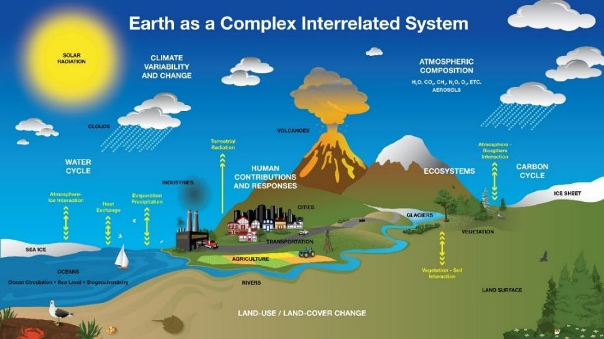
Figure 26: Earth as a complex interrelated system (Public Domain; Kevin Miller at NASA's Goddard Space Flight Center).

The Water Cycle

The Hydrologic (Water) Cycle: The cycle involves the continuous circulation of water in the Earth System. At its core, the water cycle is the motion of the water from the ground to the atmosphere and back again. Of the many processes involved in the hydrologic cycle, the most important are: evaporation, transpiration, condensation, precipitation, and runoff.
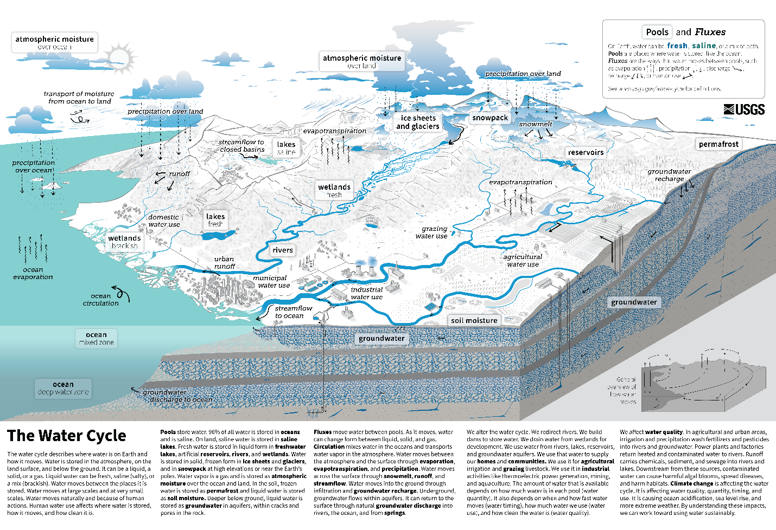
Figure 28: Earth's water is always in movement, and the natural water cycle (hydrologic cycle), describes the continuous movement of water on, above, and below the surface of the Earth. Water is always changing states between liquid, vapor, and ice, with these processes happening in the blink of an eye or over millions of years (Public Domain; Howard Perlman and John Evans, USGS).

The Rock Cycle

The rock cycle describes transitions through the three main rock types: sedimentary, metamorphic, and igneous. We will discuss this cycle in detail during this course!
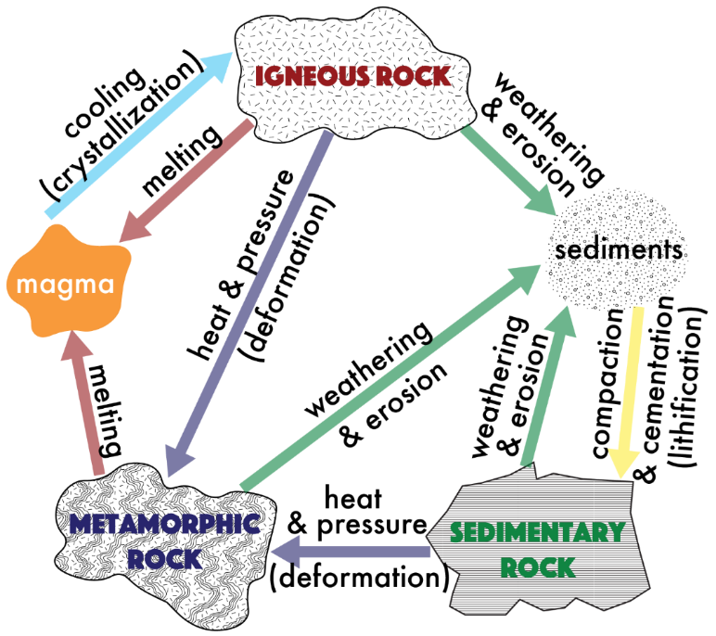
Figure 27: The Rock Cycle (CC-BY-SA 4.0, Emily Haddad).

Biogeochemical Cycles

A biogeochemical cycle is a pathway by which a chemical substance moves through biotic (biosphere) and abiotic (geosphere, atmosphere, and hydrosphere) compartments of Earth. These cycles include the carbon, nitrogen and sulfur, and phosphorus cycles.
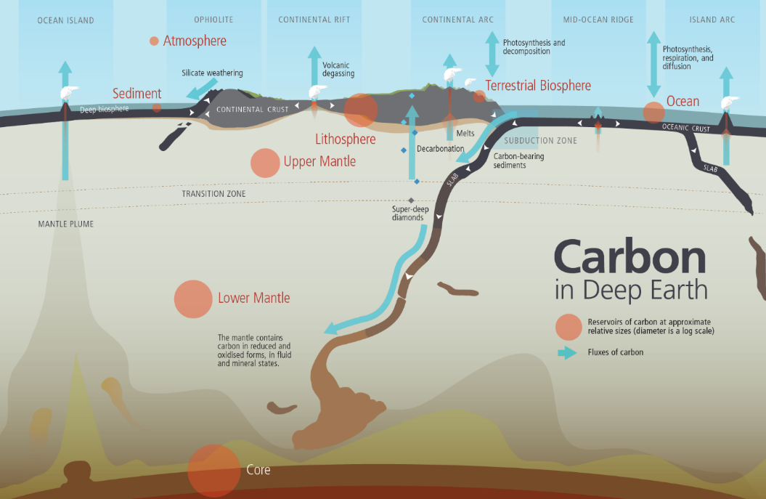
Figure 31: An overview of Earth's carbon reservoirs and the pathways between those reservoirs (CC-BY-SA 4.0; Mice of Mu).
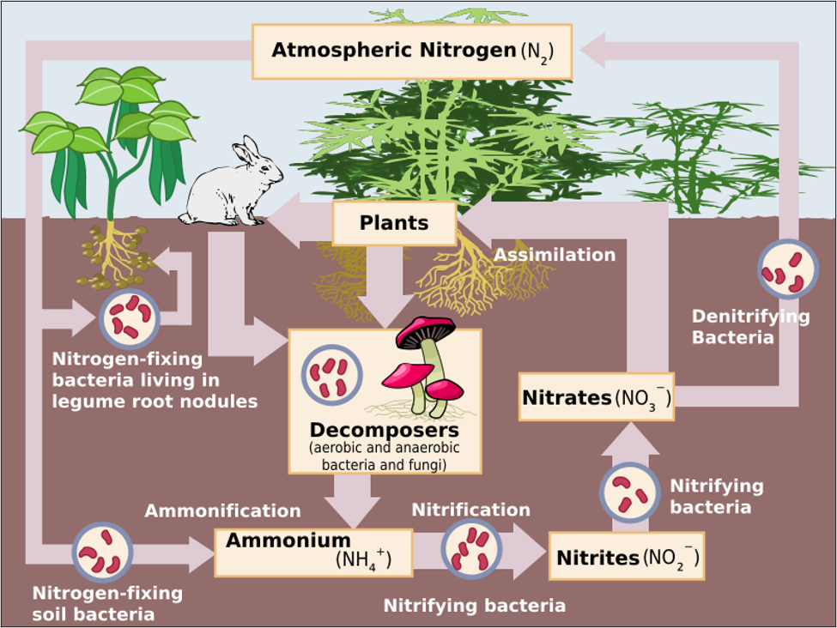
Figure 32: An overview of Earth's nitrogen reservoirs and the pathways between those reservoirs (Public Domain; EPA).
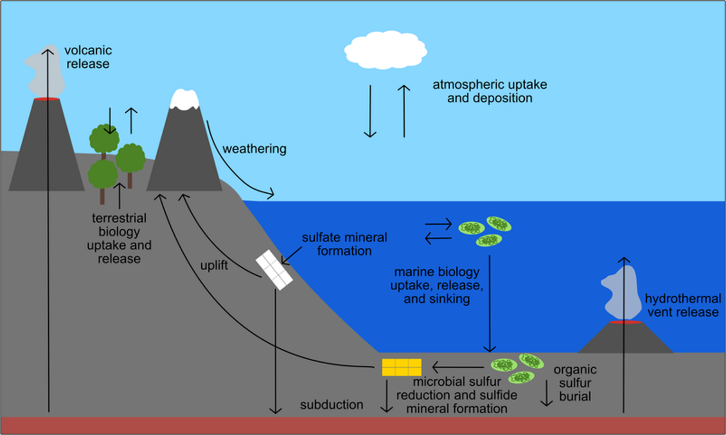
Figure 33: An overview of Earth's biogeochemical cycling of sulfur (CC-BY-SA 4.0; GeoscienceHd).
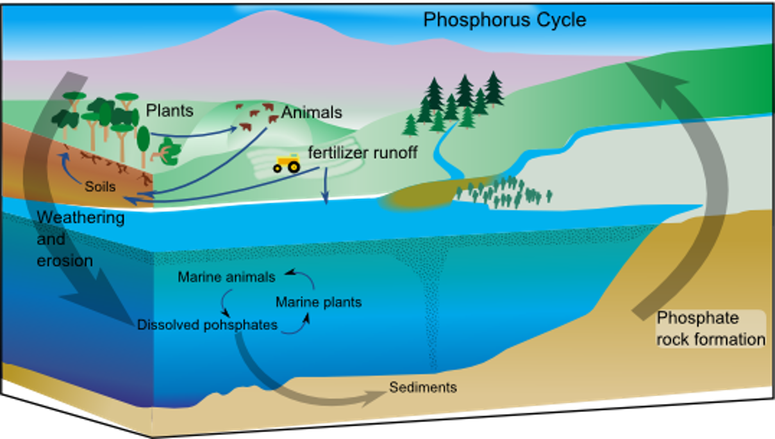
Figure 34: An overview of Earth's phosphorus reservoirs and the pathways between those reservoirs. (CC-BY-SA 3.0; Bonniemf).

Earth Systems collide: Events and Interactions

Systems exist in a state of dynamic equilibrium. Equilibrium is balance. When it is dynamic, it means that when the state of equilibrium changes the system(s) adjust. Consider a seesaw with equal weight on both sides. To balance it, you would place the fulcrum in the center. Put two people on either end and then attempt to balance it and you will find that the position of the fulcrum will need to adjust. The system would need to adjust to the new reality. Want to know more about Equilibrium? Watch this Crash Course: Chemistry episode.
Every event that occurs within the Earth system upsets a state of equilibrium. Sometimes, this is called "stasis", like with evolution. When a volcano erupts, the stasis/equilibrium is changed, and a new reality emerges for a time. In most cases, the new equilibrium is not much different than the prior situation. In some cases, a tipping point is reached. In such situations, a radically new equilibrium becomes reality, eventually, and the overall change to the system is extreme. A good example of such a tipping point in the Earth’s past is the Chicxulub asteroid impact that occurred at the end of the Cretaceous Period, mentioned earlier in this module.
However, we need to define some systems thinking terms to help us enable our ability to communicate about events and interactions. In systems parlance, events are known as “forcings.” These are things that force changes to the dynamic equilibrium at the time. Anthropogenic greenhouse emissions are a forcing that today is causing the global temperature to warm.
Forcings
The events we have been discussing are referred to as forcings in systems-speak. A forcing event is an action that moves a system away from dynamic equilibrium, usually through an initial push within one system. In terms of long term environmental change, anthropogenic additions of greenhouse gases to the atmosphere are forcing the climate to warm through additional trapping of greenhouse gases. This initial forcing, of course, leads to additional effects downstream.
In the Earth’s history, there have been plenty of examples of these. When photosynthesis evolved and led to the Great Oxygenation Event, the climate cooled which eventually led not only to the rapid radiation of photosynthetic organisms, but also the snowball Earth events of the Precambrian. During the late Devonian extinction, it is thought by some that massive expansion of vascular plants on land led to huge influxes of organic matter into the epeiric seas that existed at the time, leading to eutrophic conditions and mass extinction. In some situations, massive flood basalt events (end-Permian, end-Cretaceous) led to massive emissions of sulfur dioxide and carbon dioxide and subsequent climatic change.

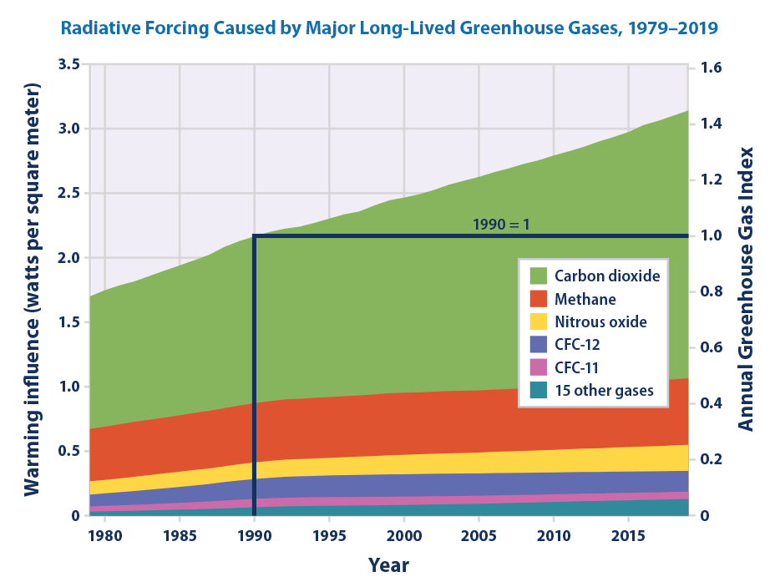
Figure 35: Natural and anthropogenic climate forcing mechanisms. Any one of these mechanisms can have an amplifying or balancing effect on the Earth’s climate, depending upon whether there is an increase or decrease in degree. (Public Domain, EPA)
In our modern environment as in the Earth’s past, the climate system is pivotal to life processes. The figure above lists an array of anthropogenic (human) forcing factors that influence the climate system. Changes in any one of these will drive the climate to warm or cool. However, a change in one factor could actually lead to a change in another, independent of any warming or cooling. That is the nature of a system – it is not linear. Interconnections matter. Forcing events never happen in isolation, there are always additional direct and indirect repercussions.
Feedbacks
Feedbacks are the results of forcings. No matter what the forcing event is, there are always feedbacks that occur as a result. Feedbacks can amplify the initial forcing (positive or amplifying feedback). They can also balance that forcing (negative or balancing feedback). A great modern example of amplifying feedback occurs because of the reduction of polar ice due to global warming. Because polar ice is reduced by warming, more dark-colored water is exposed, reducing the albedo that the ice once had in that area of the ocean. Seawater is much darker in color than ice. More energy is then absorbed by the water than was by the ice, further warming the water and melting even more ice. Because polar ice also helps moderate the planet’s climate, less ice leads to an amplification of warming.
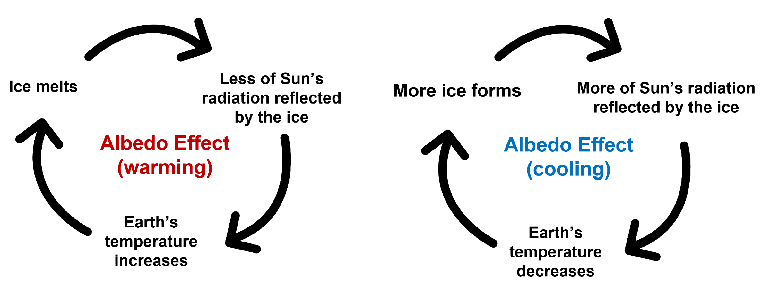
Figure 36: The ice albedo effect can be reinforcing feedback for both periods of warming and cooling in the Earth’s climate. (CC-BY, Chloe Branciforte)
Amplifying feedback loops tend to move an already off-balance system further away from regaining equilibrium. The image below illustrates the ice-albedo amplifying feedback. Arctic sea ice loss between 1979 and 2012 is shown on the map with areas north of eastern Russia and Alaska shown in false color to indicate the change in albedo color over time. Dark red areas represent much greater albedo change and, thus, warmer seas. The reduction in white sea ice and snow cover amplifies global warming forced by anthropogenic greenhouse gases.
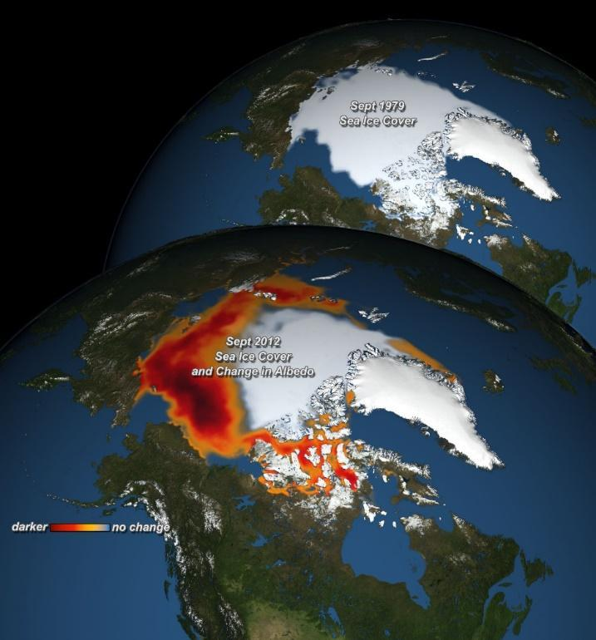
Figure 37: Decreasing Sea ice and its effect on albedo in the Arctic. (Public Domain, NASA)
Balancing (negative) feedback loops provide sustainability in systems. They are the foundations of systems at dynamic equilibrium. In the example below, when predator numbers get too high, overkill of prey will lead to a natural decrease in predators over time due to starvation. Likewise, an increase in the birthrate of prey will lead to an increase in the number of predators, until balance is reached once more.
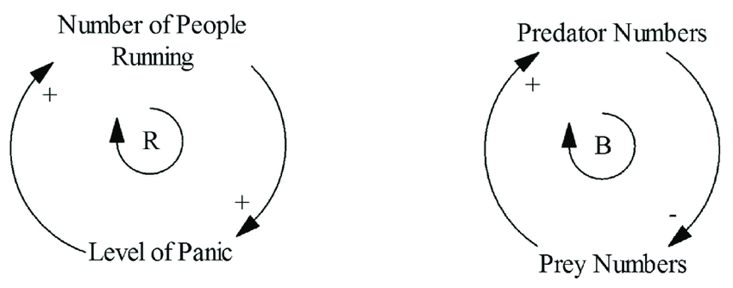
Figure 38: Examples of amplifying (positive) and balancing (negative) feedback loops. Amplifying feedback loops tend to further force a system that is out of balance further out of balance. Balancing feedback loops represent sustainability, in this case, the predator/prey relationship. (Neely and Walters, 2016)
Eventually, balancing feedbacks will work to bring a system to equilibrium once again. Amplifying feedbacks are not always going to happen, by contrast. Want to know more about feedback loops? Wach this TedEd video.
Sinks
Within systems, energy and materials can be stored until it is moved from one part of a system to another. Locations within the system where this occurs are referred to as sinks. Every biogeochemical cycle has sinks. In the carbon cycle, carbon is stored for very long periods of time in the form of limestone or fossil fuels. On the shorter term, it is stored in ocean water, in plants, or in the atmosphere. When a forcing event occurs, carbon may begin flowing from one sink to another. In the case of modern long term environmental change, carbon is flowing from coal and petroleum products into the atmosphere via combustion. For more on the Carbon Cycle watch this TedEd video.
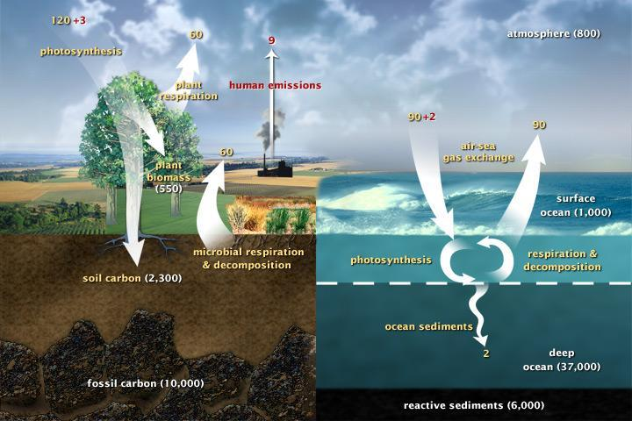
Figure 39: Short-term and long-term carbon cycles as they currently exist in the Earth System today. (Public Domain, NASA)
In the nitrogen cycle, we remove nitrogen from a sink, the atmosphere (Haber-Bosch Process), to create ammonia-based fertilizers that we then spread on crops. This nitrogen moves into storage in plants (a sink), but excess is washed into waterways where it eventually leads to eutrophic conditions as algae blooms out of control, dies, and is digested by microbes that pull the oxygen out of the water column. This kills everything else. The nitrogen then becomes a part of the sediment and, eventually, denitrifies back into the air. Throughout this biogeochemical cycling, a molecule of nitrogen can be stored in a wide range of sinks for varying duration.
For more on the Nitrogen Cycle, watch the Amoeba Sisters video.
Tipping Points
It is possible for a system to move so far out of its prior balance that, once it regains a sustainable equilibrium, it has a very different look and behavior than it did before. Initial forcings, followed by the actions of amplifying feedbacks can eventually cause a system to tip into an entirely new circumstance.
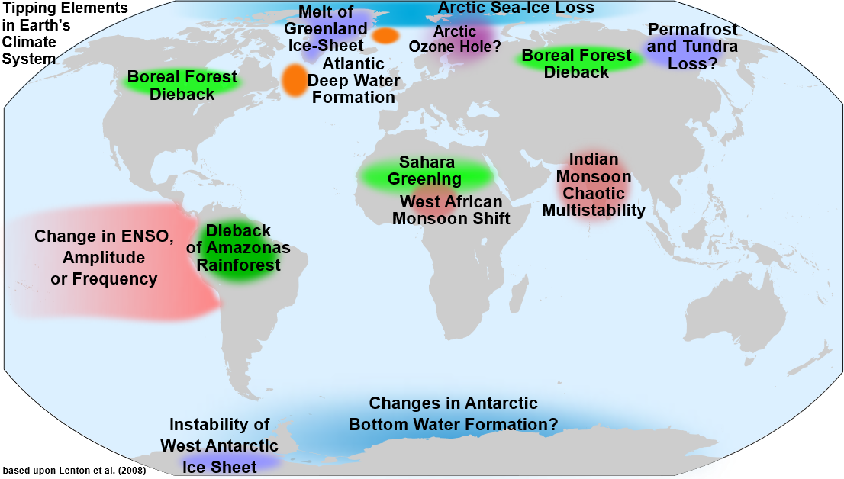
Figure 40: Global climate tipping points. While these are certainly based upon today’s environment, many of these would have also been tipping points at various times in Earth’s past. (CC-BY-SA, modified by DeWikiMan)
An excellent natural and historical example of this from the Earth’s past might be the Great Oxygenation Event. Once photosynthesis evolved, organisms using this new energy pathway could harness an abundant resource, sunshine, and radiate far and wide throughout the nascent biosphere. Evolution took on new pathways and the course of life would lead to eukaryotes and multicellular structures and, eventually, to humans. However, not before the Earth system would react violently (geologically) to this reduction in atmospheric carbon dioxide and increase in atmospheric oxygen. The result was a series of massive global glaciations as the Earth system struggled to gain a new equilibrium state.
Eventually, this period of global glaciation would subside. Afterward, the Earth that existed prior to these snowball Earth events was gone and the new Earth was much different. A new dynamic equilibrium was established.
Causal Loops
If we bring all these systems characteristics together to model a system, we can create causal loop diagrams. These diagrams allow us to do two important things. First, they are effective tools for analyzing a system in as many directions as possible. You can see that this example, focused on long term environmental change and, particularly, global biogeochemical cycles and climate tipping points, is quite complicated. These diagrams also help determine potential areas of focus for research. Finally, in a modern context we can use these to develop mitigation and management strategies for dealing with Earth system forcing events.
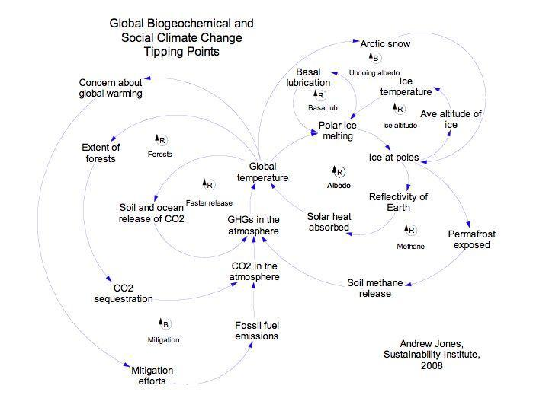
Figure 41: Causal loop diagram describing long term environmental change tipping points with various feedbacks built in (amplifying and balancing). (Andrew Jones, Climate Interactive)

Key words from this chapter

- Accuracy: How close a measurement is to the true or accepted value.
- Aerial images: Photos taken from an aircraft.
- Albedo: The reflectivity of a surface.
- Anthroposphere: The part of the Earth that is influenced by humans.
- Anthropocene: The proposed geological epoch that marks the time when human activities have had a significant global impact on Earth's ecosystems.
- Anthropogenic: Relating to or resulting from the influence of human beings.
- Atmosphere: The gaseous envelope surrounding Earth.
- Bathymetry: The study of underwater depth of lake or ocean floors.
- Biogeochemical cycle: The pathway by which a chemical substance moves through biotic and abiotic compartments of Earth.
- Biosphere: All living things on Earth.
- Carbon dioxide (CO₂): A greenhouse gas.
- Causal loop diagram: A visual representation of a system that shows the relationships between different variables.
- Chlorofluorocarbon (CFC): A man-made chemical that destroys ozone.
- Condensation: The process by which water vapor in the air changes into liquid water.
- Convection: The transfer of heat through the movement of fluids.
- Contour lines: Lines on a map that connect points of equal elevation.
- Cryosphere: All the frozen water on Earth.
- Digital Elevation Model (DEM): 3D computer-generated representation of the surface of a planet, moon, or asteroid.
- Dynamic equilibrium: A state of balance in a system where opposing forces or reactions are equal.
- Earth System: A system composed of many interacting parts, powered by energy flows, and in dynamic equilibrium.
- Eccentricity: The shape of Earth's orbit around the Sun.
- Evaporation: The process of water changing from liquid to a gas.
- Exoplanet: A planet outside our solar system.
- Exosphere: Space environment.
- Feedback: A response to a forcing that can either amplify (positive feedback) or dampen (negative feedback) the initial change.
- Forcing: An event or action that pushes a system out of equilibrium.
- Galactic cosmic rays: High-energy particles from outside the solar system.
- Gamma radiation: High-energy electromagnetic radiation.
- Geologist/Geoscientist: Someone who studies the Earth system.
- Geosphere: The solid part of Earth.
- Geoscience/Earth Science: The study of the Earth.
- Geothermal gradient: The increase in temperature with depth below Earth's surface.
- Greenhouse effect: The trapping of heat in the atmosphere by greenhouse gases.
- Greenhouse gases: Gases that trap heat in the atmosphere.
- Habitable zone (Goldilocks Zone): The region around a star where conditions are suitable for liquid water to exist.
- Historical Geology: A major branch of geology that examines the Earth's evolution through time.
- Holocene: The current geological epoch.
- Hydrologic (water) cycle: The continuous movement of water on, above, and below Earth's surface.
- Hydrosphere: All the water on Earth's surface.
- Imperial System: A system of measurement used in the US.
- Internal heat: Heat generated within a planet1.
- Lithosphere: The rigid outer part of the Earth, including the crust and upper mantle.
- Measurement: An observation expressed with accuracy.
- Mesosphere: The layer of the atmosphere above the stratosphere.
- Methane (CH₄): A greenhouse gas.
- Metric/International System (SI): A system of measurement used by scientists for consistency.
- Milankovitch cycles: Cyclical changes in Earth's orbit and axial tilt that influence Earth's climate over long periods.
- Montreal Protocol: An international agreement to phase out CFCs.
- Negative/Balancing feedback: A response to a forcing that reduces the magnitude of the initial change.
- Nitrogen dioxide (NO_{x}): A greenhouse gas.
- Oblique aerial photograph: Aerial photo taken at an angle.
- Obliquity: The angle of Earth's axis of rotation relative to its orbital plane.
- Observation: Information obtained directly from one of the five human senses.
- Ocean currents: Continuous movements of ocean water.
- Ozone: A molecule made up of three oxygen atoms.
- Photosynthesis: The process by which plants and some other organisms convert light energy into chemical energy.
- Physical Geology: A major branch of geology that focuses on the Earth's composition and processes.
- Plate tectonics: The theory that Earth's outer layer is made up of plates that move and interact with each other.
- Positive/Amplifying feedback: A response to a forcing that increases the magnitude of the initial change.
- Precession: The wobbling of Earth's axis of rotation.
- Precipitation: Water that falls to the ground from the atmosphere.
- Precision: How close measurements of the same item are to each other.
- Primordial atmosphere: The first atmosphere Earth had, composed mainly of hydrogen and helium.
- Radio waves: Low-energy electromagnetic radiation.
- Radioactive decay: The process by which an unstable atom loses energy by emitting radiation.
- Rock cycle: The continuous process of rock formation, transformation, and reformation.
- Rounding: Making a number simpler while keeping it close to its original value.
- Runoff: Water that flows over the land surface.
- Salinity: The saltiness of water.
- Satellite images: Photos of Earth or other planets taken from space.
- Scientific error: The difference between observed values and what is true.
- Scientific notation: A way to express very large or very small numbers.
- Sink: A reservoir that stores a substance.
- Solar particle events: Streams of high-energy particles emitted by the Sun.
- Solar radiation: Energy from the Sun.
- Specific heat capacity: The amount of heat required to raise the temperature of a substance by a certain amount.
- Stasis: A state of inactivity or equilibrium.
- Stratosphere: The layer of the atmosphere above the troposphere, where the ozone layer is located.
- Subsystems/Reservoirs/Spheres: Components within the Earth System such as the geosphere, hydrosphere, biosphere, and atmosphere.
- Thermosphere: The outermost layer of the atmosphere.
- Thermohaline circulation: The global circulation of ocean water driven by differences in temperature and salinity.
- Tipping point: A critical threshold in a system that, when exceeded, can lead to a significant change in the system's state.
- Topography: The shape and character of the Earth's surface.
- Transpiration: The loss of water vapor from plants.
- Trophic level: A position in a food chain.
- Troposphere: The lowest layer of Earth's atmosphere, where weather occurs.
- Vertical photograph: Aerial photo taken from directly overhead.
- Volcanism: The eruption of molten rock (magma) onto the Earth's surface.
- Water vapor: Water in its gaseous state.
- Wilson (Plate Tectonic) cycle: The cycle of the rifting and collision of continents.

Licensing/Works Cited
This document is licensed under a Creative Commons Attribution-ShareAlike 4.0 International License (CC-BY- SA) unless otherwise noted.


Acknowledgements:
We are thankful for the OER work done by previous faculty. Content was extensively rewritten to align with the learning outcomes for Geology 201. Chapter content was based on,
- Physical Geology 2nd Edition by Steven Earle from Vancouver Island University. CC-BY
- An Introduction to Geology by Chris Johnson, Matthew D. Affolter, Paul Inkenbrandt, Cam Mosher from Salt Lake Community College. CC-BY-NC-SA
- Laboratory Manual for Introductory Geology by Bradley Deline, Randa Harris, and Karen Tefend from the University of West Georgia. CC-BY-SA.
- Historical Geology by Matt Affolter, Callan Bentley, Shelley Jaye, Russ Kohrs, Karen Layou, and Brian Ricketts. CC-BY-NC.
- Some lab activities were rewritten or adapted from Deline, Harris & Tefend.
Finally, a hearty thank you to James St. John (The Ohio State University at Newark) who has amassed a curated Flickr page filled with amazing geology themed imagery from near and far; all of which are licensed CC-BY and have incredible resolution.

