Grab and Go - Be a Polar Scientist 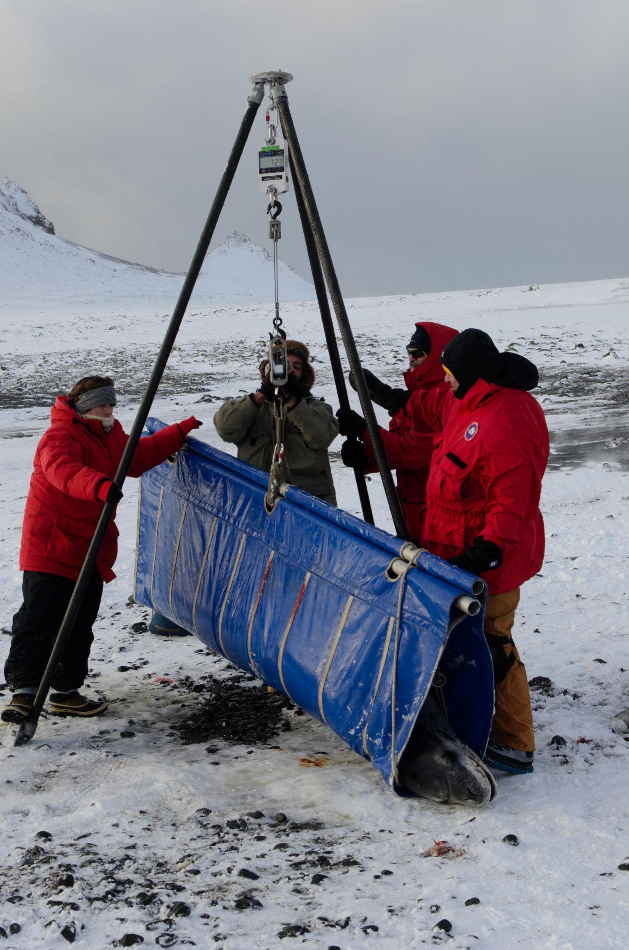
Polar STEAM - Be a Polar Scientist
Summary: Polar mammals with larger body sizes tend to survive better than smaller animals. Scientists can learn about what's happening in the polar environment by researching the body size and health of the animals that live there.

Outcomes: Guests who participate in this activity will:
- Practice data collection methods used in polar animal research
- Explain how body size measurements help researchers track animal health and indicate the state of polar food webs
- Describe why body size increases survival for animals in polar environments
Materials
- Folder containing:
  - Body condition chart
  - Pictures of polar bears
  - Pictures of seals
  - Map of polar regions
- Measuring tape
- Stuffed seal
  - Stuffed seal should have a magnet in flipper to attached replica seal flipper tag
- Stuffed polar bear
- Radio collar or “Bur on the fur”
- Replica seal flipper tag
  - Can be made by printing, laminating, then attaching magnet to the tag template
- Relevant bio materials (ex: polar bear skull)

Set-Up Instructions
- Lay out all print outs/images and biomaterials
- Arrange all supplies for the activity near or around the stuffed polar bear and seal

Interpretive Hooks
Ø “How do animals survive in extremely cold places like the Arctic and Antarctica?”
Ø How would you measure the body size of a polar bear or seal?

Activity Instructions
1. Introduce yourself!
a. Hello my name is _______ and today I’m talking all about how scientists learn about animals who live in the polar regions.
2. Ask participants if they would like to be a polar scientist, learning about the animals that live in the arctic and antarctic.
- Invite participants to name a few animals that live in the Arctic and Antarctic.
  - Examples include leopard seals, polar bears, whales, and penguins.
- Many polar animals share similar physical characteristics that allow them to survive in extremely cold environments. Ask participants if they can think of any similarities between the animals they had mentioned
  - Participants may list fur, blubber, ability to swim, sharp teeth, large body size, etc.
- After discussing a few of these characteristics, ask participant to choose either a seal or polar bear to investigate further
- For younger participants, you can expand on how animals can’t tell us if they are healthy, so scientists use measurements to figure out how well animals are doing in the wild
3. Explain that scientists measure some of those characteristics in order to learn more about the animal and see how healthy/well they are surviving
- Tagging: How do we learn about wild animals as individuals?
  - Explain how polar bears and seals are captured. Large mammals are typically given a tranquilizer (by dart or by hand) that puts the animal to sleep before scientists can approach them and take measurements.
  - Explain how scientists will record unique characteristics (scars, spotting patterns, etc.) or put a tag/tracker on the animal in order to find them again in the future.
  - Explain that’s important for researchers to monitor animals to see if there are any changes to their bodies over time
    - Flipper tags (Seals)
    - Satellite/radio tags (Seals)
    - Radio Collar/”Bur on the Fur” (Polar Bears)
  - Have participant attach a replica flipper tag to the seal or demonstrate where the “bur on the fur” would go on the stuffed polar bear
- Walk participants through the different measurements they will be recording
  - Body length, axillary girth, and weight
- Body Length: How do scientists measure body length?
  - Have participant use the measuring tape to measure from the nose to the tail by holding the measuring tape in a straight line above the stuffed animal’s body
- Axillary Girth: How do scientists measure axillary girth?
  - Explain that axillary girth is the circumference around the body right at the animals “armpits”
    - You could have participants think about where their axillary girth would be
  - Have the participant use the measuring tape to measure around the “armpits” of the stuffed animal
- Weight: How does body size give us information on an animal’s body condition and survival?
  - Explain that by measuring body length and axillary girth you can estimate an animal’s weight if you can’t measure it directly (like put a wild animal on a scale)
  - Ask how body size might affect animal’s survival in polar environments
    - Example: Is it better to be a bigger or smaller animal?
  - Show the polar bear body condition chart to explain how scientists can estimate how healthy an animal is by looking at their body condition (especially important if they aren’t able to measure the weight)
  - Have the participant compare the stuffed animal to the body condition chart
Conclusion: Talk about melting sea ice
- Ask participants what they think that scientists learn about the Arctic/Antarctic by monitoring the body size of polar animals
- Ask participants to imagine that scientists come back the next year and find the same polar bear/seal and discover that the same measurements are much lower than the year before. Ask what they can guess is going on in the environment to make the animal lose weight.
- Explain that polar animals are dependent on sea ice to hunt for food. As the earth warms, the sea ice melts, preventing animals from hunting and catching food. What does that do to their body size, and how will that affect their survival?
  - Why do polar bears and seals need sea ice?
    - “Polar bears rely on sea ice to efficiently catch their main prey, ice seals. Although seals can out-swim polar bears underwater, bears have the edge on top of the ice—using it to sneak up on and stalk their next meal. Ice seals, and related ice-dependent species like the walrus, rely on sea ice for survival, too. They use it to rest on and as a platform for giving birth to and raising their pups.” - Polar Bears International

Program Content
How do we learn about species who live in polar regions?
Scientists track different species through various methods (ex. satellite tags, radio collars). Once an animal is captured, scientists will measure different parts of the body to learn about their body size, body condition, and health.
Why is it important to learn about body size of animals?
The body size of an animal tells us a lot about an animal’s health. If a scientist notices that animals are smaller or thinner than years before, we can deduce that there is less food available. If a scientist notices that animals are larger than previous years, we can infer that there is an abundance of food. As a result, knowing about an animal's health also tells us about the environment they are living in and how it is changing.
How do scientists determine body size of large marine animals?
Scientists have standard measurements that they record depending on the species. They will compare the measurements of many individuals to determine the average size of that species and for males and females. .
Reflection/Extension Questions:

Do you think scientists use similar methods to learn about other polar animals like penguins and whales? What might be similar or different?

