Name: _________________________________________

Pikas vs. Weasels



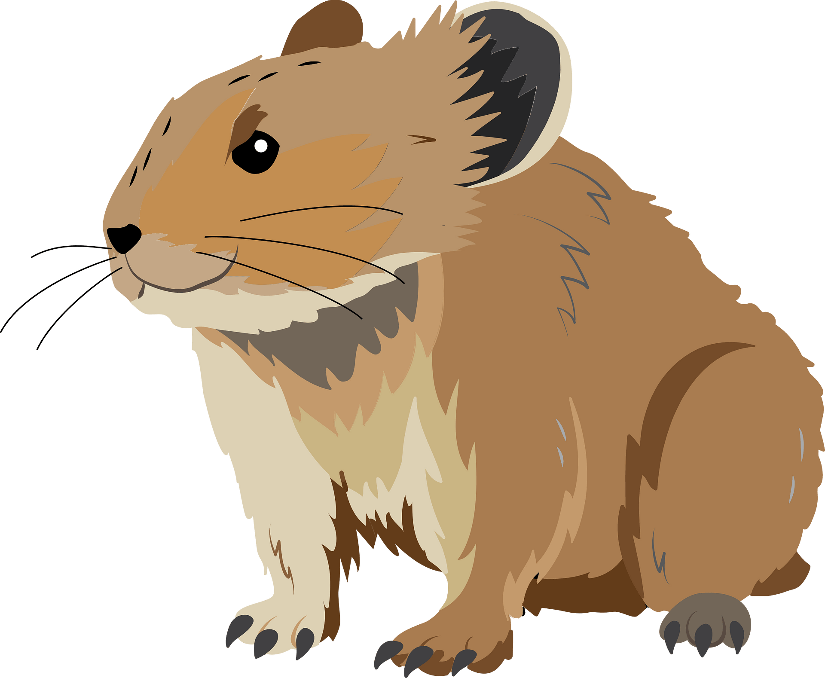

Materials (prepare in advance)
- Each group will receive 200 small squares cut from index cards (approximately 1 inch squared) -- The small squares represent the pika (prey) population.
- Each group will receive 50 large squares cut from index cards (cut index cards in half) -- The large squares represent the weasel (predator) population. Each group will receive a data table (prepared) and blank graph paper to graph the data.
- Designate your “playing area”. You can use classroom desks or tables. You can even experiment with different sized areas for different groups. You can also use masking tape to mark an area on the floor.
- It is possible to substitute other materials to represent prey and predators, such as beans, paper plates, foam squares, or pennies. Having “predator” cards with a little weight (heavier paper or cardboard) is often helpful.
- You can also change the organisms involved if you wish to model organisms local to your ecosystem.

Directions
- Spread 10 pika (prey cards) throughout your habitat (designated playing area).
- Starting with two short-tailed weasel cards (predator cards), stand about a step from the square or table area.
- One at a time, slowly drop or toss the two short-tailed weasel (predator) cards, so that they fall into the square. Do not aim them at the prey cards. Just let them fall. If they lay partially outside the square that is ok. If the short-tailed weasel card misses the box completely, pick it up and throw it again.
- Note that Year 1 in the data table below has been filled in for you. There are 10 pikas and 2 short-tailed weasels
- You have now started the game! Here are the rules to follow from now on:

(First, find those that died)
  - The pika cards that have been touched by, or lie underneath the short-tailed weasel cards are “captured, eaten, and dead”. Remove them from the game and place them to the side.
  - Any short-tailed weasel card that does NOT touch any of the pika cards “did not eat and starved and died”. They should also be removed from the game. Set them aside.

(Now find those that lived)
  - Pikas reproduce much faster than short-tailed weasels. The pika cards that were not touched by the short tailed weasel cards “escaped and survived to reproduce”. So count them and then double their number for the next round of the game (the next year). Record that number in the data table below. d) The short-tailed weasel cards that landed on only one pika card have managed to eat & survive, but did NOT reproduce”. So that short-tailed weasel card should stay in the game for the next round of the game.

(next year)
  - The short-tailed weasel cards that land on two or more pika cards have “eaten very well and they get to reproduce”. Count them and double their number for the next round of the game (the next year).

  - NOTE! IMPORTANT EXCEPTION: If either the short-tailed weasels or the pikas are ALL gone (extinct), pretend as though they are not extinct and write “1” instead of “0” in your data table. This keeps the game from ending. In a real ecosystem, it is nearly impossible for short-tailed weasels to locate and eat all of the pikas.

Summary of Directions
- First, remove the predator and prey cards that have "died". (following the rules above)
- Then, remove the predator and prey cards that have "survived." Double those that are allowed to reproduce according to the rules above.
- Finally, record the number of predator(s) and prey in your data table. This represents one year in the ecosystem.
- Repeat!

Data Table
Year (Round) | Weasels | Pikas
1 | 2 | 10
2
3
4
5
6
7
8
9
10
11
12
13
14
15
16
17
18
19
20

Graph (on separate sheet)
- Don’t forget to label the axes!
- Choose one color to plot weasels
- Choose a different color to plot pikas

Questions
- Describe the pattern that you see in the graph.

- Imagine you find that an ecosystem suddenly has a very high number of Pikas. What do you expect to happen to the number of weasels next year?

- The number of Weasels suddenly grows one year. What might happen to the number of Pikas the next year?

- Summarize how the populations of predators and prey are related.

