Observing Change in Greenland’s Far North
Student Worksheet
Instructions for Part 1. Welcome to Greenland’s Far North
After reading Part 1, answer the following questions.
1-1. Have you previously learned about the Arctic tundra biome and permafrost? If yes, when and where have you learned about these topics? If not, why do you think that you have never learned about these topics?
________________________________________________________________________________________________________
________________________________________________________________________________________________________
________________________________________________________________________________________________________
1-2. Why is it important to learn about the Greenland Ice Sheet and permafrost in Greenland? Explain your response in two to three sentences.
________________________________________________________________________________________________________
________________________________________________________________________________________________________
________________________________________________________________________________________________________
Instructions for Part 2. Investigating the High Arctic Water Cycle
After reading Part 2, answer the following questions.
2-1. Refer to the Arctic Water Cycle diagram. Using bullet points or create a labeled sketch, explain each step of glacial melting starting with rivers and pools of meltwater at the top of the glacier and ending with calving.

2-2. On the diagram below, highlight the reservoirs in one color and the transport pathways in another color. Be sure to include a legend.
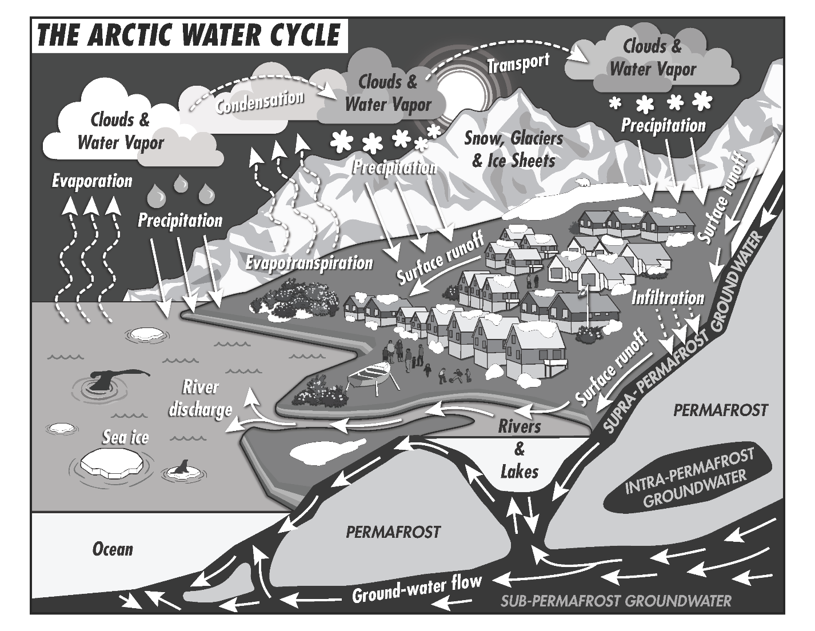
2-3. Watch this drone video and identify the permafrost thaw features identified.
A: _____________________________________________________________________________________
B: _____________________________________________________________________________________
C: _____________________________________________________________________________________
2-4. Find a peer-reviewed journal article related to research on the Arctic water cycle or Greenland’s hydrology. Read the journal article and answer the following questions.
A. Publication date: _____________________
B. Journal name: ____________________________________________________________________________________
C. Article title: ______________________________________________________________________________________

_______________________________________________________________________________________________________
D. Study location(s) and scale(s) of analysis (e.g., Greenland study location and watershed scale of analysis):
________________________________________________________________________________________________________
________________________________________________________________________________________________________
________________________________________________________________________________________________________
________________________________________________________________________________________________________
E. What data collection methods and/or computer models were used for this research?
________________________________________________________________________________________________________
________________________________________________________________________________________________________
________________________________________________________________________________________________________
________________________________________________________________________________________________________
F. What is one hypothesis that was tested in this research project?
________________________________________________________________________________________________________
________________________________________________________________________________________________________
________________________________________________________________________________________________________
________________________________________________________________________________________________________
G. In your own words, describe one key finding from this research.
________________________________________________________________________________________________________
________________________________________________________________________________________________________
________________________________________________________________________________________________________
________________________________________________________________________________________________________
________________________________________________________________________________________________________
H. What question do you have about this research? (You must come up with a question).
________________________________________________________________________________________________________
________________________________________________________________________________________________________
________________________________________________________________________________________________________
Instructions for Part 3. Formulating Hypotheses about the High Arctic Water Cycle
After reading Part 3, answer the following questions.
3-1. Why do you think NSF’s Interagency Arctic Research Policy Committee established the five principles for Arctic research? Explain your response in two to three sentences.
________________________________________________________________________________________________________
________________________________________________________________________________________________________
________________________________________________________________________________________________________
3-2. How did Lars Jeremiassen’s description of Arctic changes align with the Annual Arctic Sea Ice Minimum Area 1979-2022 video?
________________________________________________________________________________________________________
________________________________________________________________________________________________________
________________________________________________________________________________________________________
In preparation for an in-class activity, read the document about the research method assigned to you:
- Water Quality Meter
  - Temperature
  - pH
  - Dissolved Oxygen
  - Conductivity
- Piezometer (pages 1 through 8 “Wetland Hydrology” through “Hydropattern”)
- Oxygen Isotopes
- Acoustic Doppler Current Profiler
3-3. In three to four sentences, summarize the information that you learned about the research method assigned to you.
________________________________________________________________________________________________________
________________________________________________________________________________________________________
________________________________________________________________________________________________________
________________________________________________________________________________________________________
________________________________________________________________________________________________________
________________________________________________________________________________________________________
3-4. Complete the table below for the research method assigned to you based on what you learned about the watersheds in Part 3.
Watershed | Formulate a Hypothesis: In the next decade, how do you think the data collected at the watershed will change? (e.g., will there be an increase or decrease of a variable) | What is one reason for your hypothesis?
North Mountain
Narssarssak
Fox Canyon

